PENNSYLVANIA

PUBLIC UTILITY COMMISSION

Harrisburg, PA 17105-3265

Public Meeting held October 29, 2020

Commissioners Present:

Gladys Brown Dutrieuille, Chairman
David W. Sweet, Vice Chairman
John F. Coleman, Jr.
Ralph V. Yanora

Periodic Review of Duquesne Light Company’s Long-Term Infrastructure Improvement Plan | Docket No. M-2020-3019708

OPINION AND ORDER

BY THE COMMISSION:

On May 26, 2020, via a Secretarial Letter, the Commission initiated the periodic review of Duquesne Light Company’s (DLC’s) Long-Term Infrastructure Improvement Plan (LTIIP) as required by the Public Utility Code. 52 Pa. Code § 121.7(a). Unless otherwise directed, the periodic review shall begin at the midpoint of the term of the current LTIIP. DLC’s LTIIP was approved by a Commission Order entered on April 15, 2016, at Docket No. P-2016-2540046. DLC’s LTIIP began with calendar year 2017 and ends in 2022 and thus the midpoint is approximately January 1, 2020.

For the purposes of the periodic review, the Commission established a thirty (30) day comment period and a twenty (20) day reply comment period. DLC filed comments on June 25, 2020. No other comments were filed. DLC stated its LTIIP has successfully aided it in maintaining the reliability of the overall distribution system and enhancing the reliability of assets that were repaired and replaced under the LTIIP initiatives.

For the reasons expressed in this Opinion and Order, the Commission finds that the Electric Long-Term Infrastructure Improvement Plan of DLC is designed adequately to ensure and maintain safe, adequate, reasonable, and reliable service and that DLC has substantially adhered to its plan.

BACKGROUND

Effective February 14, 2012, Act 11 of 2012, (Act 11) provides jurisdictional water and wastewater utilities, electric distribution companies (EDCs), and natural gas distribution companies (NGDCs) or a city natural gas distribution operation with the ability to implement a Distribution System Improvement Charge (DSIC) to recover reasonable and prudent costs incurred to repair, improve or replace certain eligible distribution property that is part of the utility’s distribution system. The eligible property for the utilities is defined in 66 Pa. C.S. §1351. Act 11 states that as a precondition to the implementation of a DSIC, a utility must file a LTIIP with the Commission consistent with 66 Pa. C.S. §1352.

The Commission promulgated regulations relating to LTIIPs at 52 Pa. Code §§ 121.1 – 121.8 that became effective December 20, 2014. The Code provides that the periodic review will determine:
- If the utility has adhered to its LTIIP.
- If changes to the LTIIP are necessary to maintain and improve the efficiency, safety, adequacy, and reliability of the utility’s existing distribution infrastructure.

The Code further provides that if the utility’s LTIIP is found to be no longer adequate to ensure and maintain the efficiency, safety, adequacy and reliability of the utility’s existing distribution infrastructure, the Commission would direct the utility to revise, update or resubmit its LTIIP as appropriate. If the utility chooses not to abide by the Commission’s direction in this regard, the utility may elect to withdraw its LTIIP and forfeit its right to recover expenses through a DSIC. 52 Pa. Code § 121.7(d).

PERIODIC REVIEW OF DLC’s LTIIP

The review of DLC’s LTIIP considers the three calendar years 2017 through 2019. The stated long-term goal of DLC’s LTIIP is to enhance system resilience, reliability, and facility relocation and to recover reasonable and prudent costs incurred to repair, improve or replace certain eligible distribution property that is part of DLC’s distribution system as permitted by 66 Pa. C.S. §1351. DLC states its LTIIP includes five asset programs and nine initiatives and that it is on track with the spending forecasted in its LTIIP. DLC’s expenditures, asset programs, and initiatives are discussed further in this Order.

DLC’s total projected expenditures in its LTIIP at the end of 2019 was $204.6 million, while actual expenditures were $177.8 million, which is a variance of 15%. The negative variance was primarily due to each of the 4 kilovolt (kV) Substation Elimination projects varying significantly in scope and cost. For example, the conversion of one circuit on one project may require the conversion of the same number of miles as the conversion of four circuits on another project. Accordingly, the units of work completed are less than anticipated.

When DLC filed its LTIIP, an average cost per circuit converted was used to estimate the number of circuits that would be converted over six years. This approach did not account for the varying lengths of circuits that would be included in the specific projects ultimately selected for this initiative. More attention is needed by DLC in 2020 through 2022 to reconcile the variance in its planned and actual costs.

Table 1 below shows projected and actual expenditures for DLC’s various LTIIP initiatives for the years 2017 through 2019.

Table 1: Plan and Actual LTIIP Project Expenditures for 2017 through 2019

DLC’s infrastructure replacements and completed initiatives have either met or exceeded their original plan for 2017, 2018 and 2019 for four initiatives and did not meet planned goals for five initiatives. More attention is needed by DLC in 2020 through 2022 to reconcile its planned and actual project variances.

Table 2 below shows DLC’s projected and actual LTIIP Initiatives Completed for 2017, 2018, and 2019.

Table 2: Plan and Actual LTIIP Initiatives Completed for 2017 through 2019

The following sections will provide analysis of the spending, units of work, and benefits associated with DLCs nine LTIIP Initiatives shown in Table 2.

- 4 kV Substation Elimination

DLC spent 74.1% of its planned expenditures on this project and completed 45.5% of planned projects. DLC avers when it filed its LTIIP, an average cost per circuit converted was used to estimate the number of circuits that would be converted over six years. This approach did not account for the varying lengths of circuits that would be included in the specific projects ultimately selected for this initiative and DLC notes that is why there is an underspend and under completion.

DLC avers the annual average System Average Interruption Frequency Index (SAIFI) for equipment failures related to the 4kV substations was 0.16 before the elimination work and 0.26 after. DLC also notes the annual average System Average Interruption Duration Index (SAIDI) for equipment failures related to the 4kV substations was 17.09 before the work and 14.69 after. While there was no apparent improvement in SAIFI, there was modest improvement in SAIDI. DLC notes that more importantly, the 4kV substations being eliminated are over 50 years old and approaching end-of-life and are being replaced via load conversion to a 23kV supply. DLC notes this improvement will increase overall load capacity, system reliability, and operational capabilities of the distribution system.

- 4kV Stepdown Transformer Conversion

DLC spent 82.2% of its planned expenditures on this project and completed 72.2% of planned projects. The Stepdown Transformer Conversion project appears to have been generally executed as planned.

DLC avers the annual average SAIFI for equipment failures related to the stepdown transformers was 0.39 before the work and 0.50 after the work. The annual average SAIDI was 32.18 before the work and 28.69 after. While during this period there was no improvement in SAIFI, there was modest improvement in SAIDI. DLC notes that this initiative will decommission portions of the 4kV system that is antiquated with a 23kV infrastructure.

- Modular Integrated Transformer System (MITS)

DLC spent 110% of its planned expenditures from 2017 through 2019 on this project and completed 100% of the planned projects. The Modular Integrated Transformer System project appears to have been generally executed as planned.

DLC avers it completed 13 installations and forecasted the likelihood of failure would increase from 56% to 67% by 2020 without the accelerated 4kV unit transformer replacement program. Additionally, DLC reduced the average age of distribution substation transformers on DLC’s system from 53 years in service to 51 years of service.

- Aerial Cable Replacement

DLC spent 90.5% of its planned project expenditures from 2017 through 2019, and completed 59.1% of its planned projects. DLC avers it experienced higher than expected costs for the Aerial Cable Replacement initiative because of project specific scope and location factors, such as the number of pole replacements required and traffic control requirements. Based on current information, DLC expects to replace 85% of the units forecasted in the LTIIP with the allotted budget.

DLC avers that the 15 miles of aerial cable that were replaced had experienced a total of 25 failures in the 10 years before replacement and none since replacement.

- Underground Cable Replacement

DLC spent 88.2% of its planned project expenditures from 2017 through 2019 and completed over 178.8% of its planned projects. The Underground Cable Replacement project appears to have been executed as planned.

DLC avers that the 8.9 miles of underground cable that were replaced had experienced a total of 24 failures in the 10 years before replacement and none since replacement.

- Network Transformer & Protector Replacement

DLC spent 78.6% of its planned project expenditures from 2017 through 2019 and completed 72.8% of its planned projects. The Network Transformer & Protector Replacement project appears to have been generally executed as planned. DLC avers it completed replacement of over 90 transformers that were manufactured with an internal lead wiped termination inside the transformer that is prone to failure and cannot be detected through typical testing.

DLC forecasted that the likelihood of failure would increase from 11% to 13% by 2020 without the accelerated network transformer replacements program and that the likelihood of failure was reduced to 10%. Additionally, DLC reduced the average age of network transformers on DLC’s system from 27 years in service to 19 years in service.

- Underground Residential Distribution Rehabilitation

DLC spent 116.7% of its planned project expenditures from 2017 through 2019 and completed 109.7% of its planned projects. The Underground Residential Distribution (URD) Rehabilitation project appears to have been executed as planned.

DLC avers the annual average SAIFI for equipment failures related to the rehabilitated URD was 0.42 before the work and .05 after the work. The annual average SAIDI was 74.23 before the work and 7.06 after.

- Breaker and Switch Replacements

DLC spent 143% of its planned project expenditures from 2017 through 2019 and completed 70.4% its planned projects. DLC experienced higher site-specific costs associated with this initiative. The Breaker and Switch Replacements project appears to need to be adjusted with a greater investment to complete the plan over the next three years.

DLC avers the breaker switch replacement project reduces the risk of outages increased by advanced circuit breaker age and removes obsolete equipment no longer supported by manufacturers.

DLC forecasted the likelihood of failure would increase from 49% to 58% by 2020 without an accelerated breaker replacement program and DLC notes the likelihood of failure was reduced to 38%. DLC notes it also reduced the average age of 23kV oil breakers on its system from 49 years in service to 37 years in service.

- Substation Upgrades

DLC spent 96.9% of its planned project expenditures from 2017 through 2019 and completed 300% of its planned projects. The Substation Upgrade initiative appears to have outperformed its planned schedule.

DLC notes this initiative replaced aged infrastructure within the balance of the substation including, but not limited to, relays and transformers. The key benefits realized include a reduced risk of outages caused by equipment failure, reduced risk of unplanned events from failed legacy substation equipment, removal of obsolete equipment, and reduced or avoided emergency repair or replacement.

In addition to the nine LTIIP initiatives described above, DLC spent 77.3% of its planned expenditures from 2017 through 2019 for Unreimbursed Highway Relocations. This initiative consists of work that arises during normal operations required by the State of Pennsylvania, PennDOT, counties, cities, municipalities, or other government agencies.
For all LTIIP projects, DLC spent 15% less than planned. However, it appears the plan is being executed and adjustments are being made based on changing priorities. It also appears DLC will need to continue to adjust its 4kV Substation Elimination and Aerial Cable Replacement projects.

Tables 3 and 4 below, detail DLC’s SAIFI and Customer Average Interruption Duration Index (CAIDI) metrics, which measure performance in a rolling 12-month period. As can be seen, DLC’s SAIFI reliability has been consistently below benchmark and CAIDI performance has been improving since 2018 and is below benchmark performance.

Table 3: DLC’s SAIFI from 2004 through 2019
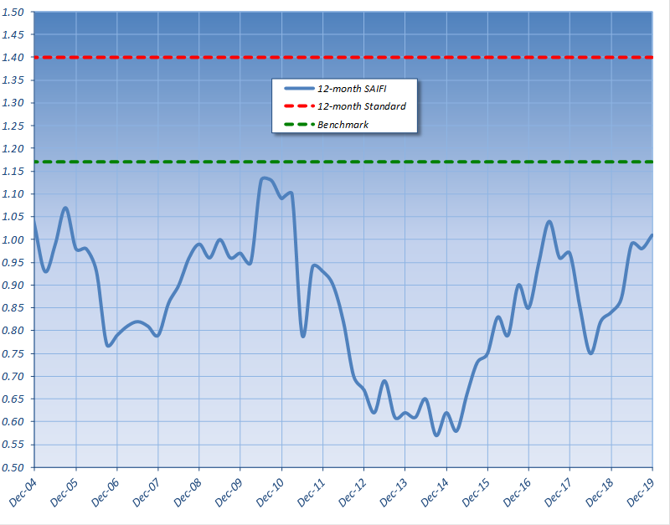

Table 4: DLC’s CAIDI from 2004 through 2019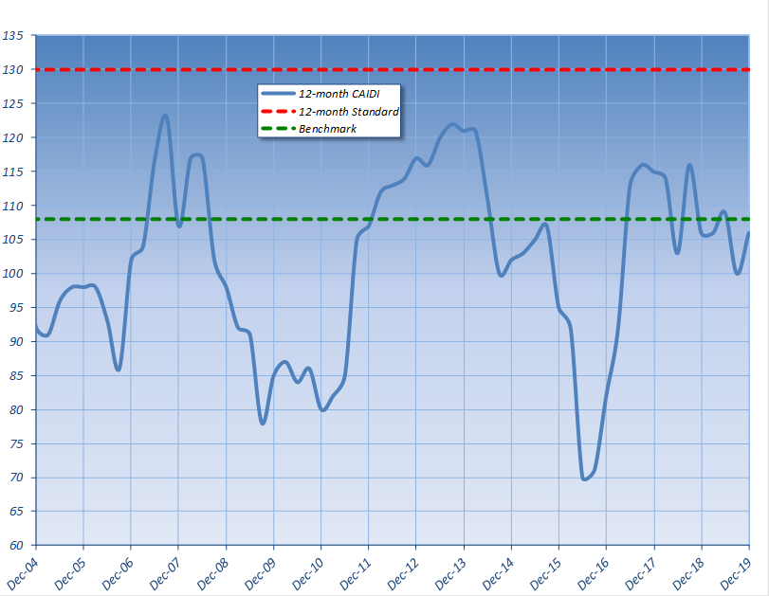

RECOMMENDATION REGARDING UTILITY'S LTIIP

As shown in Tables 3 and 4 above, DLC’s reliability performance is still within benchmark for SAIFI and CAIDI. DLC has also demonstrated improvements in the areas targeted by the LTIIP programs. In addition, DLC appears to be generally on track with its expenditures and infrastructure initiatives. Based on the analysis of expenditures and infrastructure initiatives above, DLC is in compliance with its LTIIP obligations and meeting its LTIIP goals.

The Commission finds that the Long-Term Infrastructure Improvement Plan of DLC is designed adequately to ensure and maintain safe, adequate, reasonable, and reliable service and that DLC has substantially adhered to its plan; THEREFORE,
IT IS ORDERED:

1. That the Long-Term Infrastructure Improvement Plan of Duquesne Light Company is designed adequately to ensure and maintain safe, adequate, reasonable, and reliable service and that DLC has substantially adhered to its plan.

2. That the proceeding at Docket No. M-2020-3019708 be closed.


BY THE COMMISSION,

Rosemary Chiavetta
Secretary

(SEAL)

ORDER ADOPTED: October 29, 2020

ORDER ENTERED: October 29, 2020

52 Pa. Code § 121.7(b).
SAIFI: Measures average frequency of power interruptions for every customer served during the reporting period.
SAIDI: Measures average outage duration time (by minutes) for every customer served during the reporting period.
CAIDI: Measures average power restoration time (by minutes) for every customer who lost power during the reporting period. The Commission currently uses three main metrics to measure reliability performance: SAIFI, CAIDI, and SAIDI. The benchmark performance value represents the statistical average of the EDC’s annual, systemwide, reliability performance index values for the five years from 1994-98. The benchmark value serves as an upper limit that EDCs should be consistently achieving to ensure reliability performance is considered satisfactory and acceptable.

