 | COMMONWEALTH OF PENNSYLVANIA  PENNSYLVANIA PUBLIC UTILITY COMMISSION  P.O. BOX 3265, HARRISBURG, PA 17105-3265 | IN REPLY PLEASE REFER TO OUR FILE

C-2020-3022393

Date of Service: November 16, 2020

MONSTER TRANSPORTATION LLC
T/A MONSTER BODY SHOP
1803 LATTA STREET
ALLENTOWN PA 18104

PENNSYLVANIA PUBLIC UTILITY COMMISSION
BUREAU OF INVESTIGATON & ENFORCEMENT
v.
MONSTER TRANSPORTATION LLC T/A MONSTER BODY SHOP

Dear Sir/Madam:

Please be advised that the attached complaint has been filed against you by the Bureau of Investigation & Enforcement.

Detailed instructions on how to proceed are contained in the NOTICE section, and you are advised to read everything carefully or consult with your attorney.

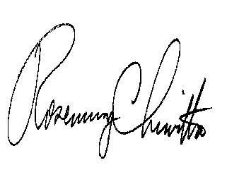
Very truly yours,

Rosemary Chiavetta
Secretary

Attachments

NW

