 | COMMONWEALTH OF PENNSYLVANIA  PENNSYLVANIA PUBLIC UTILITY COMMISSION  COMMONWEALTH KEYSTONE BUILDING  400 NORTH STREET, HARRISBURG, PA 17120 | IN REPLY PLEASE REFER TO OUR FILE
November 18, 2020
C-2019-3013004
A-00115443
BULOW HOTTLE & CO
PO BOX 1078
SOMERSET PA 15501

RE: Pennsylvania Public Utility Commission, Bureau of Investigation & Enforcement v.
CHRISTOPHER P WALKER T/A CW TRUCKING

To Whom It May Concern:

By Secretarial Letter dated January 2, 2020, the Commission cancelled the authority of Christopher P Walker t/a CW Trucking, at Case Docket No. C-2019-3013004 and assessed a fine of $500.00 for failure to file permanent proof of insurance with this Commission, a violation of 66. Pa. C.S. §512, 52 Pa Code §32.2(c), 52 Pa. Code §32.11(a), 52 Pa. Code §32.12(a) and/or 52 Pa. Code §32.13(a).

This Commission has the power to rescind a Secretarial Letter in light of newly discovered evidence or a change of circumstances which justify reconsideration. On October 20, 2020, a Petition for Reconsideration was filed requesting that the fine be rescinded due to extenuating circumstances; however, the authority remains cancelled.

THEREFORE, THE PETITION FOR RECONSIDERATION IS HEREBY GRANTED. THE AUTHORITY AT DOCKET NO. A-00115443, UTILITY CODE A-703478, REMAINS CANCELLED, AND THE $500.00 FINE IS HEREBY RESCINDED. THE COMPLAINT AT DOCKET NO. C-2019-3013004 IS HEREBY SATISFIED AND MARKED CLOSED.

THE PENNSYLVANIA DEPARTMENT OF TRANSPORTATION IS HEREBY INSTRUCTED TO LIFT ANY ADMINISTRATIVE HOLDS ON APPLICANT’S VEHICLE REGISTRATIONS.

Very truly yours,

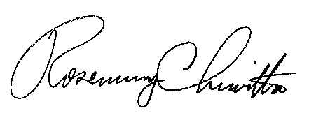

Rosemary Chiavetta
Secretary

Cc: Secretary’s Bureau – File CHRISTOPHER P WALKER
Bureau of Administrative Services – Fiscal T/W CW TRUCKING
PA Department of Transportation 110 MARILYN WAY
PA Department of Revenue FRIEDENS PA 15541

