 | COMMONWEALTH OF PENNSYLVANIA  PENNSYLVANIA PUBLIC UTILITY COMMISSION  P.O. BOX 3265, HARRISBURG, PA 17105-3265 | IN REPLY PLEASE REFER TO OUR FILE

C-2020-3022796

Date of Service: November 20, 2020

PENN TRANS SHUTTLE LLC
2200 WASHINGTON LANE
HUNTINGDON VALLEY, PA 19006

PENNSYLVANIA PUBLIC UTILITY COMMISSION
BUREAU OF INVESTIGATON & ENFORCEMENT
v.
PENN TRANS SHUTTLE LLC

Dear Sir/Madam:

Please be advised that the attached complaint has been filed against you by the Bureau of Investigation & Enforcement.

Detailed instructions on how to proceed are contained in the NOTICE section, and you are advised to read everything carefully or consult with your attorney.

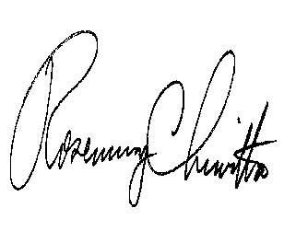
Very truly yours,

Rosemary Chiavetta
Secretary

Attachments

NW

