 | COMMONWEALTH OF PENNSYLVANIA  PENNSYLVANIA PUBLIC UTILITY COMMISSION  P.O. BOX 3265, HARRISBURG, PA 17105-3265 | IN REPLY PLEASE REFER TO OUR FILE

C-2020-3022451

Date of Service: November 24, 2020

J J SERAFIN INC TA AAAA LIMO TA AAAA TRANSPORT
14 DENNISON STREET
FORTY FORT PA 18704

PENNSYLVANIA PUBLIC UTILITY COMMISSION
BUREAU OF INVESTIGATON & ENFORCEMENT
v.
J J SERAFIN INC TA AAAA LIMO TA AAAA TRANSPORT

Dear Sir/Madam:

Please be advised that the attached complaint has been filed against you by the Bureau of Investigation & Enforcement.

Detailed instructions on how to proceed are contained in the NOTICE section, and you are advised to read everything carefully or consult with your attorney.

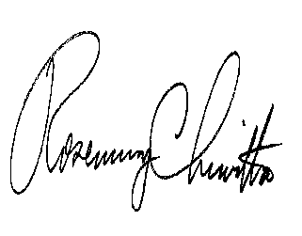
Very truly yours,

Rosemary Chiavetta
Secretary

Attachments

NW

