PENNSYLVANIA PUBLIC UTILITY COMMISSION

NOTICE TO BE PUBLISHED

Joint Petition of Commonwealth Telephone Company d/b/a Frontier Communications Commonwealth Telephone Company LLC and Comcast Phone of Pennsylvania LLC for approval of an Amendment to Interconnection Agreement under Section 252 (e) of the Telecommunications Act of 1996.
Docket Number: A-2020-3023208
_____________________

Commonwealth Telephone Company d/b/a Frontier Communications Commonwealth Telephone Company LLC and Comcast Phone of Pennsylvania LLC by its counsel, filed on December 7, 2020, at the Public Utility Commission, a Joint Petition for approval of an Amendment to Interconnection Agreement under Sections 251 and 252 of the Telecommunications Act of 1996.

Interested parties may file comments concerning the petition and agreement with the Secretary, Pennsylvania Public Utility Commission, 400 North Street, Harrisburg, PA 17120.
All such comments are due on or before 10 days after the date of publication of this notice.
The documents filed in support of Commonwealth Telephone Company d/b/a Frontier Communications Commonwealth Telephone Company LLC and Comcast Phone of Pennsylvania LLC Joint Petition are available for inspection at the Commission’s website at www.puc.pa.gov, and at the applicant’s business website.

Contact person is Kathryn Sophy, Director, Office of Special Assistants, (717) 787-1827.

BY THE COMMISSION
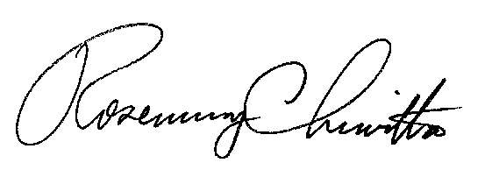

Rosemary Chiavetta
Secretary

