 | COMMONWEALTH OF PENNSYLVANIA  PENNSYLVANIA PUBLIC UTILITY COMMISSION  P.O. BOX 3265, HARRISBURG, PA 17105-3265 | IN REPLY PLEASE REFER TO OUR FILE

C-2020-3023058

Date of Service: December 14, 2020

IRISHTOWN ENTERPRISES LLC
6146 STATE ROUTE 103 SOUTH
MCVEYTOWN, PA 17051

PENNSYLVANIA PUBLIC UTILITY COMMISSION
BUREAU OF INVESTIGATON & ENFORCEMENT
v.
IRISHTOWN ENTERPRISES LLC
Dear Sir/Madam:

Please be advised that the attached complaint has been filed against you by the Bureau of Investigation & Enforcement.

Detailed instructions on how to proceed are contained in the NOTICE section, and you are advised to read everything carefully or consult with your attorney.

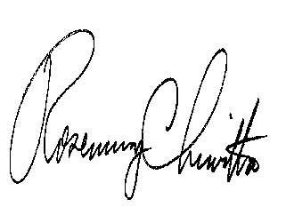
Very truly yours,

Rosemary Chiavetta
Secretary

Attachments

NW

