Via electronic service only due to Emergency Order at Docket No. M-2020-3019262

BEFORE THE
PENNSYLVANIA PUBLIC UTILITY COMMISSION

Frank Cservak :
:
v. : F-2020-3019005
:
Duquesne Light Company :
:

INTERIM ORDER
CLOSING THE RECORD

AND NOW, the transcript of the July 9, 2020 hearing in this case having been filed with the Commission’s Secretary’s Bureau in Harrisburg on November 17, 2020; and the hearing exhibits having been filed with the Secretary on November 26, 2020; and no further hearings in this matter are to be scheduled or held,

THEREFORE,

IT IS ORDERED:

- That the record at Docket No. F-2020-3019005 is closed.

2. That the Initial Decision in this case shall be prepared and issued.
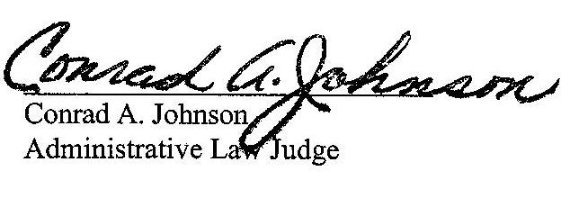

Dated: December 22, 2020

F-2020-3019005 - FRANK J. CSERVAK, JR. V. DUQUESNE LIGHT COMPANY
FRANK J CSERVAK JR
174 BARBERRY RD
SEWICKLEY PA 15141
412.427.4385
FCSERVAK@C-MSERVICES.COM
EMILY M FARAH COUNSEL
DUQUESNE LIGHT COMPANY
411 SEVENTH AVENUE
PITTSBURGH PA 15219
412.393 6431
ACCEPTS E-SERVICE

