 | COMMONWEALTH OF PENNSYLVANIA  PENNSYLVANIA PUBLIC UTILITY COMMISSION  P.O. BOX 3265, HARRISBURG, PA 17105-3265 | IN REPLY PLEASE REFER TO OUR FILE

C-2020-3023189

Date of Service: December 23, 2020

GET MOVIN & STORAGE LLC
1121 SOUTH SIDE AVENUE
PITTSBURGH, PA 15212

PENNSYLVANIA PUBLIC UTILITY COMMISSION
BUREAU OF INVESTIGATON & ENFORCEMENT
v.
GET MOVIN & STORAGE LLC

Dear Sir/Madam:

Please be advised that the attached complaint has been filed against you by the Bureau of Investigation & Enforcement.

Detailed instructions on how to proceed are contained in the NOTICE section, and you are advised to read everything carefully or consult with your attorney.

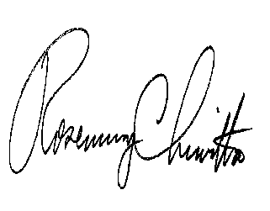
Very truly yours,

Rosemary Chiavetta
Secretary

Attachments

NW

