 | COMMONWEALTH OF PENNSYLVANIA  PENNSYLVANIA PUBLIC UTILITY COMMISSION  P.O. BOX 3265, HARRISBURG, PA 17105-3265 | IN REPLY PLEASE REFER TO OUR FILE

C-2020-3022993

Date of Service: December 23, 2020

BATTAGLIA,JOHN L & JAMES A COTPS
T/A BATTAGLIA MVG & STG
262 HICKORY DRIVE
BEAVER FALLS, PA 15010

PENNSYLVANIA PUBLIC UTILITY COMMISSION
BUREAU OF INVESTIGATON & ENFORCEMENT
v.
BATTAGLIA,JOHN L & JAMES A COTPS T/A BATTAGLIA MVG & STG

Dear Sir/Madam:

Please be advised that the attached complaint has been filed against you by the Bureau of Investigation & Enforcement.

Detailed instructions on how to proceed are contained in the NOTICE section, and you are advised to read everything carefully or consult with your attorney.

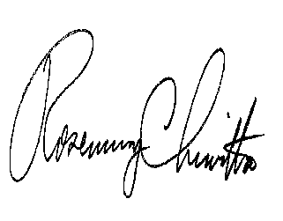
Very truly yours,

Rosemary Chiavetta
Secretary

Attachments

NW

