 | COMMONWEALTH OF PENNSYLVANIA  PENNSYLVANIA PUBLIC UTILITY COMMISSION  P.O. BOX 3265, HARRISBURG, PA 17105-3265 | IN REPLY PLEASE REFER TO OUR FILE

C-2021-3022972

Date of Service: January 13, 2021

HENRY L GRIFFIN
281 BRUSH MT ROAD
SPRING MILLS, PA 16875

PENNSYLVANIA PUBLIC UTILITY COMMISSION
BUREAU OF INVESTIGATON & ENFORCEMENT
v.
HENRY L GRIFFIN

Dear Sir/Madam:

Please be advised that the attached complaint has been filed against you by the Bureau of Investigation & Enforcement.

Detailed instructions on how to proceed are contained in the NOTICE section, and you are advised to read everything carefully or consult with your attorney.

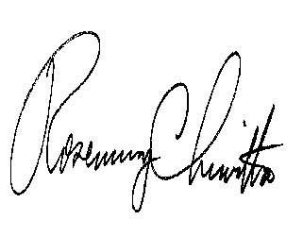
Very truly yours,

Rosemary Chiavetta
Secretary

Attachments

NW

