
COMMONWEALTH OF PENNSYLVANIA
PENNSYLVANIA PUBLIC UTILITY COMMISSION _{IN REPLY PLEASE}
400 North Street, HARRISBURG, PA 17120 ^{REFER TO OUR FILE}

January 13, 2020

Via Email per COVID-19 Emergency Order
ALL PARTIES OF RECORD

RE: Helen Leung vs. Philadelphia Gas Works
Docket Number: F-2020-3020041
To All Parties of Record:

On December 23, 2020, my office received Efiled Exceptions to the Initial
Decision of Administrative Law Judge Eranda Vero in the above captioned matter.

Our review of the filing revealed that no Certificate of Service or other indication that the parties of record to the case were served with the Exceptions. Therefore, we have attached a copy of the Exceptions to constitute service for purposes of 52 Pa. Code §5.533.
Due to the failure of Helen Leung to provide service on all the parties of record to the case, and in order to avoid prejudice to any party pursuant to 52 Pa. Code 5.535, the Respondent shall have until January 25, 2021 to file Reply Exceptions.

Sincerely,
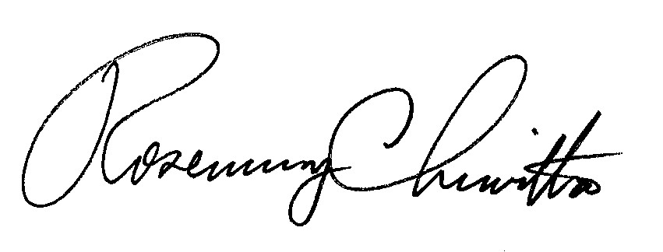
Rosemary Chiavetta

Secretary

Attachment: Exceptions of Helen Leung

RC: JAV

cc: All Parties of Record
Document Folder

