BEFORE THE
PENNSYLVANIA PUBLIC UTILITY COMMISSION

PENNSYLVANIA PUBLIC UTILITY COMMISSION | :
BUREAU OF INVESTIGATION AND ENFORCEMENT | :
 | :
V. | : DOCKET NO. C-2021-3023752
 | :
TIGER 1 TRANSPORTATION INC  815 CHRISTY AVENUE  CROYDON, PA 19021 | :  :  :  :

COMPLAINT

The Pennsylvania Public Utility Commission (Commission) is a duly constituted agency of the Commonwealth of Pennsylvania empowered to regulate public utilities within the Commonwealth. The Commission has delegated its authority to initiate proceedings which are prosecutory in nature to the Bureau of Investigation and Enforcement and other bureaus with enforcement responsibilities. Pursuant to that delegated authority and Section 701 of the Public Utility Code, the Bureau of Investigation and Enforcement hereby represents as follows:

1. That all authority issued to TIGER 1 TRANSPORTATION INC, (respondent) is under suspension effective December 30, 2020 for failure to maintain evidence of insurance on file with this Commission.

2. That respondent maintains a principal place of business at 815 CHRISTY AVENUE, CROYDON, PA 19021.

3. That respondent was issued a Certificate of Public Convenience by this Commission on February 14, 2019, at A-8921721.

4. That respondent has failed to maintain evidence of Liability and Cargo insurance on file with this Commission. The Bureau of Investigation and Enforcement’s proposed civil penalty for this violation is $500.00 and cancellation of the Certificate of Public Convenience.

5. That respondent, by failing to maintain evidence of insurance on file with this Commission, violated 66 Pa. C.S. §512, 52 Pa. Code §32.2(c), and 52 Pa. Code §32.11(a), §32.12(a) or §32.13(a).

WHEREFORE, unless respondent pays the penalty of $500.00 or files an answer in compliance with the attached notice and/or causes its insurer to file evidence of insurance with this Commission within twenty (20) days of the date of service of this Complaint, the Bureau of Investigation and Enforcement will request that the Commission issue an Order which (1) cancels the Certificate of Public Convenience held by respondent at A-8921721 for failure to maintain evidence of current insurance on file with the Commission, (2) fines Respondent the sum of five hundred dollars ($500.00) for the illegal activity described in this Complaint, (3) orders such other remedy as the Commission may deem to be appropriate, which may include the suspension of a vehicle registration and (4) imposes an additional fine on the respondent should cancellation occur.

Respectfully submitted,
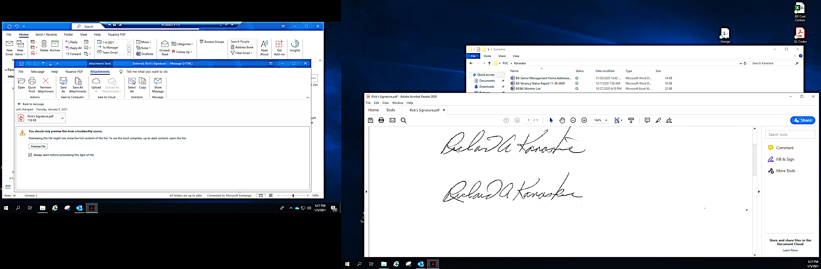
Richard Kanaskie, Director
Motor Carrier Enforcement
Bureau of Investigation and Enforcement
400 North Street
Harrisburg, PA 17120
VERIFICATION

I, Richard Kanaskie, Director, Motor Carrier Enforcement, Bureau of Investigation and Enforcement, hereby state that the facts above set forth are true and correct to the best of my knowledge, information and belief and that I expect that the Bureau will be able to prove same at any hearing held in this matter. I understand that the statements herein are made subject to the penalties of 18 Pa. C.S. §4904 relating to unsworn falsification to authorities.

Date: January 26, 2021 ________________________________________
Richard Kanaskie, Director
Motor Carrier Enforcement
Bureau of Investigation and Enforcement

NOTICE

- You must file an Answer within 20 days of the date of service of this Complaint. The date of service is the mailing date as indicated at the top of the Secretarial Letter. See 52 Pa. Code §1.56(a). The Answer must raise all factual and legal arguments that you wish to claim in your defense, include the docket number of this Complaint, and be verified. You may file your Answer by mailing an original to:

Rosemary Chiavetta, Secretary
Pennsylvania Public Utility Commission
400 North Street
Harrisburg, PA 17120

Or, you may eFile your Answer using the Commission’s website at www.puc.pa.gov. The link to eFiling is located under the Filing & Resources tab on the homepage. If your Answer is 250 pages or less, you are not required to file a paper copy. If your Answer exceeds 250 pages, you must file a paper copy with the Secretary’s Bureau.

Additionally, a copy should either be mailed to:

Michael L. Swindler, Deputy Chief Prosecutor
Pennsylvania Public Utility Commission
Bureau of Investigation and Enforcement
400 North Street
Harrisburg, PA 17120

Or, emailed to Mr. Swindler at: RA-PCCmplntResp@pa.gov

- If you fail to answer this Complaint within 20 days, the Bureau of Investigation and Enforcement will request that the Commission issue an Order imposing the penalty.

- You may elect not to contest this Complaint by causing your insurer to file proper evidence of current insurance in accordance with the Commission’s regulations and by paying the fine proposed in this Complaint by certified check or money order within twenty (20) days of the date of service of this Complaint. ACCORD CERTIFICATES OF INSURANCE and FAXED FORM Es and Hs ARE UNACCEPTABLE AS EVIDENCE OF INSURANCE.

The proof of insurance must be filed with the:

Compliance Office, Bureau of Technical Utility Services
Pennsylvania Public Utility Commission
400 North Street
Harrisburg, PA 17120

Payment of the fine must be made to the Commonwealth of Pennsylvania and should be forwarded to:

Rosemary Chiavetta, Secretary
Pennsylvania Public Utility Commission
400 North Street
Harrisburg, PA 17120

Your payment is an admission that you committed the alleged violation and an agreement to cease and desist from further violations. Upon receipt of the evidence of insurance from your insurer, and upon receipt of your payment, the Complaint proceeding shall be closed.

- If you file an Answer which either admits or fails to deny the allegations of the Complaint, the Bureau of Investigation and Enforcement will request the Commission to issue an Order imposing the penalty set forth in this Complaint.

- If you file an Answer which contests the Complaint, the matter will be assigned to an Administrative Law Judge for hearing and decision. The Judge is not bound by the penalty set forth in the Complaint, and may impose additional and/or alternative penalties as appropriate.

- If you are a corporation, you must be represented by legal counsel. 52 Pa. Code §1.21.

Alternative formats of this material are available for persons with disabilities by contacting the Commission’s ADA Coordinator at 717-787-8714. Do not call this number if you have questions as to why you received this complaint. For those questions you may call 717-783-3847.

