 | COMMONWEALTH OF PENNSYLVANIA  PENNSYLVANIA PUBLIC UTILITY COMMISSION  400 NORTH STREET, HARRISBURG, PA 17120 | IN REPLY PLEASE REFER TO OUR FILE
February 12, 2021
A-8921219
C-2020-3022309

TRENT BERTOTHY
1765 BLACK MOSHANNON ROAD
PHILIPSBURG PA 16866

CANCELLATION NOTICE

Re: Pennsylvania Public Utility Commission, Bureau of Investigation & Enforcement v. Trent Bertothy

Respondent:

On October 27, 2020, the Bureau of Investigation and Enforcement instituted a Complaint against Trent Bertothy, Respondent, for failure to maintain evidence of Liability insurance and Cargo insurance on file with the Commission, a violation of 66 Pa. C.S. §512, 52 Pa. Code §32.2(c), 52 Pa. Code §32.12(a) and/or 52 Pa. Code §32.13(a).

In accordance with 52 Pa. Code §5.61, the Bureau of Investigation and Enforcement notified the Respondent that an Answer to the Complaint must be filed within twenty (20) days of the date of service. The Notice further specified that, if Respondent failed to answer the Complaint within twenty (20) days, the Bureau of Investigation and Enforcement would request that the Commission cancel Respondent’s Certificate of Public Convenience.

The Complaint was served on Respondent, October 27, 2020, by e-mail. To date, more than twenty (20) days later, Respondent has failed to file and Answer to the Complaint and has failed to have his insurer file evidence of insurance with this Commission.

Therefore, the allegations in the Complaint are deemed to be admitted. The Complaint is hereby sustained and the Certificate of Public Convenience, issued to Respondent at
A-8921219 is hereby CANCELLED.

Respondent is assessed a fine of $500.00 for failure to maintain evidence of insurance on file with this Commission as required at 52 Pa. Code §32. Payment must be made by certified check or money order payable to the Commonwealth of PA, and mailed to Pa. Public Utility Commission, 400 North Street, Harrisburg, PA 17120.

Furthermore, this Commission will request the Pennsylvania Department of Transportation to put an administrative hold on Respondent’s vehicle registrations. Respondent will NOT be able to register any new vehicles or renew any existing vehicle registrations until all past due assessments are paid, all past due fines are paid, all insurance filings are up to date, and it holds an active Certificate of Public Convenience issued by this Commission.

This Secretarial Cancellation Letter will also be served on:

The Department of Revenue
Bureau of Audit Programs
Sales and Use Taxes
Tenth Floor, Strawberry Square
Harrisburg, PA 17128-1061

Respondent is hereby notified to cease and desist from further violations of the Public Utility Code, 66 Pa. C.S. §§1.1 et seq., and the regulations of the Commission, 52 Pa. Code §§1.1 et seq. In view of the cancellation of respondent’s Certificate of Public Convenience, it is specifically prohibited from rendering service as a common carrier by motor vehicle in intrastate commerce in the Commonwealth of Pennsylvania.

APPEAL RIGHTS

If you disagree with this determination, you may send a Petition for Reconsideration from Staff Action (Petition) to: Secretary, PA Public Utility Commission, 400 North Street, Harrisburg, PA 17120. Such a Petition is a written statement asking the Commission to change its determination.

Due to the pandemic emergency, the Commission has no access to mail delivery. ALL Parties to proceedings pending before the Commission must open an e-filing account through the Commission’s website and use e-filing and accept e-service as required by the Commission’s Emergency Order at Docket Number M-2020-3019262. If a filing contains confidential or proprietary material, the filing may be sent to Secretary Chiavetta at rchiavetta@pa.gov.

The Petition must be filed with the Commission within twenty (20) days of the date of this letter. If no timely request for reconsideration is made, this action will be deemed to be the final action of the Commission.

The Petition MUST include: (1) a written statement (divided into numbered paragraphs) outlining the reasons for the request, (2) the case docket number(s) (they are provided for you at the top right-hand corner of this letter), (3) the name of the person on whose behalf the petition is made, (4) copies of relevant documentation, and (5) a verification with original signature. See 52 Pa. Code §§1.31 and 5.44. Below is a sample Verification:

VERIFICATION

I, (YOUR NAME GOES HERE), hereby state that the facts above set forth are true and correct (or are true and correct to the best of my knowledge, information and belief) and that I expect to be able to prove the same at a hearing held in this matter. I understand that the statements herein are made subject to the penalties of 18 Pa.C.S. §4904 (relating to unsworn falsification to authorities).
(SIGN AND DATE)

If you believe that you have received this letter in error, please contact the Compliance Office of the Motor Carrier Services Division in the Bureau of Technical Utility Services at 717-787-3834 within ten (10) days of the date of this letter.

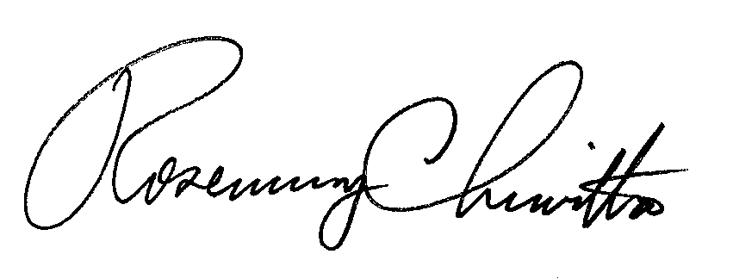
Very truly yours,

Rosemary Chiavetta,
Secretary

CC: PA Department of Transportation
PA Department of Revenue

