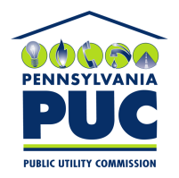 | COMMONWEALTH OF PENNSYLVANIA  PENNSYLVANIA PUBLIC UTILITY COMMISSION  400 NORTH STREET, HARRISBURG, PA 17120 | IN REPLY PLEASE REFER TO OUR FILE
January 7, 2021

HERCULES ENERGY LLC
5411 MARKET STREET
BOARDMAN, OH 44512

Dear Sir/Madam:

On December 10, 2020, the Commission received the Application of Hercules Energy LLC for approval to supply natural gas services to the public in the Commonwealth of PA. Upon initial review, the Application has been determined to be missing information for the following reasons:

- No signature (Page 16 of Application)
- No Application Affidavit and/or Operations Affidavit (Pages 18 through 20 of Application)
- No Proofs of Publication (Please refer to Pages 29 through 30 of Application.)
- No Certificate of Service (Pages 21 through 22 of Application)
- Pages 7 through 10, Pages 13 through 15, and Page 17 are missing.
- No Bonding Letters

Pursuant to 52 Pa. Code §1.4, you are being advised of this missing information and are required to file corrections. Failure to correct the foregoing missing information within 20 days of the date of this letter will result in the Application being returned unfiled.
Please return your items to the above listed address and address to the attention of the Office of the Secretary.
If you have any question in regards to this letter, please contact our bureau at (717) 772-7777. Thank you
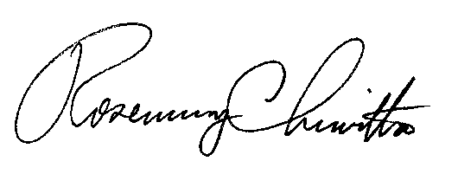
Sincerely,

Rosemary Chiavetta
Secretary

RC:AEL

