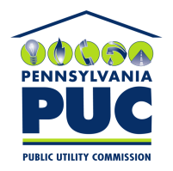 | COMMONWEALTH OF PENNSYLVANIA  PENNSYLVANIA PUBLIC UTILITY COMMISSION  400 NORTH STREET, HARRISBURG, PA 17120 | IN REPLY PLEASE REFER TO OUR FILE
February 18, 2021

HERCULES ENERGY LLC
5411 MARKET STREET
BOARDMAN, OH 44512

Dear Sir/Madam:

On February 17, 2021, the Commission received the Proofs of Publication and Bonding Letters of the Application of Hercules Energy LLC for approval to supply natural gas services to the public in the Commonwealth of PA. Upon initial review, the Application has been determined to be missing information for the following reason:

- No second page of the Certificate of Service (Page 22 of Application)

Pursuant to 52 Pa. Code §1.4, you are being advised of this missing information and are required to file correction. Failure to correct the foregoing missing information within 20 days of the date of this letter will result in the Application being returned unfiled.
Please return your item to the above listed address and address to the attention of the Office of the Secretary.
If you have any question in regards to this letter, please contact our bureau at (717) 772-7777. Thank you
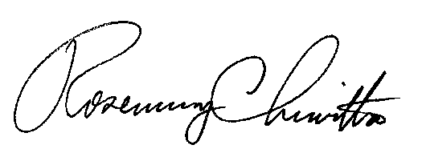
Sincerely,

Rosemary Chiavetta
Secretary

RC:AEL

