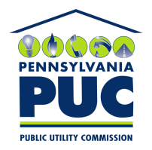 | COMMONWEALTH OF PENNSYLVANIA  PENNSYLVANIA PUBLIC UTILITY COMMISSION  400 NORTH STREET, KEYSTONE BUILDING, SECOND FLOOR  HARRISBURG, PENNSYLVANIA 17120 | IN REPLY PLEASE REFER TO OUR FILE
March 3, 2021

Via Certified Mail

Citicorp North America Inc.
3800 Citibank Center
Building B 1st Floor
Tampa FL 33610

RE: Letter of Credit Amendment
Direct Energy Services LLC
A-110164

Dear Sir or Madam:

Please find under cover of this letter the financial instrument filed on behalf of Direct Energy Services LLC because it is not acceptable.

In all locations where the name of the Principal appears, please note that this must match exactly with the license issued by the Commission, including any trade or fictitious names that appear on the license. The enclosed amendment lists “Direct Energy Business LLC” instead of “Direct Energy Services LLC”

In addition, we are unable to accept an amendment that reduces the current financial instrument to $0.00 without an approved replacement being provided first.

Please file the original financial instrument with my office within 30 days of the date of this letter, preferably by overnight delivery. If you are unable to meet this deadline due to the ongoing pandemic emergency of COVID-19, please email Secretary Rosemary Chiavetta at rchiavetta@pa.gov.

Sincerely,

Rosemary Chiavetta
Secretary of the Commission

RC: alw
Enclosures

