COMMONWEALTH OF PENNSYLVANIA
PENNSYLVANIA PUBLIC UTILITY COMMISSION
400 NORTH STREET, HARRISBURG PA 17120
IN REPLY PLEASE
REFER TO OUR FILE
Secretary
717-772-7777
February 26, 2021
A-2021-3024295
GARRETT LENT, ESQUIRE
POST & SCHELL. PC
17 NORTH SECOND STREET, 12TH FLOOR
HARRISBURG, PA 17101-1601

Dear Mr. Lent:

Receipt is acknowledged of the Letter of Notification of PPL Electric Utilities Corporation, which has been captioned and docketed to the above number.

This matter will receive the attention of the Commission and you will be advised of any further necessary procedure.

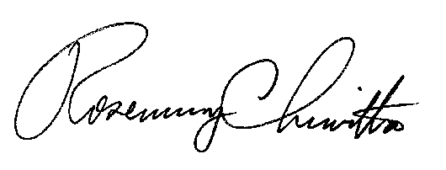
Sincerely,

Rosemary Chiavetta
Secretary

RC:AEL

