PENNSYLVANIA PUBLIC UTILITY COMMISSION
NOTICE TO BE PUBLISHED

Application of PECO Energy Company for approval of the transfer by sale to New Garden Township of street lighting facilities located in Chester County, Pennsylvania. Docket Number: A-2021-3024422
_________________________________________________

Formal protests and petitions to intervene must be filed in accordance with Title 52 of the Pennsylvania Code, on or before Monday, April 5, 2021. All filings must be made with the Secretary of the Pennsylvania Public Utility Commission, Keystone Building, 400 North Street, Harrisburg, PA 17120, with a copy served on the Applicant. The documents filed in support of the Application are available ONLY online for inspection and copying on the Commission's website at www.puc.pa.gov, and at the Applicant's business address. In accordance with the Commission’s Emergency Order at M-2020-3019262, all parties participating in matters pending before the Commission are required to Efile their submissions by opening an Efiling account – free of charge - through our website and accepting Eservice.

Applicant:

PECO Energy Company

Through and By Counsel:

Jack R. Garfinkle
PECO Energy Company
2301 Market Street/S23-1
Philadelphia, PA 19101-8699

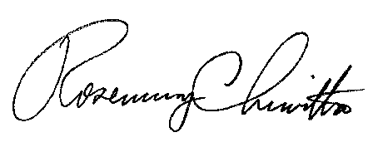
BY THE COMMISSION

Rosemary Chiavetta
Secretary

