 | COMMONWEALTH OF PENNSYLVANIA  PENNSYLVANIA PUBLIC UTILITY COMMISSION  P.O. BOX 3265, HARRISBURG, PA 17105-3265 | IN REPLY PLEASE REFER TO OUR FILE

C-2020-3022798

Date of Service: March 10, 2021 - RESERVE

BETTER MANAGEMENT CORPORATION OF OHIO INC
PO BOX 130
COLUMBIANA, OH 44408

PENNSYLVANIA PUBLIC UTILITY COMMISSION
BUREAU OF INVESTIGATON & ENFORCEMENT
v.
BETTER MANAGEMENT CORPORATION OF OHIO INC

Dear Sir/Madam:

Please be advised that the attached complaint has been filed against you by the Bureau of Investigation & Enforcement.

Detailed instructions on how to proceed are contained in the NOTICE section, and you are advised to read everything carefully or consult with your attorney.

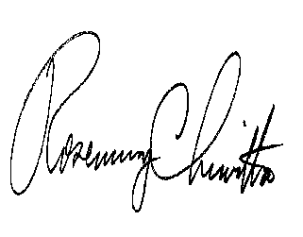
Very truly yours,

Rosemary Chiavetta
Secretary

Attachments

NW

