 |  | COMMONWEALTH OF PENNSYLVANIA  PENNSYLVANIA PUBLIC UTILITY COMMISSION  400 NORTH STREET, HARRISBURG, PA 17120 |  | IN REPLY PLEASE REFER TO OUR FILE  Phone: 717-772-7777

March 10, 2021
P-2021-3024328

CHRISTOPHER A. LEWIS, ESQUIRE
BLANK ROME LLP
ONE LOGAN SQUARE
130 NORTH 18TH STREET
PHILADELPHIA, PA 19103-6998

Dear Mr. Lewis:

Receipt is acknowledged of the Petition of PECO Energy Company for a Finding of Necessity Pursuant to 53 P.S. § 10619 That the Situation of Two Buildings Associated with a Gas Reliability Station in Marple Township, Delaware County Is Reasonably Necessary for the Convenience and Welfare of the Public, which has been captioned and docketed to the above number.

Enclosed is a copy of the Publication Notice that will appear in the Saturday, March 27, 2021 issue of the Pennsylvania Bulletin. This notice is being sent to you for informational purposes only.

This matter will receive the attention of the Commission and you will be advised of any further necessary procedure.

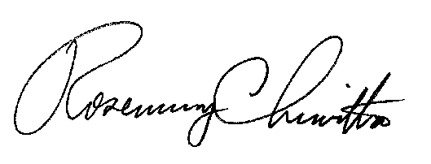
Sincerely,

Rosemary Chiavetta
Secretary

RC:AEL

Enclosure

PENNSYLVANIA PUBLIC UTILITY COMMISSION

NOTICE TO BE PUBLISHED

Petition of PECO Energy Company for a Finding of Necessity Pursuant to 53 P.S. § 10619 That the Situation of Two Buildings Associated with a Gas Reliability Station in Marple Township, Delaware County Is Reasonably Necessary for the Convenience and Welfare of the Public.
Docket Number: P-2021-3024328
________________________________________________

Formal protests and petitions to intervene must be filed in accordance with Title 52 of the Pennsylvania Code, on or before April 12, 2021. All filings must be made with the Secretary of the Pennsylvania Public Utility Commission, 400 North Street, Harrisburg, PA 17120, with a copy served on the Applicant. The documents filed in support of the Petition are available for inspection and copying at the Office of the Secretary between the hours of 8:00 a.m. and 4:30 p.m., Monday through Friday, at the Commission’s website at www.puc.pa.gov , and at the Applicant's business address.

Applicant:

PECO ENERGY COMPANY

Through and By Counsel:

Christopher A. Lewis, Esquire
Blank Rome LLP
One Logan Square
130 North 18th Street
Philadelphia, PA 19103-6998

BY THE COMMISSION:
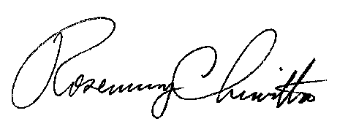

Rosemary Chiavetta
Secretary

Petition of PECO Energy Company
For a Finding of Necessity Pursuant to 53 P.S. § 10619 that the Situation of Two Buildings Associated with a Gas Reliability Station in Marple Township, Delaware County Is Reasonably Necessary for the Convenience and Welfare of the Public
Telephonic Prehearing Conference Notice

This is to inform you that a Telephonic Prehearing Conference on the above-captioned case will be held as follows:

Type: Call-in Telephonic Prehearing Conference

Date: Wednesday, April 21, 2021

Time: 10:00 a.m.
Presiding Officer: Administrative Law Judge Emily DeVoe
At the above date and time, you must call into the Prehearing Conference.
You will not be called by the Presiding Officer.

Protests and answers to the above-captioned petition must be filed with the Commission’s Secretary’s Bureau by April 12, 2021. Protests and answers should be
e–filed. Instructions on how to e-file can be found at:
https://www.puc.pa.gov/filing-resources/efiling/.
.

To participate in the Prehearing Conference,

- You must dial the toll-free number listed below.
- You must enter a PIN number when instructed to do so, also listed below.
- You must speak your name when prompted.
- The telephone system will connect you to the prehearing conference.

Toll-free Bridge Number: 877.653.9972
PIN Number: 29149724
If you require an interpreter to participate in the Prehearing Conference, we will make every reasonable effort to have an interpreter present. Please email the
Presiding Officer Emily DeVoe at edevoe@pa.gov least ten (10) business days prior to your conference to submit your request.

• Scheduling Office: 717.787.1399
• AT&T Relay Service number for persons who are deaf or hearing-impaired: 1.800.654.5988

The Public Utility Commission offers a free e-Filing Subscription Service, which allows users to automatically receive an email notification whenever a document is added, removed, or changed on the PUC website regarding a specific case. Instructions for subscribing to this service are on the PUC’s website at http://www.puc.pa.gov/Documentation/eFiling_Subscriptions.pdf.

