 | COMMONWEALTH OF PENNSYLVANIA  PENNSYLVANIA PUBLIC UTILITY COMMISSION  400 NORTH STREET, HARRISBURG, PA 17120 | IN REPLY PLEASE REFER TO OUR FILE

Date of Service: February 26, 2021 Docket Number: C-2021-3024289

JERWIN CULMER
T/A CULMER MOVING
6730 MCPHERSON BOULEVARD
PITTSBURGH, PA 15208

Bureau of Investigation and Enforcement
v.
JERWIN CULMER T/A CULMER MOVING

Dear Sir/Madam:

The Pennsylvania Public Utility Commission has delegated its authority to initiate prosecutory proceedings to several of its Commission bureaus with enforcement responsibilities. Pursuant to this delegated authority and Section 701 of the Public Utility Code, 66 Pa. C.S. § 701, Bureau of Investigation and Enforcement staff has filed the attached Complaint in the above docketed proceeding.

Sincerely,
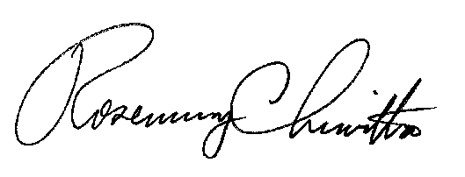

Rosemary Chiavetta
Secretary

RC:AEL

VIA EMAIL OR ESERVICE DUE TO TEMPORARY EMERGENCY PROCEDURES
Due to the pandemic emergency, the Commission has no access to mail delivery at this time. ALL Parties to proceedings pending before the Commission must open an efiling account through the Commission’s website and use efiling and accept eservice as required by the Commission’s Emergency Order at Docket Number M-2020-3019262. If a filing contains confidential or proprietary material, the filing may be sent to Secretary Chiavetta at rchiavetta@pa.gov

