
COMMONWEALTH OF PENNSYLVANIA
PENNSYLVANIA PUBLIC UTILITY COMMISSION _{IN REPLY PLEASE}
400 North Street, HARRISBURG, PA 17120 ^{REFER TO OUR FILE}

March 22, 2021

Via Email per COVID-19 Emergency Order
ALL PARTIES OF RECORD

RE: Leslie Griggs dba vs. Philadelphia Gas Works
Docket Number: F-2020-3021754
To All Parties of Record:

On March 22, 2021, my office received Exceptions to the Initial
Decision of Administrative Law Marta Guhl in the above captioned matter.

Our review of the filing revealed that no Certificate of Service or other indication that the parties of record to the case were served with the Exceptions. Therefore, we have attached a copy of the Exceptions to constitute service for purposes of 52 Pa. Code §5.533.

Sincerely,
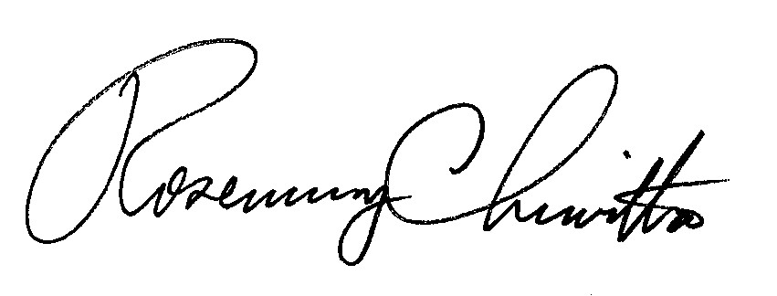
Rosemary Chiavetta

Secretary

Attachment: Exceptions of Leslie Griggs dba

RC: JAV

cc: All Parties of Record
Document Folder

