BEFORE THE
PENNSYLVANIA PUBLIC UTILITY COMMISSION

PENNSYLVANIA PUBLIC UTILITY COMMISSION | :
BUREAU OF INVESTIGATION AND ENFORCEMENT | :
 | :
V. | :
 | : | DOCKET NO. C-2021-3019571
 | :
DELAWARE VALLEY CORPORATE SEDAN INC | :
877 STEVENS LANE | :
LANGHORNE PA 19053 | :

COMPLAINT

The Pennsylvania Public Utility Commission (Commission) is a duly constituted agency of the Commonwealth of Pennsylvania empowered to regulate public utilities within the Commonwealth. The Commission has delegated its authority to initiate proceedings which are prosecutory in nature to the Bureau of Investigation and Enforcement and other bureaus with enforcement responsibilities. Pursuant to that delegated authority and Section 701 of the Public Utility Code, the Bureau of Investigation and Enforcement hereby represents as follows:

- That Delaware Valley Corporate Sedan, Inc., Respondent, maintains a principal place of business at 877 Stevens Lane, Langhorne, Pennsylvania, 19053.

- That Respondent was issued certificates of public convenience by this Commission authorizing transportation of passengers in limousine service on July 20, 2020 and in groups and party 16 or greater service on April 21, 2020, at PUC utility code no. 6422969.

- That Respondent, by Commission Secretarial letter dated April 16, 2020, was advised that failure to comply with all applicable requirements of the Commission may subject the carrier to penalties, including fines, suspension on operating rights, or cancellation of authority. A satisfactory safety fitness rating must be achieved in order to maintain a certificate of public convenience to operate as a common carrier of property.

- That Motor Carrier Enforcement Officer Freda Culver attempted to contact Respondent several times by phone in order to schedule the SFR appointment. A certified letter was mailed on February 2, 2021 instructing the Respondent to contact the Philadelphia regional office to schedule the SFR appointment.

- That Respondent contacted the Philadelphia regional office on February 8, 2021 as directed and was given Officer Culver’s phone number to call. Respondent called Officer Culver who spoke with him and gave him her e-mail address to forward documents for the SFR. Officer Culver never received the documents despite several attempts to contact Respondent to request the documents be provided.

- That Respondent, by failing to achieve a satisfactory evaluation on a safety fitness review, violated 66 Pa. C.S. §501(c) and, for failure to maintain adequate, efficient and safe service and facilities, violated 66 Pa. C.S. §1501.

WHEREFORE, the Bureau of Transportation Investigation and Enforcement hereby requests that the Commission revoke the certificate of public convenience issued to Delaware Valley Corporate Sedan, Inc. at PUC utility code no. 6422969.

Respectfully submitted,
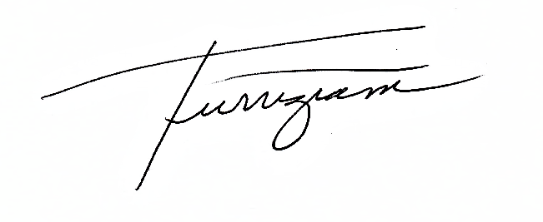
_______________________________
Andrew Turriziani, Chief
Motor Carrier Enforcement
Bureau of Investigation and Enforcement
400 North Street
Harrisburg, PA 17120

VERIFICATION

I, Andrew Turriziani, hereby state that the facts above set forth are true and correct to the best of my knowledge, information and belief and that I expect that the Bureau will be able to prove same at any hearing held in this matter. I understand that the statements herein are made subject to the penalties of 18 Pa. C.S. §4904 relating to unsworn falsification to authorities.

Date: March 29, 2021 _________________________________

Andrew Turriziani, Chief
Motor Carrier Enforcement
Bureau of Investigation and Enforcement

NOTICE

- You must file an Answer within twenty (20) days of the date of service of this Complaint. The date of service is the mailing date as indicated at the top of the Secretarial Cover Letter for this Complaint and Notice, 52 Pa. Code §1.56(a). An Answer is a written explanation of circumstances wished to be considered in determining the outcome. The Answer shall raise all factual and legal arguments that you wish to claim in your defense and must include the reference number of this Complaint. Your Answer must be verified and the original shall be mailed to:

Rosemary Chiavetta, Secretary
Pennsylvania Public Utility Commission
400 North Street, 2nd Floor
Harrisburg, Pennsylvania 17120

Or, you may eFile your Answer using the Commission’s website at www.puc.pa.gov. The link to eFiling is located under the Filing & Resources tab on the homepage. If your Answer is 250 pages or less, you are not required to file a paper copy. If your Answer exceeds 250 pages, you must file a paper copy with the Secretary’s Bureau.

Additionally, a copy should either be mailed to:

Michael L. Swindler, Deputy Chief Prosecutor
Bureau of Investigation and Enforcement
Pennsylvania Public Utility Commission
400 North Street
Harrisburg, Pennsylvania 17120

Or, e-mailed to Mr. Swindler at: RA-PCCmplntResp@pa.gov

- If you fail to answer this complaint within twenty (20) days, the Bureau of Investigation and Enforcement will request that the Commission issue a Secretarial Letter imposing a penalty. The penalty could include a fine, the suspension or revocation of your certificate of public convenience or other remedy.

- If you file an Answer, which admits or fails to deny the allegations of the Complaint, the Bureau of Investigation and Enforcement will request that the Commission issue a Secretarial Letter imposing a penalty.

- If you file an Answer which contests the Complaint, the matter will be assigned to an Administrative Law Judge for hearing and decision. The judge is not bound by the optional fine set forth above.

- Alternative formats of this material are available for persons with disabilities by contacting the Commission’s ADA Coordinator at 717-787-8714.

