 |  | COMMONWEALTH OF PENNSYLVANIA  PENNSYLVANIA PUBLIC UTILITY COMMISSION  400 NORTH STREET, KEYSTONE BUILDING SECOND FLOOR  HARRISBURG, PA 17120 |  | IN REPLY PLEASE REFER TO OUR FILE  Phone: 717-772-7777
Formal Complaint Docket #: C-2021-3025263

Date Served: April 16, 2021

Via e-mail only due to Emergency Order at M-2020-3019262

BRYCE R. BEARD ESQUIRE
HAWKE MCKEON & SNISCAK LLP
100 NORTH TENTH STREET
HARRISBURG, PA 17101
brbeard@hmslegal.com

RE: PA PUC vs COMMUNITY UTILITIES OF PENNSYLVANIA INC
Rate Case Docket #: R-2021-3025206

Dear Mr. Beard,

A Formal Complaint has been filed against Community Utilities of Pennsylvania Inc. in the above-captioned matter before the Pennsylvania Public Utility Commission by the Office of Small Business Advocate.

This true and correct copy of the complaint has been filed of record with the Pennsylvania Public Utility Commission. Both the Pennsylvania Public Utility Code, 66 Pa. C.S. and the Commission’s regulations at 52 Pa. Code Section 1.53, requires the Commission to serve on each party named in a Formal Complaint a copy of the complaint.

Within ten (10) days from the above date of service, you may either satisfy or answer this complaint in accordance with the provisions of 52 Pa Code, §5.61(d).

When filing your answer to the Formal Complaint, please reference the “Formal Complaint Docket Number” located in the upper-right hand corner of this Notice.

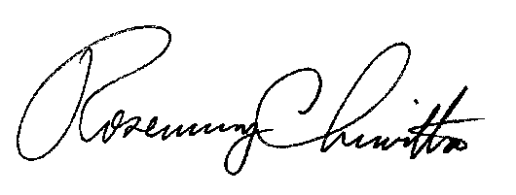
Very Truly Yours,

Rosemary Chiavetta
Secretary

RC/mm
(SEAL)

