Via electronic service only due to Emergency Order at M-2020-3019262

BEFORE THE
PENNSYLVANIA PUBLIC UTILITY COMMISSION

James E. Elliott, Jr. :
:
v. : C-2021-3024007
:
Pennsylvania Electric Company :

FIRST INTERIM ORDER
GRANTING COMPLAINANT’S MOTION FOR HEARING CONTINUANCE

By Notice dated March 16, 2021, the Parties were informed that an Initial Call-In Telephonic Hearing was scheduled before me for the captioned proceeding on Wednesday, April 28, 2021, at 10:00 a.m. On April 13, 2021, via email, Complainant James E. Elliott, Jr. requested a continuance of the scheduled hearing. Mr. Elliott represented that his current health condition prevented him from participating in the scheduled hearing.

On April 15, 2021, via email, Respondent Pennsylvania Electric Company (Penelec) represented, “The Company will not oppose a single, brief continuance for the reason stated.” Penelec further stated, “The Company requests that any future requests for continuances for medical reasons be accompanied by a letter from his (Mr. Elliott’s) treating physician with a specific timeframe in which Mr. Elliott would be able to attend a telephonic hearing.”

Although Complainant’s email requesting a hearing continuance does not conform to the requirements of a formal motion under Section 1.15(b) of the Commission’s regulations, waiver of this requirement is permitted. Under Section 1.2, 52 Pa.Code § 1.2, a presiding officer at any stage of an action or proceeding may waive a requirement of a rule when necessary or appropriate if waiver does not adversely affect a substantive right of a party. Such are the circumstances in this case. Therefore, Complainant’s email dated April 13, 2021, is treated as a motion for continuance of the telephonic hearing.
After due consideration, I find that the motion states good cause to warrant a continuance. Thus, the motion will be granted in the ordering paragraphs below. A notice rescheduling the initial telephonic hearing will be issued to the Parties.

However, Complainant is cautioned that any further request for a hearing continuance for medical reasons must be accompanied by a statement from his medical provider substantiating Complainant’s need for a hearing continuance.

The parties are encouraged to talk with each other to resolve this matter or a
portion thereof. It is the Commission’s policy to encourage settlements. 52 Pa.Code § 5.231.

THEREFORE,

IT IS ORDERED:

- That the motion of Complainant James E. Elliot, Jr. for a continuance of the Initial Call-In Telephonic Hearing scheduled in the case of James E. Elliott, Jr. v. Pennsylvania Electric Company at Docket No. C-2021-3024007 for Wednesday, April 28, 2021, is granted.

- That the Scheduling Staff of the Office of Administrative Law Judge shall reschedule the Initial Call-In Telephonic Hearing in the case of James E. Elliott, Jr. v. Pennsylvania Electric Company at Docket No. C-2021-3024007 for the next available hearing date after May 17, 2021, and so notify the parties in writing.
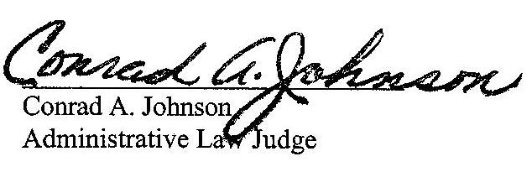

Date: April 21, 2021

C-2021-3024007 - JAMES E ELLIOTT JR v. PENNSYLVANIA ELECTRIC COMPANY
JAMES E. ELLIOTT JR.
263 HOUSE15 4TH ST
PO BOX
LUCERNE MINES PA 15748
724.599.7810
msstephanie5690@gmail.com
“Via e-mail only due to
Emergency Order at M-2020-3019262”
MARGARET MORRIS ESQUIRE
REGER RIZZO & DARNALL
CIRA CENTRE 13TH FL
2929 ARCH STREET
PHILADELPHIA PA 19104
215.495.6524
mmorris@regerlaw.com
Accepts eService

