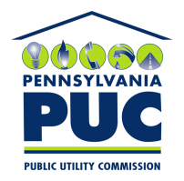 | COMMONWEALTH OF PENNSYLVANIA  PENNSYLVANIA PUBLIC UTILITY COMMISSION  400 North Street, Keystone Building, Second Floor  Harrisburg, Pennsylvania 17120 | IN REPLY PLEASE REFER TO OUR FILE
April 28, 2021

Via Certified Mail

Martha Lopez
Spark Energy LLC
12140 Wickchester Lane Suite 100
Houston TX 77079

RE: Bond Continuation Certificate
Spark Energy LLC
A-2009-2145787

Dear Ms. Lopez:

Please find under cover of this letter the financial instrument filed on behalf of Spark Energy LLC because it is not acceptable.

The Commission requires a supplier to file an original bond, letter of credit, continuation certificate, amendment, or other financial instrument as part of a supplier’s licensing requirements under Section 2809(c) of the Pennsylvania Public Utility Code, including naming the Pennsylvania Public Utility Commission as the beneficiary or obligee of the security instrument along with all other required information on the document.

The enclosed Continuation Certificate names “PPL Electric Utilities Corporation” as the Obligee.

As the current Bond Continuation on file which list Pennsylvania Public Utility Commission as the Obligee is valid through October 24, 2021, no further action is required at the time.

Sincerely,

Rosemary Chiavetta
Secretary of the Commission

Enclosures
RC:alw

