 | COMMONWEALTH OF PENNSYLVANIA  PENNSYLVANIA PUBLIC UTILITY COMMISSION  P.O. BOX 3265, HARRISBURG, PA 17105-3265 | IN REPLY PLEASE REFER TO OUR FILE

C-2021-3025530

Date of Service: April 27, 2021

TEUTONIC TRANSPORTATION LLC
2000 BENNETT ROAD
PHILADELPHIA, PA 19116

PENNSYLVANIA PUBLIC UTILITY COMMISSION
BUREAU OF INVESTIGATON & ENFORCEMENT
v.
TEUTONIC TRANSPORTATION LLC

Dear Sir/Madam:

Please be advised that the attached complaint has been filed against you by the Bureau of Investigation & Enforcement.

Detailed instructions on how to proceed are contained in the NOTICE section, and you are advised to read everything carefully or consult with your attorney.

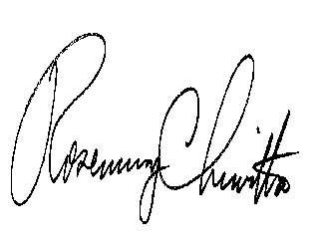
Very truly yours,

Rosemary Chiavetta
Secretary

Attachments

NW

