COMMONWEALTH OF PENNSYLVANIA
PENNSYLVANIA PUBLIC UTILITY COMMISSION
P.O. BOX 3265, HARRISBURG, PA 17105-3265

April 28, 2021

Docket Nos. P-2017-2637855
P-2017-2637857
P-2017-2637858
P-2017-2637866

TORI GIESLER
FIRSTENERGY SERVICE COMPANY
2800 POTTSVILLE PIKE
PO BOX 16001
READING PA 19612

Re: Results of Request for Proposals Process – DSP-V April 2021 Solicitation for:
Metropolitan Edison Company
Pennsylvania Electric Company
Pennsylvania Power Company
West Penn Power Company

Dear Ms. Giesler:

On April 27, 2021, Metropolitan Edison Company, Pennsylvania Electric Company, Pennsylvania Power Company, and West Penn Power Company (collectively FirstEnergy) filed the results of its Request for Proposals (RFP) Process and Rules for the April 2021 Solicitation for provider of last resort service. The filing includes bid results of twenty products in a declining clock auction for the supply for residential and commercial customers who will receive default service from FirstEnergy within the period June 1, 2021 through May 31, 2023.

This filing was submitted in accordance with the RFP Process and Rules filed by FirstEnergy. The RFP Process and Rules were filed pursuant to the Commission’s Order, entered September 4, 2018, at Docket Nos. P-2017-2637855, P-2017-2637857, P-2017-2637858 & P-2017-2637866.

FirstEnergy requests that the Commission approve the bid results from the April 2021 Solicitation on or before April 28, 2021.

Further investigation does not appear to be warranted at this time, since the bid results from the April 2021 Solicitation appear to have been conducted in accordance with the RFP Process and Rules as approved by the Commission.

Therefore, we direct FirstEnergy to disclose the results of the April 2021 Solicitation in accordance with the Commission’s Secretarial Letter in Re: Disclosure of Default Service Solicitation Results and Creation of a Default Service Rate Calculation Model, issued
October 12, 2010, at Docket No. M-2009-2082042.

Please direct any questions to Debra Backer, Energy Supervisor, Bureau of Technical Utility Services, at (717) 783-9787.

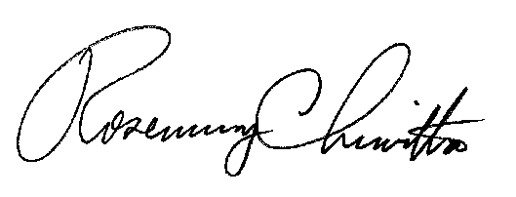
Sincerely,

Rosemary Chiavetta
Secretary

