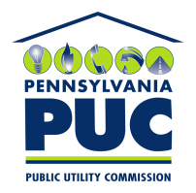 | COMMONWEALTH OF PENNSYLVANIA  PENNSYLVANIA PUBLIC UTILITY COMMISSION  400 NORTH STREET, HARRISBURG, PA 17120 | IN REPLY PLEASE REFER TO OUR FILE
April 28, 2021

Docket No. A-2010-2181867
Utility Code: 1112299
EMAIL

LEAH GIBBONS DIRECTOR
STREAM ENERGY PENNSYLVANIA LLC
3711 MARKET STREET 10TH FL
PHILADELPHIA PA 19104

RE: Financial Security Reduction Annual Compliance Filing Data Requests

Dear Ms. Gibbons:
On March 30, 2021, Stream Energy Pennsylvania LLC (Stream Energy) filed an Annual Compliance Filing to maintain its bonding level of 5% of its most recent 4 quarters of revenue subject to the minimum of $250,000, per the Commission’s Orders entered July 24, 2014, at Docket No. M-2013-2393141 and September 20, 2018, at Docket No. P-2017-2608078. The Annual Compliance Filing was incomplete. In order for us to complete our analysis of your filing, the Energy Industry Group requires answers to the attached question(s).

Please be advised that you are directed to forward the requested information to the Commission within 30 days from the date of this letter. Failure to respond may result in the filing being denied. As well, if Stream Energy has decided to withdraw its filing, please reply notifying the Commission of such a decision.

Please forward the information to the Secretary of the Commission at the address listed below. When submitting documents, all documents requiring notary stamps must have original signatures. Please note that some responses may be e-filed to your case, http://www.puc.pa.gov/efiling/default.aspx. A list of document types allowed to be e-filed can be found at http://www.puc.pa.gov/efiling/DocTypes.aspx.

Rosemary Chiavetta, Secretary
Pennsylvania Public Utility Commission
400 North Street
Harrisburg, PA 17120

Your answers should be verified per 52 Pa Code § 1.36. Accordingly, you must provide the following statement with your responses:

I, ________________, hereby state that the facts above set forth are true and correct to the best of my knowledge, information and belief, and that I expect to be able to prove the same at a hearing held in this matter. I understand that the statements herein are made subject to the penalties of 18 Pa. C.S. § 4904 (relating to unsworn falsification to authorities).
The blank should be filled in with the name of the appropriate company representative, and the signature of that representative should follow the statement.

Please direct any questions to Stephen Jakab, Bureau of Technical Utility Services, at sjakab@pa.gov (preferred).

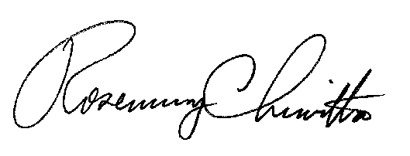
Sincerely,

Rosemary Chiavetta
Secretary

Enclosure
Docket No. A-2010-2181867
Stream Energy Pennsylvania LLC
Data Requests

- Reference Annual Compliance Filing – The Applicant’s provided gross receipts for the sale of electricity to retail customers in Pennsylvania does not match its Electric Choice Quarterly Reports on file with the Commission. Please file updated Electric Choice Quarterly Reports for 1Q20, 2Q20, 3Q20, and 4Q20.

2. Reference Annual Compliance Filing - Applicant failed to provide a letter from the AEPS Administrator confirming compliance with AEPS requirements. Please provide the missing documentation.

Final Order at Docket No. P-2017-2608078 (adopted September 20, 2018)

