PENNSYLVANIA
PUBLIC UTILITY COMMISSION
Harrisburg, PA 17120

Public Meeting held May 6, 2021

Commissioners Present:

Gladys Brown Dutrieuille, Chairman
David W. Sweet, Vice Chairman, Statement
John F. Coleman, Jr.
Ralph V. Yanora

Pennsylvania Public Utility Commission,  Bureau of Investigation and Enforcement  v.  PECO Energy Company |  | M-2021-3014286

Opinion and Order

BY THE COMMISSION:

Before the Pennsylvania Public Utility Commission (Commission) for consideration and disposition is a Joint Petition for Approval of Settlement (Joint Petition, Settlement or Settlement Agreement) filed on February 12, 2021, by the Commission’s Bureau of Investigation and Enforcement (I&E) and PECO Energy Company (PECO or Company) (collectively, the Parties), with respect to an informal investigation conducted by I&E concerning improper electric service terminations for approximately 49,500 customers. Both Parties submitted Statements in Support of the Settlement. The Parties submit that the proposed Settlement is in the public interest and consistent with the Commission’s Policy Statement at 52 Pa. Code § 69.1201, Factors and standards for evaluating litigated and settled proceedings involving violations of the Public Utility Code and Commission regulations—statement of policy. Settlement ¶ 39 at 13. We will publish the Settlement in the Pennsylvania Bulletin and seek comments from interested parties within twenty-five days after the date of its publication. We shall also direct that the Settlement be posted to PECO’s website.

History of the Proceeding

On June 25, 2018, PECO’s call center third-party vendor made a dialer platform change resulting in two separate computer errors that ultimately caused improper service termination for approximately 49,500 electric customers between June 25, 2018 and September 10, 2019.

PECO discovered the first error on August 9, 2018, and suspended all service terminations. This error led to the termination of a large number of electric customers without those customers first receiving the required second seventy-two-hour telephone call to either the customer or an adult occupant of the household at least three days, or seventy-two hours, prior to the scheduled termination. PECO reported the incident to the Commission’s Bureau of Consumer Services (BCS) on August 16, 2018, and BCS referred the matter for investigation to I&E. PECO resolved the first issue on August 20, 2018.

The second error was not detected by PECO until September 10, 2019, when the Company was investigating an informal complaint filed by a customer on September 5, 2019. This error led to the Company’s termination of service for a large number of customers on a day different than that on which the previous service termination occurred due to the first error. PECO again suspended all service terminations until September 12, 2019, which was the date the second error was resolved.
Upon completion of its informal investigation, I&E was prepared to file a Formal Complaint against PECO that it had violated Section 1503(b) of the Pennsylvania Public Utility Code (Code), 66 Pa. C.S. ¶ 1503(b), regarding personal contact before service is discontinued, and Section 56.333 (a) and (b) of the Commission’s Regulations, 52 Pa. Code § 56.333, regarding termination of service. However, I&E and PECO engaged in voluntary negotiations and achieved an agreement to resolve the matter through a settlement.

On February 12, 2021, the Parties filed the Joint Petition for Approval of Settlement for the Commission’s consideration.

Background

As noted, on June 25, 2018, PECO’s call center third-party vendor made a dialer platform change that resulted in two separate computer errors that ultimately caused improper service terminations for approximately 49,500 electric customers between June 25, 2018 and September 10, 2019. Settlement ¶¶ 12, 13 at 4; ¶ 18 at 5. The first computer error, which was discovered on August 9, 2018, was caused by a platform change that incorrectly recorded the second three-day notice telephone attempt as being successful, when it was not. Settlement ¶ 13 at 4. For this reason, PECO did not complete the required three-day or seventy-two-hour telephone call attempt to contact the customer. Id. The erroneous designation of the second three-day notice telephone attempt was due to a missed unidentified coding requirement specific to calls categorized as “not made” during the testing. Settlement ¶ 15 at 4. Therefore, the vendor made a subsequent change in the call-pacing to address service level concerns. However, this caused the second call attempts to appear as “not made” within the calling window. Id. at 5. Since there was no code assigned in the new dialer platform for calls that were “not made,” the calls were deemed “successful” by default. Id. Consequently, certain residential customer accounts were passed over, but were still reported as “successful” calls. Id. These changes caused PECO to incorrectly record the seventy-two hour calls as “successful” when PECO did not complete the second three-day telephone call attempt. This first issue was fully resolved by August 20, 2018. Settlement ¶ 14 at 4.

The second computer error, which was discovered when the Company was investigating a formal complaint on September 10, 2019, also caused the seventy-two-hour call to incorrectly list the customer’s current bill due date as the termination date. This resulted in the incorrect termination date during the seventy-two-hour call. Settlement ¶ 16 at 5. This second issue was fully resolved by September 12, 2019. Settlement ¶ 17 at 5.

As a result of its informal investigation, I&E concluded it had sufficient data to substantiate allegations of violations of Section 1503(b) of the Code and Section 56.333 of the Commission’s Regulations. Settlement ¶ 19 at 5; ¶ 27 at 7-8. In this regard, I&E was prepared to contend, through filing a formal complaint, that PECO violated certain provisions of the Code and Commission Regulations as described below:

A. PECO through its third-party vendor failed to comply with 66 Pa.C.S.A. § 1503(b) and 52 Pa. Code § 56.333(a) – (c), in that PECO through its third-party vendor illegally terminated service to the accounts due to the vendor’s dialer platform error. Specifically:

i. The 72-hour call attempts were incorrectly recorded as “successful” when PECO did not complete the second three-day telephone attempt. Consequently, these accounts were terminated without the company complying with provision that it must attempt personal contact with the customer or adult occupant at least three days prior to the scheduled termination date. 52 Pa. Code § 56.333(a) – (b); and

ii. The 72-hour call attempts incorrectly listed the customer’s current bill due date as the termination date. Therefore, PECO did not provide the correct termination date during the 72-hourcall. 52 Pa. Code § 56.333(c).

B. If proven, these would be violations of 66 Pa.C.S.A. § 1503(b) and 52Pa. Code § 56.333(a) – (c).

Settlement ¶ 29 at 8-9.

As a result of negotiations between I&E and PECO, the Parties have agreed to resolve their differences and urge the Commission to approve the Settlement as being in the public interest. Settlement at 1; ¶ 10 at 4; ¶ 45 at 15. In the Settlement, PECO does not dispute I&E’s allegations and fully acknowledges the seriousness of those allegations. In addition, I&E credits PECO with placing into effect appropriate measures approved by I&E to ensure that such oversight is not likely to reoccur. Settlement ¶ 30 at 9. I&E also acknowledges that PECO: (1) remained active in communications and informal discovery; (2) fully cooperated and complied with I&E’s investigation and requests for information and documentation; and (3) continued to explore the possibility of resolving this investigation, which ultimately culminated in the instant Settlement. Settlement ¶¶ 31, 32 at 9.

Terms of the Settlement

Pursuant to the Settlement, the Parties agree to stipulate to the following terms:

A. PECO will pay a civil penalty amount of Fifty Thousand Dollars ($50,000.00) to resolve all allegations of illegal termination of electrical service to fully and finally settle all possible liability and claims of alleged violations of the Commission’s regulations arising from, or related to, the termination of the accounts at issue. No portion of this civil penalty payment shall be recovered from Pennsylvania consumers by any future proceeding, device, or manner whatsoever. Said payment shall be made within thirty (30) days of the date of the Commission’s final order approving the Settlement Agreement and shall be made by certified check or money order made payable to the “Commonwealth of Pennsylvania” and sent to:

Secretary
Pennsylvania Public Utility Commission
Commonwealth Keystone Building
400 North Street
Harrisburg, PA 17120

B. PECO will also make a contribution of Twenty-Five Thousand Dollars ($25,000) to its Matching Energy Assistance Fund (“MEAF”) in 2021. Specifically, in 2021 PECO will donate $5,000 to each of its five major MEAF agencies to fund additional MEAF grants: Bucks County – Bucks County Opportunity Council, Inc.; Chester County – Human Services, Inc.; Delaware County – Community Action Agency of Delaware County, Inc.; Montgomery County – Community Action Development Commission; and Philadelphia County – Utility Emergency Services Fund. PECO’s MEAF assists approximately 750 to 1,000 customers annually who have been terminated or are in danger of termination. While not precedent setting, due to the unique circumstances presented in 2020, the contribution to PECO’s MEAF will provide much needed assistance given the impact of 2020 on its customers.

C. PECO will take or has taken corrective action and implemented revisions to its operating procedures which will act as safeguards against future termination issues as outlined above. The pertinent portions of PECO’s corrective actions are briefly described as follows:

PECO implemented a change to fix the dialer system glitch, which has been validated through testing and confirmation in the results file. The primary change implemented was to add a new dialer code for calls not made. If this code is returned in the results file, the attempt is coded as “unsuccessful.” PECO also corrected the error resulting in an incorrect termination date being listed in the 72-hour calls.

D. For the next two years (from January 1, 2021 through December 31, 2022), PECO will summarize and report the results of its regulatory noticing audits as part of its quarterly meeting with BCS:²

• The noticing audits track transactions between CIMS [Customer Information and Marketing System], vendors, and customers to ensure notices are being processed and delivered correctly;

• The notices that will be audited are: Disconnect Notice; 72-hour (first call); 72-hour (second call)/48 Hour (field notice); and Cut Out for Non-Pay (post termination notice);

• The data points reviewed for accuracy will be as follows: account balances; termination dates; and dates and times of each contact;

• With respect to frequency of audits: detailed transactions will be audited on a monthly basis at the notice level and daily monitoring will include recording transactions through each hand off to ensure the process is working as designed; and

• PECO will confirm with both I&E and BCS when the change to its new third-party vendor (Agent511) has been completed.³
______________
² PECO will begin this reporting at the BCS quarterly meeting following the filing of this Settlement Petition.
³ The changeover to Agent511 was completed on December 10, 2020.

Discussion

Pursuant to our Regulations at 52 Pa. Code § 5.231, it is the Commission’s policy to promote settlements. The Commission must, however, review proposed settlements to determine whether the terms are in the public interest. Pa. PUC v. Philadelphia Gas Works, Docket No. M-00031768 (Order entered January 7, 2004).

Conclusion

Before issuing a decision on the merits of the proposed Settlement, and consistent with the requirement of 52 Pa. Code § 3.113(b)(3), we shall: (1) publish this Opinion and Order and a copy of the proposed Settlement and Statements in Support, attached hereto, in the Pennsylvania Bulletin; (2) direct PECO to post this Opinion and Order and a copy of the proposed Settlement and Statements in Support on its website; and (3) provide an opportunity for interested parties to file comments regarding the proposed Settlement within twenty-five days after the date of publication in the Pennsylvania Bulletin; THEREFORE,
IT IS ORDERED:

1. That, the Secretary’s Bureau shall duly certify this Opinion and Order along with the attached Settlement Agreement and Statements in Support, and deposit them with the Legislative Reference Bureau for publication in the Pennsylvania Bulletin.

2. That, within twenty-five (25) days after the date that this Opinion and Order and the attached Settlement Agreement and Statements in Support are published in the Pennsylvania Bulletin, interested parties may file comments concerning the proposed Settlement Agreement. Comments to the proposed Settlement Agreement shall be filed through efiling. Please know that at this time ALL parties wanting to file with the Commission and participate in proceedings before the Commission, must open an efiling account free of charge through our website and accept eservice. This is in accordance with the Commission’s Emergency Order at Docket No. M-2020-3019262. An efiling account may be opened at our website, https://www.puc.pa.gov/efiling/default.aspx.

3. That, within five (5) days after the date that this Opinion and Order and the attached Settlement and Statements in Support are published in the Pennsylvania Bulletin, PECO Energy Company shall post the documents on its website along with a statement that includes the specific deadline (i.e., the month and day associated with the twenty-fifth day after the documents are published in the Pennsylvania Bulletin) for interested parties to file comments with the Commission.

4. That a copy of this Opinion and Order, together with the attached Settlement Agreement and the Statements in Support thereof, shall be served on the Office of Consumer Advocate and the Office of Small Business Advocate.

5. That, subsequent to the Commission’s review of comments filed in this proceeding, an Opinion and Order will be issued by the Commission.

BY THE COMMISSION,

Rosemary Chiavetta
Secretary

(SEAL)

ORDER ADOPTED: May 6, 2021

ORDER ENTERED: May 6, 2021

ATTACHMENT

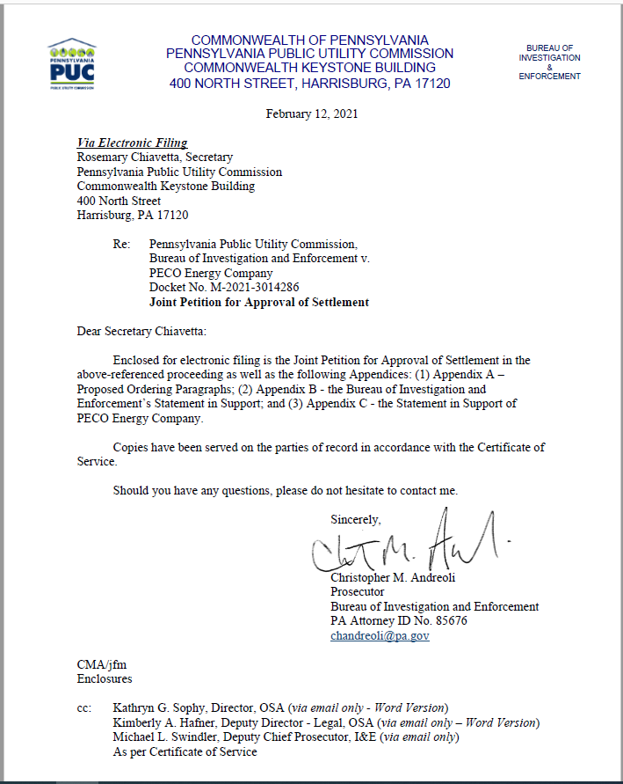

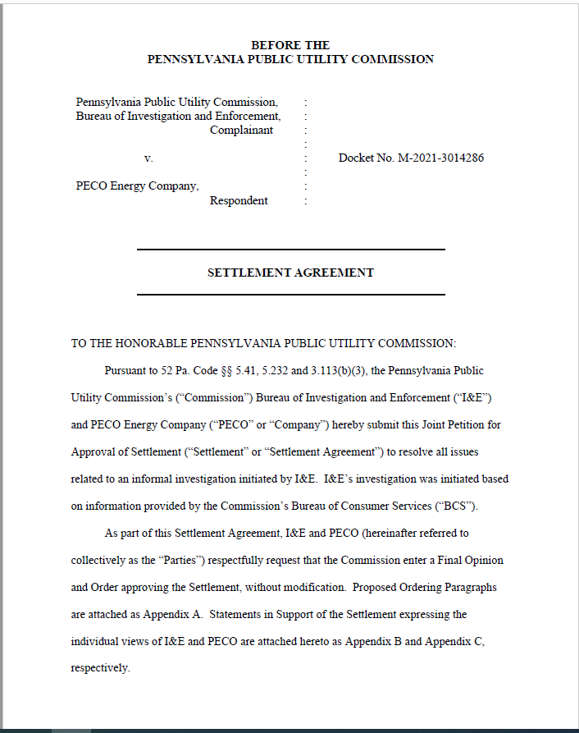

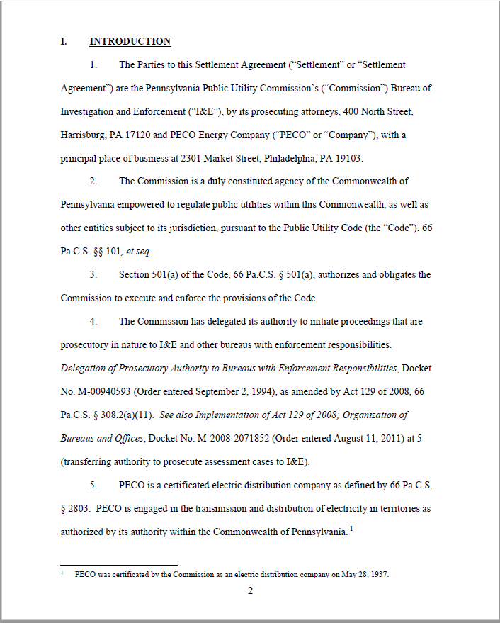

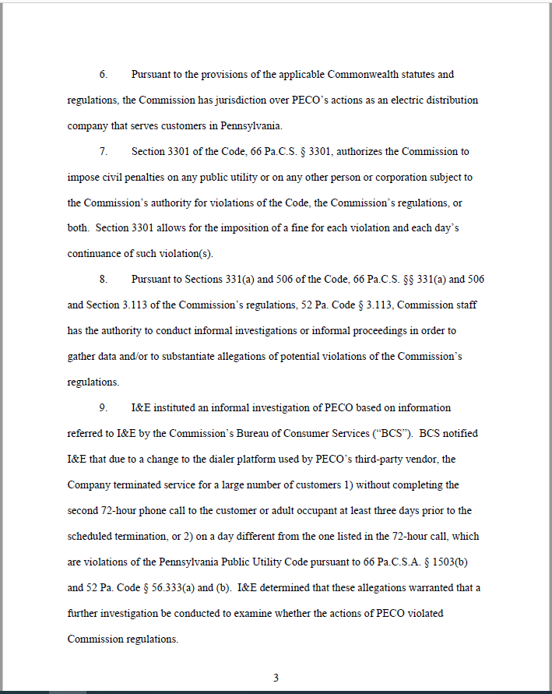

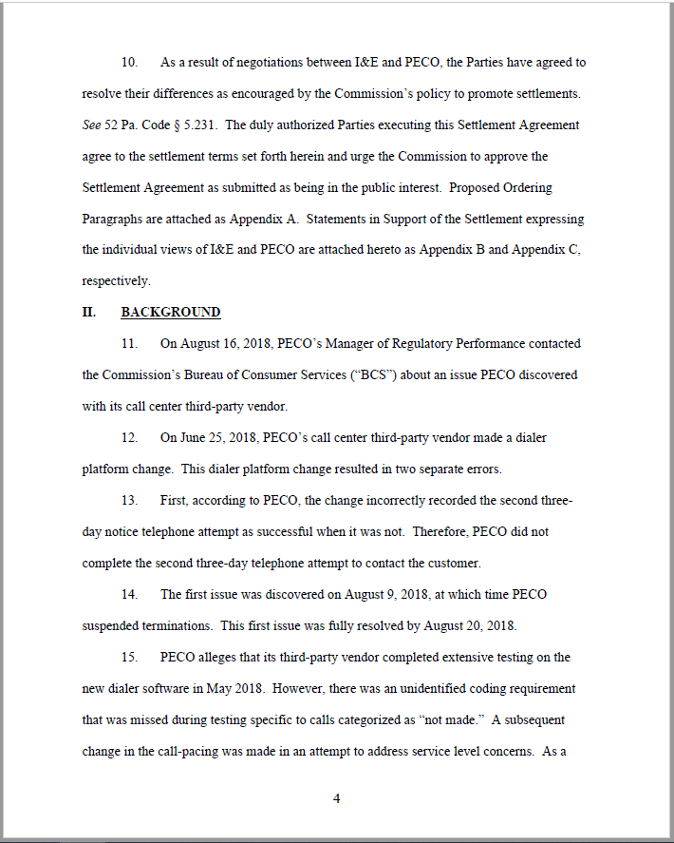

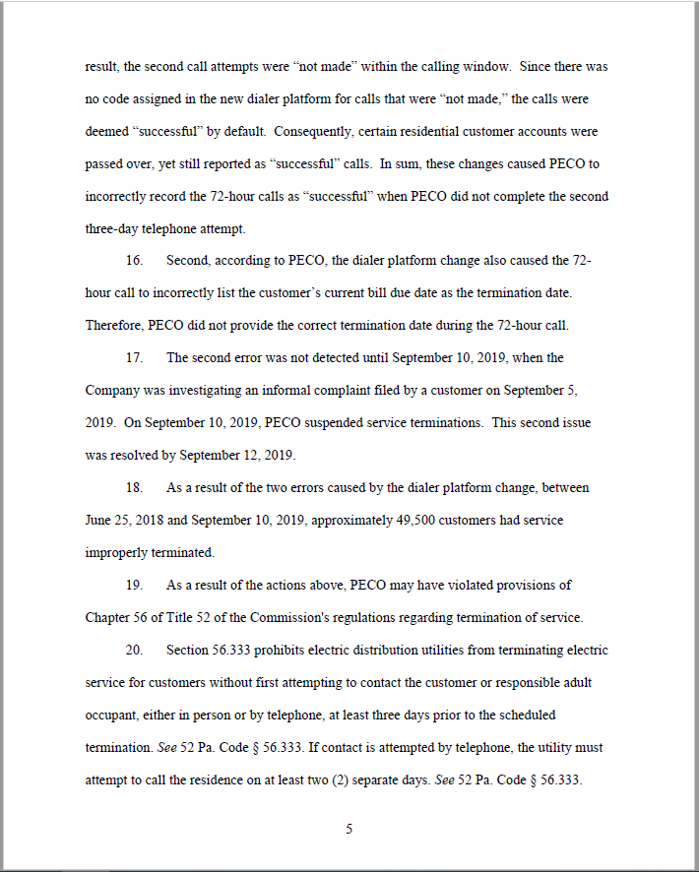

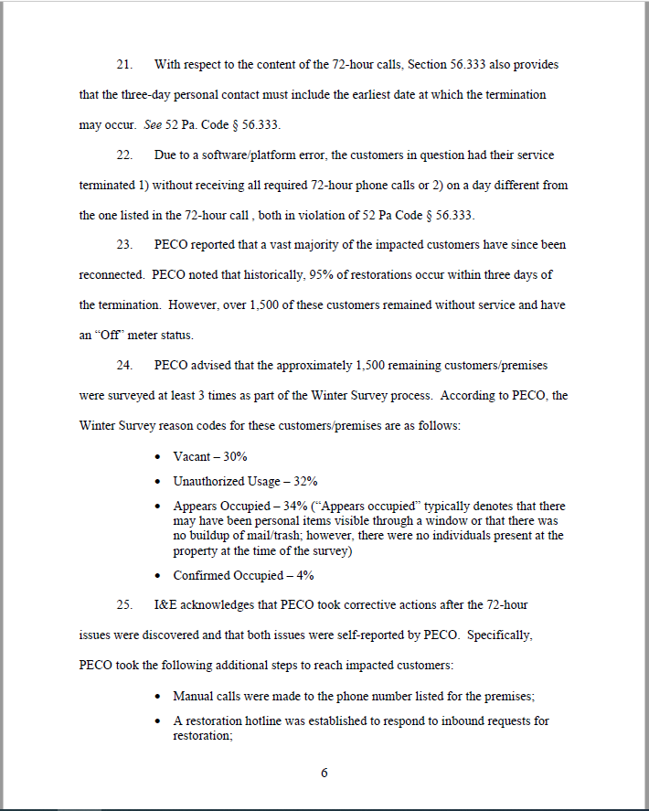

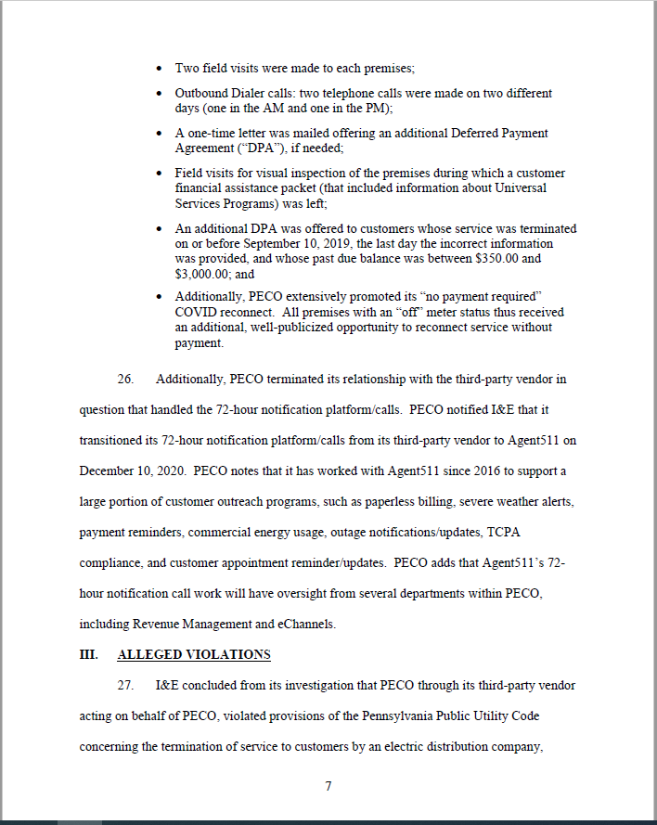

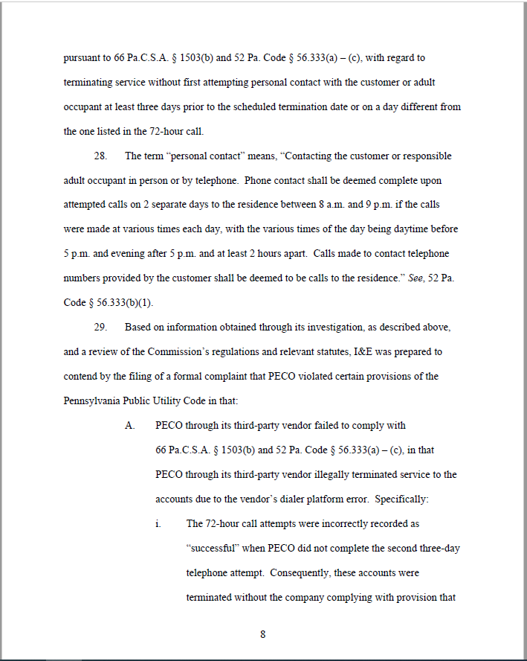

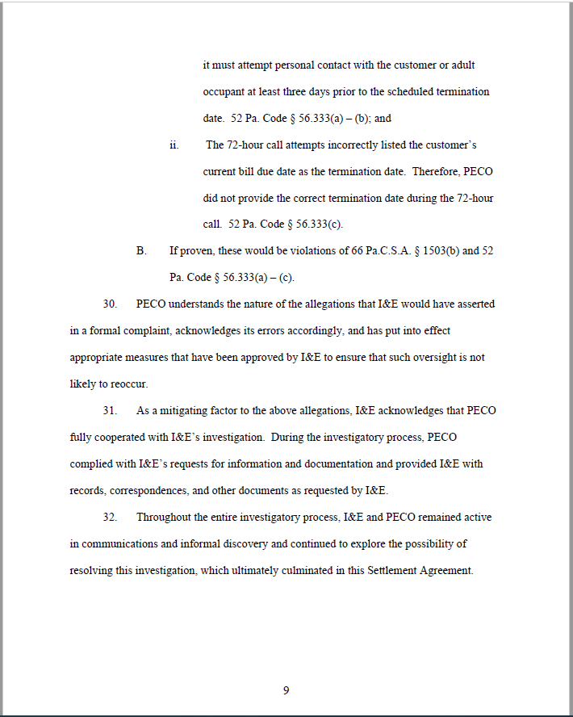

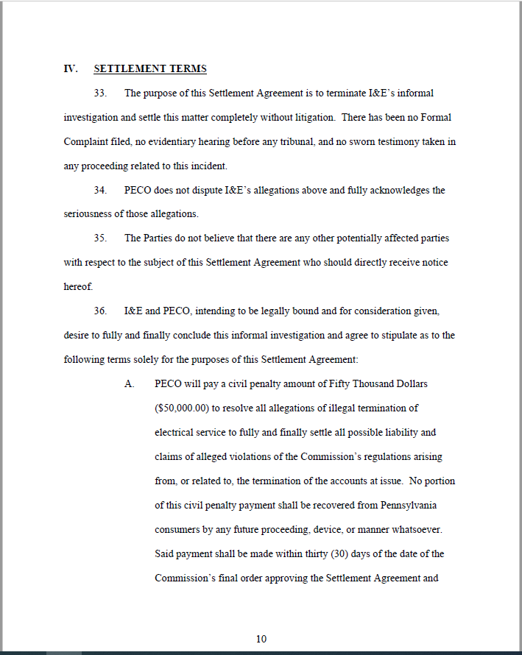

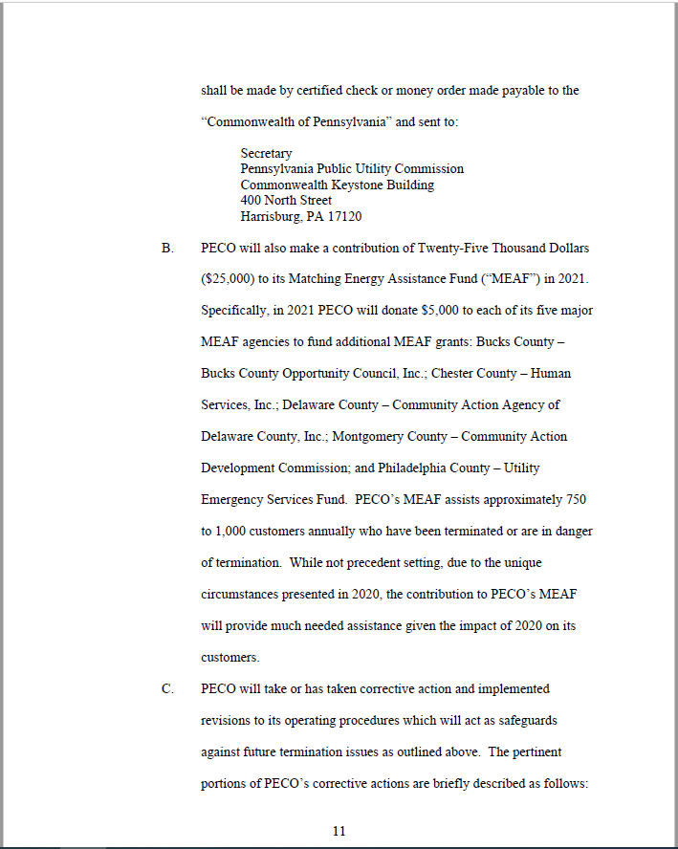

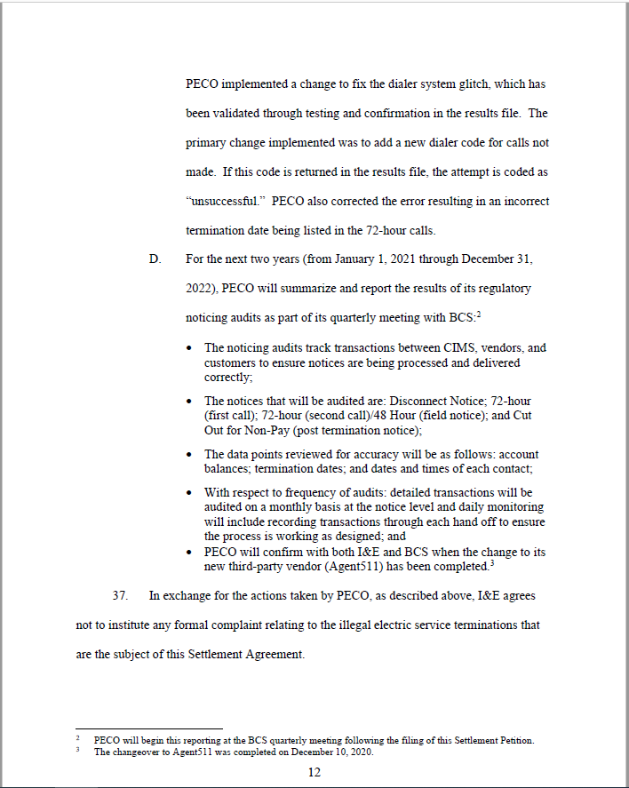

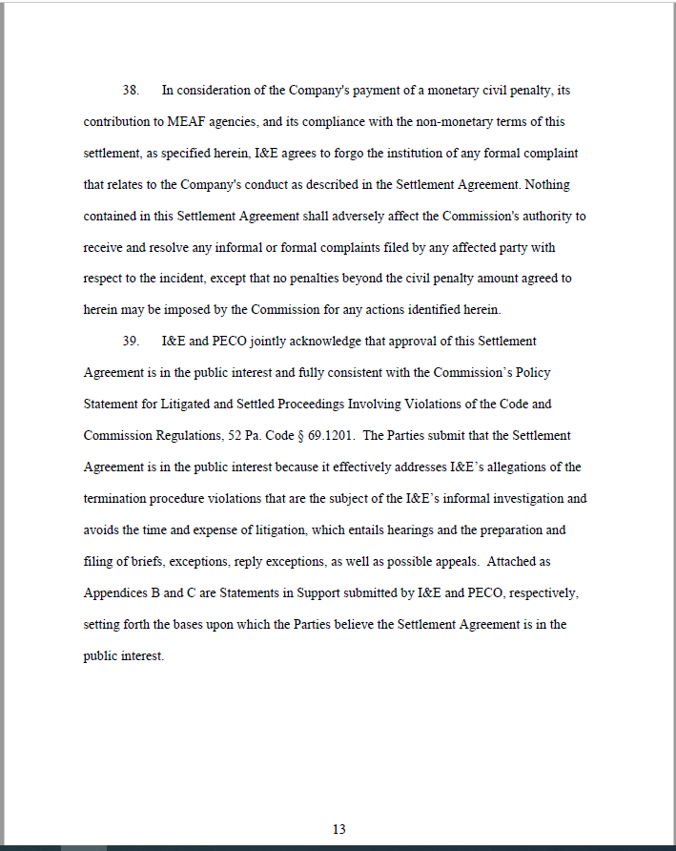

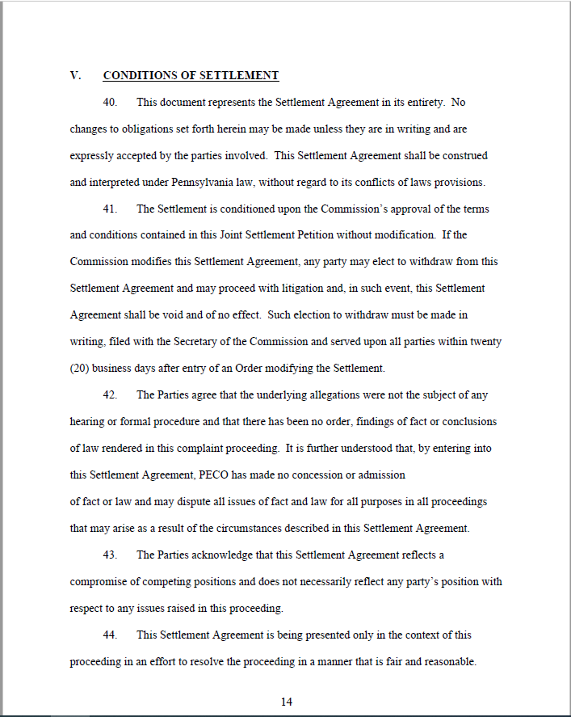

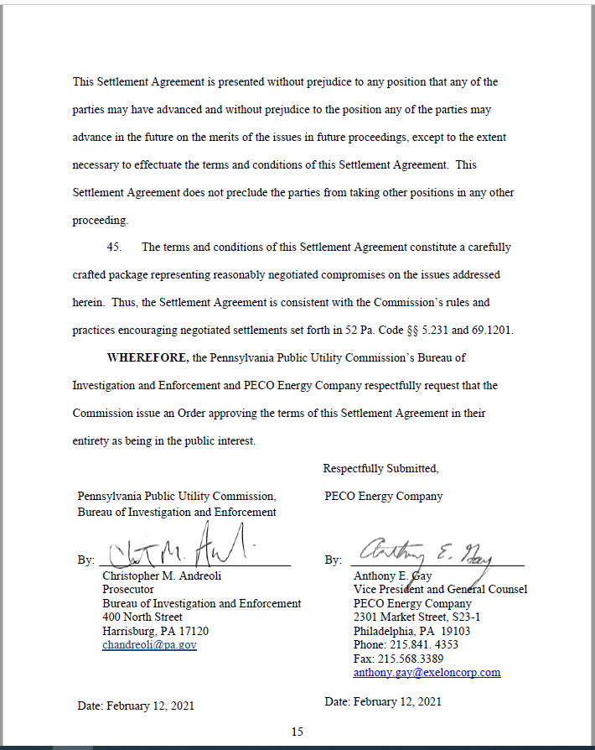

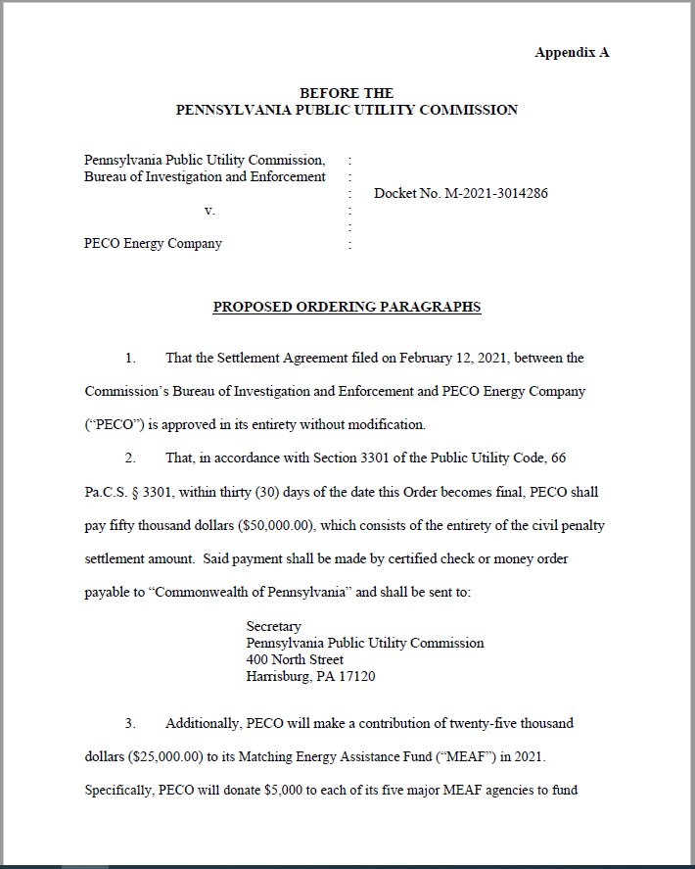

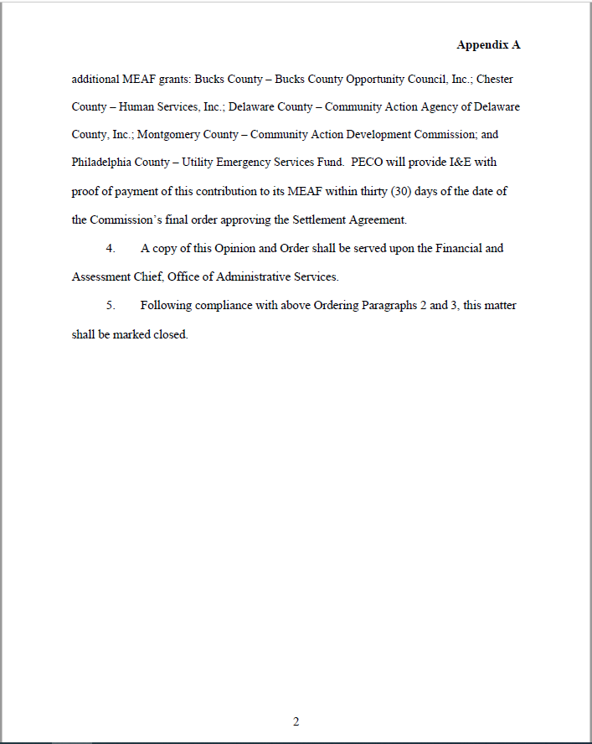

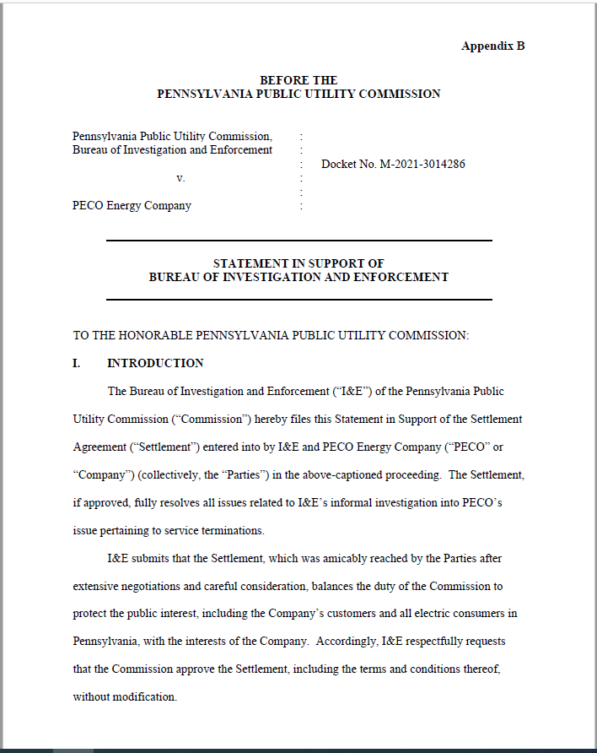

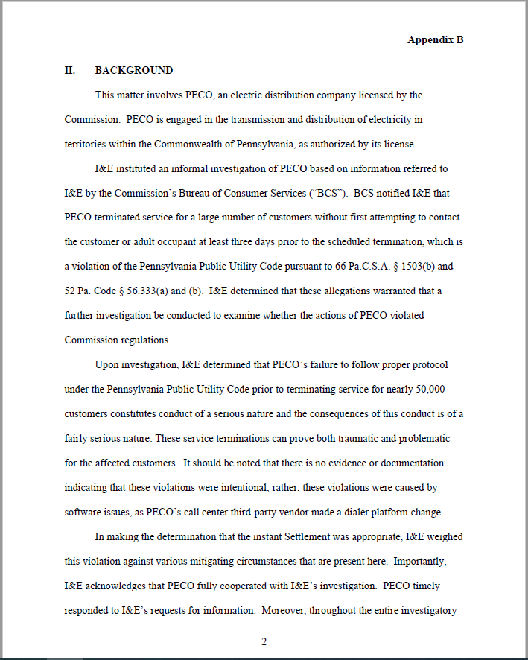

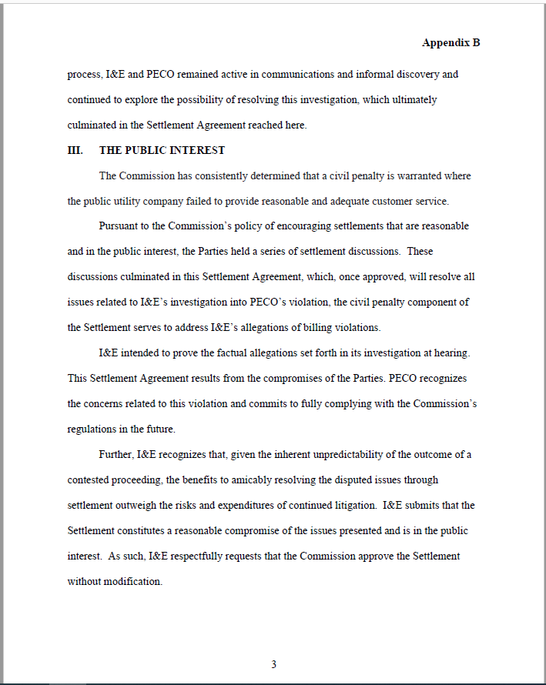

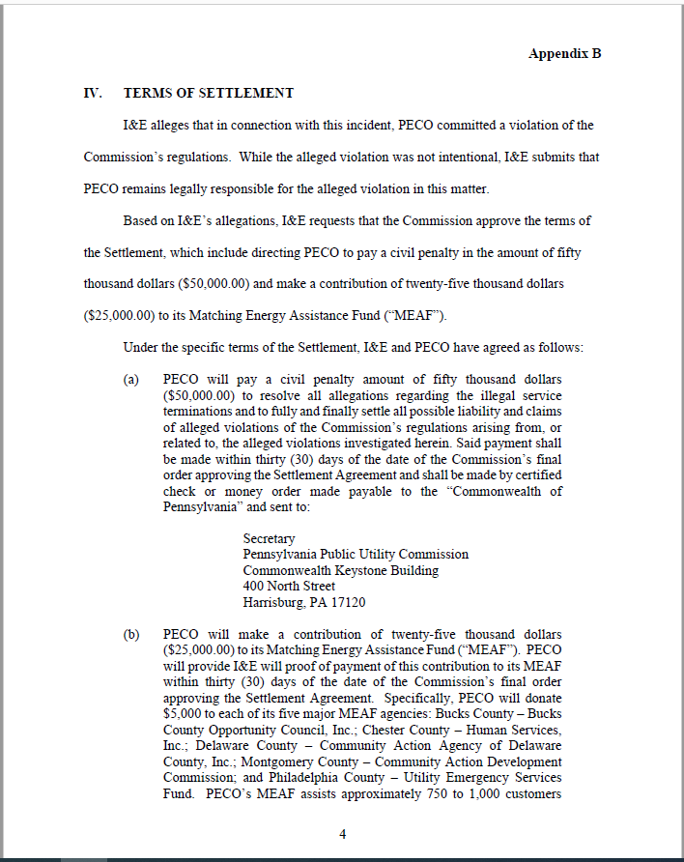

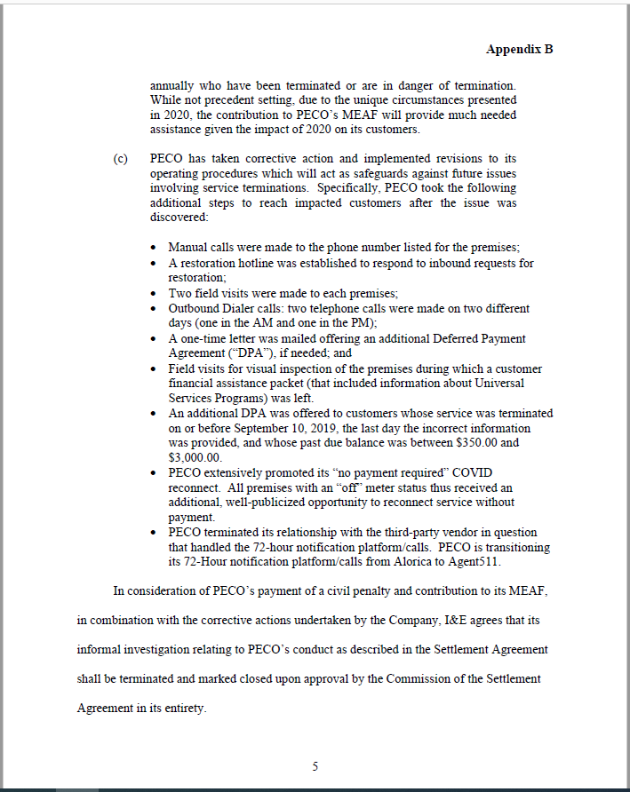

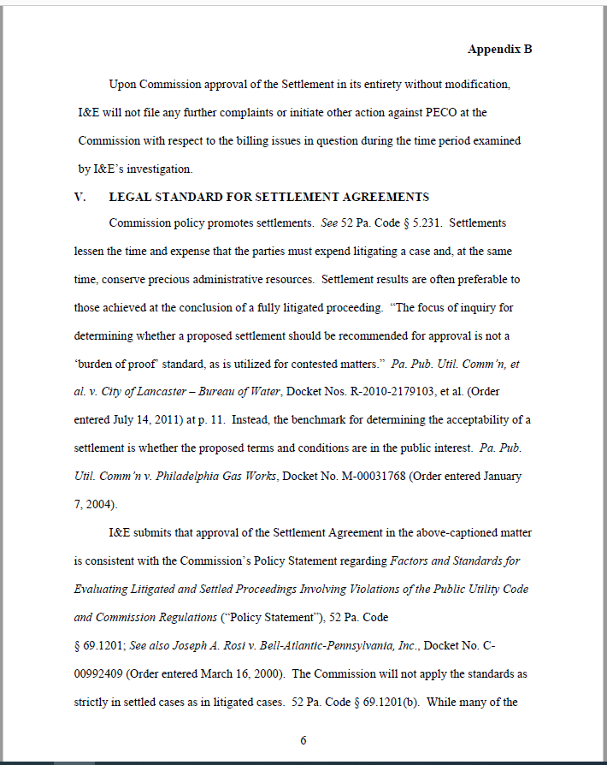

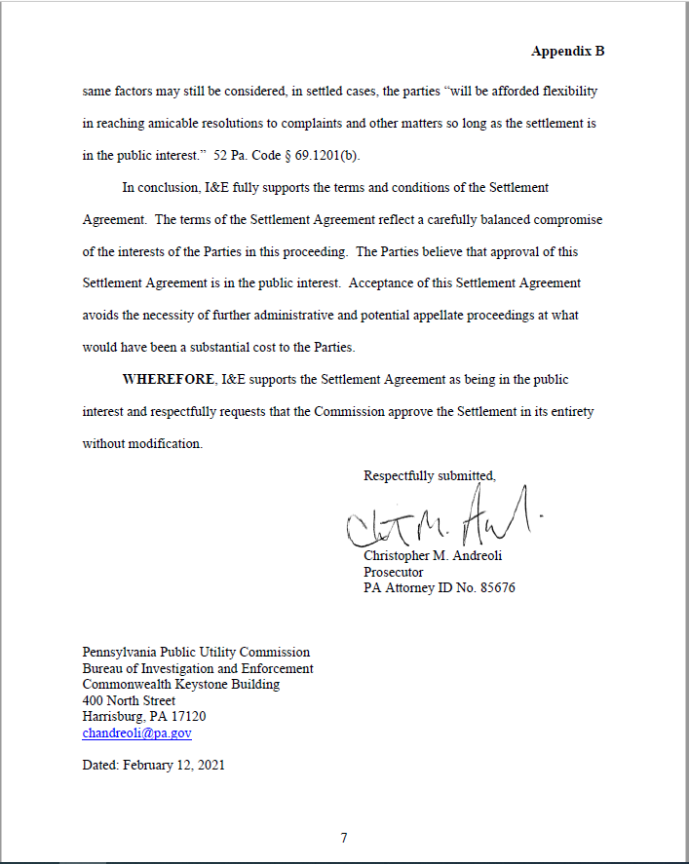

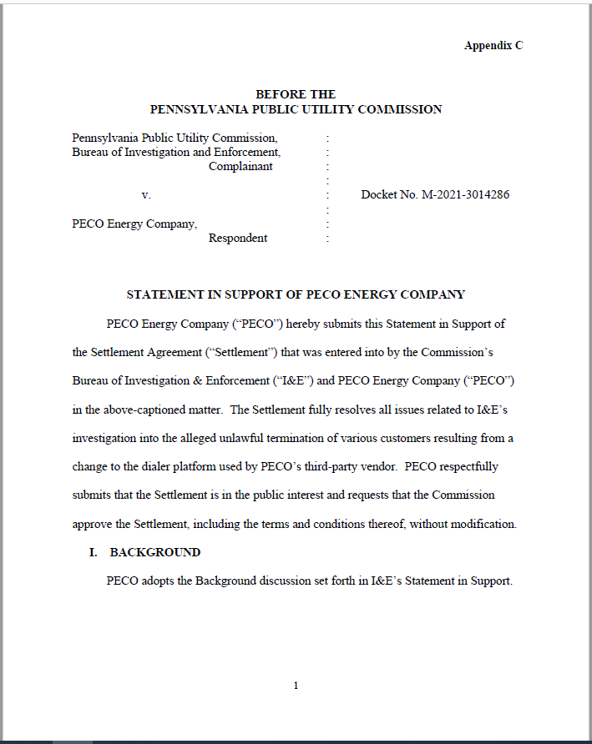

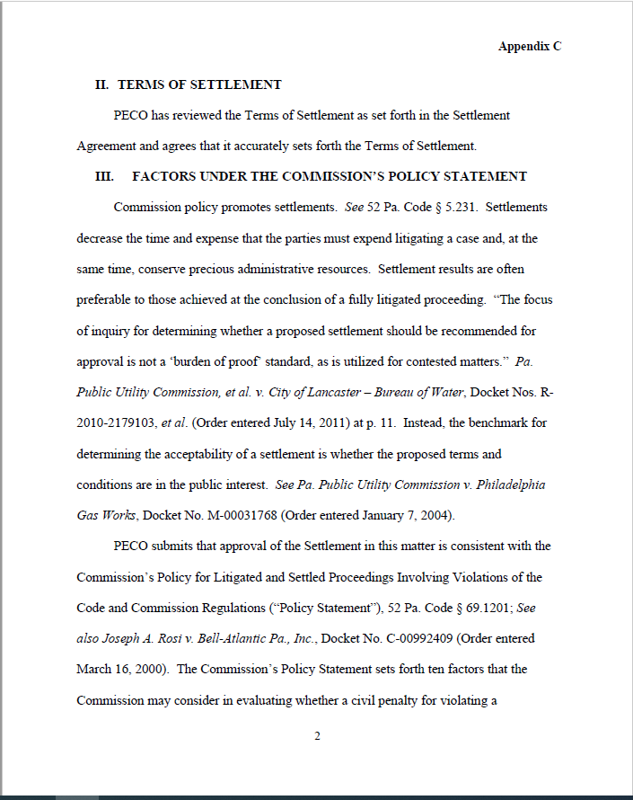

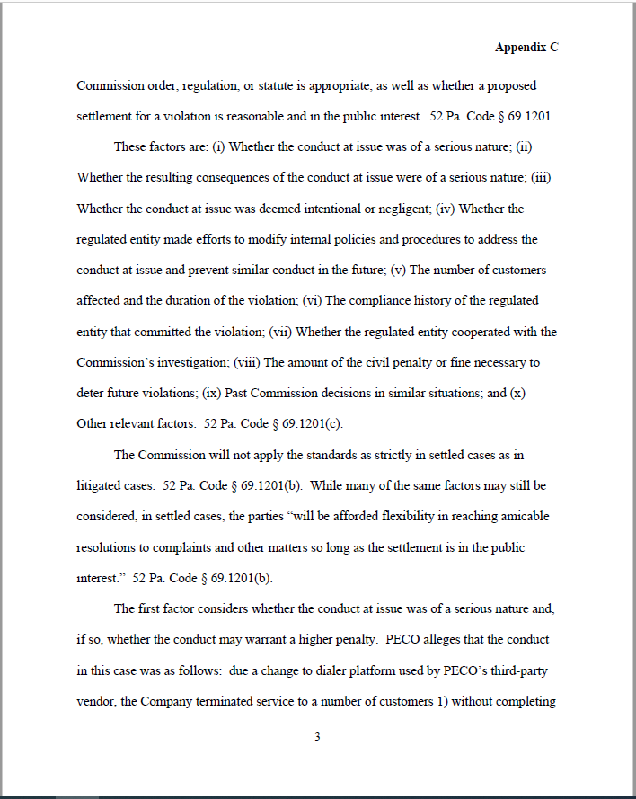

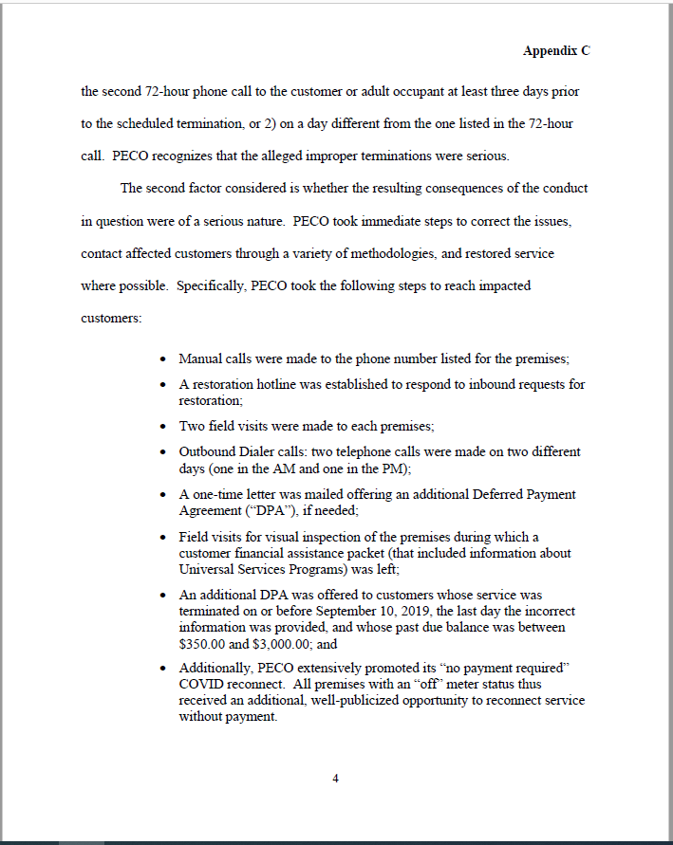

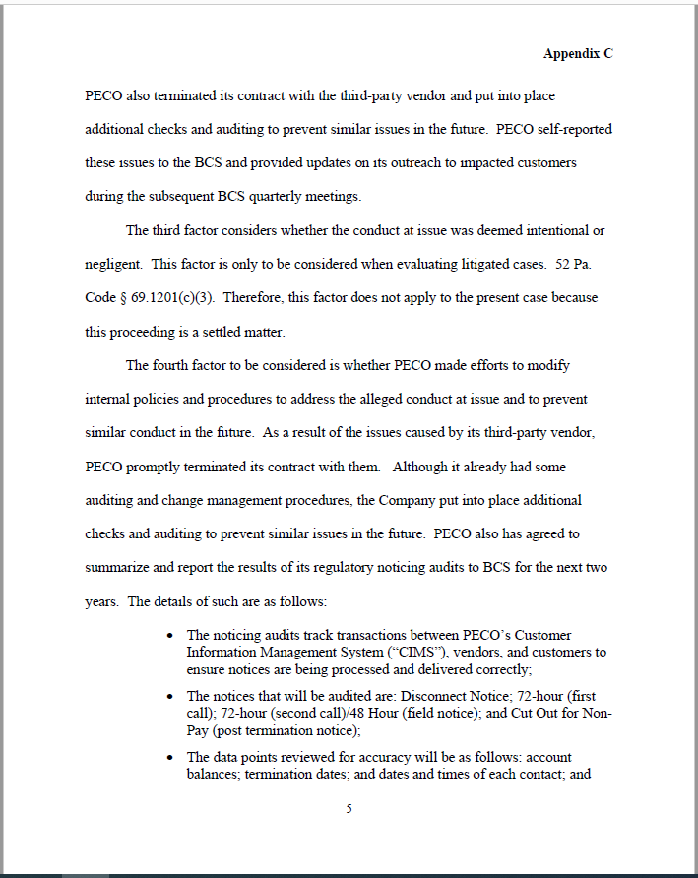

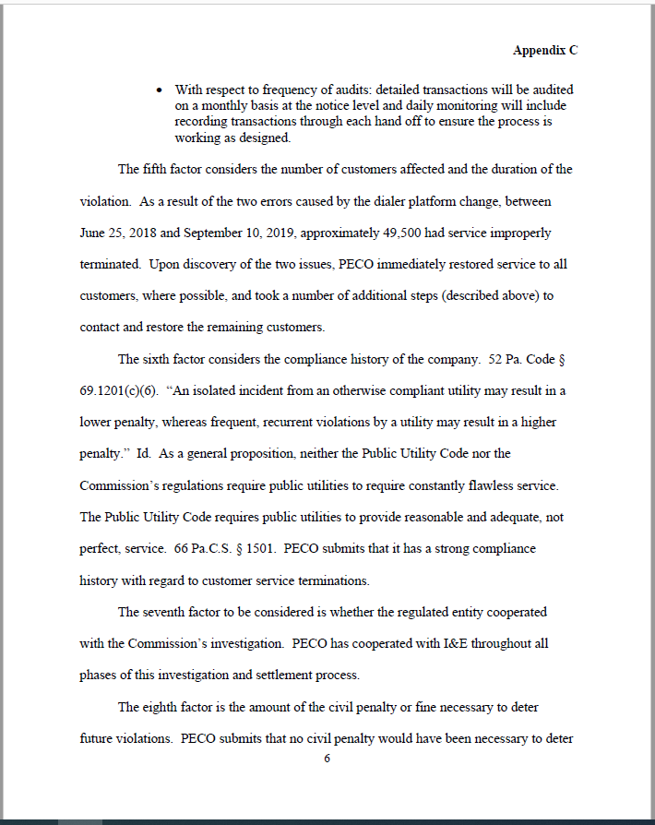

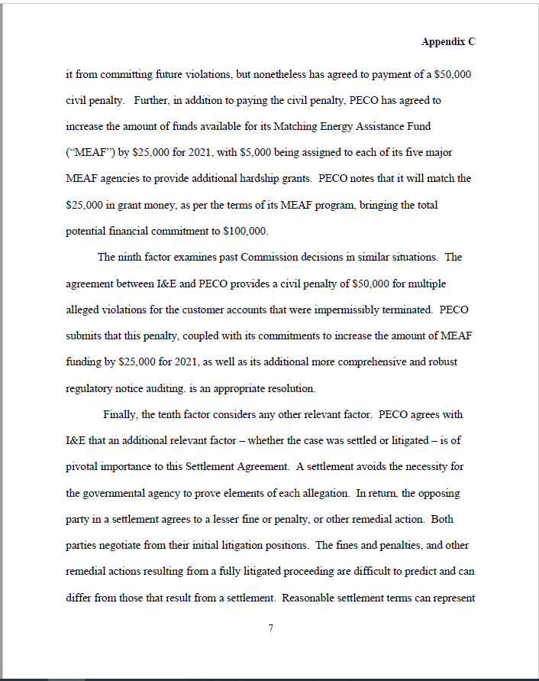

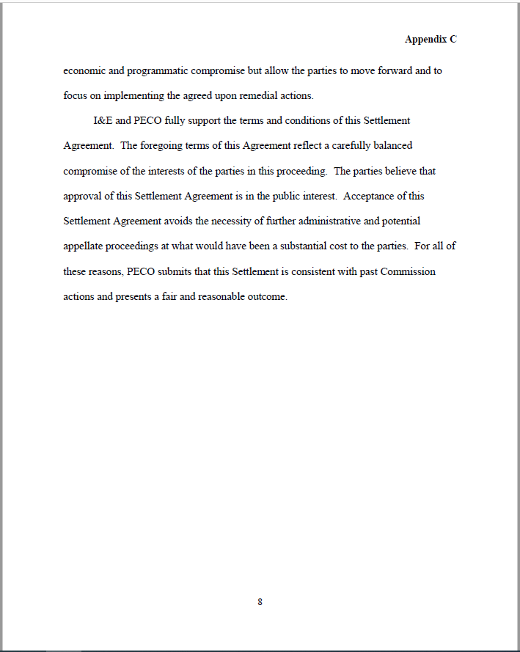

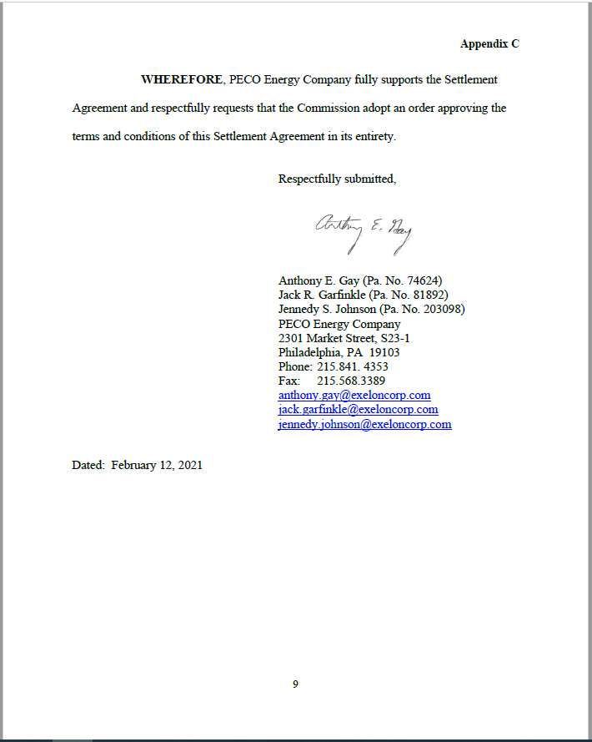

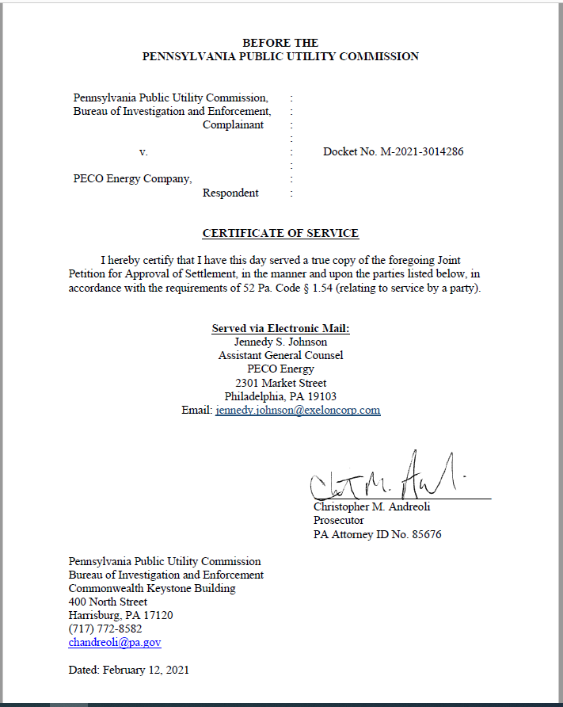

Section 1503(b) of the Code requires that, in addition to any written notice of discontinuance of a customer’s service, the utility must personally contact the customer at least three days, or seventy-two hours, prior to discontinuing service.
Section 56.333 of the Commission’s Regulations prohibits electric distribution utilities from terminating electric service for customers without first attempting to contact the customer or responsible adult occupant, either in person or by telephone, at least three days prior to the scheduled termination. If contact is attempted by telephone, the utility must attempt to call the residence on at least two (2) separate days. With respect to the content of the seventy-two-hour calls, Section 56.333 also provides that the three-day personal contact must include the earliest date at which the termination may occur. Settlement ¶¶ 20, 21 at 5-6.

