PENNSYLVANIA
PUBLIC UTILITY COMMISSION

IN THE MATTER OF THE APPLICATION OF: A-2021-3024218

EFFECTIVE DATE: May 6, 2021

Application of Hercules Energy, LLC for the right to begin to offer, render, furnish or supply electricity or electric generation services as a broker/marketer to residential, small commercial (25 kW and under demand), large commercial (over 25 kW demand), industrial, and governmental customers in all of the electric distribution company service territories throughout the Commonwealth of Pennsylvania.

The Pennsylvania Public Utility Commission hereby certifies that after an investigation and/or
hearing, it has, by its report and order made and entered, found and determined that the granting of the
application is necessary or proper for the service, accommodation, convenience and safety of the public and
hereby issues, evidencing the Commission's approval, to the applicant this:

LICENSE FOR ELECTRIC GENERATION SUPPLIER AS A BROKER/MARKETER.

In Witness Whereof, the PENNSYLVANIA PUBLIC UTILITY COMMISSION
has caused these presents to be signed and sealed, and duly attested by its Secretary
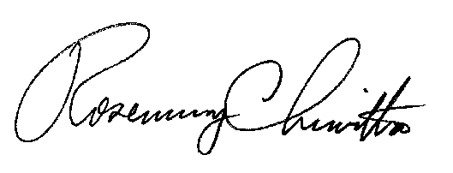
at its office in the city of Harrisburg this 6th day, of May, 2021.

Secretary

