 | COMMONWEALTH OF PENNSYLVANIA  PENNSYLVANIA PUBLIC UTILITY COMMISSION  P.O. BOX 3265, HARRISBURG, PA 17105-3265 | IN REPLY PLEASE REFER TO OUR FILE

C-2021-3025857
Date of Service: May 18, 2021

JAMES F COLEMAN TRANSPORTATION LLC
216 W JAMES ST
LANCASTER, PA 17603

PENNSYLVANIA PUBLIC UTILITY COMMISSION
BUREAU OF INVESTIGATON & ENFORCEMENT
v.
JAMES F COLEMAN TRANSPORTATION LLC

Dear Sir/Madam:

Please be advised that the attached complaint has been filed against you by the Bureau of Investigation & Enforcement.

Detailed instructions on how to proceed are contained in the NOTICE section, and you are advised to read everything carefully or consult with your attorney.

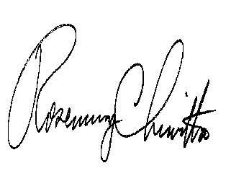
Very truly yours,

Rosemary Chiavetta
Secretary

Attachments

NW

