PENNSYLVANIA
PUBLIC UTILITY COMMISSION
Harrisburg, PA 17120

Public Meeting held May 20, 2021

Commissioners Present:

Gladys Brown Dutrieuille, Chairman
David W. Sweet, Vice Chairman
John F. Coleman, Jr.
Ralph V. Yanora

Pennsylvania Public Utility Commission,  Bureau of Investigation and Enforcement  v.  National Gas & Electric, LLC |  | M-2020-2637688

Opinion and Order

BY THE COMMISSION:

Before the Pennsylvania Public Utility Commission (Commission) for consideration and disposition is a proposed Joint Petition for Approval of Settlement (Settlement, Settlement Agreement, or Petition) filed on November 19, 2020, by the Commission’s Bureau of Investigation and Enforcement (I&E) and National Gas & Electric, LLC (NG&E or Company) (collectively, the Parties), with respect to an informal investigation conducted by I&E. Both Parties submitted Statements in Support of the Settlement. The Parties submit that the proposed Settlement is in the public interest and is consistent with the Commission’s Policy Statement at 52 Pa. Code § 69.1201, Factors and standards for evaluating litigated and settled proceedings involving violations of the Public Utility Code and Commission regulations—statement of policy. Settlement at 4. We will issue the Settlement for comment.

History of the Proceeding

This matter stems from I&E’s concerns regarding a promotional postcard that NG&E mailed to prospective customers in November 2017. The postcard in question, promoting NG&E’s fixed price electricity supply offer, allegedly may have disclosed confidential information of a PPL Electric Utilities, Inc. (PPL) customer, misrepresented savings with NG&E, and provided inaccurate and untimely information about PPL’s rate; therefore, violating the Public Utility Code (Code) and the Commission’s Regulations. Petition at 4, 7.

Upon determining that the allegations warranted a further investigation to examine whether the actions of NG&E violated Commission Regulations, I&E instituted an informal investigation of NG&E based on information referred to I&E by the Commission’s Office of Competitive Market Oversight (OCMO). Petition at 4.

Thereafter, the Parties entered into negotiations and agreed to resolve the matter in accordance with the Commission’s policy to promote settlements at 52 Pa. Code § 5.231. Petition at 4. The Parties filed the instant Settlement on November 19, 2020. Id.

Background

On December 1, 2017, via mail, Daniel Mumford, Director of OCMO, received NG&E’s marketing material, a postcard, that was headlined “NOTICE OF PPL ELECTRIC RATE INCREASE.” Petition, Exhibit 1 (emphasis in original). The postcard stated that “PPL’s residential default electric rate increased 14% effective June 1st 2017” and that customers could “Save 25% compared to PPL’s higher June-November 2017 rate.” Id. (emphasis in original). The postcard also referenced a PPL customer’s name and the last four digits of the customer’s PPL account number. Id.

On December 5, 2017, OCMO contacted NG&E regarding the postcards in question and advised NG&E to cease sending the postcards and to review all enrollments resulting from the inaccurate and outdated information on the postcards to ensure that its customers clearly understood the pricing of the NG&E offer and its comparative relationship to the June-November 2017 PPL default rate as well as to the new December 2017 default rate.

In response, NG&E informed OCMO that NG&E had already ceased mailing the postcards in question and that it had instructed its agents to point out to customers the date range on the postcard, June-November 2017, and to inform customers of PPL’s new December 2017 default rate of 7.463 cents per kWh and the accurate percentage of savings to NG&E’s lowest offer, which became 17% savings instead of the 25% savings based upon the quoted June-November 2017 PPL default rate. Petition at 5.

Subsequently, OCMO initiated a referral to I&E regarding NG&E’s marketing material in question.

I&E’s informal investigation concluded that sufficient data had been gathered to substantiate alleged violations of the Commission’s Regulations in connection with the marketing material. Upon investigation, I&E determined that NG&E mailed a total of 155,252 postcards to prospective customers on November 22, 2017 and that approximately 90,634 of NG&E’s prospective customers received a postcard that improperly contained the confidential and personal information of a PPL customer, including the customer’s name and the last four digits of the customer’s PPL account number. I&E also determined that because PPL’s default rate for December 2017 through May 2018 had decreased to 7.463 cents per kWh on December 1, 2017, the postcard misrepresented savings with NG&E and contained inaccurate and outdated information about PPL’s default rate by the time the prospective customers received the postcards. Approximately 2,500 of the prospective customers may have received the postcard in question after PPL’s December 1, 2017 rate decrease. In response to the postcards, seventy customers enrolled with NG&E. Petition at 6-7.

NG&E advised that the printing of the confidential information on the postcards was due to a mail merge error on the part of the vendor that NG&E used for printing and mailing services. NG&E also alleged that the postcards accurately represented the savings compared to the quoted PPL price to compare from June-November 2017, but mis-stated savings with NG&E compared to the new PPL price to compare effective December 1, 2017, and that the postcards contained outdated information about PPL’s price to compare because the delivery schedule for the postcards was inadvertently delayed by the same vendor. According to the Company, the delay is what caused some prospective customers to receive the postcards after PPL’s December 1, 2017 price to compare decrease. Petition at 6.

Upon review of NG&E’s marketing material and NG&E’s responses to I&E’s data requests, I&E identified four types of potential violations. Specifically, I&E alleged that NG&E: (1) failed to maintain the confidentiality of a consumer’s personal information in violation of 52 Pa. Code § 54.43(d), with regard to 90,634 of the 155,252 postcards that were mailed to prospective customers on November 22, 2017; and with regard to the approximately 2,500 postcards that may have been received after December 1, 2017; (2) misrepresented savings offered by NG&E in violation of 52 Pa. Code § 111.12(d)(2); (3) provided inaccurate and untimely information about PPL’s rates being offered in violation of 52 Pa. Code § 111.12(d)(4); and (4) as a result of the postcards that misrepresented savings with NG&E and provided inaccurate and untimely information about PPL’s rates, customers were enrolled with NG&E in violation of 52 Pa. Code § 111.12(d)(1). Petition at 7-9.

Weighing the seriousness of the disclosure of confidential customer information, misrepresentation of savings with NG&E, inaccurate and untimely information related to PPL’s rates, and the customer enrollments against various mitigating circumstances that are present here, I&E determined that the Settlement was appropriate. I&E noted NG&E’s efforts to remediate the situation by addressing the misrepresented savings percentage and inaccurate and untimely information regarding PPL’s rates with customers who received the postcards, as explained above. Additionally, I&E acknowledged that the Company has been cooperative with I&E’s investigation, as exemplified by the Company’s responsiveness to data requests and by identifying policies and procedures that can be further improved to assist NG&E in enhancing consumer protection and its marketing materials and to satisfy the commitments that I&E has required in the settlement process. I&E Statement in Support at 4-5.

Terms and Conditions of the Settlement

The Parties indicate that the Settlement, which is attached to this Opinion and Order, has been filed by the Parties to resolve all issues related to I&E’s informal investigation and represents a compromise by both I&E and NG&E of their respective competing positions in this proceeding. Additionally, the Parties submit that the Settlement is in the public interest and is consistent with the Commission’s Policy Statement at 52 Pa. Code § 69.1201, Factors and standards for evaluating litigated and settled proceedings involving violations of the Public Utility Code and Commission regulations—statement of policy. The Parties further state that the Settlement constitutes a carefully crafted package representing reasonably negotiated compromises on the issues addressed herein. Petition at ¶¶ 41, 43. The Parties urge the Commission to approve the Settlement as being in the public interest. Petition at 15.

The Settlement consists of the Joint Petition for Approval of Settlement containing the terms and conditions of the Settlement, an exhibit, and three appendices. Exhibit 1 contains the postcard received by the Director of OCMO on December 1, 2017. Appendix A contains Proposed Ordering Paragraphs, while Appendices B and C to the Settlement are the Statements in Support of the Settlement submitted by I&E and NG&E, respectively.

The essential terms of the Settlement are set forth in Paragraph 34. Settlement at 10-12. The Parties agreed to the following terms and conditions, excerpted in relevant part, as follows:

- A. NG&E will pay a civil penalty in the amount of One Hundred and Twenty Thousand Dollars ($120,000.00). Said payment shall be made within thirty (30) days of the entry date of the Commission’s Final Order approving the Settlement Agreement and shall be made by certified check or money order payable to the “Commonwealth of Pennsylvania.” The docket number of this proceeding shall be indicated with the certified check or money order and the payment shall be sent to:

Rosemary Chiavetta, Secretary
Pennsylvania Public Utility Commission
Commonwealth Keystone Building
400 North Street
Harrisburg, PA 17120

The civil penalty shall not be tax deductible pursuant to Section 162(f) of the Internal Revenue Code, 26 U.S.C.S. § 162(f) and shall not be passed through as an additional charge to NG&E’s customers in Pennsylvania.

B. In addition to the civil penalty above, NG&E will contribute the amount of Thirty Thousand Dollars ($30,000.00) into PPL’s hardship fund. Said contribution shall be made within thirty (30) days of the entry date of the Commission’s Final Order approving the Settlement Agreement. NG&E shall file a verification with the Commission showing its compliance with this settlement term within sixty (60) days of the date of entry of the Final Order in this proceeding.

C. NG&E will take or has taken corrective action and implemented revisions to its operating procedures which will act as safeguards against future distribution of marketing materials that disclose confidential customer information, misrepresent savings, and provide inaccurate and untimely information about rates being offered. The pertinent portions of NG&E’s modified procedures are briefly described as follows:

- NG&E shall continue its quality and control measures that require NG&E to review and authorize a proof of all marketing materials that are to be printed by a third-party vendor before the mailing occurs;

- NG&E shall be required to mail out any time-sensitive marketing materials at least two (2) months before an EDC’s price to compare goes into effect to ensure that prospective customers receive information that is accurate and timely;

- For the next three (3) years, NG&E will provide any future mailing material intended for Pennsylvania customers to I&E for review at least fifteen (15) days prior to printing;

- NG&E will continue to utilize tracking methods to determine how many customers enrolled in response to each unique mailer, so the scope and impact of any future problems can be quickly identified; and

- NG&E’s customer service and sales scripts related to the utility price to compare shall continue to specifically state the end date of the current utility price to compare.

Settlement at 10-12.

In response, I&E agrees to forgo the institution of any formal complaint against NG&E with respect to allegations which were subject of I&E’s instant investigation. Petition at 12-13.

The proposed Settlement is conditioned on the Commission’s approval without modification of any of its terms or conditions. If the Commission does not approve the proposed Settlement or makes any change or modification to the proposed Settlement, either Party may elect to withdraw from the Settlement. Id. at 13-14.

Discussion

Pursuant to our Regulations at 52 Pa. Code § 5.231, it is the Commission’s policy to promote settlements. The Commission must, however, review proposed settlements to determine whether the terms are in the public interest. Pa. PUC v. Philadelphia Gas Works, Docket No. M-00031768 (Order entered January 7, 2004).

Conclusion

Before issuing a decision on the merits of the proposed Settlement, and consistent with the requirement of 52 Pa. Code § 3.113(b)(3), we are providing an opportunity for interested parties to file comments regarding the proposed Settlement; THEREFORE,

IT IS ORDERED:

1. That this Opinion and Order, together with the attached Settlement Agreement and Statements in Support, shall be issued for comments by any interested party.
2. That a copy of this Opinion and Order, together with the attached Settlement Agreement and the Statements in Support thereof, shall be served on the Office of Consumer Advocate and the Office of Small Business Advocate.

3. That within twenty (20) days from the date of entry of this Opinion and Order, interested parties may file comments concerning the proposed Settlement Agreement. Comments to the proposed Settlement Agreement shall be filed through efiling. Please know that at this time ALL parties wanting to file with the Commission and participate in proceedings before the Commission, must open an efiling account free of charge through our website and accept eservice. This is in accordance with the Commission’s Emergency Order at Docket No. M-2020-3019262. An efiling account may be opened at our website, https://www.puc.pa.gov/efiling/default.aspx.

4. That, subsequent to the Commission’s review of any comments filed in this proceeding, an Opinion and Order will be issued.

BY THE COMMISSION,

Rosemary Chiavetta
Secretary

(SEAL)

ORDER ADOPTED: May 20, 2021

ORDER ENTERED: May 20, 2021

ATTACHMENT

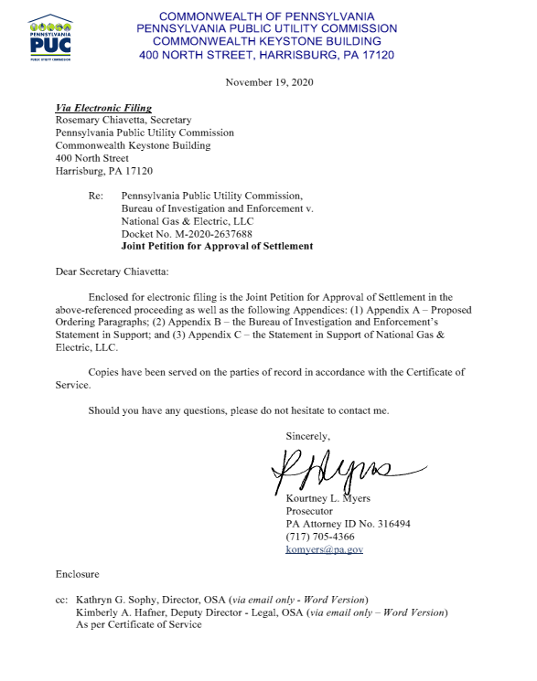
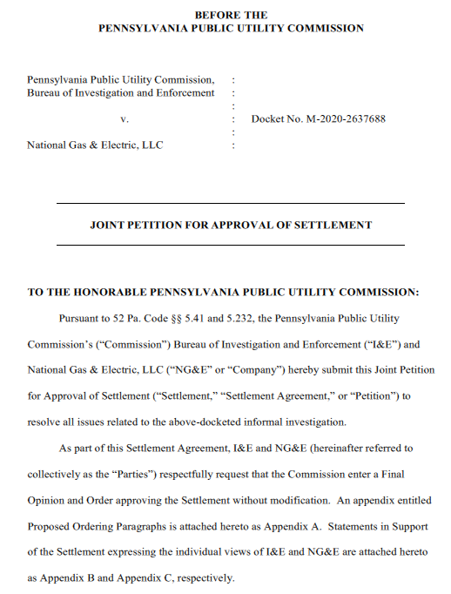

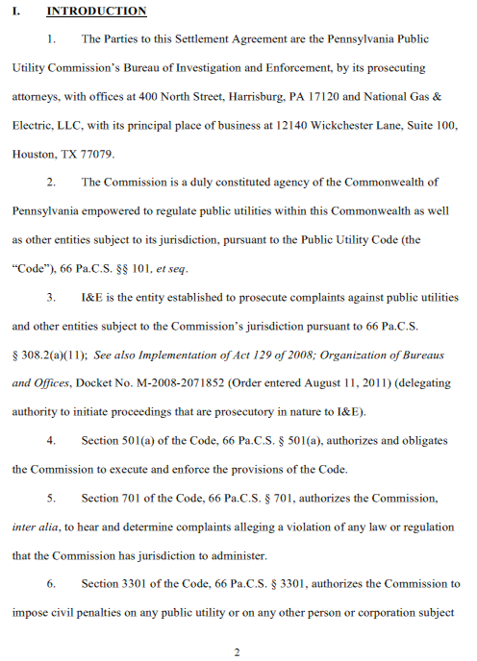
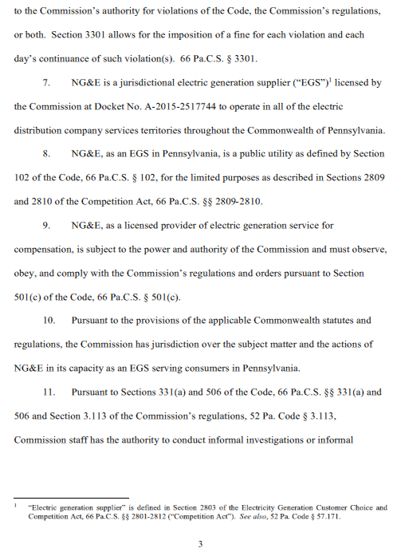
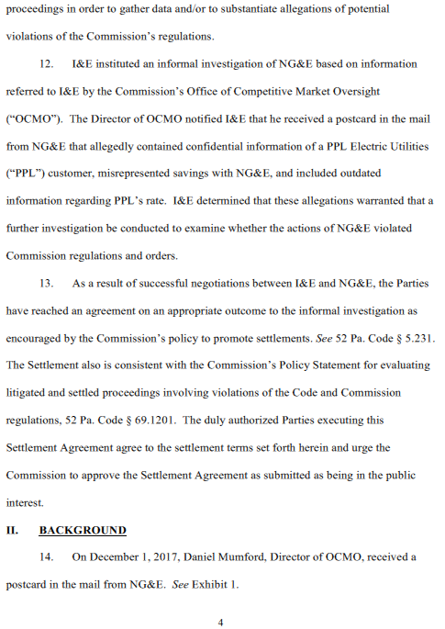
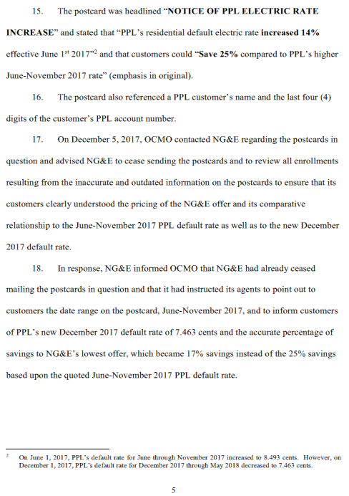
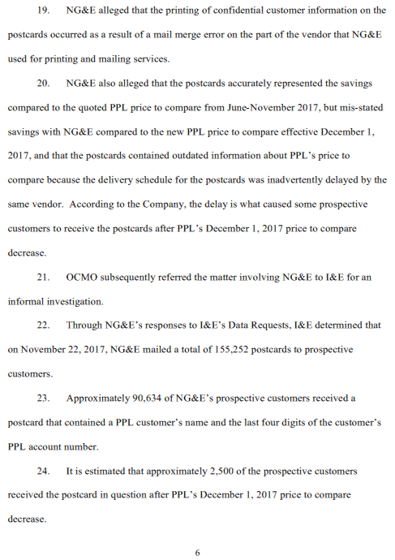
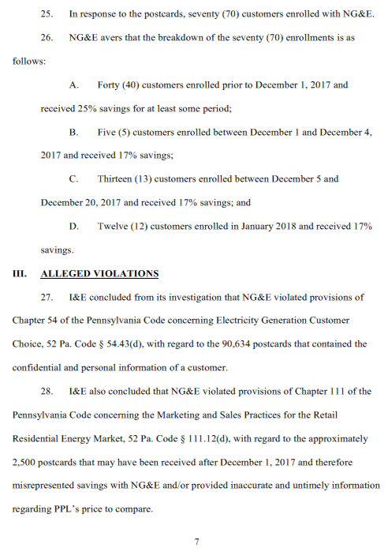
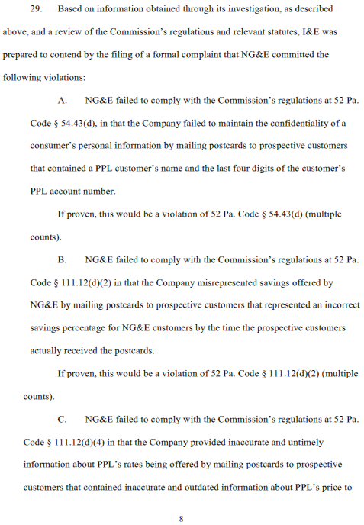
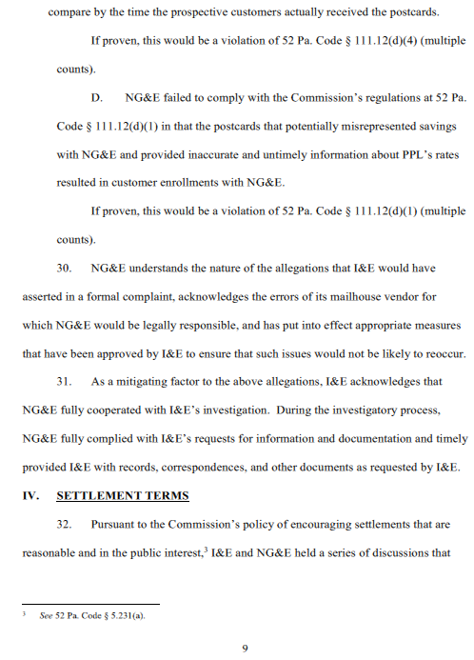
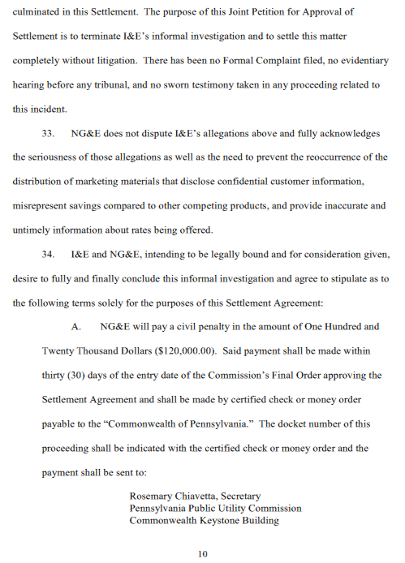
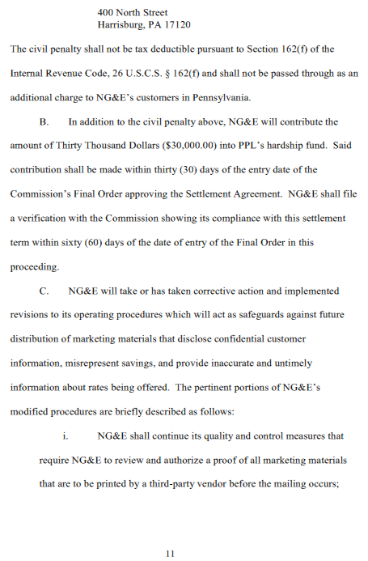
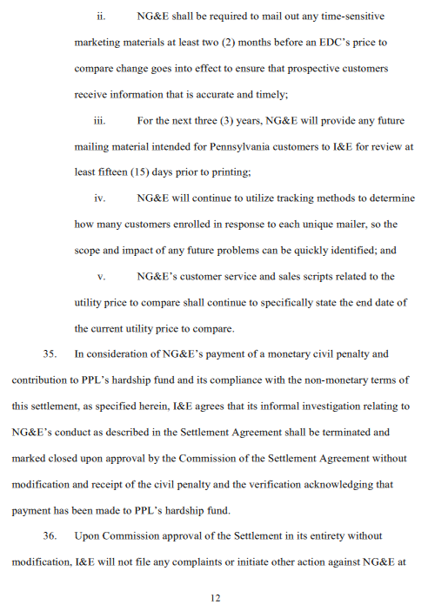
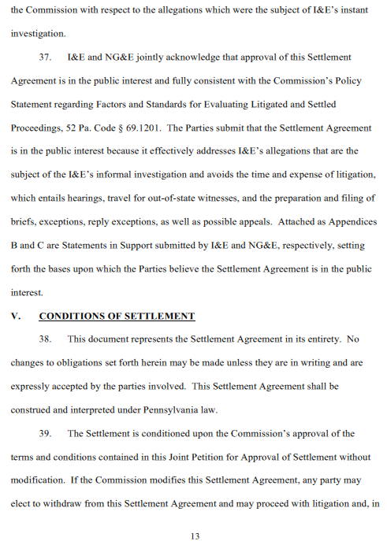
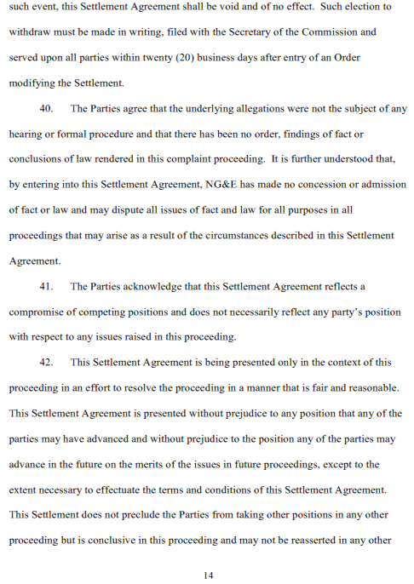
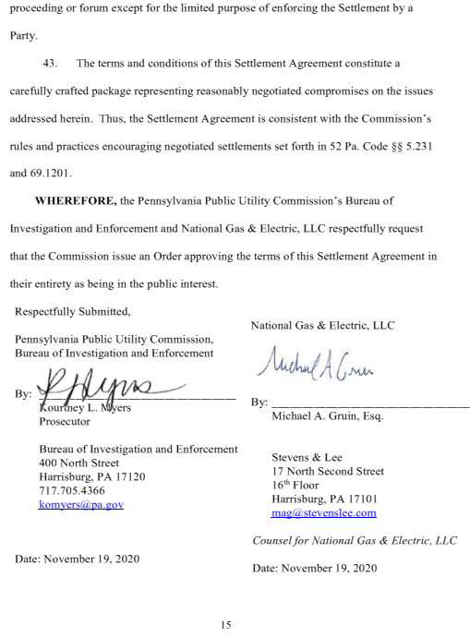

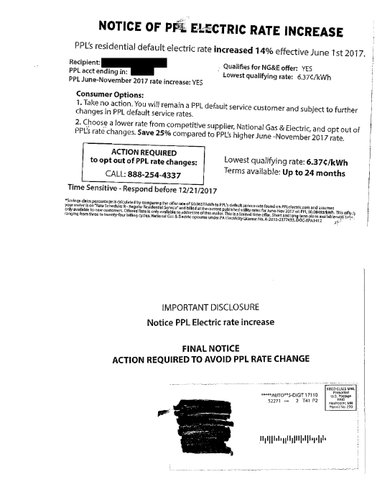

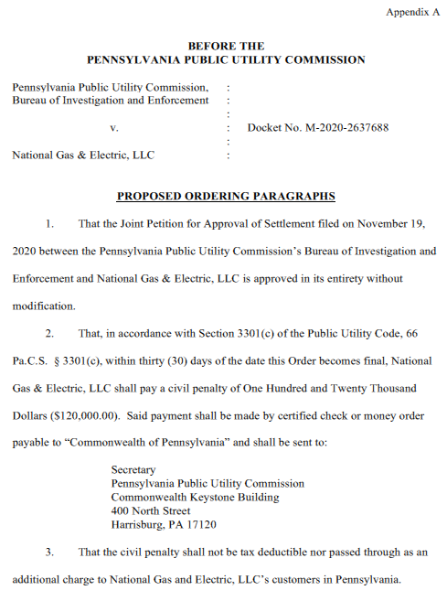

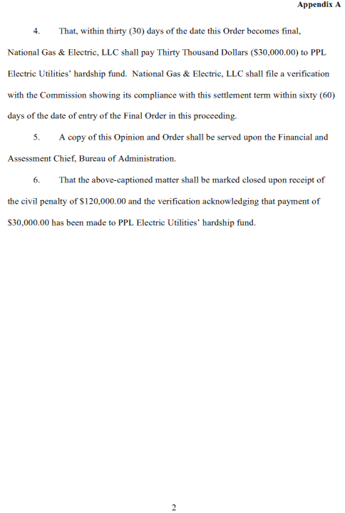
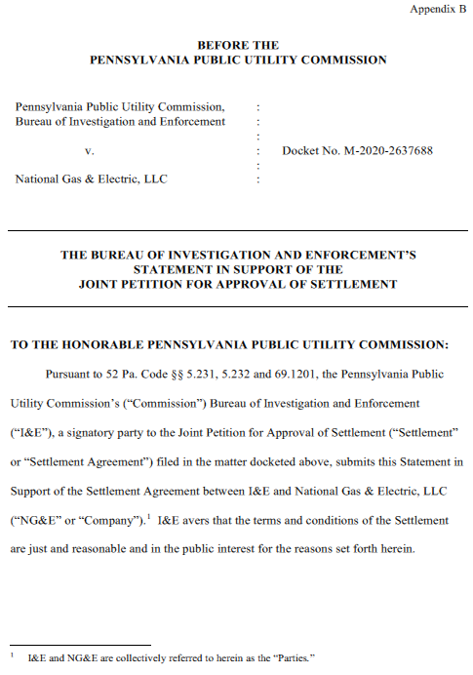
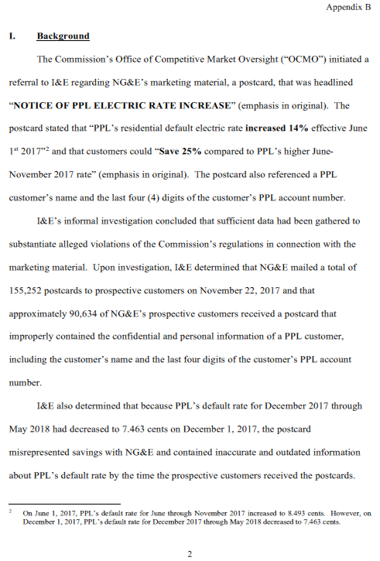
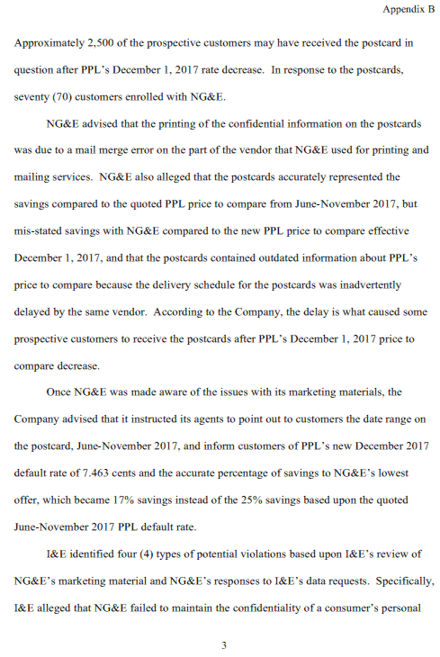
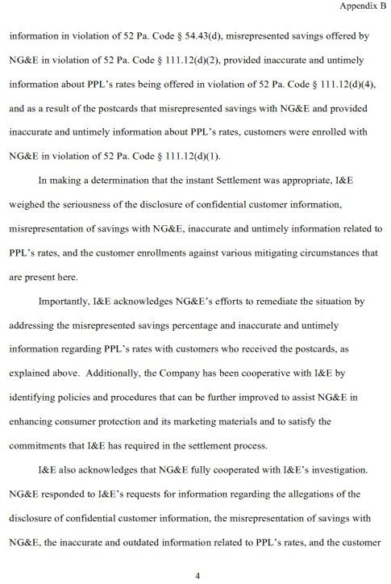
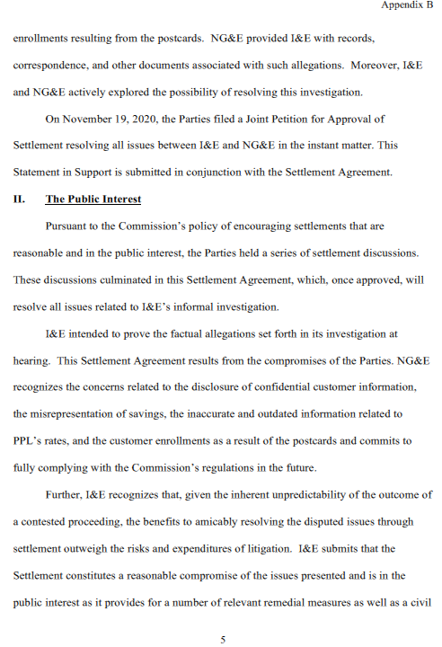
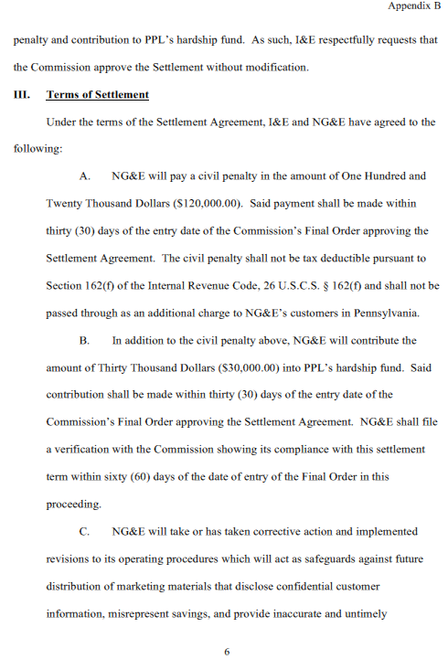
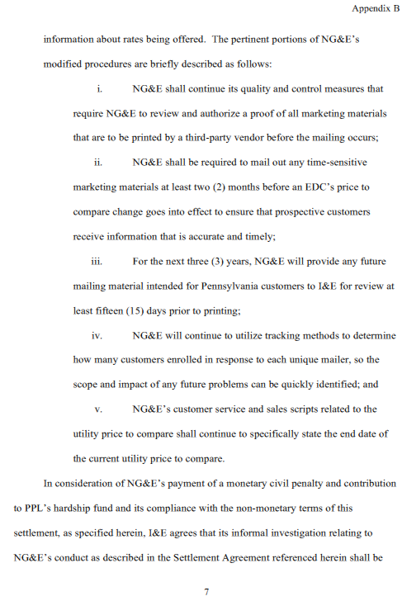
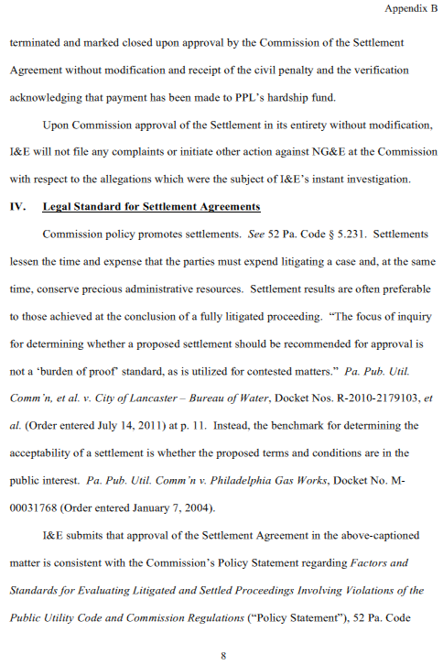
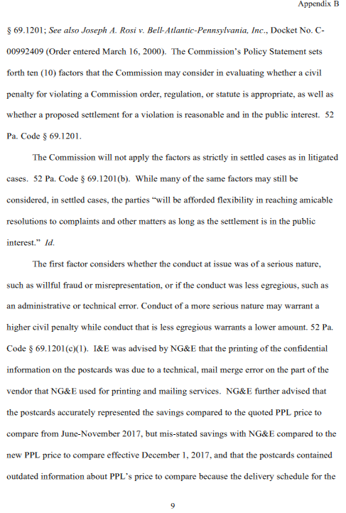
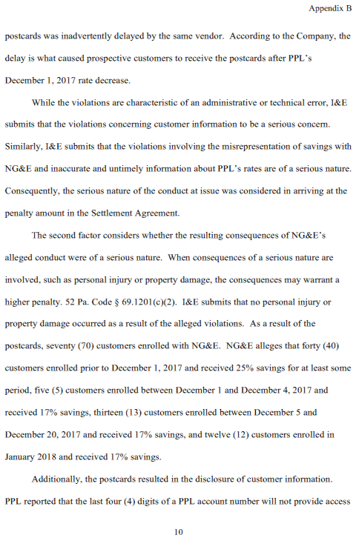
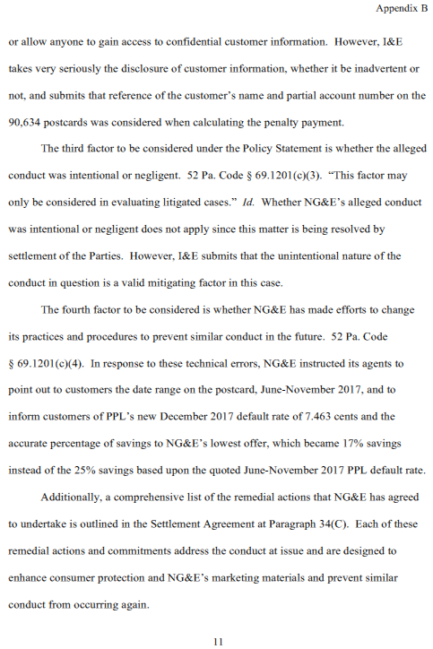
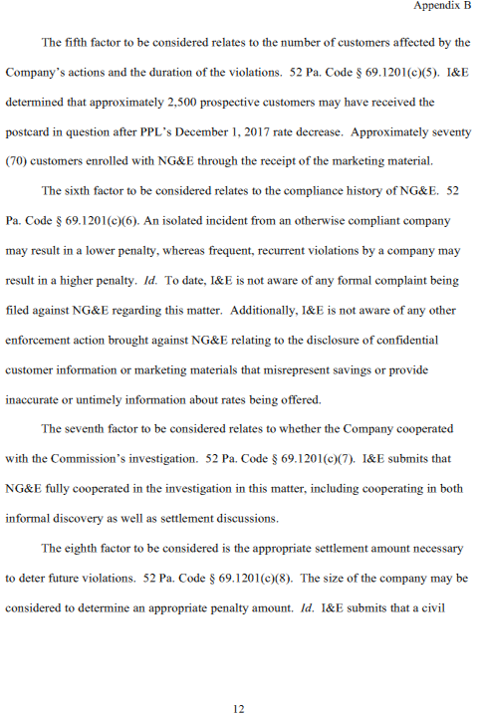
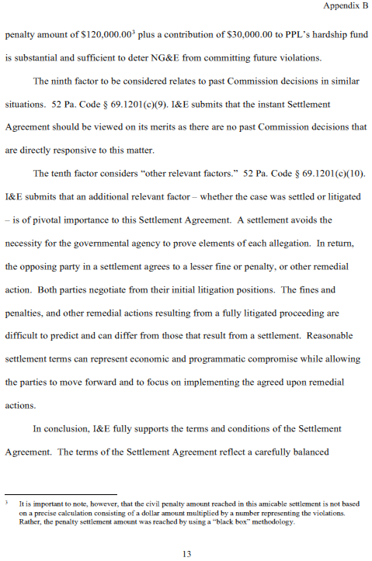
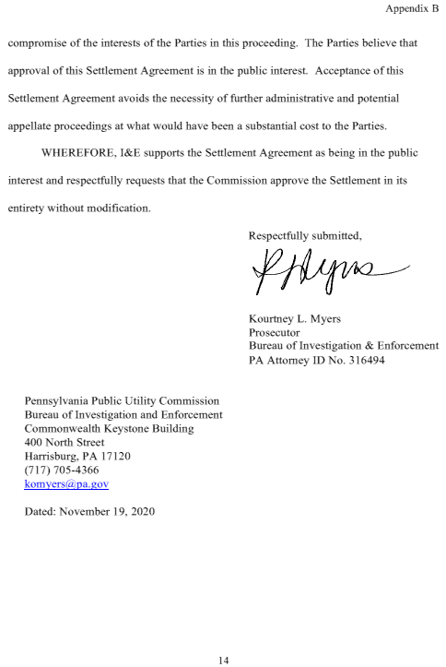
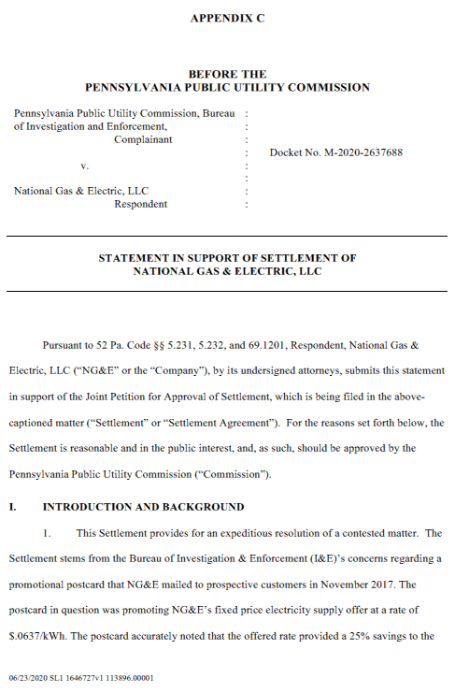
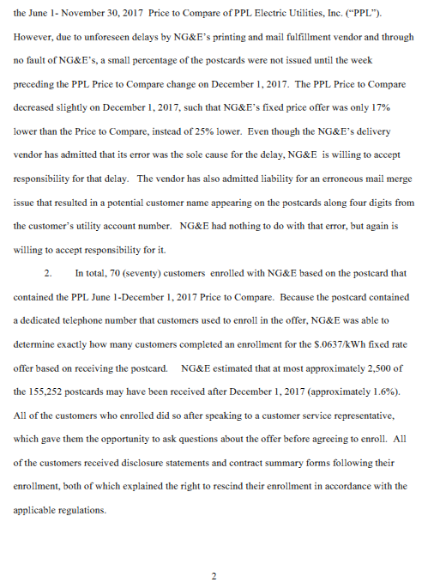

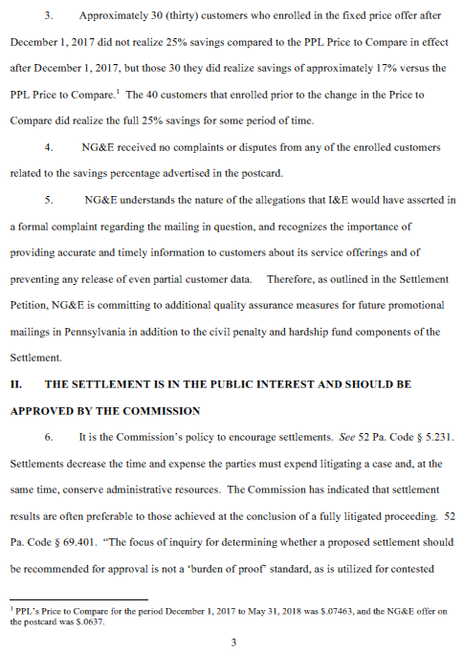
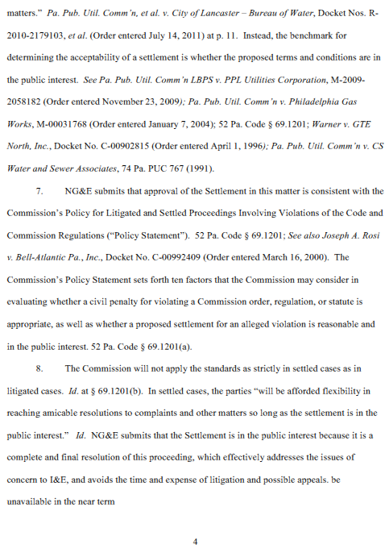
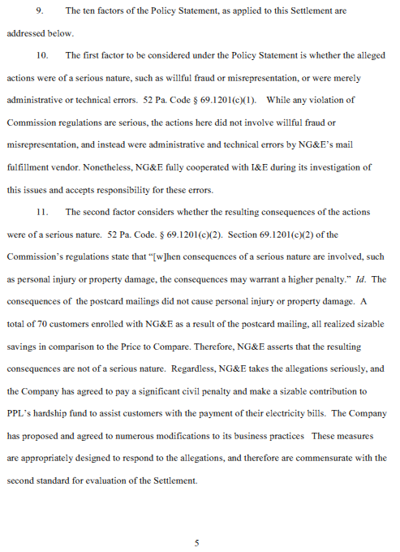

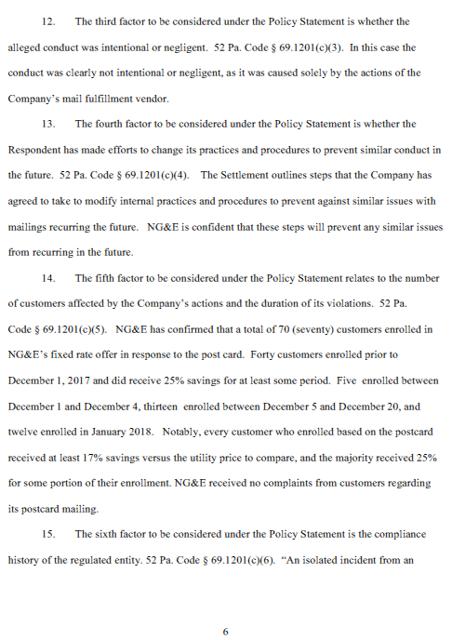
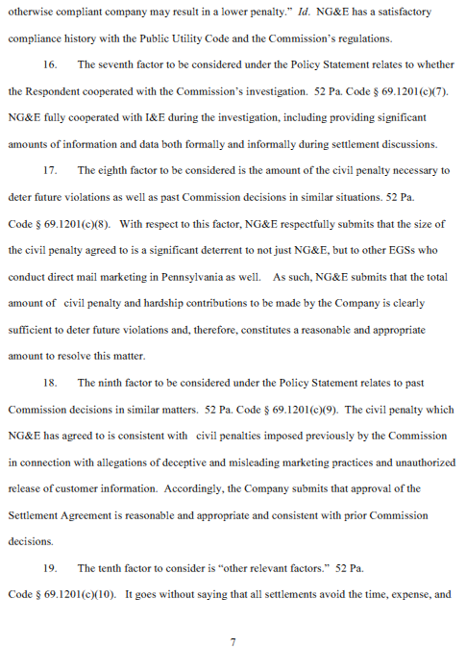
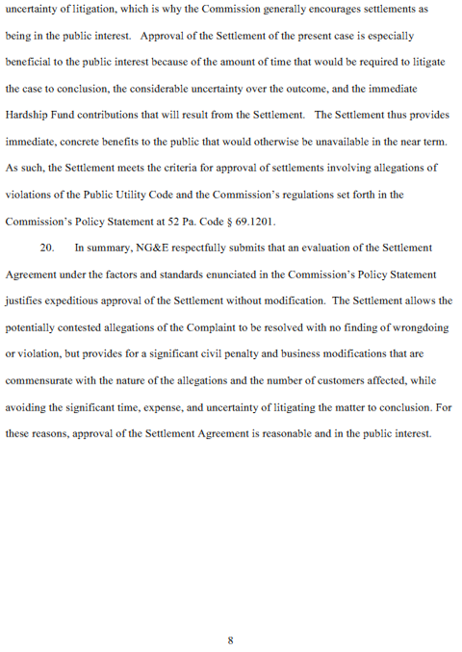
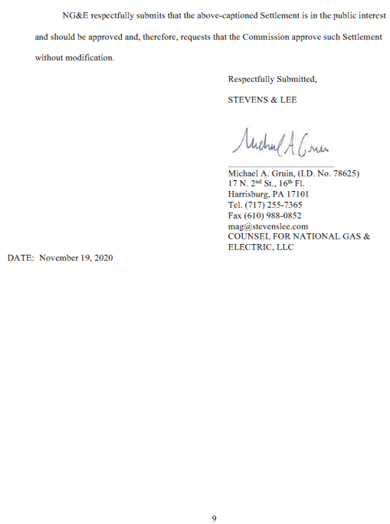

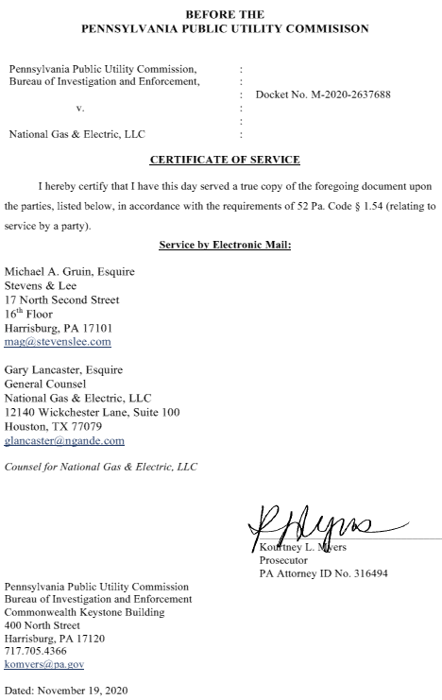

On June 1, 2017, PPL’s default rate for June through November 2017 increased to 8.493 cents per kilowatt-hour (kWh). However, on December 1, 2017, PPL’s default rate for December 2017 through May 2018 decreased to 7.463 cents per kWh. Petition at 5.
“A licensee shall maintain the confidentiality of a consumer's personal information including the name, address and telephone number, and historic payment information, and provide the right of access by the consumer to his own load and billing information.” 52 Pa. Code § 54.43(d).
“A supplier may not make false or misleading representations including misrepresenting rates or savings offered by the supplier.” 52 Pa. Code § 111.12(d)(2).
“A supplier shall provide accurate and timely information about services and products being offered. Information includes rates being offered, contract terms, early termination fees and right of cancellation and rescission.” 52 Pa. Code § 111.12(d)(4).
“A supplier may not engage in misleading or deceptive conduct as defined by State or Federal law, or by Commission rule, regulation or order.” 52 Pa. Code § 111.12(d)(1).

