PENNSYLVANIA
PUBLIC UTILITY COMMISSION
Harrisburg, PA 17105-3265

StoneyBank Development LLC :
:
v. : C-2020-3022179
:
The Walnut Hill Utility Company :

FINAL ORDER

In accordance with the provisions of Section 332(h) of the Public Utility Code, 66 Pa. C.S. §332(h), the decision of Deputy Chief Administrative Law Judge Joel H. Cheskis dated April 21, 2021, has become final without further Commission action:

THEREFORE,

IT IS ORDERED:

- That the petition of StoneyBank Development LLC for leave to withdraw its complaint filed on April 1, 2021 at docket number C-2020-3022179 is hereby granted.

- That the formal complaint filed by StoneyBank Development LLC against The Walnut Hill Utility Company at docket number C-2020-3022179, and dated September 24, 2020, is withdrawn.

- That a copy of this Initial Decision shall be served on the Commission’s Bureau of Investigation and Enforcement.

- That this matter be marked closed.

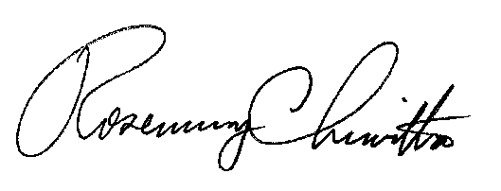
BY THE COMMISSION,

Rosemary Chiavetta
Secretary

(SEAL)

ORDER ENTERED: May 25, 2021

