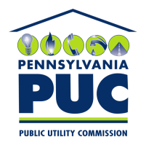 | COMMONWEALTH OF PENNSYLVANIA  PENNSYLVANIA PUBLIC UTILITY COMMISSION  400 NORTH STREET, HARRISBURG, PA 17120 | IN REPLY PLEASE REFER TO OUR FILE
May 25, 2021

NIMESH PATEL, PRESIDENT
VALLEY CHOICE ENERGY CORP
1534 HIGHWAY 315, SUITE 101
WILKES-BARRE, PA 18702

Dear Sir:

On May 13, 2021, the Commission received your Application of Valley Choice Energy Corp for approval to supply electric generation services to the public in the Commonwealth of PA. Upon initial review, the Application has been determined to be missing information for the following reason:

- The Application is outdated. Your Application must be based on the latest version of the template, accessible in the application packet on our website.

Pursuant to 52 Pa. Code §1.4, you are being advised of this missing information and are required to file corrections. Failure to correct the foregoing missing information within 20 days of the date of this letter will result in the Application being returned unfiled.
Please return your item to the above listed address and address to the attention of the Office of the Secretary.
If you have any question in regards to this letter, please contact our bureau at (717) 772-7777. Thank you
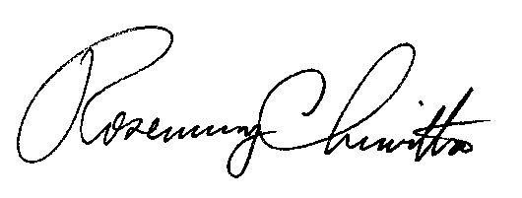
Sincerely,

Rosemary Chiavetta
Secretary

RC:AEL

