 | COMMONWEALTH OF PENNSYLVANIA  PENNSYLVANIA PUBLIC UTILITY COMMISSION  400 NORTH STREET, HARRISBURG, PA 17120 | IN REPLY PLEASE REFER TO OUR FILE
Date Served: May 13, 2021

MOVING U & JUNK U LLC
207 CARTER DR STE E
WEST CHESTER PA 19382

RE: Fine Payment

Dear Sir/Madam:

We are in receipt of Company check # 1080 in the amount of $100.00 as a fine payment for C-2020-3015105. We attempted to contact you by e-mail, but have not heard back. Please know that the Commission does not accept personal or checks drawn from Corporate accounts. All fine payments must be made by certified check or money order. Enclosed, please find your company check # 1080. Please remit the $100.00 fine payment in the form of a certified check or money order as soon as possible to satisfy the fine. Thank you.

Sincerely,

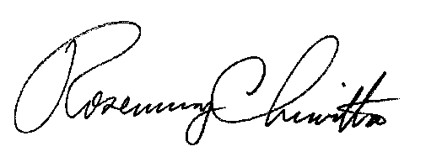
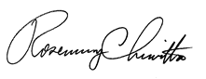

Rosemary Chiavetta
Secretary of the Commission

Enclosure

RC:ane

