 | COMMONWEALTH OF PENNSYLVANIA  PENNSYLVANIA PUBLIC UTILITY COMMISSION  400 NORTH STREET, HARRISBURG, PA 17120 | IN REPLY PLEASE REFER TO OUR FILE
June 01, 2021

A-2021-3026132
Alexander R. Stahl, Regulatory Counsel
Aqua Pennsylvania Wastewater, Inc.
762 W. Lancaster Avenue
Bryn Mawr, PA 19010

Dear Attorney Stahl,

The Commission acknowledges receipt of Aqua Pennsylvania Wastewater, Inc.’s Letter/Notice of Licensed Engineer and Utility Valuation Expert Engagement Concerning Acquisition of East Whiteland Township, Chester County Sanitary Wastewater Collection System, which was received by the Commission on May 28, 2021.

The Commission has assigned Docket No. A-2021-3026132 to the filing for document management purposes only. Future filings made with the Commission regarding Aqua Pennsylvania Wastewater, Inc.’s Acquisition of East Whiteland Township, Chester County Sanitary Wastewater Collection System should reference the above referenced “A” docket number.

This matter will receive the attention of the Commission and you will be advised of any further necessary procedure.
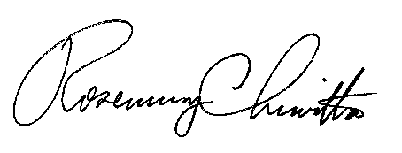
Sincerely,

Rosemary Chiavetta
Secretary

cc: Via Email only:
Tanya J. McCloskey, Office of Consumer Advocate
Erin Fure, Office of Small Business Advocate
Richard A. Kanaskie, Bureau of Investigation and Enforcement
Paul Diskin, Bureau of Technical Utility Services

