 | COMMONWEALTH OF PENNSYLVANIA  PENNSYLVANIA PUBLIC UTILITY COMMISSION  400 NORTH STREET, KEYSTONE BUILDING SECOND FLOOR  HARRISBURG, PA 17120 | IN REPLY PLEASE REFER TO OUR FILE

June 8, 2021

A-8911832

David Temple, Esq. (representing)
Barry Mills Moving and Hauling LLC
935 West Lancaster Avenue
Bryn Mawr, Pennsylvania 19010

Dear Attorney Temple:

We have received your Petition for Reinstatement efiled with my office on May 17, 2021 on behalf of your client, Barry Mills Moving and Hauling LLC (Barry Mills).

On November 18, 2019, Barry Mills was served with the attached letter citing the company’s failure to respond to a complaint at Docket Number C-2019-3012040 whereby Barry Mills did not submit its proof of insurance as required by its Certificate of Public Convenience to operate in Pennsylvania. As a result of that failure to comply, Barry Mills’ license to operate was cancelled.

Additionally, Barry Mills never submitted its proof of insurance to the Commission in compliance with the November 18, 2019 Secretarial Letter. Barry Mills had ample time to answer the complaint and was given an opportunity to object to the cancellation two years ago. No action was ever taken by Barry Mills.

The Pennsylvania Public Utility Commission requires the Secretary of the Commission to reject a Petition for Reinstatement where the regulated utility has an outstanding assessment or an unpaid fine. According to a review of the Commission’s records, and the Cancellation Letter dated November 18, 2019, Barry Mills still owes a fine of $600. The fine must be paid by certified check made payable to the Commonwealth of Pennsylvania and submitted by overnight delivery to the address in this letterhead.

Therefore, the Petition is rejected. Once the fine has been satisfied, you may then refile the Petition for Reinstatement. Please note that pursuant to 52 Pa. Code §5.44, this Secretarial Letter may be appealed within 10 days of above date of service.

Sincerely,
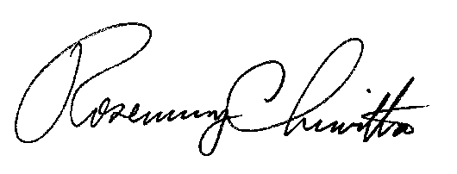
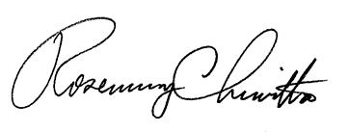
Rosemary Chiavetta
Secretary

Attachment: Cancellation Letter dated November 18, 2019

