 | COMMONWEALTH OF PENNSYLVANIA  PENNSYLVANIA PUBLIC UTILITY COMMISSION  P.O. BOX 3265, HARRISBURG, PA 17105-3265 | IN REPLY PLEASE REFER TO OUR FILE

C-2021-3025505

Date of Service: June 11, 2021

LA MEXICANA EXPRESS SERVICE LLC
1044 UNION STREET
READING PA 19604

PENNSYLVANIA PUBLIC UTILITY COMMISSION
BUREAU OF INVESTIGATON & ENFORCEMENT
v.
LA MEXICANA EXPRESS SERVICE LLC

Dear Sir/Madam:

Please be advised that the attached complaint has been filed against you by the Bureau of Investigation & Enforcement.

Detailed instructions on how to proceed are contained in the NOTICE section, and you are advised to read everything carefully or consult with your attorney.

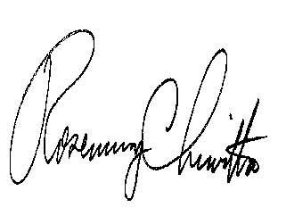
Very truly yours,

Rosemary Chiavetta
Secretary

Attachments

NW

