BEFORE THE
PENNSYLVANIA PUBLIC UTILITY COMMISSION

PENNSYLVANIA PUBLIC UTILITY COMMISSION :
BUREAU OF INVESTIGATION AND ENFORCEMENT :
:
V. : DOCKET NO. C-2021-3025926
:
NAVARRO TRUCKING LLC :
780 JAMES P CASEY ROAD :
BRISTOL CT 06010 :

COMPLAINT

The Pennsylvania Public Utility Commission (Commission) is a duly constituted agency of the Commonwealth of Pennsylvania empowered to regulate public utilities within the Commonwealth. The Commission has delegated its authority to initiate proceedings which are prosecutory in nature to the Bureau of Investigation and Enforcement and other bureaus with enforcement responsibilities. Pursuant to that delegated authority and Section 701 of the Public Utility Code, the Bureau of Investigation and Enforcement hereby represents as follows:

- That Navarro Trucking, LLC, Respondent maintains a principal place of business at 780 James P. Casey road, Bristol, Connecticut, 06010.

- That Respondent applied to the Commission for authority to transport property between points in Pennsylvania on March 16, 2020. A letter was sent to Respondent September 2, 2020, requesting that Respondent direct their insurer to file proof of insurance. Correspondence sent out November 28, 2020 dismissed Respondent’s application for failure to file proof of insurance. Respondent currently does not hold operating authority with the PUC.

- That on May 17, 2021, PUC Enforcement Officer Jeremy Smith performed a roadside inspection in Somerset Borough, Somerset County on a 2015 Freightliner truck with Connecticut license No. 57507A and Vehicle Identification No. 1FVXGF004FLGJ7476. Officer Smith determined Respondent was transporting property for compensation between points in Pennsylvania while not holding authority with the Commission.

- That Respondent, by holding out to transport property between points in Pennsylvania while not having operating authority with this Commission, violated the Public Utility Code, 66 Pa. C.S. §1101. The penalty for this violation is $1,000.

WHEREFORE, the Bureau of Investigation and Enforcement hereby requests the Commission fine Navarro Trucking, LLC the sum of one thousand dollars ($1,000.00) for the illegal activity described in this Complaint.

Respectfully submitted,

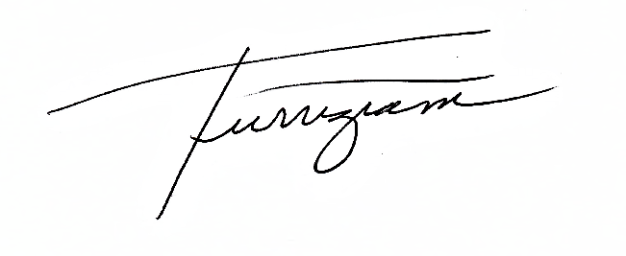
Andrew Turriziani, Chief
Motor Carrier Enforcement
Bureau of Investigation and Enforcement
P.O. Box 3265
Harrisburg, PA 17105-3265
VERIFICATION

I, Andrew Turriziani, hereby state that the facts above set forth are true and correct to the best of my knowledge, information and belief and that I expect that the Bureau will be able to prove same at any hearing held in this matter. I understand that the statements herein are made subject to the penalties of 18 Pa. C.S. §4904 relating to unsworn falsification to authorities.

6/11/2021
Date: _______________ ____________________________

Andrew Turriziani, Chief
Motor Carrier Enforcement
Bureau of Investigation and Enforcement

NOTICE

- You must file an Answer within twenty (20) days of the date of service of this Complaint. The date of service is the mailing date as indicated at the top of the Secretarial Cover Letter for this Complaint and Notice, 52 Pa. Code §1.56(a). An Answer is a written explanation of circumstances wished to be considered in determining the outcome. The Answer shall raise all factual and legal arguments that you wish to claim in your defense and must include the reference number of this Complaint. Your Answer must be verified and the original shall be mailed to:

Rosemary Chiavetta, Secretary
Pennsylvania Public Utility Commission
400 North Street, 2nd Floor
Harrisburg, Pennsylvania 17120

Or, you may eFile your Answer using the Commission’s website at www.puc.pa.gov. The link to eFiling is located under the Filing & Resources tab on the homepage. If your Answer is 250 pages or less, you are not required to file a paper copy. If your Answer exceeds 250 pages, you must file a paper copy with the Secretary’s Bureau.

Additionally, a copy should either be mailed to:

Michael L. Swindler, Deputy Chief Prosecutor
Bureau of Investigation and Enforcement
Pennsylvania Public Utility Commission
400 North Street, 3rd Floor
Harrisburg, Pennsylvania 17120

Or, e-mailed to Mr. Swindler at: RA-PCCmplntResp@pa.gov

- If you fail to answer this complaint within twenty (20) days, the Bureau of Investigation and Enforcement will request that the Commission issue a Secretarial Letter imposing a penalty. The penalty could include a fine, the suspension or revocation of your certificate of public convenience or other remedy.

- You may elect not to contest this complaint by paying the fine proposed in this Complaint by certified check or money order. Payment must be made to the Commonwealth of Pennsylvania and should be forwarded to:

Rosemary Chiavetta, Secretary
Pennsylvania Public Utility Commission
400 North Street, 2nd Floor
Harrisburg, Pennsylvania 17120

- Your payment is an admission that you committed the alleged violation and an agreement to cease and desist from further violations. Upon receipt of your payment, the complaint proceeding shall be closed.

- If you file an Answer, which admits or fails to deny the allegations of the Complaint, the Bureau of Investigation and Enforcement will request that the Commission issue a Secretarial Letter imposing a penalty.

- If you file an Answer which contests the Complaint, the matter will be assigned to an Administrative Law Judge for hearing and decision. The judge is not bound by the optional fine set forth above.

- Alternative formats of this material are available for persons with disabilities by contacting the Commission’s ADA Coordinator at 717-787-8714.

