Via electronic service only due to Emergency Order at Docket No. M-2020-3019262

BEFORE THE
PENNSYLVANIA PUBLIC UTILITY COMMISSION

Jacqueline N’Jai :
:
v. : C-2020-3016134
:
Peoples Natural Gas Company LLC :

INTERIM ORDER
ATTACHING EXHIBITS TO RECORD AND CLOSING RECORD

An evidentiary hearing in the above-captioned matter convened on October 5, 2020. Complainant appeared pro se and the Company was represented by counsel. Complainant testified on her on behalf and Complainant’s Exhibit 1 through Exhibit 11 were admitted into the record. Denice Claudon, Customer Communication Relations Specialist, testified on behalf of the Company, and the Company’s Exhibits A through I were admitted into the record. The exhibits entered into the record are attached to this Order.

On October 27, 2020, an Interim Order Establishing Briefing Schedule was entered. Main briefs were due within 30 days of the date of the Order and reply briefs were due within fourteen days of the date of service of the opposing party’s main brief.

On November 11, 2020, Complainant filed a Main Brief, and on December 1, 2020, the Company filed its Main Brief. On December 7, 2020, Complainant filed her Reply Brief.

THEREFORE,

IT IS ORDERED:

1. Complainant’s Exhibit 1 through Exhibit 11 and Company’s Exhibits A through I are hereby attached to the hearing record at Docket No. C-2020-3016134.

2. The evidentiary record in Docket No. C-2020-3016134 is closed.

3. An Initial Decision in Docket No. C-2020-3016134 shall be issued forthwith.

Date: June 15, 2021 /s/
Emily I. DeVoe
Administrative Law Judge
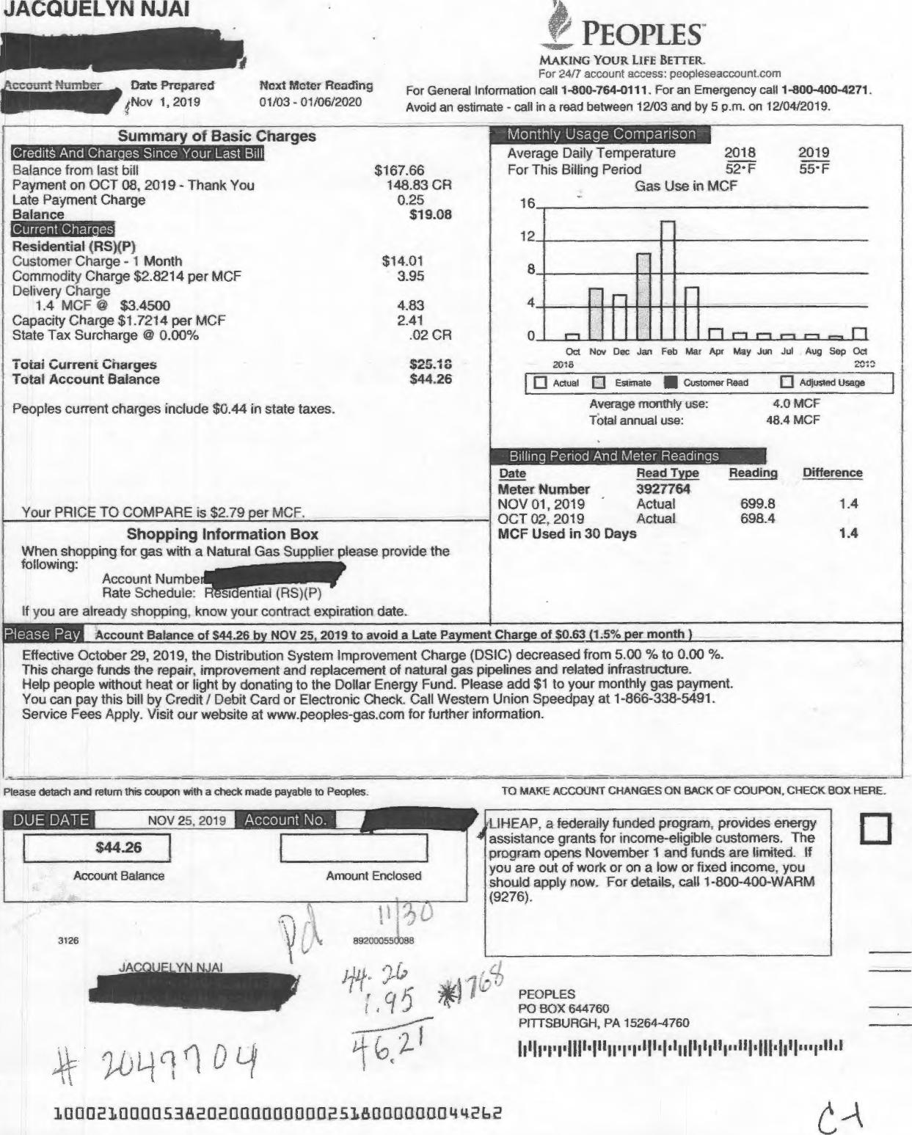
JACQUELYN NJA1
111.11111111.1
mount Number Date Prepared Next Mcter Reading
/Nov 1, 2019 01/03 - 01/06/2020
r PEOPLES
MAKING YOUR LIFE BETTER.
For 2417 account access: peopleseaccount.com
For General Information call 1-800-764-0111. For an Emergency call 1-800-400-4271. Avoid an estimate - call in a read between 12/03 and by 5 p.m. on 12/04/2019.
Amount Enclosed
$4426
Account Balance
3126
89200055308E
JA Y Al
PEOPLES
PO BOX 644760
PITTSBURGH, PA 15264-4760
10002100005382020111111110000E516011301313044262
TO MAKE ACCOUNT CHANGES ON BACK OF COUPON, CHECK BOX HERE.
4_IHEAP, a federally funded program. provides energy assistance grants for income-eligible customers. The program opens November 1 and funds are limited. If you are out of work or on a low or fixed income, you should apply now. For details, call 1-800-400-WARM (9276).
Please detach and return this coupon with a check made payable to Peoples
Monthly Usage Comparison
Summary of Basic Charges
Peoples current charges include $0.44 in state taxes.
$14.01
3.95
4.83
2.41
.02 CR
$20.10
$44.26
Residential (RS)(P)
Customer Charge - 1 Month
Commodity Charge $2.8214 per MCF
Delivery Charge
1.4 MCF @ $3.4500
Capacity Charge $1.7214 per MCF
State Tax Surcharge @ 0.00%
Total Current Charges Total Account Balance
0 Actual 0 Estimate IN Customer Read
0 Adjusted Usage
Average monthly use: Total annual use:
4.0 MCF
48.4 MCF
Difference
1.4
1.4
699.8
698.4
Reading
ease Pa
Account Balance of 544.26 by NOV 25, 2019 to avoid a Late Payment Charge of 50.63 (1.5% per month )
CreditS And Char•es Since Your Last Bill
Balance from last bill $167.66
Payment on OCT 08, 2019 - Thank You 148.83 CH
Late Payment Charge 0.25
Balance $19.08
Average Daily Temperature For This Billing Period  Gas Use  16 |  |  |  |  |  | 2018 2019
 |  |  |  |  |  | 52-F 55•F in MCF
12
8
4
0 | 1⁻1 |  |  |  |  | r⁻t r⁻t
Oct Nov Dec Jan Feb Mar Apr May Jun Jul Aug Sep Oct

2018
Billing Period And Meter Readings
Your PRICE TO COMPARE is $2.79 per MCF.
Shopping Information Box
When shopping for gas with a Natural Gas Supplier please provide the
following:
If you are already shopping. know your contract expiration date.
Effective October 29, 2019, the Distribution System Improvement Charge (DSIC) decreased from 5.00 'Y. to 0.00 %. This charge funds the repair. improvement and replacement of natural gas pipelines and related infrastructure. Help people wrthout heat or light by donating to the Dollar Energy Fund. Please add $1 to your monthly gas payment. You can pay this bill by Credit / Debit Card or Electronic Check. Call Western Union Speedpay at 1-866-338-5491. Service Fees Apply. Visit our website at www.peoples-gas.com for further information.
Date Read Type
Meter Number 3927764
NOV 01, 2019 Actual
OCT 02, 2019 Actual MCF Used in 30 Days
Account Numbe Rate Schedule:
entiai (RS)(P)
DUE DATE
NOV 25. 2019
Account No.

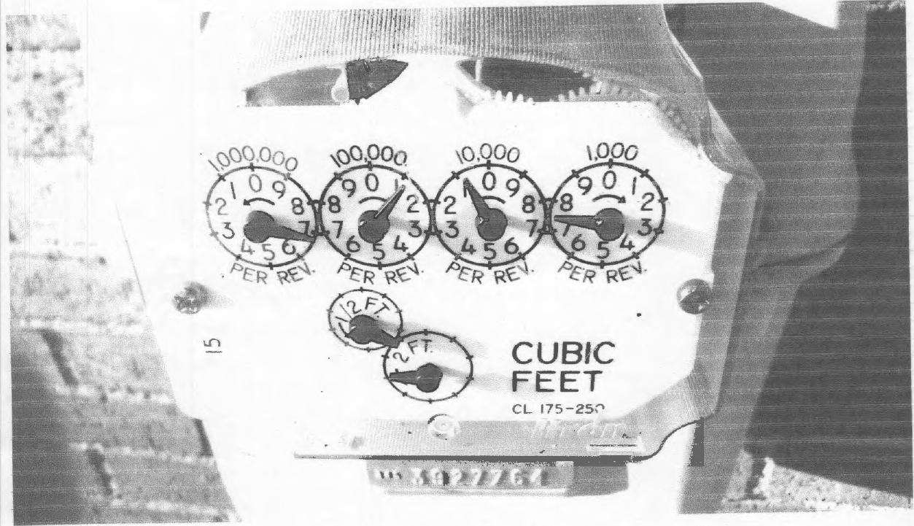

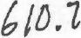 | 12•(1.19  IMG-- 20019 (Z. n- 01544-⁰  9:59 A.M

C,--

JACQUELYN NJA1
PEOPLES'
21 8-1 9 4 MAKING YOUR LIFE BETTER.
For 24/7 account access: peopieseaccount.corn
Date Prepared Next Meter Reading For General Information call 1-800-764-0111. For an Emergency call 1-800-400-4271.
Dec 4, 2019 02/03 - 02/04/2020 Avoid an estimate - call in a read between 01/03 and by 5 p.m. on 01/06/2020.
Please detach and return this coupon with a check made payable to Peoples. TO MAKE ACCOUNT CHANGES ON BACK OF COUPON, CHECK BOX HERE.

•••••••••
n r-t r⁻t fl
Monthly Usage Comparison
Summa of Basic Charges
$44.26 44.26 CR
$0.00
$14.50
24.02
36.87
14.79
$90.18
$90.18
Credits And Charies Since Your Last Bill
Balance from iast bill
Payment on NOV 30, 2019 - Thank You
Balance
Current Char.es
Residential (RS)(P)
Customer Charge - 1 Month
Commodity Charge $2.7930 per MCF
Delivery Charge
8.6 MCF $4.2872
Capacity Charge $1.7198 per MCF
Total Current Charges
Total Account Balance
Peoples current charges include $1.57 in state taxes.
Average Daily Temperature 2018
For This Billing Period 37* F
Gas Use in MCF
Nov Dec Jan Feb Mar Apr May Jun Jul Aug Sep Oct Nov
2018 , 2019
Acgual 0 Estimate 111 Customer Read ❑ Actusted Usage
2019
37•F
16
12
8
0
Average monthly use: Total annual use: | 4.2 MCF  50.8 MCF

Billing Period And Meter Readings
Your PRICE TO COMPARE is $2.82 per MCF
Shopping Information Box
When shopping for gas with a Natural Gas Supplier please provide the
following:
Account Numbel.111111,11.
Rate Schedule: Residential
If you are already shopping, know your contract expiration date.

lease Pay | Account Balance of $90.18 by DEC 26, 2019 to avoid a Late Payment Charge of 51.35 (1.5% per month )

Effective October 29, 2019, the Distribution System Improvement Charge (DSIC) decreased from 5.00 % to 0.00 %. This charge funds the repair, improvement and replacement of natural gas pipelines and related infrastructure. Help people without heat or light by donating to the Dollar Energy Fund. Please add $1 to your monthly gas payment. You can pay this bill by Credit / Debit Card or Electronic Check. Call Western Union Speedpay at 1-866-338-5491. Service Fees Apply. Visit our website at www.peoples-gas.com for further information.
Date
Meter Number
DEC 04, 2019
NOV 01, 2019
MCF Used in 33 Days
Reading Difference
708.4 8.6
699.8
8.6
Read Type 3927764 Actual Actual

LIHEAP, a federally funded program, provides energy assistance grants for income-eligible customers. The program opens November 1 and funds are limited. If you are out of work or on a low or fixed income, you should apply now. For details, call 1-800-400-WARM (9276).

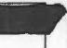
$90.18
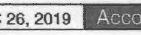

Account Balance | Amount Enclosed

9428 848000588168

J ELYN A
p
J ELYN A  p | PEOPLES  PO BOX 644760  PITTSBURGH, PA 15264-4760

10002100005382020000000009018000000090182 | 

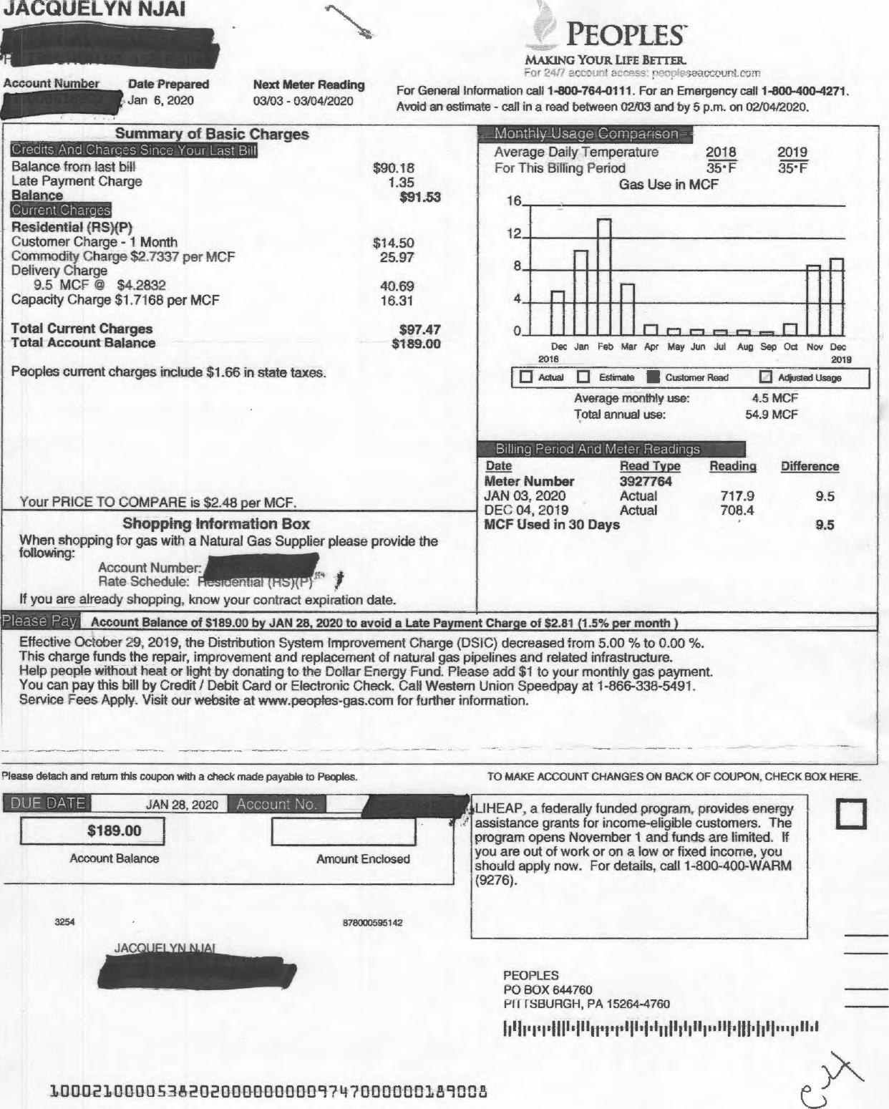
PEOPLES⁻
JACQUELYN NJAI
Account Number Date Prepared Next Meter Reading
Jan 6, 2020 03/03 - 03/04/2020
MAKING YOUR LIFE BEI Ik.R.
⁷-Tr⁻ '7!•-::t1⁷ pE.41)0,3eat⁻7,⁻`,.Qunt.c:⁻2⁻r
For General Information call 1-800-764-0111. For an Emergency call 1-800-400-4271. Avoid an estimate - call in a read between 021)3 and by 5 p.m. on 02/04/2020.
Actual El Estirnate ■
Customer Read
Reading
Difference
717.9 9.5
708.4
9.5
tae P
Account Balance of 6189.00 by JAN 28, 2020 to avoid a Late Payment Charge of S2.81 (1.5% per month )
JAN 28, 2020
DUE DATE
Account No.
3254
878000595142
100021013-00538213200000001109747000000189008
TO MAKE ACCOUNT CHANGES ON BACK OF COUPON, CHECK BOX HERE.
JAC
PEOPLES
PO BOX 644760
H I ISBURGH, PA 15264-4760
Amount Enclosed
Please detach and return this coupon with a check made payable to Peoples.
$189.00
Account Balance
Balance from last bill Late Payment Charge Balance
Current Char es
Residential (RS)(P)
Customer Charge - 1 Month
Commodity Charge $2/337 per MCF Delivery Charge
9.5 MCF $4,2832
Capacity Charge $1.7168 per MCF
Total Current Charges Total Account Balance
Peoples current charges include $1.66 in state taxes.
Compatison
Average Daily Temperature 2018
For This Billing Period 35' F
Gas Use in MCF
n ri r⁻⁻v r⁻1
Dec Jan Feb Mar Apr May Jun Jui Aug Sep Oct Nov Dec
2018 2019
El Adiusted Usage
4.5 MCF 54.9 MCF
$90.18
1.35
$91.53
$14.50
25.97
40.69
16.31
$97.47
$189.00
16 12 8 4
0
Billing Period And Meter Readings
Your PRICE TO COMPARE is 52.48 per MCF.
Shopping Information Box
When shopping for gas with a Natural Gas Supplier please provide the following:
Account Number:
Rate Schedule: en to
If you are already shopping, know your contract expiration date.
Effective October 29, 2019, the Distribution System Improvement Charge (DSIC) decreased from 5.00 % to 0.00 %. This charge funds the repair, improvement and replacement of natural gas pipelines and related infrastructure. Help people without heat or light by donating to the Dollar Energy Fund. Please add $1 to your monthly gas payment. You can pay this bill by Credit / Debit Card or Electronic Check. Call Western Union Speedpay at 1-866-338-5491. Service Fees Apply. Visit our website at www.peopfes-gas.com for further information.
T Summary of Basic Charges
Credits And Charms Since Your Last Bill
2019
35⁻F
Average monthly use: Total annual use:
Date
Meter Number JAN 03, 2020 DEC 04, 2019 MCF Used in 30
Read Type 3927764 Actual Actual
Days
ILIHEAP, a federally funded program. provides energy assistance grants for income-eligible customers. The program opens November 1 and funds are limited. If you are out of work or on a low or fixed income, you should apply now. For details, call 1-800-400-WARM (9276).

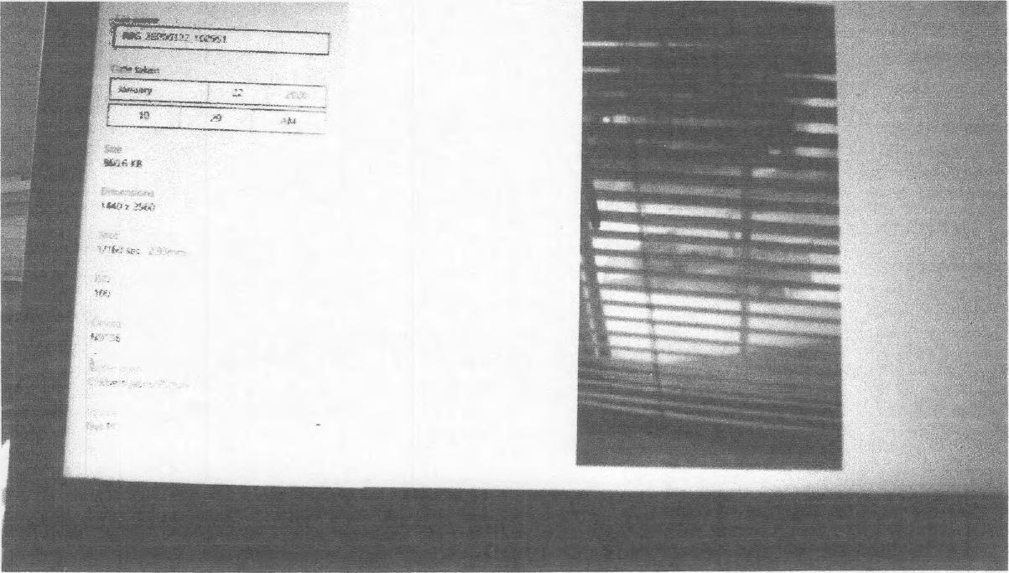
I M6._ aoatz ⁹.26:181704
gazizo20
/0: 2 7 4-m
Es

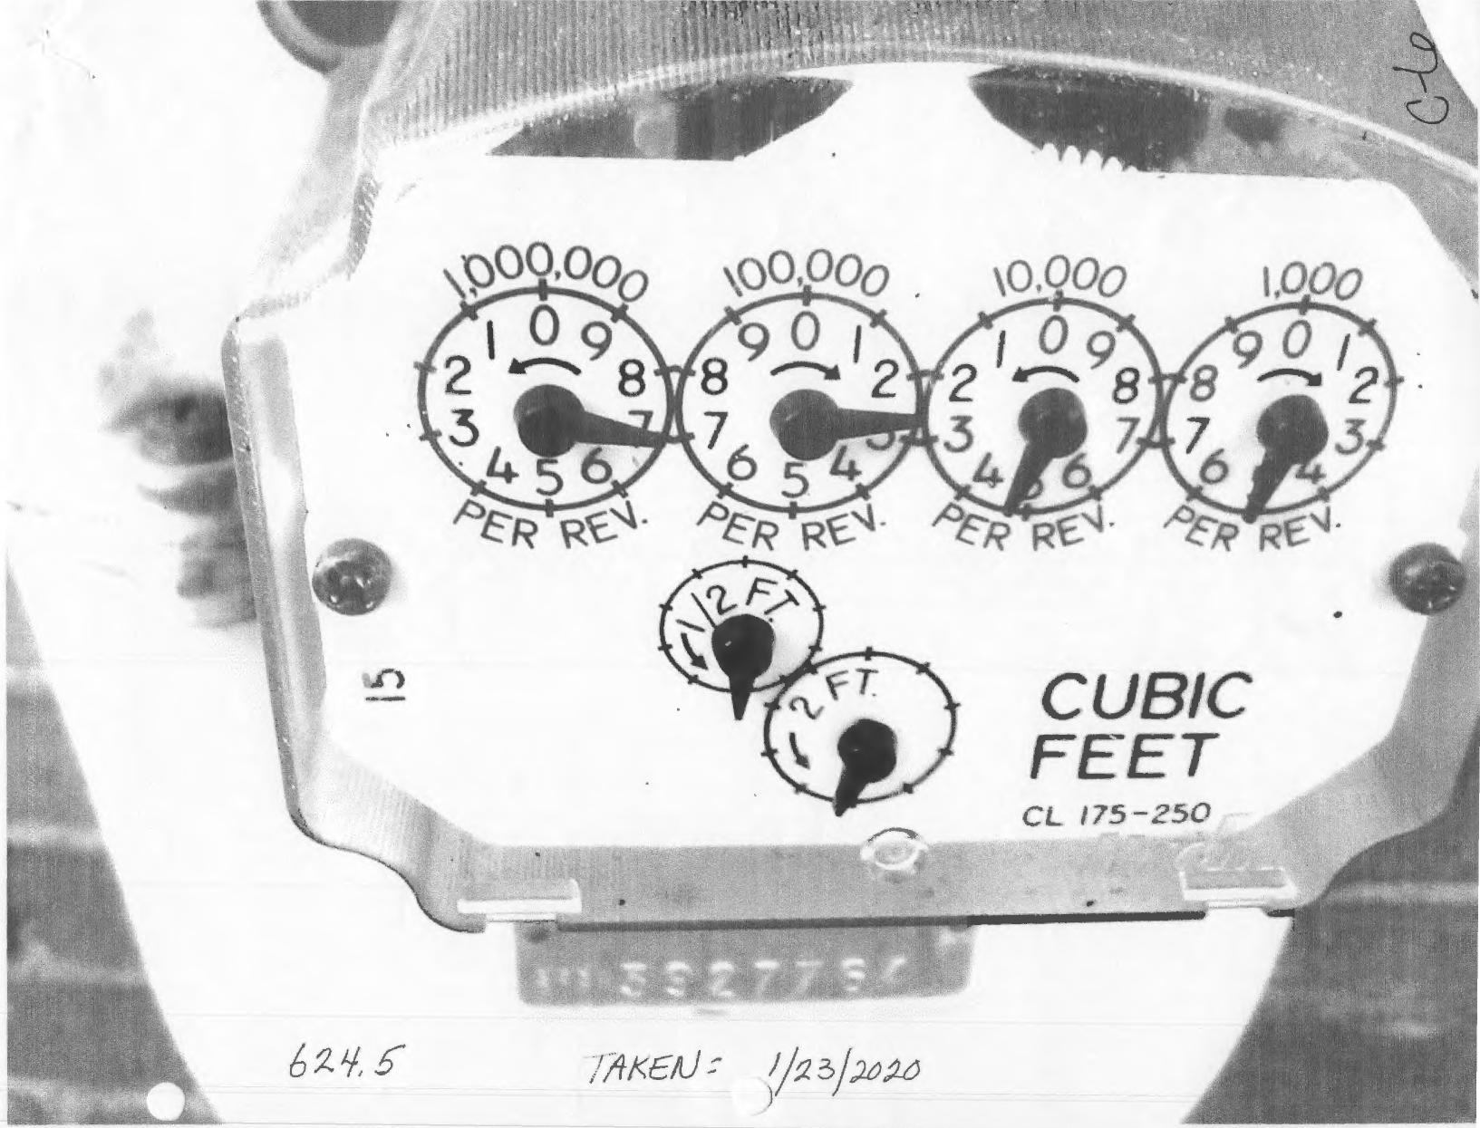
000,00₀ 00,000 \O ⁰00
Woo
^{/(}kFi• R-‘¹* R ‘⁴⁻ R ^{m}eR
CUBIC
FEET
CL 175-250
a
//a³/₂0„1_

Peoples Natural Gas
Contact Form - Customer Service
Form Topic: Customer Service
Subject: Wrong Meter Readings from July-December
Full Name: Jacquelyn N'Jai
Current Customer: True
Email Address: jredeemed@gmail.com
Phone Number: 217-572-2327
Message: I have gotten the wrong readings and it has cost me more. I am being cheated. Here are the facts Compare this picture of real reading to your bill Actual 6 1 1 .7 Nov. 6 9 9 .4 vs Oct. 6 9 7 . 4 Sept. 6 9 8 . 0 Bill Aug. 6 9 7 . 8 July 6 9 6. 8 7 0 8, 4 December As you can see they are all wrong. I tried the email I was given but it does not work customercarepeoples_gas.com I wanted to send the pictures.
Time of Submission: December 11, 2019, 10:37 am
ntaille,:,1
*they
re, copytng, cHstribu or • :⁻,1nte tti i ^{z} zJc••
u :7 . .

N'Jai <jredeernedaligmaiLco^{rn>}
E53DFF05DA302 Contact Form -Customer Service
Contact Us <contactus@peoples⁻gas.com> Wed, Dec 11, 2019 at 1:01 PM To: iredeemed@gmail.com
Good Afternoon,
Thank you for contacting Peoples Natural Gas. I would be happy to look into this for you. Please email back with your gas account number and service address. The email listed below is incorrect, the correct email is custornercarepeopies@peopies-aas.corn. You can just email back to this email though which is contactus©oeoples-gas.corn with your account information and a picture of the gas meter. I will then go ahead and enter your meter reading in our system and look further into this.
Thank you,
Megan
Customer Service
From: Contact Us <contactus@peoples-gas.com>
Sent: 2019/12/11 12:45:37 •
To: Contact Us <contactus@oeopies-gas co n>
Subject: [SUSPICIOUS MESSAGE] Contact Form -Customer Service
From: no⁻replypecplesnaturalgas.corn <no-reply@peoplesnaturalgas.corri>
Sent: 2019/12/11 10:37:37
To: Contact Us <contactusgpeo.pies-gas corn>; Peoples Gas CC <peoplesgas-forms@barkleyrei.corn> Subject: [SUSPICIOUS MESSAGE] Contact Form - Customer Service
[External email: Use caution with links and attachments]
This Message contains suspicious characteristics and has originated outside your organization.
Peoples Natural Gas
Contact Form - Customer Service
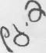

Jacquelyn N'Jai iredeernelParnail.corn>
Re: E53DFFO5DA3O2 Contact Form -Customer Service
Jacquelyn N'Jai <jredeenned@gmail.corn> Thu, Dec 12, 2019 at 10:43 AM
To: Contact Us <contactus@peoples-gas.com>
The number isii
Thanks
On Wed, Dec 11, 2019 at 1:06 PM Contact Us <contactus@peoples-gas.com> wrote:
Good Afternoon,
Thank you for contacting Peoples Natural Gas. I would be happy to look into this for you. Please email back with your gas account number and service address. The email listed below is incorrect, the correct email is customercarepeopies©peopies-gas.corn. You can just email back to this email though which is
c:-Tr,,;:is@ipeopies-gas.corn with your account information and a picture of the gas meter. I will then go ahead and enter your meter reading in our system and look further into this.
Thank you,
Megan
Customer Service
From: Contact Us <contactus@peoples-das.com>
Sent: 2019/12/11 12:45:37
To: Contact Us <contactus,,L7,peoples-clas corn>
Subject: [SUSPICIOUS MESSAGE] Contact Form -Customer Service
From: no-repiy@peoplesnaturaigas corn <no-reply@peoplesnaturalgas.com>
Sent: 2019112/11 10:37:37
To: Contact Us <::::,;⁻,tsct.,:siftpecip:es-gas cciir,›; Peoples Gas CC <peoplesgas-forms@barkleyrei.corn>
Subject: [SUSPICIOUS MESSAGE] Contact Form - Customer Service
(External email: Use caution with links and attachnients7
This Message contains suspicious characteristics and has originated outside your organization.

212⁷/₂020 Gmail - EA198F25D8500 Response
Gm Jacquelyn N'Jai <iredeemed@gmail.com>
EA198F25D8500 Response
1 message
Contact Us <contactus@peoples-gas.com> Fri, Dec 13, 2019 at 7:04 AM
To: Jacquelyn N'Jai <jredeemed@gmail.corn>
Good Morning,
Thank you for contacting Peoples Gas. I have entered the meter read of 6107 on your account. If you have any further questions or concerns, please feel free to contact us via Email, Chat or through our Customer Service Department at 1800-764-0111. We are available from 7a-5p, EST, Monday-Friday.
[hank you
Tammy
Customer Service
From: Jacquelyn N'Jai <jredeemed@gmail.com>
Sent: 2019/12/12 19:41:37
To: Contact Us <contactus@peoples-gas.com>
Subject: Response
[External email: Use caution with links and attachments]
Mirnecast Attachment Protection has deemed this file to be safe, but always exercise caution when opening files.
210000538202
Disclaimer
The information contained in this communication from the sender is confidential. It is intended solely for use by the recipient and others authorized to receive it. If you are not the recipient, you are hereby notified that any disclosure, copying, distribution or taking action in relation of the contents of this information is strictly prohibited and may be unlawful,
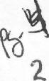
https://maii.googte.com/rnailiu/0?*=6d4a7007118wiew=ptasearch=a118,pemIthid=thread"3A1652806245045883749%7Cmsg"3A1652806245045... 1/1

JOURNAL OF JACQUELYN N'JAI, COMPLAINTANT'S METER READINGS THAT WERE CONTRARY TO PEOPLE'S BILL READINGS/USAGE
(A COMPARISION VIEW)
DATE | READING | TIME  /Use | GAS  COMPANY'S READINGS | COSTS | PAYMENTS | 10-day Notice/ NEIGHBORS' METERS READING
¹/₂²/₂018 |  |  |  | 57.18 | 71.95 1/22
²/₂6/2018 |  |  |  | 57.08 | 66.84
3/23 |  |  | No reading | 53.52 | Pd. 53.52 #473329
4/14 |  |  | No Reading | 61.95
4/20 |  | 6.1 | 647.0 | 67.55/$311.88 | 60.00/Pd ⁴/₂1
5/22 |  | 1.5 | 648.5 | 27.73/$356.70
6/21 |  |  |  | 142.55
⁷/₂³/₂018 |  | 0.5 | 649.3 | 18.51/$258.65 | Pd 140.60, 7/13  #698823
8/20/2018 |  | 0.9 | 650.2 | $62.94/$22.22 | 8/14 pd 134.623  464452
⁹/₂0/2018 |  | 0.5 | 650.7 | $146.25/$128.07
10/19/2018 |  | 0.7 | 651.4 | $189.51
11/19/2018 |  | 6.2 | 657.6 | 66.15/$207.75 | $50.00cr/ $141.60 due? | 2:48 pm
12/20/2018 |  | 5.4 | 663.0 |  | 107.00 (12/16 pay) $102.26 due $161.80 due
¹/₂1/2019 |  | 24.7  687.7-  663.0
 |  |  |  | No 2/2019 bill? | 2/17-Pd 172.03 | 2/6-
3/5/2019 |  | 14.3 | 687.7 | 148.41/5424.46 | 172.03/5256.16? | 3/5-  272.03/436.03
⁴/₃/2019 |  | 6.3 | 694.0 | 72.63/5328.79 |  | 4/3/2019  252.48/$404.43
5/3/2019 |  | 1.3 | 695.3 | 24.72/$358.33
6/5/2019 |  | 0.8 | 696.1 | 20.57(no heat  on)/$384.09 | $100.00/ ⁶/₈,  #1617069 | 11¹/₅-  358.33/502.33
7/3/2019 |  | 0.7 | 696.8 | 19.62/$307.70 | 100.00 #1810663
 |  |  |  |  | 101.45 #1683984 7/:
8/5/2019 |  | 0.6 | 697.4 | 18.30 (heat off)/228.85 |  | 207.70/345.70, 10/2
9/³/₂019 |  | 0.6 | 689.0 | 18.30/5148.83
10/2/2019 |  | 0.4 | 698.4 | $148.83/150.78 | 5150.78 #1924217 | 290.00
1¹/₁/2019 |  | 1.4 | 699.8 | 25.18/$44.26 | $44.26 #2047704 424.9 (neighbor's)
12/4/2019 |  | 8.6 | 708.4 | 90.18 (0.00/bal. from Nov.)
12/10/2019 |  | 1:55

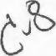

12/11/2019 | 610.7 | 9:54 a.m. |  | IMG _ 20191211_ 165900 | 435.1  IMG_20191211_095446 | --,
 |  | 4:59 p.m. |  | IMG 20191211 095440  _ _
12/31/2019 |  |  |  |  | 435.1
1/10/2020 (Note) Meter for 116 taken 12/10/2019) | 610.7 | 2:32 |  |  | 431,4
1/6/2020 |  | 9.5 | 717.9 | Bill: $97.47/$189.00
1/3/2020 |  |  | 717,9 | Bill: 92.63/$264.47
1/1¹/₂020 | 620,6 | 9:41 |  | IMG 202000111 000941  _ _  Meter 1 11 2020
1/2³/₂020 | 734.5 | 11:00
1/28/2020
2/4/2020 |  | 9.9 | 727.8
2/6/2020 | 738. | 7:30 |  | IMG _ 202000206 _073015 | 437.2 6  IMG_20200213_084657
2/8/2020 | 738.8 | 1:51 |  | IMG 202000208 102048  _ _
2/11/2020 | 739.0 | 2:10 |  | IMG_202000211_141008  _141005 | 447.9  IMG 20200211 141012  _ _
2/1³/₂020 | 731. | 8:46 |  | IMG 20200213  _ _ | 444.6  1MG_20200208_084657
2/14/2020 | 731.0 | 11:13 |  | IMG_20200214_111353 | 448.6  IMG_20200214_111357
2/2⁷/₂020 | 734.5 | 6:50 |  | IMG_ 20200227_ 065008 | 441.6
3/3/2020 |  | 8.4 | 736.2 | Bi1¹/$80.80  $345.27
3/3/2020 | 736.3 | 4:07 | 736.2 | IMG_ 20200303_ 160725 IMG_20200303_160724 IMG_20200303_160720 IMG_20200303_160715 | 443.1 4:07  IMG_20200303_160731
³/₁3/2020  ³/₁⁴/₂020 | 638.2 -  738.2 | 2:22  12:28 |  | 1MG_20200313022230  IMG_20200313_024353  IMG_20200314_122807 | 441.6  444.5  IMG20200227_065002 | _,
3/25/2020 | 740.2 | 5:17 |  | IMG 20200325_171724  182327 |  | Heat was off 2 wks (Mild weather)
3/26/2020 |  |  |  |  |  | Heat off (Mild weather)
3/27/2020 |  |  |  |  |  | Heat off
³/₂8/2020 |  |  |  |  |  | Heat off until  11:00 p.m.  .
3/29/2020 | 740.5 |  |  | IMG 20200329 102907  _ _ | 445.6 | Heat on 62, thermometer on clock read 72 degrees in the apartment

Heat came on for 10-15 mins. Anyway.
Turned heat off 10:15 a.m. very mild outside
4/2/2020 |  | 4,9 | 741.1/53.10 pd.  #2312098 | IMG_20200402_ | 446.1
⁴/₆/2020 | 741.4

DATE/TIME | TEMPERATURE | USAGE | BILL READING/COST | HEAT ON/OFF
2/3/2020 | 63/40 |  | 90.00 | OFF
2/4/2020 | 61/32 | 9.9 |  | OFF
2/22/2020 | 46/21 |  |  | ON/ 62-64
2/23/2020 | 53/28 |  |  | OFF/ON
2/24/2020 | 56/34 |  |  | OFF/MOSTLY
3/2/2020 | 58/42 | 8.4 | 736.4/ 80.80 | ON
3/⁷/₂020 | 57/42 |  |  | OFF/mostly
3/8/2020 | 55/35 |  |  | OFF
3/9/2020 | 6⁷/₄5 |  |  | OFF
3/10/2020 | 58/38 |  |  | ON/OFF
3/11/2020 | 46/37 |  |  | OFF/ON (1:00 pm)
3/12/2020 | 65/43 |  |  | OFF
3/13/2020 | 5⁸/₄1 |  |  | ON/OFF
3/1⁴/₂020 | 44/32 |  | 738.2 | ON/OFF
³/₁5/2020 | 50/42 |  |  | OFF/ 11:30-8:45 PM
³/₁6/2020 | 4⁷/₃1 |  |  | OFF/ON 11:00 AM
3/17/2020 | 44/41 |  |  | OFF/ON
3/1⁸/₂020 | 57/33 |  |  | OFF
3/19/2020 | 64/52 |  |  | OFF
3/20/2020 | 73/40 |  |  | OFF
3/21/2020 | 39/30 |  |  | ON
³/₂2/2020 | 50/27 |  |  | OFF/ON
³/₂3/2020 | 47/39 |  |  | OFF/ON
³/₂4/2020 | 46/37 |  |  | ON
3/25/2020 | 5⁴/₄1 |  |  | ON/OFF
³/₂6/2020 | 70/37 |  |  | OFF
3/2⁷/₂020 | 5⁹/₄9 |  |  | OFF/ON
3/28/2020 | 77/51 |  |  | OFF
³/₂9/2020 | 78/57 |  | 741. | OFF/10:15 AM
3/30/2020 | 5⁷/₄2 |  |  | OFF/ON
3/3¹/₂020 | 47/39 |  |  | ON
4/1/2020 | 52/34 |  |  | OFF
4/2/2020 | 55/34 | 4.9 | 741.5 | OFF
4/3/2020 | 58/34 |  |  | OFF/ON 10:00 am
4/4/2020 | 66/46 |  |  | OFF
4/⁵/₂020 | 66/47 |  | 53.10/Pd 4/5/2020 | OFF
4/6/2020 | 69/55 |  |  | OFF
⁴/₇/2020 | 69/55 |  |  | OFF
⁴/₈/2020 | 71/53 |  |  | OFF
4/9/2020 | 65/49 |  |  | OFF/ 11:00 PM ON
4/10/2020 | 62/48 |  |  | OFF/2:00 AM ON (Mostly off)
⁴/₁1/2020 | 54/32 |  |  | ON (62 degrees)(Mostly off)
⁴/₁2/2020 | 68/56 |  |  | OFF/ON 8:15 PM
⁴/₁3/2020 | 65/34

4/14/2020 | 48/32
4/15/2020 | 50/32
4/16/2020 | 4⁸/₃2
4/17/2020 | 51/35
4/18/2020 | 51/38
4/19/2020 | 63/42
4/20/2020 | 60/42
4/21/2020 | 61/42
4/22/2020 | 63/44
4/23/2020 | 62/44
4/24/2020 | 6³/₄5
4/25/2020 | 63/44
4/26/2020 | 68/47
4/2⁷/₂020 | 71/49
4/28/2020 | 68/41
4/29/2020 | 69/48
4/30/2020 | 71/50
4/31/2020 | 71/50

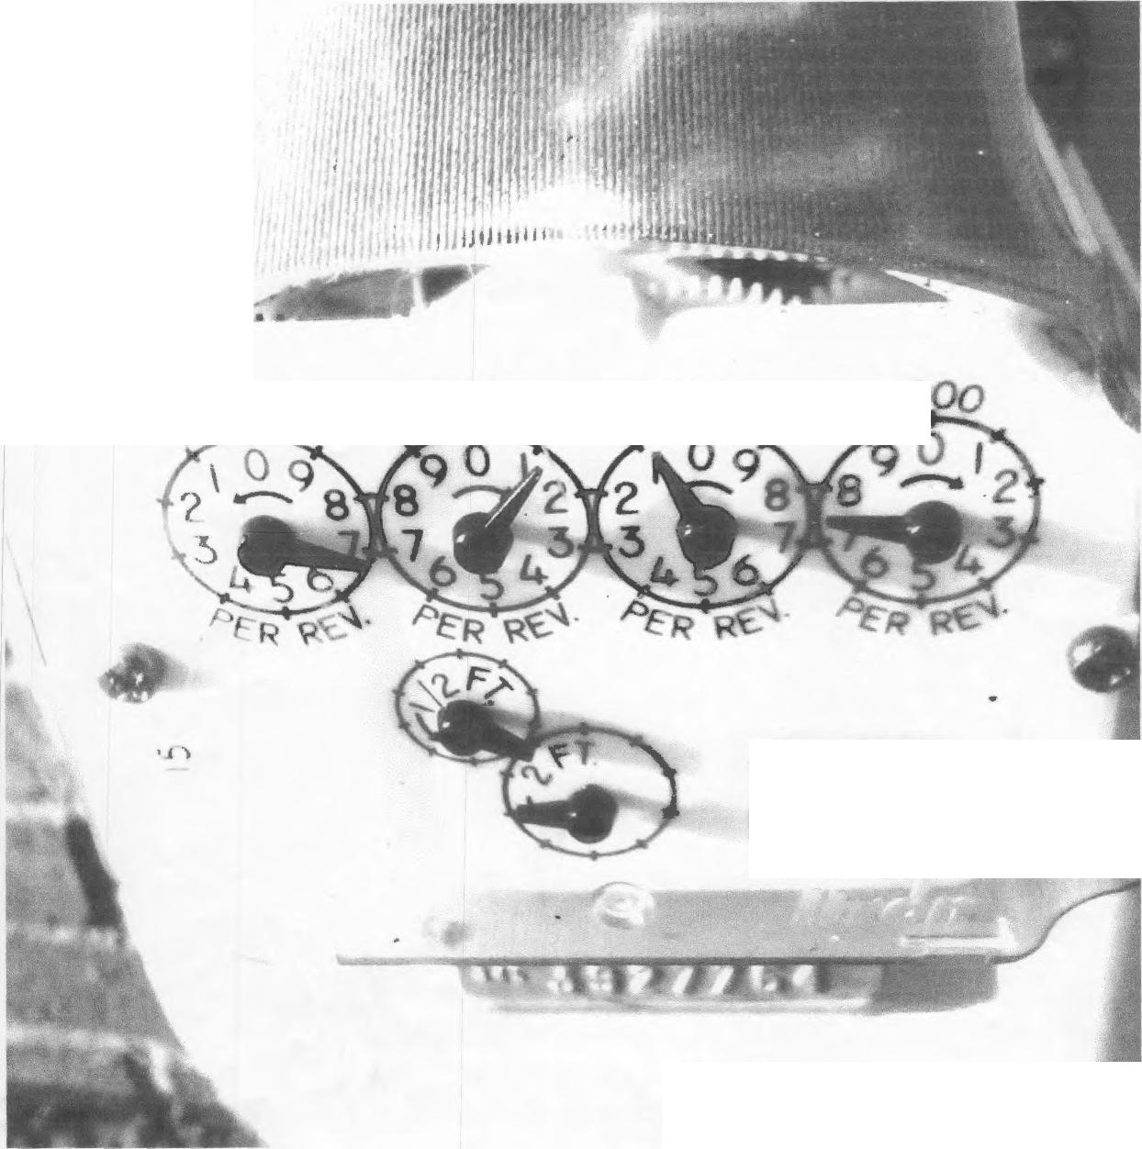

cpo.00 00.000 \O#¹oo
CUBIC
FEET
."t

4C7O-
>-ceetibec 11₇2.ot ci


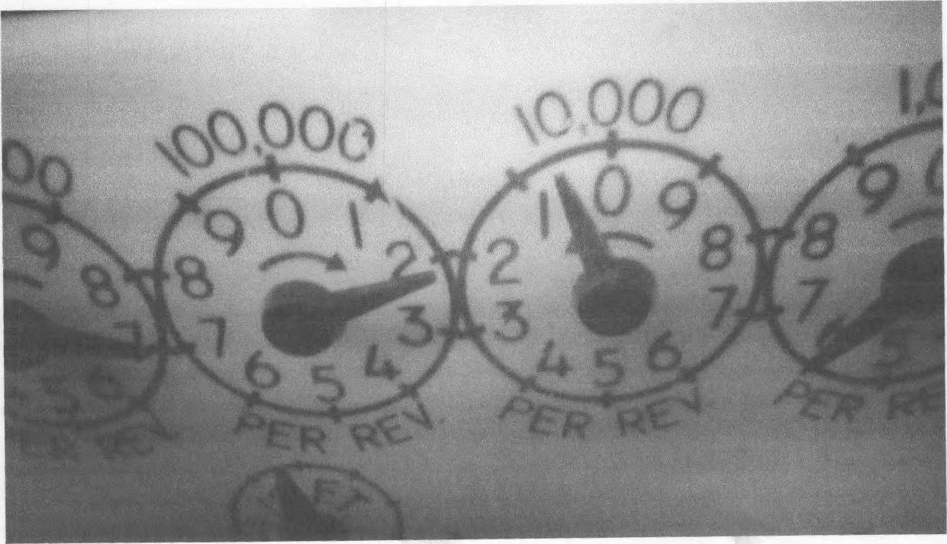
IA. 117')..07,0
(9^{1,}1^{4,}
.vvt&... 9,0-001ii, qq1,-/,y
q:cfs, A ,AA.

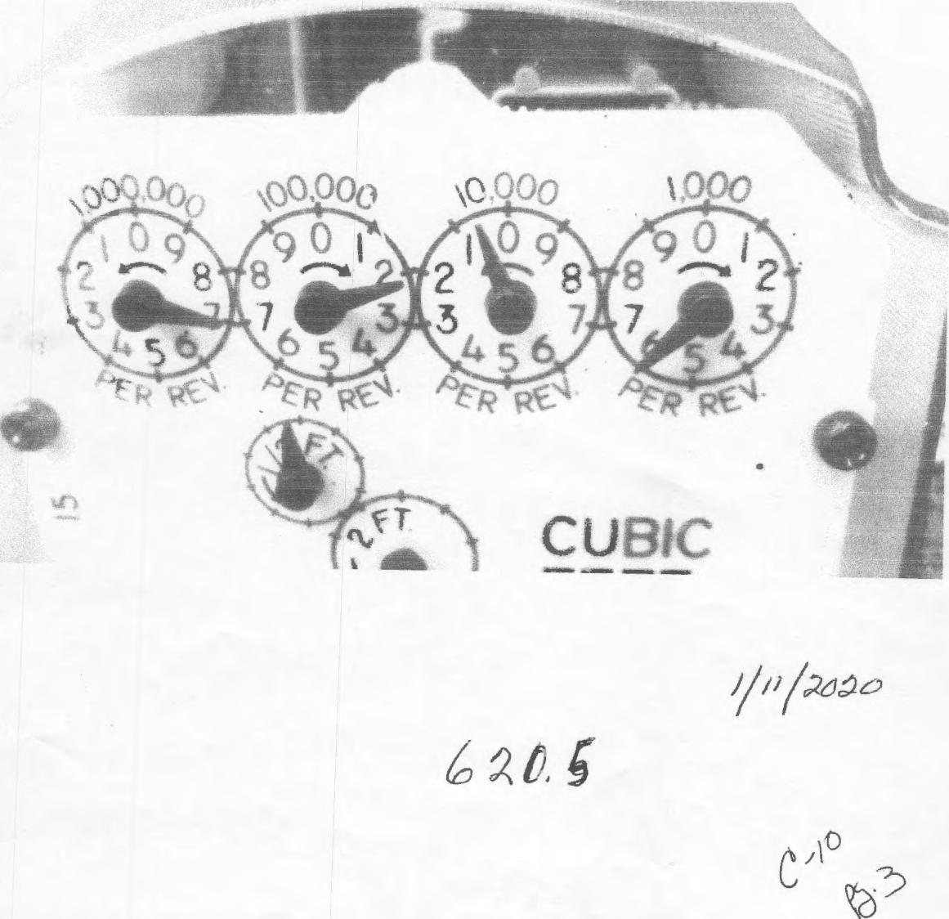
CUB
-- a
1//%772oe'-,
6ai

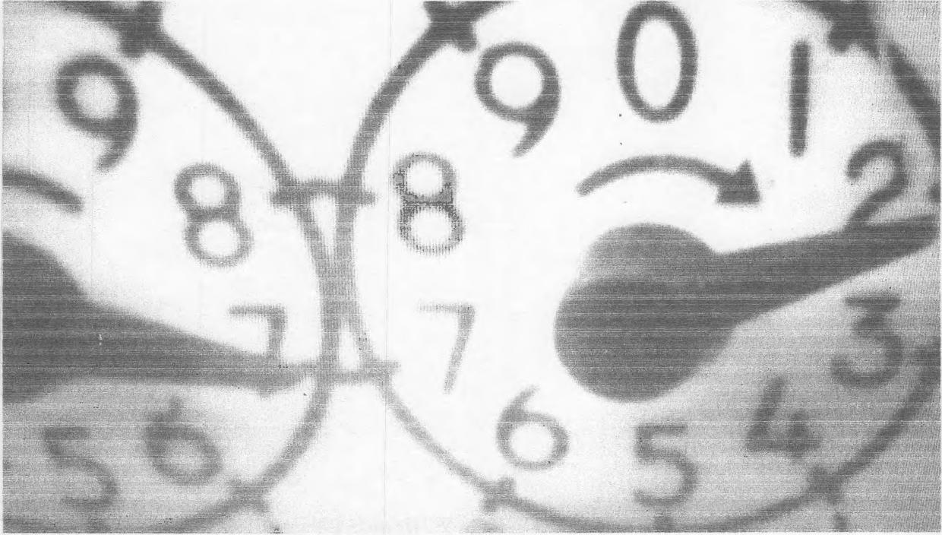
01/24 12)/(4_ 2e2e!
⁻2,¹t¹A

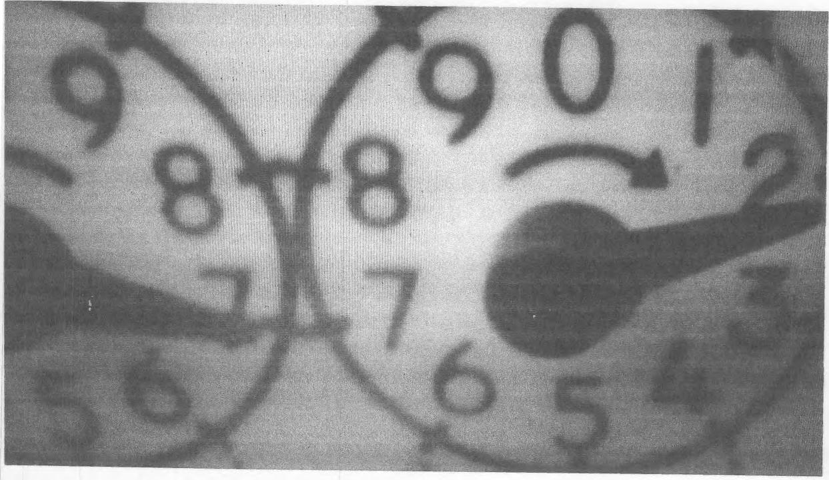
Jain 1(₎ D.62E3
2 i_{v}(6._₂₆₂zoi II-- ⁶9⁴-1225
q:42- Ail.4.
nt,3

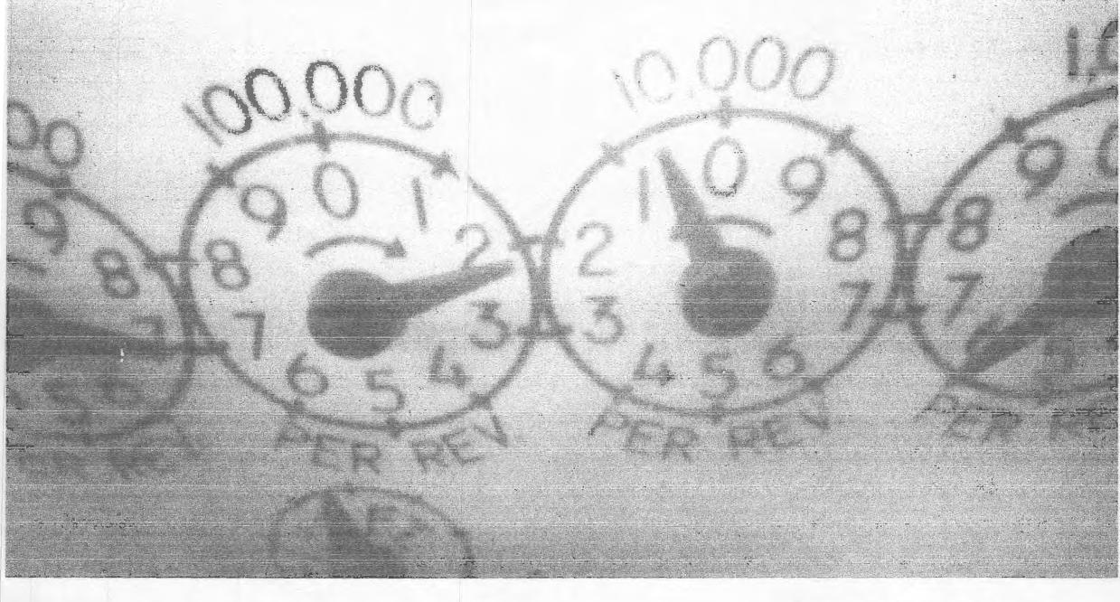
Jan s zoz6


2026


1A46-... 20106211- 191005
2.- 11.2¹322=,
2:10 PM
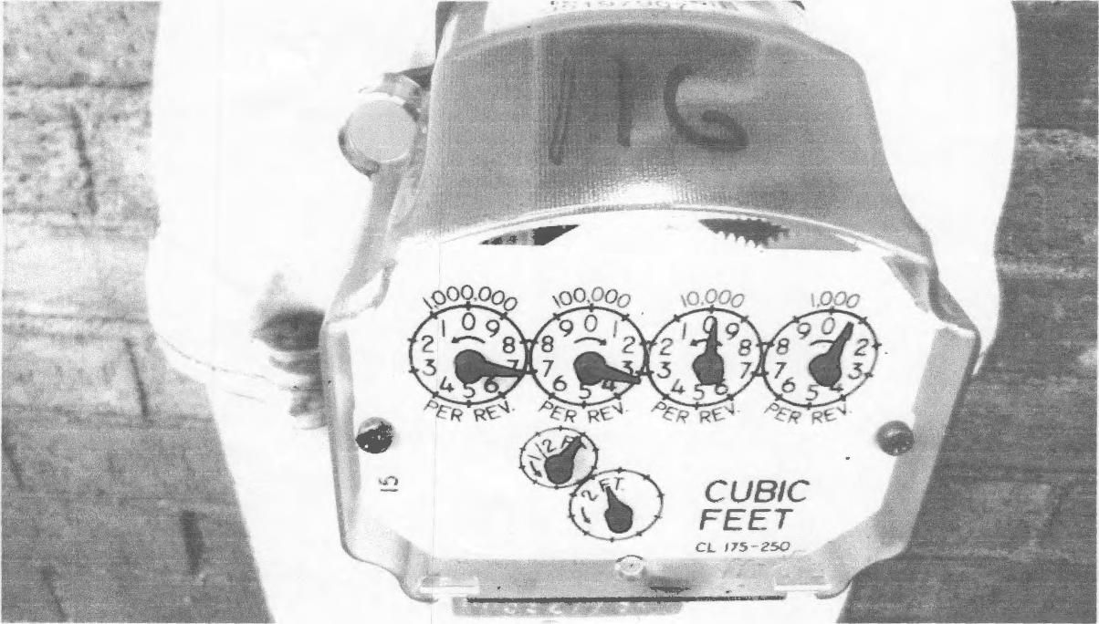
CUBIC FEET
CL 175-250
A

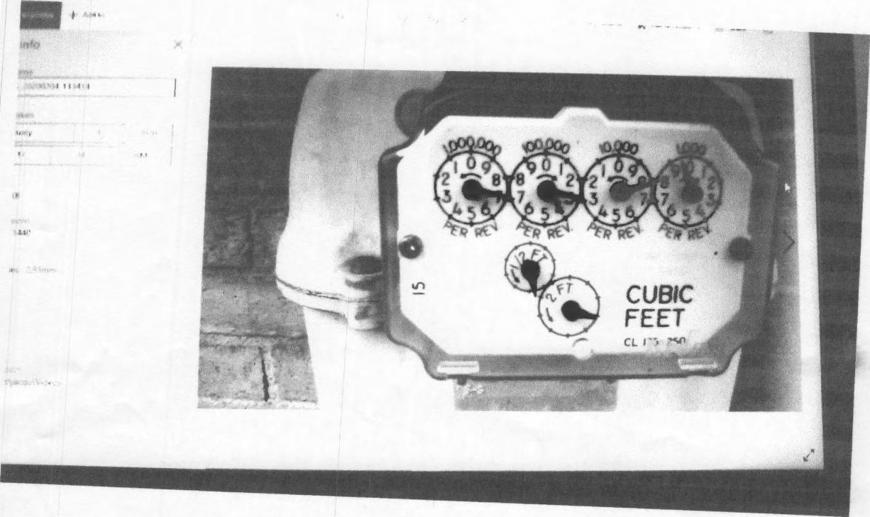
~~q• 910,6 II: 3⁴1 14AI
-7A7.

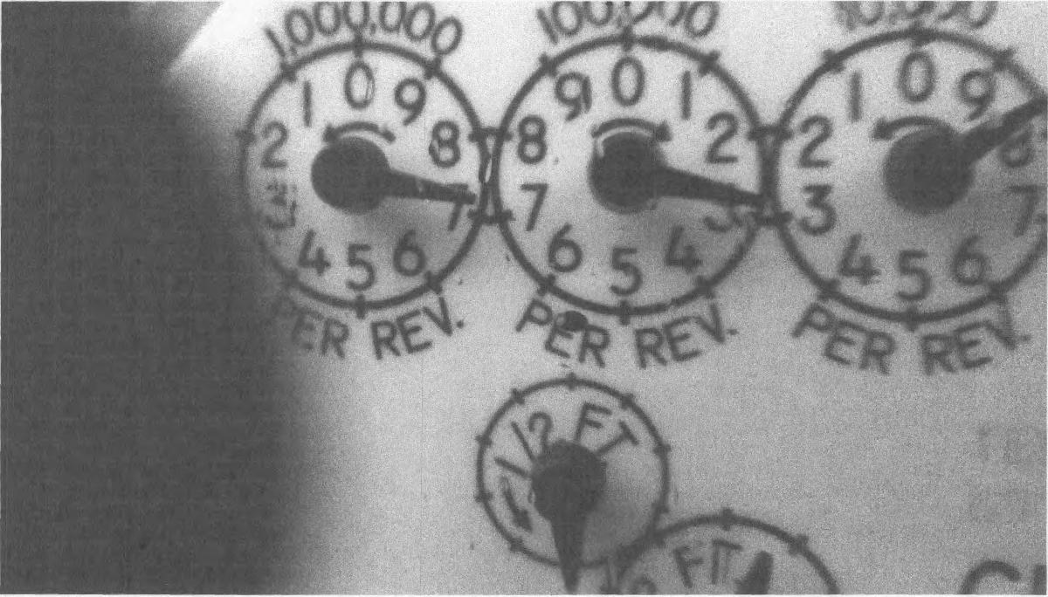
er, 2,p Z.00 lo6 _{or} n Oi
710. eLDel•° 1⁹-e
o A .Nt-

qi$¹
_{(r}vit(1⁻111`6
'171100Yt--9dv
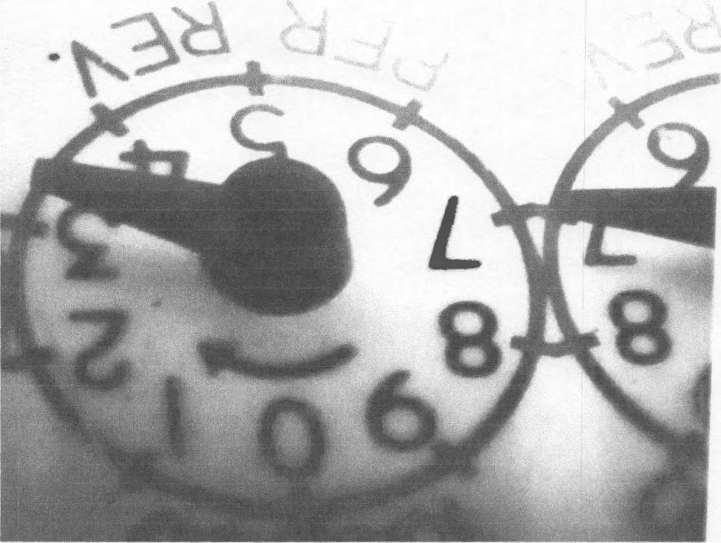

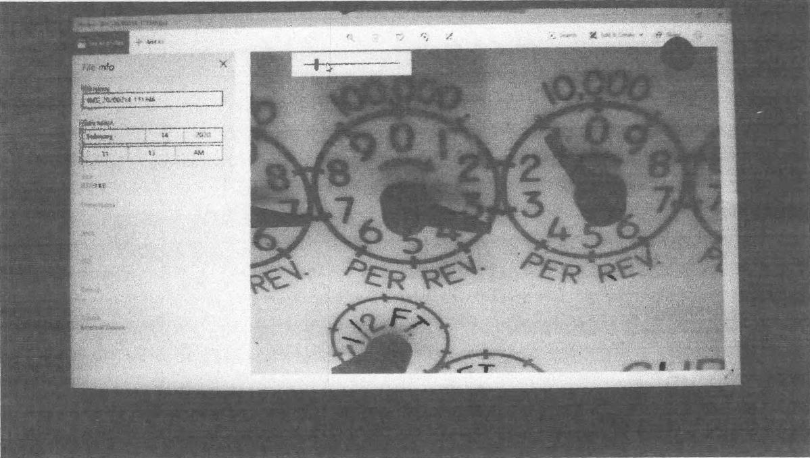
_2424192.N /1/ .31/4,
a.0₄₎
II:IS
63/,

x fix- 20260214— 1113%

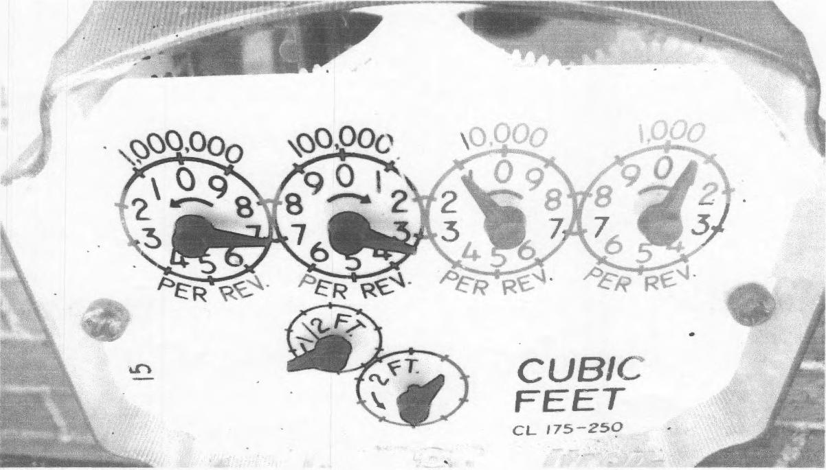
CUBIC
FEET
CL 175-250
tr)
2-11. 2b20
11:13 AN

Zdt46-, 202.co3613-/k⁶a⁹

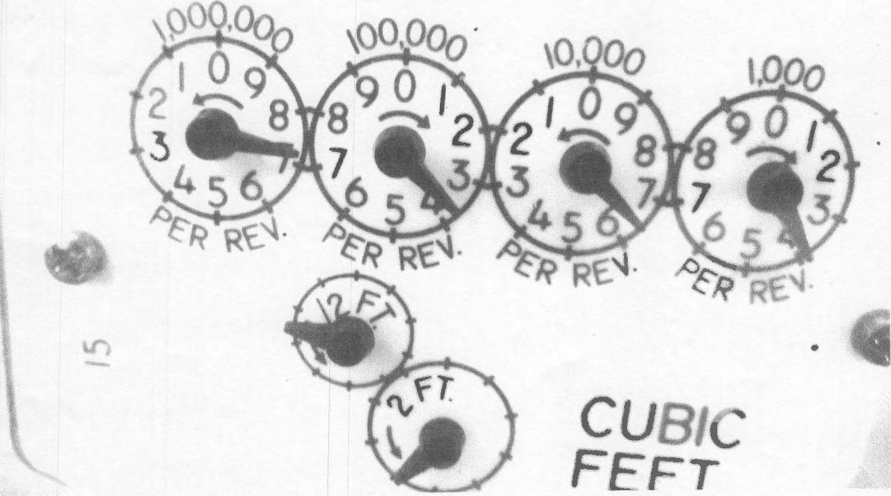
r
CUBIC
FEF T
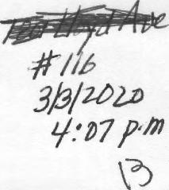

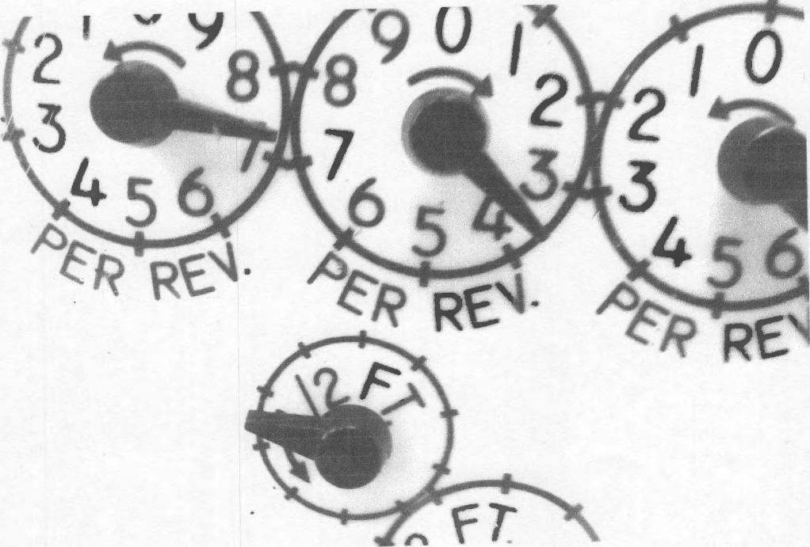
3Ie 3 )2-⁰?
ito7
fit4&-,. 26v90363 ,
1 &67ao

31312zzo

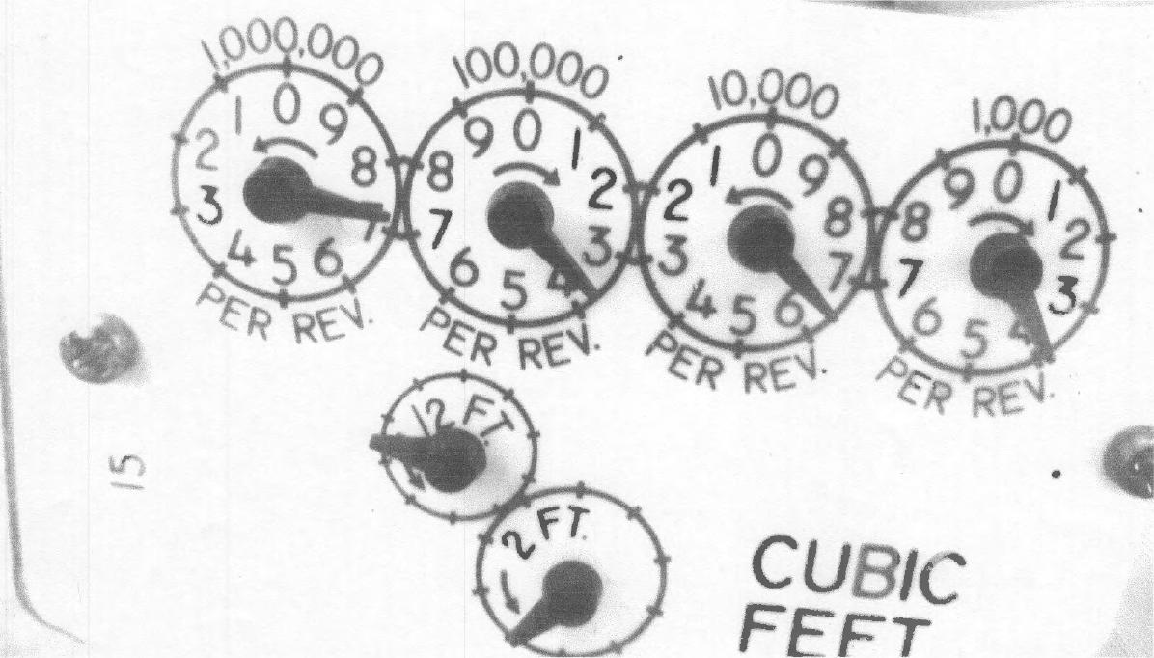
•
Ciii,.„.:..k:
FFFT
IMO- - 20260363—
/60725
9:67 em
c6

₁,₄₎₄4 15:1
orZa⁻71c,i(g⁻⁻
9/QL0 ⁻⁻,aZooz0Z⁻ -9wl
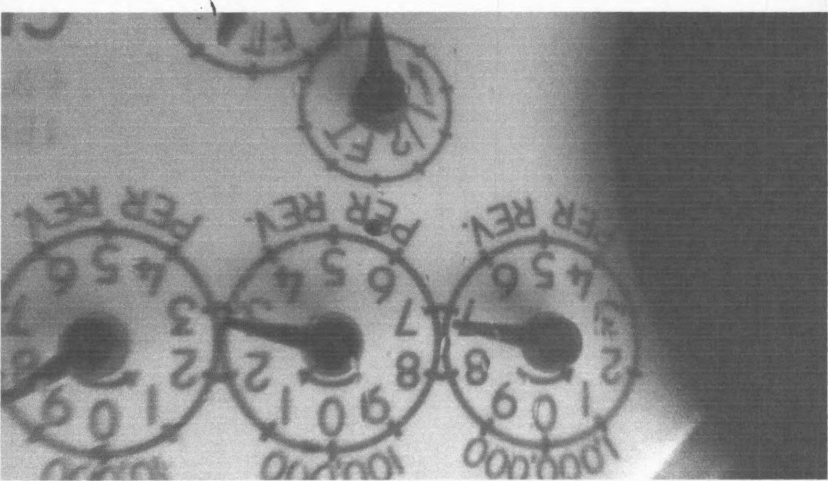

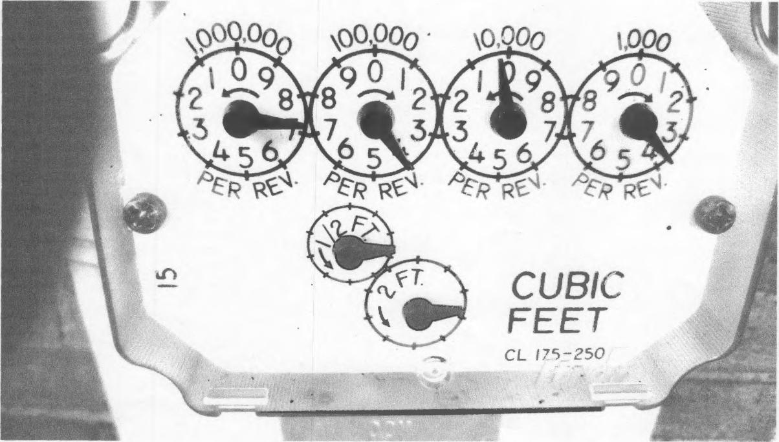
3.2.5./cao /31.3
v_{A}c_{r}_2_{o}rt.003i.5,, 1/1/26
5.11 poi

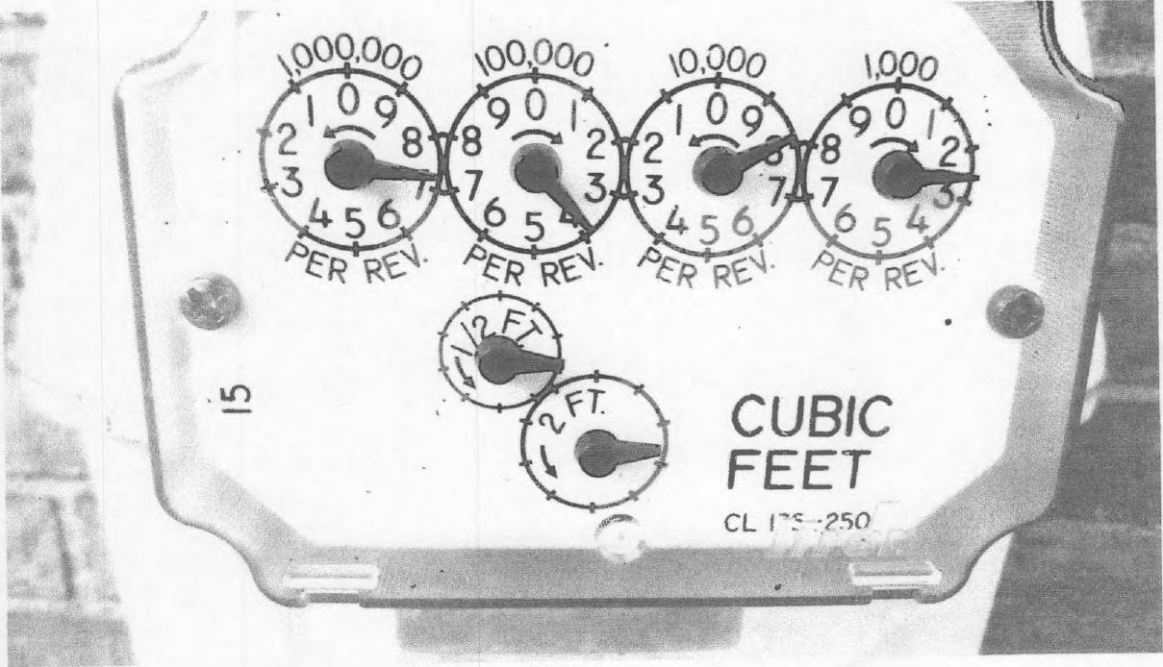
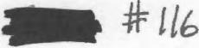
1M6-__262es63/q In 757
0j2.9124
io: 4‘ A M

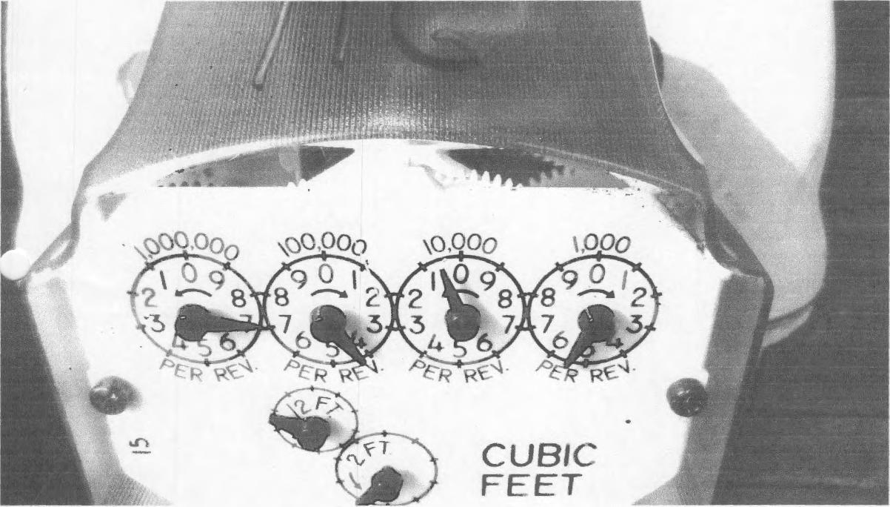
1 fri6-.2624e329, M2957
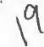
3- 2? • 202-e)
/ a' 97 Me

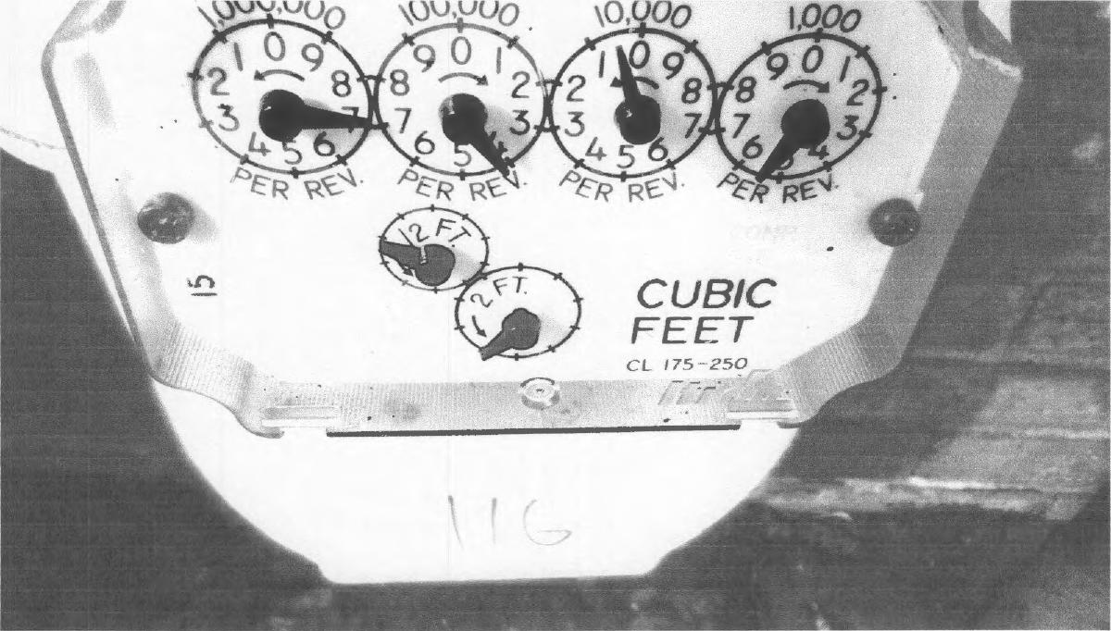

74/•5
3. • 2q• ADP-⁰
TM &— 2-o 2-DO 32.,_ /oarit 8"
cip

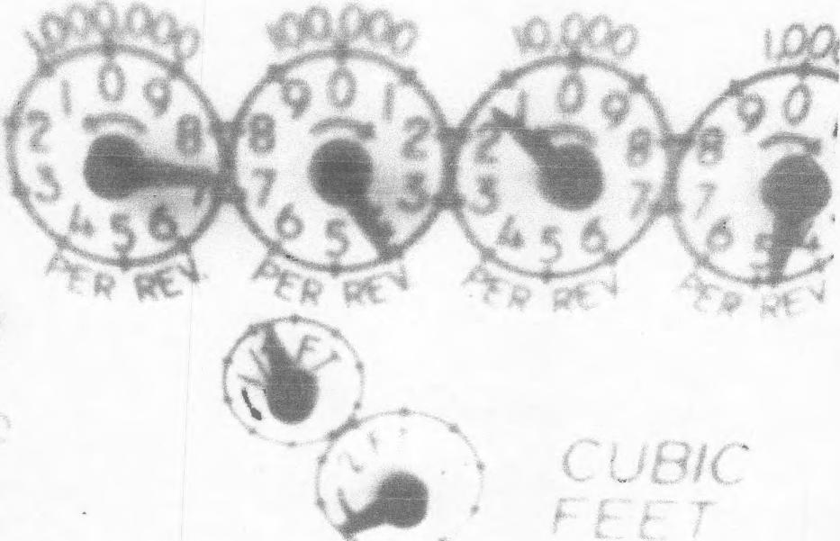

4¹/¹412.02-6
⁷11.4
5:.g2 P
IN6-4.210241.0e.... '

PEOPLES

JACQUELYN NJAI
PITTSBURGH PA 15218-1944
Acceunt Number fillIN11111?
flats yarcrt
Aug 21, 2018
Meter R.•=.⁴1.1⁻rg
10/18 - 10/19(2018
MAKING YOUR LIFE BETTER.
- - -7.count access: peopleseaccount.com
I-or tieneral Information call 1-800-764-0111. For an Emergency call 1-800-400-4271. Avoid an estimate - call in a read between 09/19 and by 5 p.m. on 09/20/2018.

Summar of Basic Char.es | Monthly Usage Comparison  Average Daily Temperature 2017 2018
Credits And Charges Since Your Last Bill
Balance from last bill $258.65
Payment on AUG 14, 2018 - Thank You 134.62 CR
Balanc 9124.03
Rate RS Residential(P)
Customer Charge - 1 Month $14.00
Price-to-Compare Commodity $3.6667 per MCF 3.30 Delivery Charge
0.9 MCF © 53.6222 3.26
Capacity Charge $1.7889 per MCF 1.61
DSIC Surcharge 5.00% .87
State Tax Surcharge © 0.23% .01 CR
Tax Cuts and Jobs Act .81 CR
Total Current Charges $22.22
Total Account Balance $146.25
Peoples current charges include $0.35 in state taxes.
For This Billing Period 72-F 72- F
Gas Use in MCF
16
 | 12 |  |  |  |  | _
 | 8 |  |  |  |  |  | -
 | 4 |  |  | - | ___, |  |  | ___. | -
 | 0 |  | . ti |  |  |  |  |  | ri .--.. r...7 i⁻i
Aug Se Oct Nov De^ Jae .ct ktc• Apt May Jur. JO /.4.g
2017 2018
 |  | 111 Actual 0 Estimate . Customer Read 0 Adjusted Usage
Average monthly use: 4.3 MCF
Total annual use: 52.1 MCF
 | Billing Period And Meter Readings
 | Date Read Type Reading Difference
Meter Number 3927764
AUG 20, 2018 Actual 650.2 0.9
JUL 20. 2018 Estimate 649.3
MCF Used in 31 Days 0.9
Shopping Information Box
When shopping for gas with a Natural Gas Supplier please provide the
following:
Account Number:
Rate Schedule: Rate esi ential(P)
If you are already shopping, know your contract expiration date.
lease Pa Plan Amount of $62.94 by SEP 12, 2018 to avoid a Late Payment Charge of $2.19 (1.5% per month )
Effective July 1, 2017, the Distribution System Improvement Charge (DSC) increased from 0.00 % to 5.00 °/0.
This charge funds the repair, improvement and replacement of natural gas pipelines and related infrastructure.
Help people without heat or light by donating to the Dollar Energy Fund. Please add $1 to your monthly gas payment.
You can pay this bill by Credit I Debit Card or Electronic Check. Call Western Union Speedpay at 1-866-338-5491.
Service Fees Apply. Visit our website at www.peoples-gas.corn for further information.

Please detach and return this coupon with a check made payable to Peoples.

Plan Amount Amount Enclosed

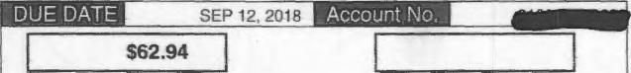
SEP 12, 2018
$62.94
3547 884000360627
TO MAKE ACCOUNT CHANGES ON BACK OF COUPON. CHECK BOX HERE.

JACQUELYN NJAI
11111111.1111114
JACQUELYN NJAI  11111111.1111114 | PEOPLES  PO BOX 644760  i-'11 I SBUI-11.31⁻1, PA 15264-4760

11111111 rill lig 11111111111111111 1111 it 0111111111111111 11111111d
1000211:100E15382020111:10110001:12.2220.001:100062949

JACQUELYN [JAI

PEOPLES
PITTSBURGH¹¹1,1,21.44
Ntiertiof Prepar=a⁴ Me=t⁻ Meter Reach:mg
Sep 20, 2018 10/18 - 10/19/2018
MAKING YOUR LIFE BETTER.
For 2417 account access: peopleseaccount.com
For General Information call 1-800-764-0111. For an Emergency call 1-800-400-4271.

Summa of Basic Char• es
Monthly Usage Comparison

CreditgAnd Charges Since Your Last.Bill

Balance from last bill
Late Payment Charge
$146.25
2.19
8148.44
Bolan_{mmimimm} •
Rate RS Residential(P)  Customer Charge - 1 Month  Price-to-Compare Commodity $3.6600 per MCF  Delivery Charge | $14.00  1.83
0.5 MCF @ $3.6200 | 1.81
Capacity Charge $1.8000 per MCF | .90
DSIC Surcharge 5.00% | .79
Tax Cuts and Jobs Act | .75 CR
Total Current Charges | $18.58
Total Account Balance | $167.02
Peoples current charges include $0.29 in state taxes.
Average Daily Temperature 2017 2018
For This Billing Period 66⁻F 74-F
Gas Use in MCF
0 Actuat 0 Estimate ₁₁ Customer Reed 0 Adjusted Usage

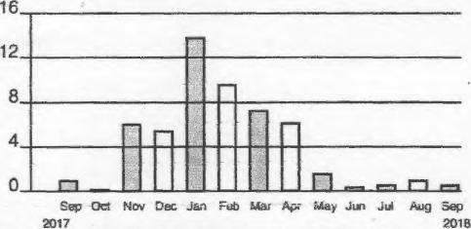
16 12 8 4
0
•••••••1
Sep Oct Nov Dec Jun Feb Mai A. May .tun jud Aug Sep
2017 20113
1⁻1
n
Average monthly use: 4.3 MCF
Total annual use: 51.7 MCF

Billing Period AnctMeter Readings

Shopping Information Box
Date Road Type
Meter Number 3927764
SEP 19, 2018 Estimate
AUG 20, 2018 Actual
MCF Used in 30 Days
This is an Estimated Bill.
Reading Difference
650.7 0.5
650.2
0.5
When shopping for gas with a Natural Gas Supplier please provide the
following:
Account Number:
Rate Schedule: RLreil4MMFal(P)
If you are already shopping. know your contract expiration date.

lease Pa | Plan Amount of $128,07 by OCT 12, 2018 to avoid a Late Payment Charge of $2.47 (1.5% per month )
Effective July 1, 2017, the Distribution System Improvement Charge (DSIC) increased from 0.00 % to 5.00 %.
This charge funds the repair, improvement and replacement of natural gas pipelines and related infrastructure.
Help people without heat or light by donating to the Dollar Energy Fund. Please add $1 to your monthly gas payment.
You can pay this bill by Credit / Debit Card or Electronic Check. Call Western Union Speedpay at 1-866-338-5491.
Service Fees Apply. Visit our website at www.peoples-gas.com for further information.

'lease detach and return this coupon with a check made payable to Peoples. TO MAKE ACCOUNT CHANGES ON BACK OF COUPON. CHECK BOX HERE.
JACQUELYN NJAI

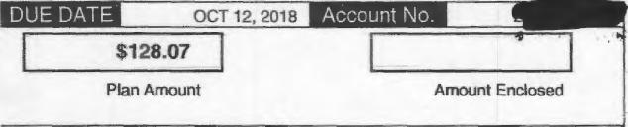
OCT 12, 2018
DUE DATE
Account No. 11111M
Amount Enclosed
$128.07
Plan Amount
79 072000377196
PEOPLES
PO BOX 644760
ISLIUHUI⁻I. PA 15264-4760
11'11.1.1.111¹.1"wrial'aldulliiini.."1.111i101¹¹¹1¹¹¹¹¹
10 0 E1!Iflaticq8PriPnhnnnnnnni.A-cAnnnrinn-i.a.ary7

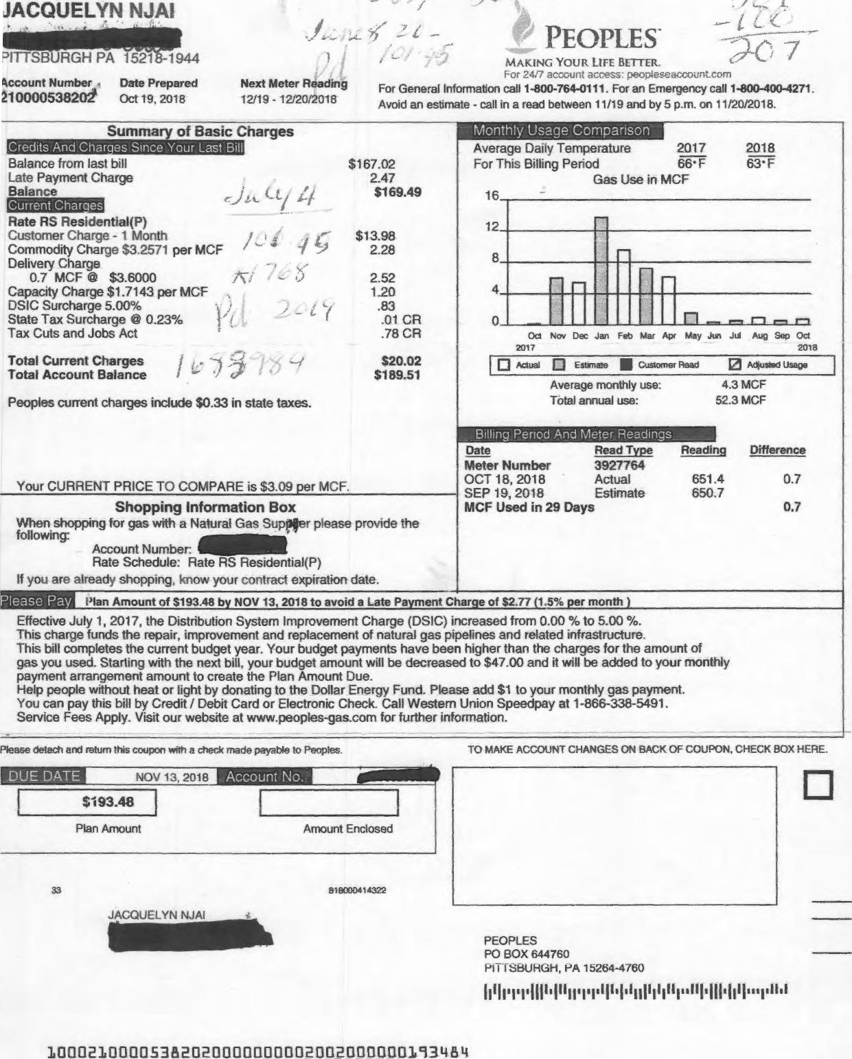
TO MAKE ACCOUNT CHANGES ON BACK OF COUPON, CHECK BOX HERE.
Please detach and return this coupon with a check made payable to Peoples.
JACQUELYN N4AI
PITTSBURGH PA 1521 -1944
Recount Number Date Prepared Next Meter Reading
1000053820.1 Oct 19, 2018 12/19 - 12/20/2018
PEOPLES⁻
MAKING YOUR LIFE BETTER.
For 2417 account access; peopleseaccount.com
For General Information call 1-800-764-0111. For an Emergency call 1-800-400-4271
Avoid an estimate - call in a read between 11/19 and by 5 p.m. on 11/20/2018.
Amount Enclosed
Enclosed
Plan Amount
33
519060414322
DUE DATE
NOV 13, 2018
Account No,
$193.48
JACQUELYN NJA1
PEOPLES
PO BOX 644760
HI I I Sl3UHGH, PA 15264-4760
11300210000538202000011000020020000110193484
Monthly Usage Comparison
Summary of Basic Charges
0
rl
0 Actual 0 Estimate Customer Head
21 Actiuslecl. Usage
Date
Read Type
Meter Number 3927764
OCT 18, 2018 Actual
SEP 19, 2018 Estimate MCF Used in 29 Days
651.4
650.7
Reading Difference
0.7
0.7
Please Pa
Plan Amount of $193.48 by NOV 13, 2018 to avoid a Late Payment Charge of $2.77 (1.5% per month )
Credits And Charges Since Your Last Bill
Balance from last bill |  |  | $167.02
Late Payment Charge |  |  | 2.47
Balance |  |  | $169.49
Current Charges | ⁴-/
Rate RS Residential(P)  Customer Charge - 1 Month  Commodity Charge $3.2571 per MCF |  | 4:5 | $13.98  2.28
Delivery Charge | _ ,

0.7 MCF @ $3.6000 | 2.52
Capacity Charge $1.7143 per MCF | 1.20
DSIC Surcharge 5.00%  -  State Tax Surcharge @ 0.23% | .83  .01 CR
Tax Cuts and Jobs Act | .78 CR
Total Current Charges | $20.02
Total Account Balance | $1 89.51
Peoples current charges include $0.33 in state taxes.

Average Daily Temperature 2017
For This Billing Period 66* F
Gas Use in MCF
Average monthly use: Total annual use:
__Billing Period And Meter Readings_
Your CURRENT PRICE TO COMPARE is $3.09 per MCF.
Shopping Information Box
When shopping for gas with a Natural Gas SuptAler please provide the
following:
Account Number:
Rate Schedule: Rate RS Residential(P)
If you are already shopping, know your contract expiration date.
Effective July 1, 2017, the Distribution System Improvement Charge (DSIC) increased from 0.00 % to 5.00 %.
This charge funds the repair, improvement and replacement of natural gas pipelines and related infrastructure.
This bill completes the current budget year. Your budget payments have been higher than the charges for the amount of
gas you used. Starting with the next bill, your budget amount will be decreased to $47.00 and it will be added to your monthly
payment arrangement amount to create the Plan Amount Due.
Help people without heat or light by donating to the Dollar Energy Fund. Please add $1 to your monthly gas payment.
You can pay this bill by Credit / Debit Card or Electronic Check. Call Western Union Speedpay at 1-866-338-5491.
Service Fees Apply. Visit our website at www.peoples-gas.com for further information.
2018
63•F
16
12
8
4
Oci Nov Dec Jan Feb Mar Apr May Jua, 2017
r--t r-t r-t
Jul Aug Sep Oct
2015
4.3 MCF 52.3 MCF

JACQUELYN NJAI  PITYSBURGH PA -1944  Account Number Date Prepared  Nov 20, 2018 | Next Meter Reading  12/19 - 12/20/2018 | PEOPLES  MAKING YOUR LIFE BETTER.  For 2⁴/₇ account access: peopleseaccount.com  For General information call 1-800-764-0111. For an Emergency call 1-800-400-4271.

Summa of Basic Charges | Monthly Usage Comparison  Average Daily Temperature 2017 2018
Credits And Char es Since Your Last Bill
Balance from last bill $189.51
Goodwill Adjustment - Cr 50.00 CR
Late Payment Charge 2.09
Balance $141.60
For This Billing Period 45' F 43•F
Gas Use in MCF
16
 | 12
Current Char es
Rate RS Residential(P)
Customer Charge - 1 Month $13.96
Commodity Charge $3.0839 per MCF 19.12
Delivery Charge
6.2 MCF @ $3.6065 22.36
Capacity Charge $1.6903 per MCF 10.48
DSIC Surcharge 5.00% 1.88
State Tax Surcharge @ 0.23% .04 CR
Tax Cuts and Jobs Act 1.61 CR
Total Current Charges $66.15
Total Account Balance $207.75
Peoples current charges include $1.12 in state taxes.
Your CURRENT PRICE TO COMPARE is $3.09 per MCF.NOV
 | 8
 | 4
 | 0 |  |  |  |  |  |  |  | .1::L..,-....
Nov Dec Jan Feb Mar Apr May Jun Jul Aug Sep Oct Nov
2017 2018
 |  | In Actual li Estimate $ Customer Read 121 Adjusted Usage
Average monthly use: 4.3 MCF
Total annual use: 52.5 MCF
 | Billing Period And Meter Readings ___
 | Date Read Type Reading Difference
Meter Number 3927764
19, 2018 Estimate 657.6 ^{6.2}OCT 18, 2018 Actual 651.4
MCF Used in 32 Days 6.2 This is an Estimated Bill.
Shopping Information Box
When shopping for gas with a Natural Gas Supplier please provide the following:
Account Number: IIIIIIINIIIIIB
Rate Schedule: Rate RS Residential(P)
If you are already shopping, know your contract expiration date.
Please Pa Account Balance of S207.75 by DEC 12, 2018 to avoid a Late Payment Charge of $3.08 (1.5% per month )
Effective July 1, 2017, the Distribution System Improvement Charge (DSIC) increased from 0.00 % to 5.00 %.
This charge funds the repair, improvement and replacement of natural gas pipelines and related infrastructure.
Help people without heat or light by donating to the Dollar Energy Fund. Please add $1 to your monthly gas payment.
You can pay this bill by Credit / Debit Card or Electronic Check. Call Western Union Speedpay at 1-866-338-5491,
Service Fees Apply. Visit our website at www.peoples-gas.com for further information.

Please detach and return this coupon with a check made payable to Peoples. TO MAKE ACCOUNT CHANGES ON BACK OF COUPON. CHECK BOX HERE.

Account Balance
1702
Amount Enclosed
804000445864
LIHEAP, a federally funded program, provides energy assistance grants for income-eligible customers. The program opens November 1 and funds are limited. If you are out of work or on a low or fixed income, you should apply now. For details, call 1-800-400-WARM (9276).
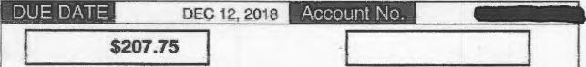

JACQUELYN NJAI
1111111111110
JACQUELYN NJAI  1111111111110 | PEOPLES  PO BOX 644760  H I I SBUFIGH, PA 15264-4760
1₁11 _{t}ip pill' 1111₁₁'₁;₁'11111st i_{l}ly ₁11 is ill t It lilltstplisi
10002100005152132000130000B66150.01101102E17755

O

JACQUELYN NJA1
0111¹¹¹111.11.
PITTSBURGH PA 15218-1944
Account Number
¹¹11111111.
Date Prepared Jan 22, 2019
Next Meter Reading
02/19 - 02/20/2019
d PEOPLES
MAKING YOUR LIFE BETTER.
For 24/7 account access⁻ peopleseaccount.com
For General Information call 1-800-764-0111. For an Emergency call 1-800-400-4271.

n
Monthly Usage Comparison
Average monthly use: 4.1 MCF
Total annual use: 49.2 MCF
Peoples current charges include $1.73 in state taxes.
Date Read Type Reading Difference
Meter Number 3927764
JAN 21, 2019 Estimate 673.4 10.4
DEC 19, 2018 Actual 663.0
MCF Used in 33 Days 10.4
This is an Estimated Bill.
Balance from last bill
Late Payment Charge
Balance
geszEpgmg
Rate RS Residential(P)
Customer Charge - 1 Month
Commodity Charge $3.6827 per MCF
Delivery Charge
10.4 MCF @ $3.6606
Capacity Charge $1.6615 per MCF
DSJC Surcharge 5.00%
State Tax Surcharge @ 0.23%
Tax Cuts and Jobs Act
Total Current Charges
Total Account Balance
$161.80
2.40
$164.20
$13.96
38.30
38.07 17.28 2.72 .07 CR 2.43 CR
$107.83
6272.03
Average Daily Temperature 2018 2019
For This Billing Period 22. F 35.F
Gas Use in MCF
Jan Feb Mar Ap May Jun Jul Aug Sep Oct Nov Dec Jan
2018 2019
0 Actual 0 Estimate II Customer Read 0 Adiusted Usage
16
12
8
4
0
Billing Period And Meter Readings
Your CURRENT PRICE TO COMPARE is $4.05 per MCF.
Shopping Information Box
When shopping for gas with a Natural Gas Supplier please provide the
following:
Account Number:
Rate Schedule: Rate esi ential(P)
If you are already shopping, know your contract expiration date.
Summa of Basic Charges
Credits And Char es Since Your Last Bill

lease Pa | Account Balance of $272.03 by FEB 13, 2019 to avoid a Late Payment Charge of $4.02 (1.5% per month )
Effective July 1, 2017, the Distribution System Improvement Charge (DSC) increased from 0.00 % to 5.00 %.
This charge funds the repair, improvement and replacement of natural gas pipelines and related infrastructure.
Help people without heat or light by donating to the Dollar Energy Fund. Please add $1 to your monthly gas payment.
You can pay this bill by Credit / Debit Card or Electronic Check. Call Western Union Speedpay at 1-866-338-5491.
Service Fees Apply. Visit our website at www.peoples-gas.com for further information.

TO MAKE ACCOUNT CHANGES ON BACK OF COUPON, CHECK BOX HERE.

Please detach and return this coupon with a check made payable to Peoples.
 |  | Account No. IMIK
DUE DATE | FEB 13, 2019

$272.03
Account Balance |  | Amount Enclosed

2460 568000437694
ammirJACQUELYN NJA1
LIHEAP, a federally funded program, provides energy assistance grants for income-eligible customers. The program opens November 1 and funds are limited. If you are out of work or on a low or fixed income, you should apply now. For details, call 1-800-400-WARM (9276).
PEOPLES
PO BOX 644760
PITTSBURGH, PA 15264-4760

I I I I I I I I I II I I 1 I 11 II I I II I I I I I I I I I I I II I 111 II II I

10002100005382020000000010783000000272039

JACQUELYN NJAI

PEOPLES
¹¹¹,¹1¹¹,14r15,944
Account Number Date Prepared Next Meter Reading
Mar 5, 2019 05/03 - 05/06/2019
MAKING YOUR LIFE BETTER.
For 24/7 account access: peopieseaccount.com
For General Information call 1-800-764-0111. For an Emergency call 1-800-400-4271. Avoid an estimate - call in a read between 04/03 and by 5 p.m. on 0410412019.

Summa of Basic Charges
Monthly Usage Comparison

redits-And Charles Since Your Last Bill
Balance from last bill  Late Payment Charge  Balance  MIESEMEMI  Rate RS Residential(P) | $272.03  4.02  $276.05
Customer Charge - 1 Month | $13.97
Commodity Charge $4.0552 per MCF | 57.99
Delivery Charge  14.3 MCF @ $3.6804 | 52.63
Capacity Charge $1.6434 per MCF | 23.50
DSIC Surcharge 5.00% | 3.49
State Tax Surcharge @ 0.23% | .10 CR
Tax Cuts and Jobs Act _ | 3.07 CR
Total Current Charges | 5146.41
Total Account Balance | $424.46
Peoples current charges include $2.29 in state taxes.
Average Daily Temperature 2018 2019
For This Billing Period 38⁻ F 31-F
Gas Use in MCF
12 9 6 3 0

1⁻¹
r--it rn r⁻i
Mar Apr May Jun Jul Aug Sep Oct Nov Dec Jan Feb Mar
2018 2019
0 Actuat 0 Estimate III Customer Read El kips⁻led Usage
Average monthly use: 3.9 MCF
Total annual use: 46.9 MCF
Billing Period And Meter Readings

Your Commodity Charge PRICE TO COMPARE is $4.05 per MCF.
Shopping Information Box

Date Read Type
Meter Number 3927764
MAR 05, 2019 Actual
JAN 21, 2019 Estimate MCF Used in 43 Days
Reading Difference
687.7 14.3
673.4
14.3
When shopping for gas with a Natural Gas Supplier please provide the following:
Account Number:
Rate Schedule: Rate esidentsa )
if you are already shopping, know your contract expiration date.

Account Balance of $424.46 by MAR 27, 2019 to avoid a Late Payment Charge of $6.25 (1.5% per month )
Please Pay

Effective July 1, 2017, the Distribution System Improvement Charge (DSIC) increased from 0.00 % to. 5.00 %.
This charge funds the repair, improvement and replacement of natural gas pipelines and related infrastructure.
Help people without heat or light by donating to the Dollar Energy Fund, Please add $1 to your monthly gas payment.
You can pay this bill by Credit / Debit Card or Electronic Check. Call Western Union Speedpay at 1-866-338-5491.
Service Fees Apply. Visit our website at www.peopies-gas.com for further information.

Please detach and return this coupon with a check made payable to Peoples. | TO MAKE ACCOUNT CHANGES ON BACK OF COUPON, CHECK BOX HERE.

DUE DATE
MAR 27, 2019
Account No.
$424.46
Account Balance |  | Amount Enclosed

874000452316
'/)
LIHEAP, a federally funded program, provides energy assistance grants for income-eligible customers. The program opens November 1 and funds are limited. If you are out of work or on a low or fixed income, you should apply now. For details, call 1-800-400-WARM (9276).
PEOPLES
PO BOX 644760
PITTSBURGH, PA 15264-4760
1111 111 11111111111111 11111111111111 111 111111111111111111 1111
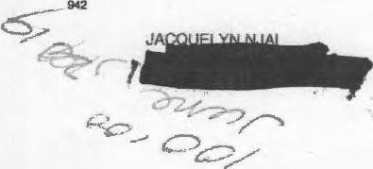

100021000051820200000000148410000011424467

!!!r!.
CI- T Pd 1•10/41
⁴¹¹¹¹.¹.¹11111MINED PITTSBURGH PA 15218-1944  4ccourii Number Date Prepared 111.1111111111e Apr 3, 2019 | Next Meter Reading  06104 - 06/05/2019 | PEOPLES  MAKING YOUR LIFE BETTER.  R.⁻)v 24(7 accoun_ access⁻ people5eaccounl.com  For General Information call 1-800-764-0111. For an Emergency call 1-800-400-4271-Avoid an estimate - call in a read between 05/03 and by 5 p.m. on 05106/2019.

Please detach and return this coupon with a died( made payable to Peoples. TO MAKE ACCOUNT CHANGES ON BACK OF COUPON. CHECK BOX HERE.

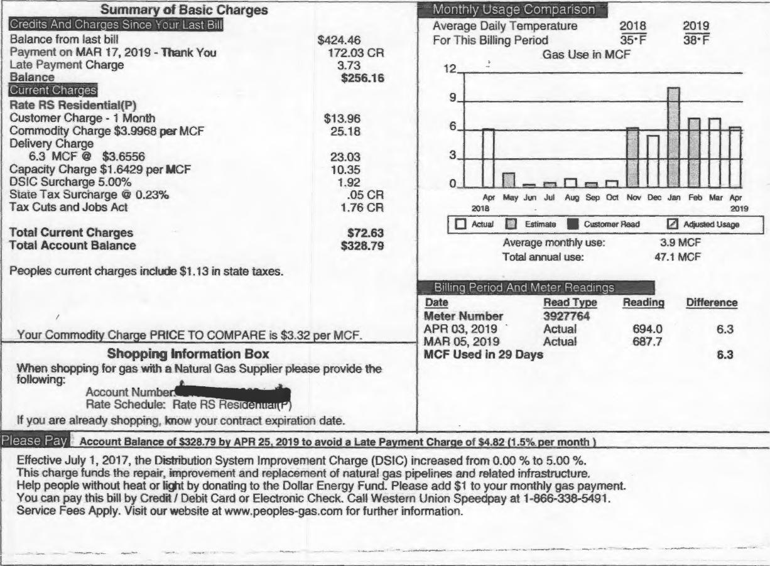
Please Pa
Account Balance of $328.79 by APR 25. 2019 to avoid a Late Payment Charge of $4.82 (1.5°/sper month 1
Mo⁻fithly⁻U⁻sage Comparisbn
Summary of Basic Charges
0 Actual El Estimate MI
Customer Read Adjusted Usage
Average monthly use: Total annual use:
3.9 MCF
47.1 MCF
694.0
687.7
Reading Difference
6.3
6.3
Credits And Chars es Since Your Last Bill
Balance from last bill
Payment on MAR 17, 2019 - Thank You
Late Payment Charge
Balance
Rate RS Residential(P)
Customer Charge - 1 Month | $13.96
Commodity Charge $3.9968 per MCF | 25.18
Delivery Charge  6.3 MCF @ $3.6556 | 23.03
Capacity Charge $1.6429 per MCF | 10.35
DSIC Surcharge 5.00% | 1.92

Average Daily Temperature 2018 2019
For This Billing Period 35- F 38' F
Gas Use in MCF
$424.46 172.03 CR
3.73
$256.16
State Tax Surcnarge t 0.23% Tax Cuts and Jobs Act
Total Current Charges Total Account Balance
Peoples current charges include $1.13 in state taxes.
Apr May Jun Jul Aug Sep Oct Nov Dec Jan Feb Mar Ap
2018 2019
.05 CR 1.76 CR
$72.63
$328.79
__Billing Period Aod Meter. Rea_clings__
Date Read Type
Meter Number 3927764
APR 03, 2019 Actual
MAR 05, 2019 Actual MCF Used in 29 Days
12
9
6
3
0
Your Commodi Charge PRICE TO COMPARE is $3.32 .er MCF. Shopping information Box
When shopping for gas with a Natural Gas Supplier please provide the
following:
Account Nu
Rate Schedule: Rate RS Rest
If you are already shopping. know your contract expiration date.
n
Effective July 1, 2017, the Distribution System Improvement Charge (DSIC) increased from 0.00 % to 5.00 %.
This charae funds the repair. improvement and replacement of natural gas pipelines and related infrastructure.
Help people without heat or light by donating to the Dollar Energy Fund. Please add $1 to your monthly gas payment.
You can pay this bill by Credit / Debit Card or Electronic Check. Call Western Union Speedpay at 1-866-338-5491.
Service Fees Apply. Visit our website at www.peoples-gas.com for further information.

DUE DATE APR 25, 2019 ACCOLICIt No.
$328.79 I
Account Balance Amount Enclosed
11673 874000466347
Call Before You Dig  Natural gas pipelines are buried on your property. There may be other utility lines there as well. For safety's sake and to avoid costly damage or loss of service, you or your contractor should call the ONE CALL SYSTEM at least three (3) working days before digging at 1-800-242-1776. As part of this free service, member utilities can help you locate underground service tines. | 0

C L

PEOPLES
PO BOX 644760
1-.IVISBUHUH, PA 15264-4760
I tit! I Ill! fis_{t}s 11111 il_{l}ip 0₁11111111 till, hilt 11,1

1000210000.5382020011001100117263MGM0328794

JACQUELYN NJAI
PEOPLES⁻
PITTSBURGH PA 15218-1944  Account Number Date Prepared Next Meter Reading  11111.111111111111 May 3, 2019 07103 - 07/0512019 | MAKING YOUR LIFE BETTER.  For 24/7 account access: peoplaseaccount,corn  For General Information call 1-800-764-0111. For an Emergency call 1-800-400-4271 Avoid an estimate - call in a read between 06/04 and by 5 p.m. on 06/05/2019.

10013210000538202011000000-02472110t3000358336

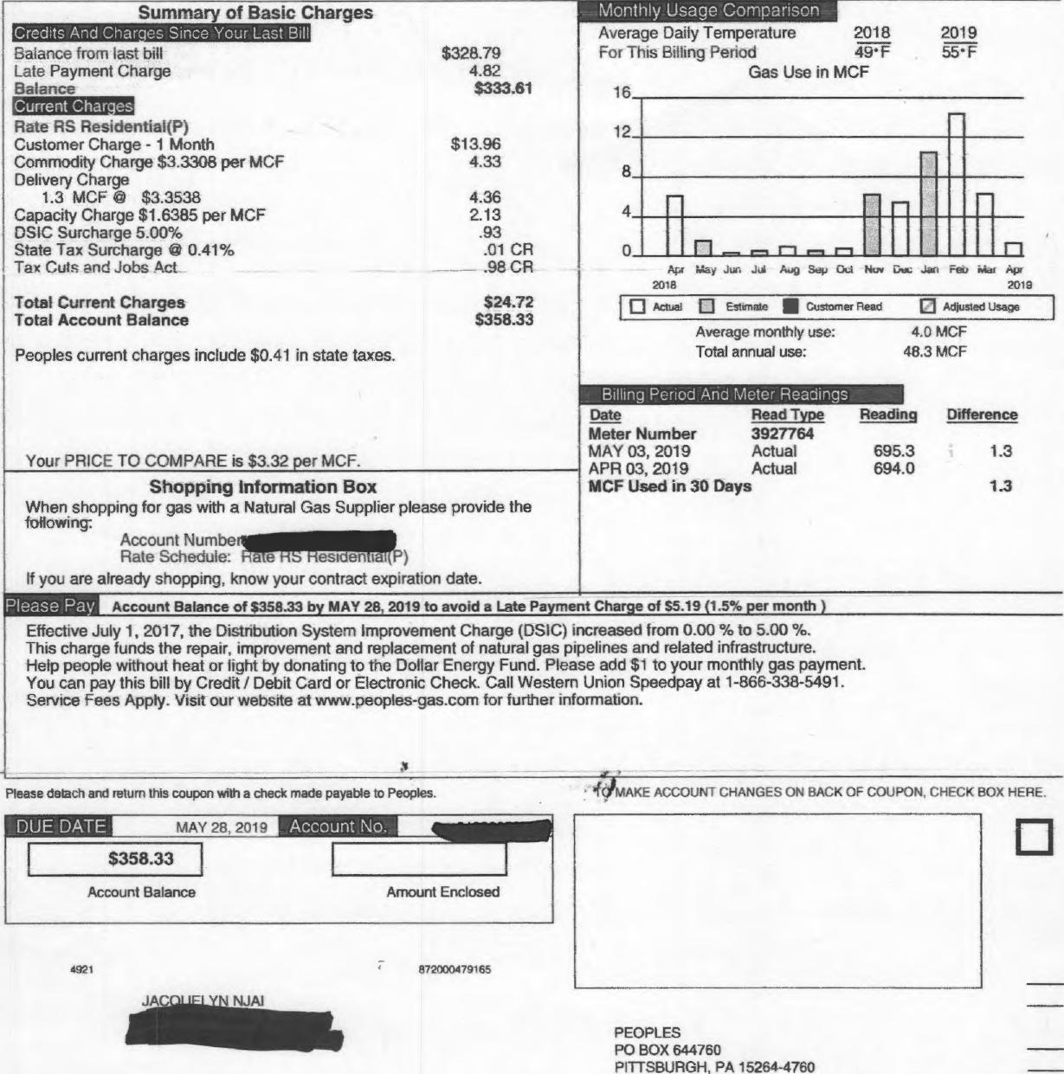
-L
Please detach and return this coupon with a check made payable to Peoples.
- 'I⁼C MAKE ACCOUNT CHANGES ON BACK OF COUPON, CHECK BOX HERE.
4921
872000479165
Effective July 1, 2017, the Distribution System Improvement Charge (DSIC) increased from 0.00 % to 5.00 %. This charge funds the repair, improvement and replacement of natural gas pipelines and related infrastructure.
Help people without heat or light by donating to the Dollar Energy Fund. Please add $1 to your monthly gas payment.
You can pay this bill by Credit / Debit Card or Electronic Check. Call Western Union Speedpay at 1-866-338-5491.
Service Fees Apply. Visit our website at www.peoples-gas.com for further information.
Account Balance
Amount Enclosed
JAC NJAI
PEOPLES
PO BOX 644760
PITTSBURGH, PA 15264-4760
Summary of Basic Charges
Monthly Usage Comparison-
Credits And Char•es Since Your Last Bill
Balance from last bill
Late Payment Charge
Balance
EMZEIZEM
Rate RS Residential(P)
Customer Charge - 1 Month
Commodity Charge $3.3308 per MCF
Delivery Charge
1.3 MCF @ $3.3538
Capacity Charge $1.6385 per MCF
DSIC Surcharge 5.00%
State Tax Surcharge @ 0.41%
Tax Cuts and Jobs Act
Total Current Charges Total Account Balance
$328.79
4.82
$333.61
$13.96
4.33
4.36
2.13
.93
.01 CR - .98 CR
$24.72 S358.33
Average Daily Temperature 2018 2019
For This Billing Period 49*F 55•F
Gas Use in MCF
16
12
8
4
0
Apr May Jung Jul Aug Sep Oct Nuv DIA; Jan Feb Mar Apr
2018 2019
ID Actual ID Estimate Customer Read ID Adjusted Usage
Peoples current charges include $0.41 in state taxes.
Average monthly use: Total annual use:
4,0 MCF 48.3 MCF
Billing Period Arid Meter Readings
Your PRICE TO COMPARE is $3.32 per MCF.
Shopping information Box
When shopping for gas with a Natural Gas Supplier please provide the
following:
Account Numbe
Rate Schedule: a e b esiden lal P)
If you are already shopping, know your contract expiration date.
Reading
695.3
694.0
Difference
1.3
1.3
Date
Meter Number MAY 03, 2019 APR 03, 2019
MCF Used in 30
Read Type
3927764
Actual Actual
Days
Account Balance of $358.33 by MAY 28, 2019 to avoid a Late Payment Charge of S5.19 (1.5% per month )
Please Pay

JACQUELYN NJAI
 |  | PEOPLES  MAKING YOUR LIFE BETTER.  r-or 24li account access: peopleseaccount.com  Fur General information call 1-800-764-0111. For an Emergency call 1-800-400-4271. Avoid an estimate - call in a read between 07/03 and by 5 p.m. on 07/05/2019.
Account Number Date Prepared Mrapt Jun 5, 2019 | Next Meter Reading  08/02 - 08/05/2019

Please detach and return this coupon with a check made payable to Peoples. TO MAKE ACCOUNT CHANGES ON BACK OF COUPON, CHECK BOX HERE.

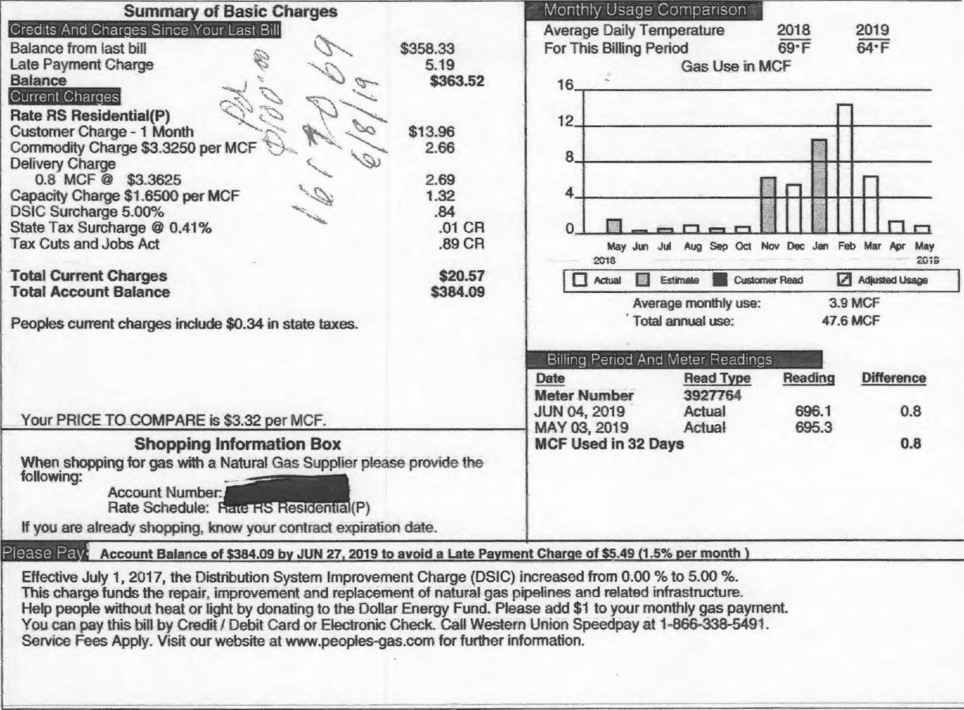
of Basic Charges
Summa
per MCF
MEZEINIE
Rate RS Residential(P) Customer Charge - 1 Month Commodity Charge $3.3250 Delivery Charge
$358.33
5.19
$363.52
$13.96
2.66
Monthly Usage Comparison
2013
201S
0 Actual 0 Estimate II Customer Read
Adjusted Usage
3.9 MCF 47.6 MCF
Average monthly use: Total annual use:
Please Pa
Account Balance of $384.09 by JUN 27, 2019 to avoid a Late Payment Charge of $5.49 (1.5% per month
0.8 MCF © $3.3625  Capacity Charge $1.6500 per MCF | 1,₄,₄ | 2.69  1.32
DSIC Surcharge 5.00% |  | .84
State Tax Surcharge @ 0.41% |  | .01 CR
Tax Cuts and Jobs Act |  | .89 CR
Total Current Charges |  | $20.57
Total Account Balance |  | $384.09

Peoples current charges include $0.34 in state taxes.
Billing Period And Meter Readinas
Your PRICE TO COMPARE is $3.32 per MCF.
Shopping Information Box
When shopping for gas with a Natural Gas Supplier please provide the
following:
OOM
Account Number:_{f}P
Rate Schedule: esi en la (P)
If you are already shopping, know your contract expiration date.
Effective July 1, 2017, the Distribution System Improvement Charge (DSIC) increased from 0.00 % to 5.00 %.
This charge funds the repair. improvement and replacement of natural gas pipelines and related infrastructure_
Help people without heat or light by donating to the Dollar Energy Fund. Please add $1 to your monthly gas payment.
You can pay this bill by Credit Debit Card or Electronic Check. Call Western Union Speedpay at 1-866-338-5491.
Service Fees Apply. Visit our website at www.peoples-gas.com for further information.
Credits And Charges Since Your Last Bill
Balance from last bill Late Payment Charge Balance
Average Daily Temperature 2018 2019
For This Billing Period 69•F 64•F
Gas Use in MCF
16
12
8
4
n
May Jun Jul Aug Sep Oct Nov Dec Jan Feb Mar Apr May
0
Reading
Read Type 3927764 Actual Actual
Days
Difference
696.1 0.8
695.3
0.8
Date
Meter Number JUN 04, 2019 MAY 03, 2019 MCF Used in 32

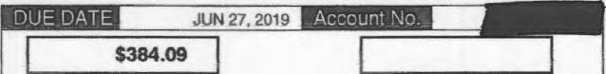
Amount Enclosed
840000128674
12213
Account Balance
Take advantage of our Budget Payment Plan. Enjoy the convenience of paying a planned amount each month - a feature which is especially helpful during the winter.We periodically review budget accounts to adjust for any over or under payments.

JACO ELYN NJAI

PEOPLES
PO BOX 644760
HI I I SBUFIGH, PA 15264-4760
h^{i}fi^{l}iT111¹¹1¹¹Wi^{s}P^{i}l^{li}lªiii^{i}i^{i}i^{ii}i"¹¹1¹111/11¹1^{11/}1¹¹¹¹¹

100D2100005382020000100130020570130000384095

JACQUELYN NJAI
PEOPLES
PITTSBURGH PA 15218-19441  ate PreparedJul 3, 2019 | Next Meter Reading  09/03 - 09/04/2019 | MAKING You R. LIFE BETTER,  For 2417 auxunt access: peopleseaccount.com  For General Information call 1-800-764-0111. For an Emergency call 1-800-400-4271 Avoid an estimate - call in a read between 08/02 and by 5 p.m. on 08/05/2019.

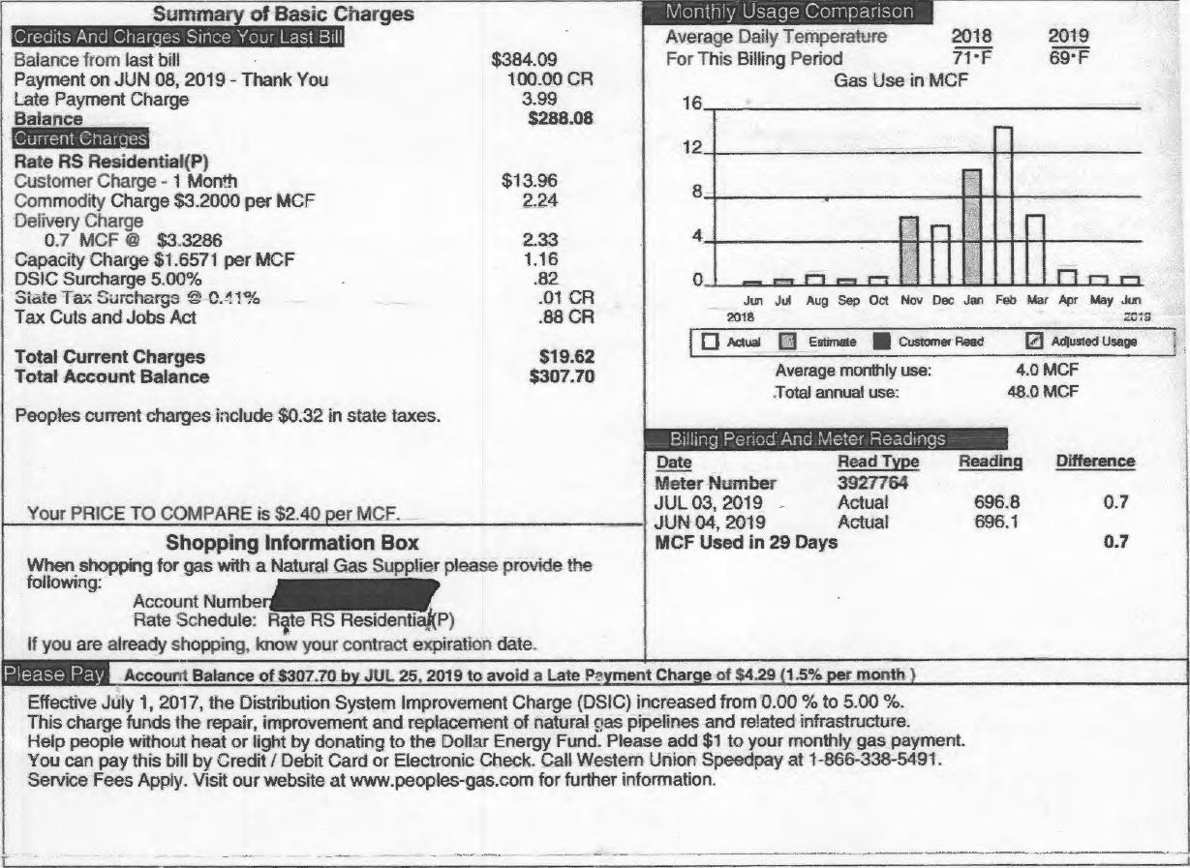
Please Pay,
Account Balance of $307.70 by JUL 25, 2019 to avoid a Late Payment Charge of $4.29 (1.5% per month
Summary of Basic Charges
Credits And Char es Since Your Last Bill
Balance from last bill
Payment on JUN 08, 2019 - Thank You
Late Payment Charge
Balance
Current Charges
Rate RS Residential(P)
Customer Charge - 1 Month
Commodity Charge $3.2000 per MCF
Delivery Charge
0.7 MCF @ $3..3286
Capacity Charge $1.6571 per MCF
DSIC Surcharge 5.00%
Slate Tax Surcharge © 0.!!1%
Tax Cuts and Jobs Act
Total Current Charges Total Account Balance
Peoples current charges include $0.32 in state taxes.
Billing,1?_{i}britA,And.Meter, Readings
$384.09 100.00 CR
3.99
$288.08
$13.96
2.24
2.33 1.16 .82 .01 CR .88 CR
$19.62
$307.70
Average Daily Temperature 2018 2019
For This Billing Period 71⁻F 69⁻F
Gas Use in MCF
16
12
8
4
n
Aug Sep Oct Nov Dec Jan Feb Mar Apr May Jun
2015
0
Actual Q Estimate Customer Read
Average monthly use: Total annual use:
Adjusted Usage
4.0 MCF 48.0 MCF
1⁻1
Jun Jul 2018
Your PRICE TO COMPARE is $2.40 •er MCF. Shopping Information Box
When shopping for gas with a Natural Gas Supplier please provide the following:
Account Number
Rate Schedule: Rite RS Residential(P)
If you are already shopping, know your contract expiration date.
Effective July 1, 2017, the Distribution System Improvement Charge (DSIC) increased from 0.00 % to 5.00 %.
This charge funds the repair, improvement and replacement of natural c:as pipelines and related infrastructure.
Help people without heat or light by donating to the Dollar Energy Fund. Please add $1 to your monthly gas payment.
You can pay this bill by Credit / Debit Card or Electronic Check. Call Western Union Speedpay at 1-866-338-5491.
Service Fees Apply. Visit our website at www.peoples-gas.com for further information.
Reading
Read Type 3927764 Actual Actual
Days
Difference
696.8 0.7
696.1
0.7
Date
Meter Number JUL 03, 2019 JUN 04, 2019 MCF Used in 29
Please detach and return this coupon with a check made payable to Peoples. | TO MAKE ACCOUNT CHANGES ON BACK OF COUPON, CHECK BOX HERE.

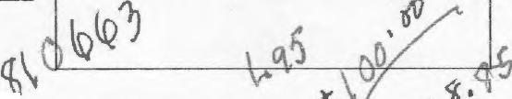
Take advantage of our Budget Payment Plan. Enjoy the convenience of paying a planned amount each month - a feature which is especially helpful during the winter.We periodically review budget accounts to adjust for any over or under payments.

Account No. 1111
Amount Enclosed
DUE DATE
$307.7⁷6⁻7
JUL 25, 2019
Account Balance

391 | 872000508876

JACQUELYN NJAI

,₆0/rd,
PEOPLES
PO BOX 644760
PITTSBURGH, PA 15264-4760
\V
‘,41 .
^{jtt}
1000210000538202000000000196200000030770⁶4\
afAX- 7:
me_04-404.

JACQUELYN NJAI  . _ 15218-1944  'Date Prepared Aug 5,2019 | Next Meter Reading  10/02 - 10/03/2019 | PEOPLES  MAKING YOUR LIFE BETTER.  For 24/7 account access: peopleseaccount.com  For General Information call 1-800-764-0111. For an Emergency call 1-800-400-4271. Avoid an estimate - call in a read between 02103 and by 5 p.m. on 09/04/2319.

Summary of Basic Charges |  |  | _ Monthly Usage Comparison  Average Daily Temperature 2018 2019
Credits And Charges Since Your Last Bill
Balance from last bill $307.70
Payment on JUL 04, 2019 - Thank You 100.00 CR
Late Payment Charge 2.85
Balance $210.55
For This Billing Period 73⁻ F 75`F
Gas Use in MCF
16
 |  |  | 12 |  |  |  |  |  | _
Current Charges  Rate IRS Residential(P) Customer Charge Commodity Charge Delivery Charge  0.6 MCF @ Capacity Charge DSIC Surcharge State Tax Surcharge Tax Cuts and Jobs  Total Current Charges Total Account Balance  Peoples current  Your PRICE TO | - 1 Month $13.96  $2.4167 per MCF 1.45  $3.2667 1.96  $1.6667 per MCF 1.00  5.00% .80  @ 0.41% .01 CR  Act .86 CR  $18.30  $228.85  charges include $0.34 in state taxes.  COMPARE is $2.40 per MCF.  8
 |  |  |  |  |  |  |  | '⁻'1
 |  |  | 4 |  |  | - | ---, |  |  | -i
 |  |  | 0 |  | _{t}-i i⁻i r-e r-i |  |  |  |  | rl r⁻1 r⁻1 r⁻t
Ad Aug Sep Oct Nov Dec Jan Feb Mar Apr May Jun J_{u}l
2010 2019
 |  |  |  | 0 Actual El Esimate III customer Read 0 Ad$usled usage
Average monthly use: 4.0 MCF
Total annual use: 48.1 MCF
Billing Period And Meter Readings
Date Read Type Reading Difference
Meter Number 3927764
AUG 02, 2019 Actual 697.4 0.6
JUL 03, 2019 Actual 696.8
MCF Used in 30 Days 0.6
Shopping Information Box
When shopping for gas with a Natural Gas Supplier please provide the
following:
Account Number
¹¹11-a 11 0 al
Rate Schedule⁻ 1 ,, (P) If you are already shopping, know your contract expiration date.
Please Pa Account Balance of $228.85 by AUG 27. 2019 to avoid a Late Payment Charge of 53.12 (1.5% per month )
Effective July 1, 2017, the Distribution System Improvement Charge (DSIC) increased from 0.00 % to 5.00 %.
This charge funds the repair, improvement and replacement of natural gas pipelines and related infrastructure.
Help people without heat or light by donating to the Dollar Energy Fund. Please add $1 to your monthly gas payment.
You can pay this bill by Credit / Debit Card or Electronic Check. Call Western Union Speedpay at 1-866-338-5491.
Service Fees Apply. Visit our website at www.peoples-gas.com for further information.

Please detach and return this coupon with a check made payable to Peoples. TO MAKE ACCOUNT CHANGES ON BACK OF COUPON, CHECK BOX HERE.
- JACQUELYN NJAI

Take advantage of our Budget Payment Plan. Enjoy the convenience of paying a planned amount each month - a feature which is especially helpful during the winter.We periodically review budget accounts to adjust for any over or under payments.
22052 828000547167
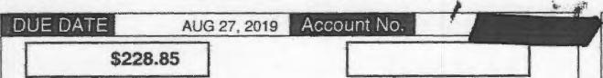
Account Balance Amount Enclosed
PFOPLFS
PO BOX 644760
PITTSBURGH, PA 15264-4760
1 _{l}ib pill' pi rill si ol nil si r ai
10002100005382020000000001830000000228850

JACQUELYN NJAI 4¹11¹110P15218-19^{I}r

PEOPLES⁻
$228.85 100.00 CR
1.68 S130.53
count- Date Prepared
MAKING YOUR Lin BETTER.
peopleseaccount.com
For General Information call 1-800-764-0111. For an Emergency call 1-800-400-4271. Avoid an estimate - call in a read between 10/02 and by 5 p.m. on 10/03/2019.
Sep 3, 2019 Next Meter Reading
10/31 - 11/01/2019
Summary of Basic Charges
Monthly Usage Comparison _

Credits And Char. es Since Your Last Bill
Average Daily Temperature 2018 2019
For This Billing Period 74'F 72•F
Gas Use in MCF
Balance from last bill
Payment on AUG 25. 2019 - Thank You
Late Payment Charge
Balance
16

EMEMBEMM
12
Rate RS Residential(P)
Customer Charge - 1 Month
$13.96
1.45
1.96
1.00 .80 .01 CR .86 C.', R
$18.30
5148.83
8
Commodity Charge $2.4167 per MCF Delivery Charge
0.6 MCF $3.2667
4
Capacity Charge $1.6667 per MCF DSIC Surcharge 5.00%
0
r-r
State Tax Surcharge @ 0.41%
Aug Sep Cot Nov Dec Jan Feb Mar Apr May Jul Jul Aug
Ana 2019
r' 1 _
I Can Vulj CAI IU t...”01/0
Actual EsIlmale Customer Sead 0 Adiusied Usage
Total Current Charges
Total Account Balance
Average monthly use: Total annual use:
3.9 MCF
47.8 MCF
Peoples current charges include $0.34 in state taxes. 1
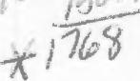
Billing Period And Meter Readings
Date
Meter Number
SEP 03. 2019
AUG 02. 2019
MCF Used in 32 Days
Read Type 3927764 Actual Actual
Reading
Difference
698.0 0.6
697.4
0.6
Your PRICE TO COMPARE is $2.40 per MCF.
Shopping Information Box
When shopping for gas with a Natural Gas Supplier please provide the
following:
Account Number'1111.1r
Rate Schedule: Rate RS Res? en )
If you are already shopping, know your contract expiration date.

Please Pa | Account Balance of 5148.83 by SEP 25. 2019 to avoid a Late Payment Charge of 51.95 (1.5% per month )
Effective July 1, 2017, the Distribution System Improvement Charge (DSIC) increased from 0.00 % to 5.00 %.
This charge funds the repair, improvement and replacement of natural gas pipelines and related infrastructure.
Help people without heat or light by donating to the Dollar Energy Fund. Please add $1 to your monthly gas payment.
You can pay this bill by Credit / Debit Card or Electronic Check. Call Western Union Speedpay at 1-866-338-5491.
Service Fees Apply. Visit our website at www.peoples-gas.com for further information.

Please detach and return this coupon with a check made payable to Peoples. TO MAKE ACCOUNT CHANGES ON BACK OF COUPON. CHECK BOX HERE.

Take advantage of our Budget Payment Plan. Enjoy the convenience of paying a planned amount each month - a feature which is especially helpful during the winter.We periodically review budget accounts to adjust for any over or under payments.

 |  |  |  | Account No. Mr_
DUE DATE | SEP 25, 2019 |  |  | Account No. Mr_

$148.83
Account Balance | Amount Enclosed

5160 896000505664
JAC ELYN NJAI | 1
JAC ELYN NJAI | 1 | PEOPLES  PO BOX 644760  PITTSBURGH, PA 15264-4760  1111111111111111111111111 I I I 1111111 11111111111111111 tut


10002100005382020000000001830000000148835

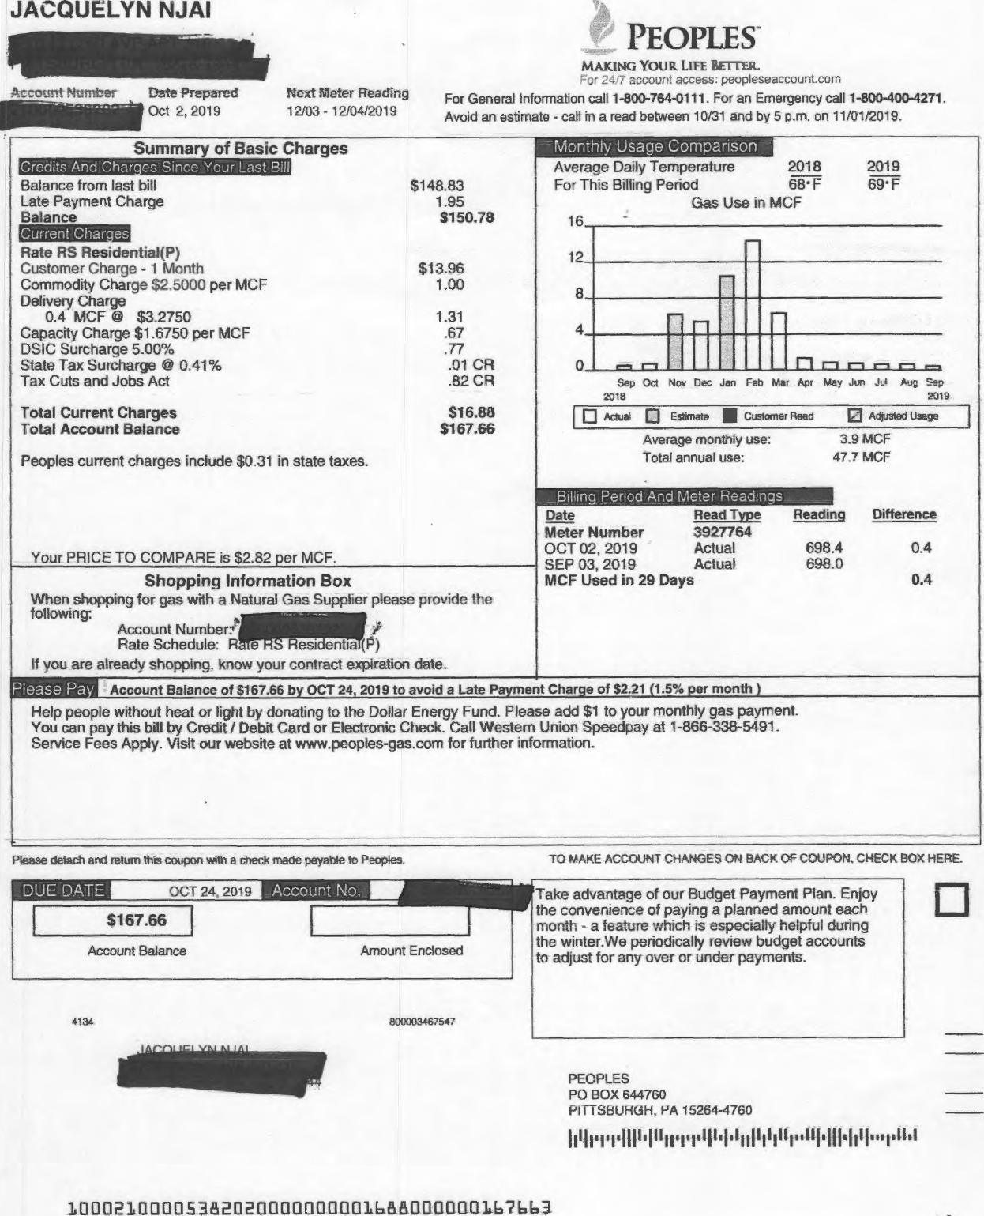
TO MAKE ACCOUNT CHANGES ON BACK OF COUPON. Cl-tECK BOX HERE.
Please detach and return this coupon with a check made payable to Peoples.
Account Balance
Amount Enclosed
4134
800003467547
PEOPLES
PO BOX 644760
1-¹111SBUKCil-1, I-⁴A 15264-4760
1111111111,
JACQUELYN NJAI
Account Number Date Prepared Next Meter Reading
111.₁₁₁₁₁1 Oct 2, 2019 12/03 - 12/0⁴/₂019
PEOPLES
MAKING YOUR LIFE BETTER.
L- recount access: peopleseaccount.com
For General Information call 1-800-764-0111. For an Emergency call 1-800-400-4271. Avoid an estimate - call in a read between 10/31 and by 5 p.m. on 11/01/2019.
Summary of Basic Charges |  | - Monthly Usage Comparison
 |  | Average Daily Temperature 2018 2019
Credits And Cha 'es Since Your Last Bill
Balance from last bill $148.83
Late Payment Charge 1.95
Balance S150.78
For This Billing Period 68. F 69. F
Cis Use in MCF
16
 |  | 12 |  |  |  |  |  | -
EIMEEM
Rate RS Residential(P)
Customer Charge - 1 Month $13.96
Commodity Charge $2.5000 per MCF 1.00 Delivery Charge
0.4 MCF kit $3.2750 1.31
Capacity Charge $1.6750 per MCF .67
DSIC Surcharge 5.00% .77
State Tax Surcharge `.1 0.41% .01 CR
Tax Cuts and Jobs Act .82 CR
Total Current Charges S16.88
Total Account Balance $167.66 Peoples current charges include $0.31 in state taxes.
Your PRICE TO COMPARE is $2.82 'or MCF.
8
 |  |  |  |  |  |  | -
 |  | 4 |  |  | r- |  |  |  | -
 |  | 0 |  | ,--, i--1 |  |  |  |  | El m t-, _r-i_ = ,-,
Sep Oct Nov Dec Jan Feb Mar Apr May Jun Jut Aug Sep
20/8 2019
 |  |  | MI Actua 0 Estimate Customer Read NI Adjusted Usage
Average monthly use: 3.9 MCF
Total annual use: 47.7 MCF
 |  | ,Billing Period And, Meter Readings_
 |  | Date Read Type Reacting Difference
Meter Number 3927764
OCT 02, 2019 Actual 698.4 ^{0.4}SEP 03, 2019 Actual 698.0
MCF Used in 29 Days 0.4
Shopping Information Box
When shopping for gas with a Natural Gas Supplier please provide the following:
Account Number; /
. ,.
Rate Schedule: R e Residentia (P)
If you are already shopping. know your contract expiration date.
Please Pa Account Balance of $167.66 by OCT 24, 2019 to avoid a Late Payment Charge of $2.21 (1.5% per month )
Help people without heat or light by donating to the Dollar Energy Fund. Please add $1 to your monthly gas payment. You can pay this bill by Credit / Debit Card or Electronic Check. Call Western Union Speedpay at 1-866-338-5491. Service Fees Apply. Visit our website at www.peoptes-gas.com for further information.

1000210000538213200000000016A8110000010663
Take advantage of our Budget Payment Plan. Enjoy the convenience of paying a planned amount each month • a feature which is especially helpful during the winter.We periodically review budget accounts to adjust for any over or under payments.

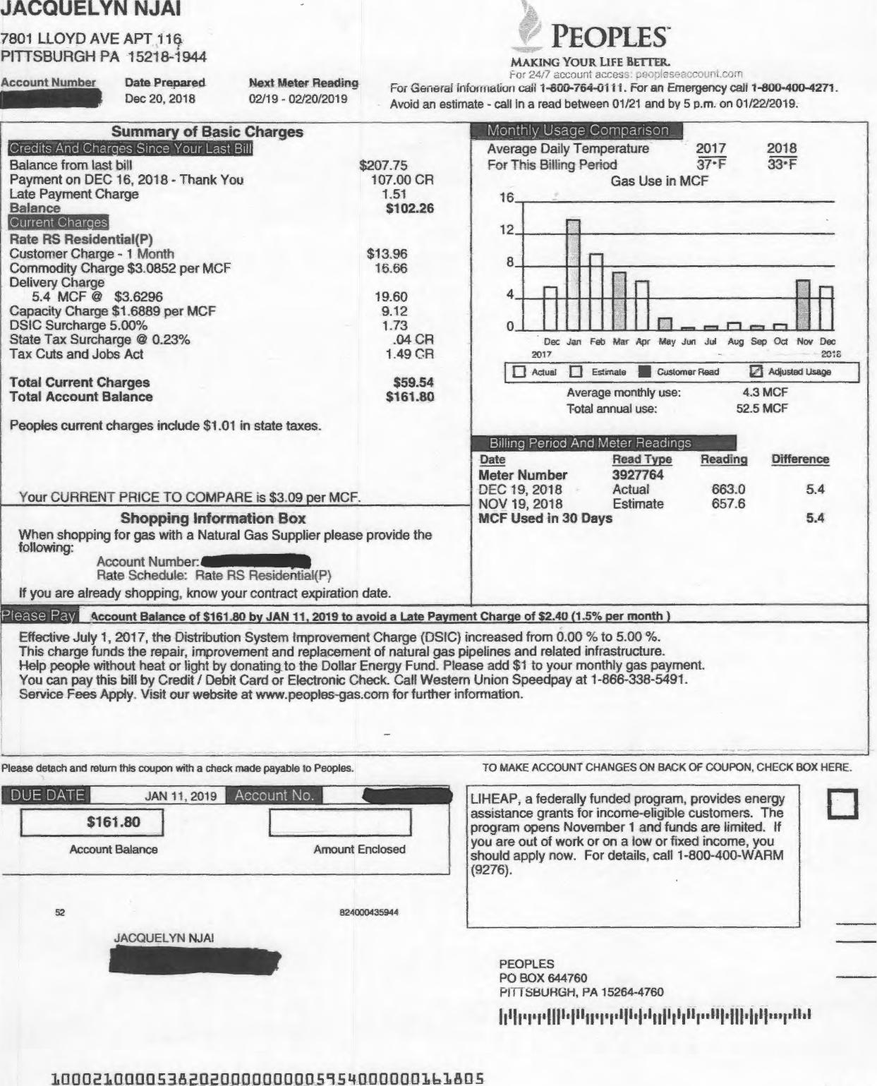
Dec 20, 2018
02/19 - 02/20/2019
0
Aaual Estimate
Customer Read Q Adlusted Usage
Reading
Difference
663.0 5.4
657.6
5.4
Please detach and return this coupon with a check made payable to Peoples.
TO MAKE ACCOUNT CHANGES ON BACK OF COUPON, CHECK BOX HERE.
JACQUELYN NJAI
1110111101it
PEOPLES
PO BOX 644760
SBUNGH, PA 15264-4760
Wh^{I}PHI1^{h}T^{I}H1^{d}1¹¹1¹1¹¹001¹¹1"1¹111¹10^{8t}i^{did}
JACQUELYN NJAI
7801 LLOYD AVE APT ilct PITTSBURGH PA 15218-1944
Account Number Date Prepared Next Meter ReaCtirta
Summary of Basic Charges
PEOPLES
MAKING YOUR LIFE BETTER.
For 2417 account acces _,E - :-. • - -
For General infoir liditUfl call 1-600-764-01 i i. For an Emergency call 1-800-400-4271. Avoid an estimate - call in a read between 01/21 and by 5 p.m. on 01/22/2019.
Monthly Usage Comparison
Ciedits And Charges Sinae Your Last Bill
Balance from last bill
Payment on DEC 16, 2018 - Thank You
Late Payment Charge
Balance
Rate RS Residential(P)
Customer Charge - 1 Month
Commodity Charge $3.0852 per MCF
Delivery Charge
5.4 MCF @ $3.6296
Capacity Charge $1 6889 per MCF
DS1C Surcharge 5.00%
State Tax Surcharge 0.23%
Tax Cuts and Jobs Act
Total Current Charges Total Account Balance
Peoples current charges include $1.01 in state taxes.
Average Daily Temperature 2017 2018
For This Billing Period 37•F 33•F
Gas Use in MCF
Dec Jan Feb Mar Ap May Jun Jul Avg Sep Oa Nov Dec
291⁷ 2131E.
16 12 8 4
0
Average monthly use: Total annual use:
Billing Period And Meter Readings
Your CURRENT PRICE TO COMPARE is $3.09 •er MCF. Shopping Information Box
When shopping for gas with a Natural Gas Supplier please provide the
following:
Account Number. Rate Schedule: Rate RS Residential(P)
If you are already shopping, know your contract expiration date.
4ccount Balance of 8161.80 b JAN 11, 2019 to avoid a Late Pa ment Charge of $2.40 1.5% •er month
Please Pa
Effective July 1, 2017, the Distribution System Improvement Charge (DSIC) increased from 0.00 % to 5.00 %.
This charge funds the repair, improvement and replacement of natural gas pipelines and related infrastructure.
Help people without heat or light by donating to the Dollar Energy Fund. Please add $1 to your monthly gas payment.
You can pay this bill by Credit / Debit Card or Electronic Check. Call Western Union Speedpay at 1-866-338-5491.
Service Fees Apply. Visit our website at www.peoples--gas.com for further information.
100021000053821320000000005954000000161805
Amount Enclosed
Enclosed
$161.80
Account Balance
52
824009425944
LIHEAP, a federally funded program, provides energy assistance grants for income-eligible customers. The program opens November 1 and funds are limited. If you are out of work or on a low or fixed income, you should apply now. For details, call 1-800-400-WARM (9276).
DUE DATE
JAN 11, 2019
Account No.
$207.75 107.00 CR
1.51
$102.26
$13.96
16.66
19.60 9.12 1.73 .04 CR 1.49 OR
$59.54
$161.80
4.3 MCF
52.5 MCF
Date Read Type
Meter Number 3927764
DEC 19, 2018 Actual
NOV 19, 2018 Estimate MCF Used in 30 Days
r⁻⁻

JACQUELYN NjAi  44  ccount Number .* Date Prepared Next Meier Reeding  Feb 4, 2020 04/01 - 04/0²/₂020 05 | PEOPLES⁻  MAKING YOUR LIFE BETTER.  t-or 24u account access. peopieseaccount.com  For General Information call 1-800-764-0111. For an Emergency call 1-800-400-4271. Avoid an estimate - call in a read between 03/03 and by 5 p.m. on 03/04/2020.

Summary of Basic Charges |  |  | Monthly Usage Comparison  Average Daily Temperature 2019 2020
CreditsAndCharses Balance from last TCJA One Time Balance  Current Charcies | Since Your Last Bill  bill  Refund | $189.00  17.16 CR  $171.84
 | Since Your Last Bill  bill  Refund | $189.00  17.16 CR  $171.84 | For This Billing Period 26⁻F 35•F  Gas Use in MCF  16
 | Since Your Last Bill  bill  Refund | $189.00  17.16 CR  $171.84 | 12 |  |  |  | _
Residential (RSXP)
Customer Charge -1 Month $14.50
Commodity Charge $1.9869 per MCF 19.67
Delivery Charge
9.9 MCF @ $4.2172 41.75
Capacity Charge $1.6679 per MCF 16.71
Total Current Charges $92.63
Total Account Balance $264.47
Peoples current charges include $1.12 in state taxes.
Your PRICE TO COMPARE is $2.48 per MCF.
 |  |  | 8 |  |  | _.., |  |  | — | , | -
 |  |  | 4
 |  |  | 0 |  |  |  |  | fl r- r-, 1—.1 rn 1--, n
Jan Feb Ma Apr May Jun Jul Aug Sep Oct Now Dec Jan
2019 2020
 |  |  |  | 0 Actual 0 Estimate 111 Customer Rawl 0 Adiustad Usage
Average monthly use: 4.5 MCF
Total annual use: 54.4 MCF
Billing Period AndMeter Readings
Date Read Type Reading Difference
Meter Number 3927764
FEB 04, 2020 Actual 727.8 ^{9.9}JAN 03, 2020 Actual 717.9
MCF Used in 32 Days 9.9
Shopping Information Box
When shopping for gas with a Natural Gas Supplier please provide the
following:
Account Number:
Rate Schedule: R )
11111101111
if you are already shopping, know your contract expiration date.
lease Pa Account Balance of $264.47 by FEB 26, 2020
Effective October 29, 2019, the Distribution System Improvement Charge (DSIC) decreased from 5.00 % to 0.00 ?lo, This charge funds the repair, improvement and replacement of natural gas pipelines and related infrastructure. Help people without heat or light by donating to the Dollar Energy Fund. Please add $1 to your monthly gas payment. You can pay this bill by Credit / Debit Card or Electronic Check. Call Western Union Speedpay at 1-866-338-5491, Service Fees Apply. Visit our website at wwwpooples-gas.com for further information.

TO MAKE ACCOUNT CHANGES ON BACK OF COUPON, CHECK BOX HERE.

Please detach and return this coupon with a check made payable to Peoples.

DUE DATE | FEB 26.2020 Account No. Illff

$264A7
Account Balance Amount Enclosed
12521 1370003139740
_{imummis}, JACQUELYN NJA1
LIHEAP, a federally funded program, provides energy assistance grants for income-eligible customers. The program opens November 1 and funds are limited. If you are out of work or on a low or fixed income, you should apply now. For details, call 1-800-400-WARM (9276).
PEOPLES
PO BOX 644760
PITTSBURGH. PA 15264-4760

~IIh

10013210000538202001113001100921.300111:11311264,47

Credits And Char es Since Your Last Bill
2020
JACQUELYN NJA1  UMW  Ikcc umber Date Prepared Next Meter Reading  Mai 3, 2020 0.5/01 - 05/04/2020 | B  05 | PEOPLE S  MAKING YOUR LIFE RErrER.  For General Information call 1-800-764-0111. For an Emergency call 1-800-400-4271. Avoid an estimate - call in a read between 04/01 and by 5 p.m. on 04/02/2020.

Manthly_Usage Comparison
Summa of Basic Charges


Balance from last bill
Balance

EMEMOSIEM
Residential (RS)(P)
Customer Charge - 1 Month
Commodity Charge $1.9869 per MCF
Delivery Charge
8.4 MCF @ $4.2179
Capacity Charge $1.6881 per MCF
Total Current Charges
Total Account Balance
$264.47
$264.47
$14.50
16.69
35.43
14.18
$80.80
$345.27
Average Daily Temperature
For This Billing Period 34 • F
2019
33'F
Gas Use in MCF
16 12 8 4
1⁻1 n
0

Peoples current charges include $0.98 in state taxes.
Feb Mar Apr May Jun Jul Aug Sep Oct Nov Dec Jan Feb
2019 2029

- ACtuat 0 Estrnete Customer Bead ❑ Ad deed Usage
Average monthly use: Total annual use: | 4.D MCF  48.5 MCF

Billing Period And Meter Readings

Your PRICE TO COMPARE is $2.48 per MCF.

Date Read Type
Meter Number 3927764
MAR 03, 2020 Actual
FEB 04, 2020 Actual MCF Used in 28 Days
Reading Difference
736.2 8.4
727.8
8.4
Shopping information Box
When shopping for gas with a Natural Gas Supplier please provide the following:
Account Numbe Rate Schedule: Fddential (
It you are already shopping. know your contract expiration date.

lease Pa | Account Balance of $345.27 by MAR 25, 2020
Effective October 29, 2019, the Distribution System Improvement Charge (DSIC) decreased from 5.00 % to 0.00 %. This charge funds the repair, improvement and replacement of natural gas pipelines and related infrastructure, Help people without heat or light by donating to the Dollar Energy Fund. Please add $1 to your monthly gas payment. You can pay this bill by Credit / Debit Card or Electronic Check. Call Western Union Speedpay at 1-866-338-5491. Service Fees Apply. Visit our website at www.peopies-gas.com for further information.

'tease detach and return this coupon with a check made payable to Peoples.
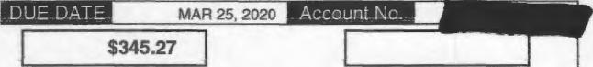
Account Balance Amount Enclosed
3796 1368090624561
JA NJAI
TO MAKE ACCOUNT CHANGES ON BACK OF COUPON, CHECK BOX HERE.
LIHEAP, a federally funded program, provides energy assistance grants for income-eligible customers. The program opens November 1 and funds are limited. if you are out of work or on a low or fixed income, you should apply now. For details, call 1-800-400-WARM (9276).

PEOPLES
PO BOX 644760
PITTSBURGH, PA 15264-4760

100021000053821:12001100EIDOD8080000000345276

JACCAUELYr4 | PEOPLES⁻  MAKING YOUR LIFE BETTER.  -ccourti iucess. peopieseaceourli.cum  For General Information call 1-800-764-0111. For an Emergency call 1-800-400-4271. Avoid an estimate - call in a read between 05/01 and by 5 p.m. on 05/04/2020.

A ate Prepared Next Meter Reading B
Apr 2, 2020 06/02 - 06/03/2020 05

Summa of Basic Charges | Monthly⁻Usage Comparison⁻⁻  Average Daily Temperature 2019 2020
Credits And Char es Since Your Last Bill
Balance from last bill $345.27
Balance $345.27
For This Billing Period 37•F 44•F
Gas Use in MCF
12
Current Char es
Residential (RS)(P)
Customer Charge - 1 Month $14.50
Commodity Charge $1.9837 per MCF 9.72 Delivery Charge
4.9 MCF @ $4.2143 20.65
Capacity Charge $1.6898 per MCF 8.28
DSIC Surcharge 0.13% .05 CR
Total Current Charges $53.10
Total Account Balance $398.37
Peoples current charges include $0.64 in state taxes.
Your PRICE TO COMPARE is $1.92 ser MCF.
 | 9 |  |  |  |  | _ | —
 | 6 |  | — |  | — |  |  | —
 | 3
 | 0 |  |  | 11 r1 ri rim ,—, n |  | _
Mar Apr May Jun Jut Aug Sep Oct Nov Dec Jan Feb Mar
2019 2020
 |  | El Actual 0 Estimate customer Read 0 Adjusted Usage
Average monthly use: 3.9 MCF
Total annual use: 47.1 MCF
Billing Period And Meter Readings
Date Read Type Reading Difference
Meter Number 3927764
APR 02, 2020 Actual 741.1 ^{4.9}MAR 03, 2020 Actual 736.2
MCF Used in 30 Days 4.9
Shopping Information Box
When shopping for gas with a Natural Gas Supplier please provide the
following: _{imilmor} i
Account Numbe ._{ii} ₋7
Rate Schedule:
if you are already shopping, know your contract expiration date.
lease Pa Account Balance of $398.37 by APR 24, 2020
Effective April 1, 2020, the Distribution System Improvement Charge (DSIC) decreased from 0.00 % to -0.13 %.
This charge funds the repair, improvement and replacement of natural gas pipelines and related infrastructure.
Help people without heat or light by donating to the Dollar Energy Fund. Please add $1 to your monthly gas payment.
You can pay this bill by Credit / Debit Card or Electronic Check. Call Western Union Speedpay at 1-866-338-5491.
Service Fees Apply. Visit our website at www.peoples-gas.com for further information.

Please detach and return this coupon with a check made payable to Peoples. TO MAKE ACCOUNT CHANGES ON BACK OF COUPON, CHECK BOX HERE.

Call Before You Dig
Natural gas pipelines are buried on your property. There may be other utility lines there as well. For safety's sake and to avoid costly damage or loss of service, you or your contractor should call the ONE CALL SYSTEM at least three (3) working days before digging at 1-800-242-1776. As part of this free service, member utilities can help you locate underground service lines.
 |  | Account No. 1111
DUE DATE | APR 24, 2020 | Account No. 1111

$398.37
Account Balance | Amount Enclosed

10381 802000704961

JACQUELYN NJAI
MOM.
JACQUELYN NJAI  MOM. | PEOPLES  PO BOX 644760  PIT I⁻SBURGH, HA 15264-4760  111111111111111111111111111111111111111111114111111111111111111111111
1000210000538202000000000531000000039.8.372 |  | 14

JACQUELYN NJAI  7801 LLOYD AVE APT 116  PITTSBURGH PA 15218-1944  Account Number Date Prepared Next Meter Reading B  210000538202 Sep 1, 2020 10/29 - 10/30/2020 05 | PEOPLEF§bit Package Page 23  -Now-  For 24/7 account access: peopleseaccount.corn  For General Information call 1-800-764-0111. For an Emergency call 1-800-400-4271. Avoid an estimate - call in a read between 09/30 and by 5 p.m. on 10/01/2020.

Summa of Basic Charges  Credits And Charges Since Your Last Bill  Balance from last bill $455.73  Balance $455.73 | Monthly Usage Comparison
Average Daily Temperature 2019 2020
For This Billing Period 72•F 74-F
Gas Use in MCF
12
MEM=
Residential (RS)(P)
Customer Charge -1 Month $14.50
Commodity Charge $1.4833 per MCF .8g Delivery Charge
0.6 MCF 0 $4.1500 2,49
Capacity Charge $1.7167 per MCF 1.03
DSIC Surcharge 0.13% .02 CR
Total Current Charges 918.89
Total Account Balance $474.62
Peoples current charges include $0.25 in state taxes.
Your PRICE TO COMPARE is $1.48 per MCF.
 | g |  |  |  | — | —
 | 6 |  |  | — |  |  | —
 | 3 |  |  |  |  |  |  | r---
 | 0 |  | n r, I7 |  |  |  |  |  | TI | n .--, t⁻⁻1 r-t
Aug Sep Oct Noy DOC Jan Feb Mar Apr May Jun Jul Aug
2019 2020
 |  | El Ached 0 Estimate Customer Real • Adjusted Usage
Average monthly use: 4.2 MCF
Total annual use: 50.5 MCF
 | Billing Period And Meter Readings
 | Date Read Type Readina Difference
Meter Number 3927764
AUG 31, 2020 Actual 748.5 0,6
JUL 31, 2020 Actual 747.9
MCF Used in 31 Days 0.6
Shopping Information Box
When shopping for gas with a Natural Gas Supplier please provide the
following:
Account Number: 210000538202
Rate Schedule: Residential (RS)(P)
If you are already shopping, know your contract expiration date.
MEM Account Balance of $474.62 by SEP 23₇2020 I
Effective April 1, 2020, the Distribution System Improvement Charge (DM) decreased from 0.00 % to -0.13 %.
This charge funds the repair, improvement and replacement of natural gas pipelines and related infrastructure.
Did you forget to pay last month's bill? As of Sep 1, 2020 , your account is past due. Please pay the full amount due
by Sep 23, 2020. If you have already paid it, thank you. If you need assistance, you can make payment arrangements
by calling us at 1-800-764-0111.
Help people without heat or light by donating to the Dollar Energy Fund. Please add $1 to your monthly gas payment.
You can pay this bill by Credit / Debit Card or Electronic Check. Call AC1 Speedpay at 1-866-338-5491.
Service Fees Apply. Visit our website at www.peoples-gas.com for further information.

TO MAKE ACCOUNT CHANGES ON BACK OF COUPON, CHECK BOX HERE.
Please detach and return this coupon with a check made payable to Peoples.
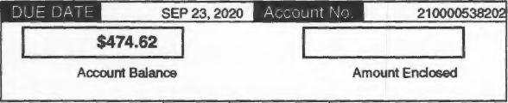
8394 804000768726
Take advantage of our Budget Payment Plan. Enjoy the convenience of paying a planned amount each month - a feature which is especially helpful during the winter.We periodically review budget accounts to adjust for any over or under payments.

JACQUELYN NJAI
7801 LLOYD AVE APT 116
PITTSBURGH PA 15218-1944
PEOPLES
PO BOX 644760
PITTSBURGH, PA 15264.4760

11111.1.1.1111.1"11.1.1.111.1.11111111"1"1.111.101ifir"
1000210 000 5382 02 00000000018890 00 000 47 4 629
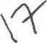

Exhibit Package Page 1

EXHIBIT A

PEOPLES NATURAL GAS Exhibit Package Page 2
Statement of Account Page 1 of 7
Name Njai, Jacquelyn Account Number 210000538202 For Questions Call (800)-764-0111
Address 7801 Lloyd Ave Apt 116 Meter Number 3927764 Hearing Impaired Customers TDD (800)-527-1333
Pittsburgh, PA 15218-1944

Date | Reading  Date | Bill Days | Meter Reading | Transaction Type | Usage | Degree Days | Transaction  Amount | Sales/State Tax | City/County Tax | Due Date | Plan Desc | Plan Amt  Due | Total Plan Amt Due | Balance
 | 07/30/12 |  | 372.5 | INITIAL ACTUAL |  |  |  |  |  |  |  |  |  | $0.00
09/20/12 |  |  |  | TRANSFER FEE |  |  | $25.00 |  |  |  |  |  |  | $25.00
09/20/12 | 08/22/12 | 24 | 372.9 | ACTUAL | 0.4 | 2 | $12.47 |  |  | 10/12/12 |  |  |  | $37.47
09/20/12 | 09/19/12 | 28 | 374.1 | SYS EST | 1.2 | 41 | $20.26 |  |  | 10/12/12 |  |  |  | $57.73
10/18/12 |  |  |  | LPC |  |  | $0.49 |  |  |  |  |  |  | $58.22
10/18/12 | 10/18/12 | 29 | 374.5 | ACTUAL | 0.4 | 302 | $15.39 |  |  | 11/09/12 |  |  |  | $73.61
11/14/12 |  |  |  | PAYMENT |  |  | ($73.63) |  |  |  |  |  |  | ($0.02)
11/21/12 | 11/19/12 | 32 | 379.0 | SYS EST | 4.5 | 630 | $47.71 |  |  | 12/13/12 |  |  |  | $47.69
12/18/12 |  |  |  | PAYMENT |  |  | ($47.69) |  |  |  |  |  |  | $0.00
12/20/12 | 12/19/12 | 30 | 382.0 | ACTUAL | 3.0 | 714 | $35.97 |  |  | 01/11/13 |  |  |  | $35.97
01/23/13 |  |  |  | LPC |  |  | $0.54 |  |  |  |  |  |  | $36.51
01/23/13 | 01/18/13 | 30 | 391.1 | SYS EST | 9.1 | 982 | $87.35 |  |  | 02/14/13 |  |  |  | $123.86
02/21/13 |  |  |  | LPC |  |  | $1.85 |  |  |  |  |  |  | $125.71
02/21/13 | 02/20/13 | 33 | 401.3 | ACTUAL | 10.2 | 1,221 | $99.36 |  |  | 03/15/13 |  |  |  | $225.07
03/25/13 | 03/21/13 | 29 | 409.3 | SYS EST | 8.0 | 885 | $78.49 |  |  | 04/16/13 | CAP | $36.00 | $36.00 | $303.56
04/03/13 |  |  |  | LIHEAP CASH |  |  | ($271.00) |  |  |  |  |  |  | $32.56
04/03/13 |  |  |  | CAP CREDIT |  |  | ($48.74) |  |  |  |  |  |  | ($16.18)
04/24/13 | 04/23/13 | 33 | 413.4 | ACTUAL | 4.1 | 597 | $48.97 |  |  | 05/16/13 | CAP | $36.00 | ($199.00) | $32.79
04/24/13 |  |  |  | CAP CREDIT |  |  | ($19.22) |  |  |  |  |  |  | $13.57
05/24/13 | 05/22/13 | 29 | 414.9 | SYS EST | 1.5 | 170 | $26.33 |  |  | 06/17/13 | CAP | $36.00 | ($163.00) | $39.90
05/24/13 |  |  |  | Pre-CAP WRITE OFF |  |  | ($4.25) |  |  |  |  |  |  | $35.65
06/21/13 | 06/20/13 | 29 | 415.4 | ACTUAL | 0.5 | 89 | $17.07 |  |  | 07/15/13 | CAP | $36.00 | ($127.00) | $52.72
06/21/13 |  |  |  | Pre-CAP WRITE OFF |  |  | ($4.25) |  |  |  |  |  |  | $48.47
07/24/13 | 07/22/13 | 32 | 415.9 | SYS EST | 0.5 |  | $16.76 |  |  | 08/15/13 | CAP | $36.00 | ($91.00) | $65.23
07/24/13 |  |  |  | Pre-CAP WRITE OFF |  |  | ($4.25) |  |  |  |  |  |  | $60.98
08/23/13 | 08/22/13 | 31 | 416.9 | ACTUAL | 1.0 | 12 | $20.82 |  |  | 09/16/13 | CAP | $36.00 | ($55.00) | $81.80
08/23/13 |  |  |  | Pre-CAP WRITE OFF |  |  | ($4.25) |  |  |  |  |  |  | $77.55
09/25/13 | 09/23/13 | 32 | 417.6 | SYS EST | 0.7 | 72 | $18.32 |  |  | 10/17/13 | CAP | $36.00 | ($19.00) | $95.87
09/25/13 |  |  |  | Pre-CAP WRITE OFF |  |  | ($4.25) |  |  |  |  |  |  | $91.62
10/23/13 | 10/22/13 | 29 | 418.1 | ACTUAL | 0.5 | 156 | $16.59 |  |  | 11/14/13 | CAP | $36.00 | $17.00 | $108.21
11/25/13 | 11/21/13 | 30 | 422.8 | SYS EST | 4.7 | 624 | $50.38 |  |  | 12/17/13 | CAP | $36.00 | $53.00 | $158.59

PEOPLES NATURAL GAS Exhibit Package Page 3
Statement of Account Page 2 of 7
Name Njai, Jacquelyn Account Number 210000538202 For Questions Call (800)-764-0111
Address 7801 Lloyd Ave Apt 116 Meter Number 3927764 Hearing Impaired Customers TDD (800)-527-1333
Pittsburgh, PA 15218-1944

Date | Reading  Date | Bill Days | Meter Reading | Transaction Type | Usage | Degree Days | Transaction  Amount | Sales/State Tax | City/County Tax | Due Date | Plan Desc | Plan Amt  Due | Total Plan Amt Due | Balance
12/02/13 |  |  |  | PAYMENT |  |  | ($20.00) |  |  |  |  |  |  | $138.59
12/20/13 | 12/20/13 | 29 | 428.8 | ACTUAL | 6.0 | 977 | $60.84 |  |  | 01/13/14 | CAP | $36.00 | $69.00 | $199.43
01/24/14 | 01/22/14 | 33 | 438.8 | SYS EST | 10.0 | 1,193 | $98.25 |  |  | 02/17/14 | CAP | $36.00 | $105.00 | $297.68
02/14/14 |  |  |  | PAYMENT |  |  | ($100.00) |  |  |  |  |  |  | $197.68
02/24/14 | 02/21/14 | 30 | 451.5 | ACTUAL | 12.7 | 1,276 | $125.25 |  |  | 03/18/14 | CAP | $36.00 | $41.00 | $322.93
03/26/14 | 03/24/14 | 31 | 460.2 | SYS EST | 8.7 | 1,036 | $89.74 |  |  | 04/17/14 | CAP | $36.00 | $77.00 | $412.67
04/03/14 |  |  |  | PAYMENT |  |  | ($42.00) |  |  |  |  |  |  | $370.67
04/24/14 | 04/23/14 | 30 | 464.0 | ACTUAL | 3.8 | 503 | $47.62 |  |  | 05/16/14 | CAP | $36.00 | $71.00 | $418.29
05/27/14 | 05/23/14 | 30 | 467.8 | SYS EST-CANCEL | 3.8 | 243 | $48.15 |  |  | 06/18/14 | CAP | $36.00 | $107.00 | $466.44
06/27/14 | 05/23/14 | -30 | 467.8 | BILL REVERSAL | -3.8 | -243 | ($48.15) |  |  |  |  |  |  | $418.29
06/27/14 | 05/23/14 | 30 | 465.0 | Corrected SYS EST | 1.0 | 243 | $23.02 |  |  | 07/21/14 | CAP | $36.00 | $107.00 | $441.31
06/27/14 | 06/24/14 | 32 | 466.2 | ACTUAL | 1.2 | 15 | $24.81 |  |  | 07/21/14 | CAP | $36.00 | $143.00 | $466.12
07/07/14 |  |  |  | PAYMENT |  |  | ($110.00) |  |  |  |  |  |  | $356.12
07/25/14 | 07/23/14 | 29 | 466.7 | SYS EST | 0.5 | 4 | $18.56 |  |  | 08/18/14 | CAP | $36.00 | $69.00 | $374.68
08/25/14 | 08/22/14 | 30 | 467.4 | ACTUAL | 0.7 | 20 | $20.33 |  |  | 09/16/14 | CAP | $36.00 | $105.00 | $395.01
09/24/14 | 09/22/14 | 31 | 468.1 | SYS EST | 0.7 | 75 | $20.33 |  |  | 10/16/14 | CAP | $36.00 | $141.00 | $415.34
09/29/14 |  |  |  | PAYMENT |  |  | ($105.00) |  |  |  |  |  |  | $310.34
10/24/14 | 10/23/14 | 31 | 468.9 | ACTUAL | 0.8 | 266 | $21.02 |  |  | 11/17/14 | CAP | $36.00 | $72.00 | $331.36
11/25/14 | 11/21/14 | 29 | 473.8 | SYS EST | 4.9 | 659 | $55.73 |  |  | 12/17/14 | CAP | $42.00 | $114.00 | $387.09
12/23/14 | 12/23/14 | 32 | 481.5 | ACTUAL | 7.7 | 911 | $79.49 |  |  | 01/14/15 | CAP | $42.00 | $156.00 | $466.58
01/26/15 | 01/23/15 | 31 | 491.3 | SYS EST | 9.8 | 1,122 | $97.64 |  |  | 02/17/15 | CAP | $42.00 | $198.00 | $564.22
02/24/15 | 02/23/15 | 31 | 503.4 | ACTUAL | 12.1 | 1,356 | $117.22 |  |  | 03/18/15 | CAP | $42.00 | $240.00 | $681.44
03/18/15 |  |  |  | PAYMENT |  |  | ($36.00) |  |  |  |  |  |  | $645.44
03/25/15 | 03/24/15 | 29 | 511.3 | SYS EST | 7.9 | 970 | $81.48 |  |  | 04/16/15 | CAP | $42.00 | $246.00 | $726.92
04/24/15 |  |  |  | LPC |  |  | $9.87 |  |  |  |  |  |  | $736.79
04/24/15 | 04/23/15 | 30 | 513.2 | ACTUAL | 1.9 | 436 | $29.17 |  |  | 05/18/15 |  |  |  | $765.96
05/08/15 |  |  |  | PAYMENT |  |  | ($114.00) |  |  |  |  |  |  | $651.96
05/26/15 |  |  |  | LPC |  |  | $9.63 |  |  |  |  |  |  | $661.59
05/26/15 | 05/22/15 | 29 | 514.9 | SYS EST | 1.7 | 204 | $26.97 |  |  | 06/17/15 |  |  |  | $688.56
06/24/15 |  |  |  | LPC |  |  | $10.04 |  |  |  |  |  |  | $698.60
06/24/15 | 06/23/15 | 32 | 514.8 | Corrected ACTUAL | -0.1 | 34 | $13.54 |  |  | 07/16/15 |  |  |  | $712.14

PEOPLES NATURAL GAS Exhibit Package Page 4
Statement of Account Page 3 of 7
Name Njai, Jacquelyn Account Number 210000538202 For Questions Call (800)-764-0111
Address 7801 Lloyd Ave Apt 116 Meter Number 3927764 Hearing Impaired Customers TDD (800)-527-1333
Pittsburgh, PA 15218-1944

Date | Reading  Date | Bill Days | Meter Reading | Transaction Type | Usage | Degree Days | Transaction  Amount | Sales/State Tax | City/County Tax | Due Date | Plan Desc | Plan Amt  Due | Total Plan Amt Due | Balance
07/24/15 | 07/23/15 | 30 | 515.3 | SYS EST | 0.5 | 4 | $17.69 |  |  | 08/17/15 | CAP | $42.00 | $42.00 | $729.83
08/21/15 | 08/21/15 | 29 | 516.6 | ACTUAL | 1.3 |  | $22.88 |  |  | 09/14/15 | CAP | $42.00 | $84.00 | $752.71
09/23/15 | 09/22/15 | 32 | 517.1 | SYS EST | 0.5 | 8 | $17.63 |  |  | 10/15/15 | CAP | $42.00 | $126.00 | $770.34
09/24/15 |  |  |  | PAYMENT |  |  | ($84.00) |  |  |  |  |  |  | $686.34
10/23/15 | 10/21/15 | 29 | 517.1 | ACTUAL | 0.0 | 204 | $14.42 |  |  | 11/16/15 | CAP | $42.00 | $84.00 | $700.76
10/29/15 |  |  |  | PAYMENT |  |  | ($42.00) |  |  |  |  |  |  | $658.76
11/20/15 | 11/19/15 | 29 | 520.0 | SYS EST | 2.9 | 374 | $33.83 |  |  | 12/14/15 | CAP | $42.00 | $84.00 | $692.59
12/22/15 | 12/21/15 | 32 | 524.7 | ACTUAL | 4.7 | 755 | $45.85 |  |  | 01/13/16 | CAP | $42.00 | $126.00 | $738.44
01/25/16 | 01/25/16 | 35 | 535.1 | SYS EST | 10.4 | 1,163 | $81.35 |  |  | 02/16/16 | CAP | $42.00 | $168.00 | $819.79
02/24/16 | 02/23/16 | 29 | 546.2 | ACTUAL | 11.1 | 931 | $84.44 |  |  | 03/17/16 | CAP | $42.00 | $210.00 | $904.23
02/24/16 |  |  |  | CAP CREDIT |  |  | ($38.26) |  |  |  |  |  |  | $865.97
02/25/16 |  |  |  | PAYMENT |  |  | ($70.00) |  |  |  |  |  |  | $795.97
03/24/16 | 03/23/16 | 29 | 551.2 | SYS EST | 5.0 | 569 | $45.95 |  |  | 04/15/16 | CAP | $41.00 | $181.00 | $841.92
04/07/16 |  |  |  | PAYMENT |  |  | ($112.00) |  |  |  |  |  |  | $729.92
04/25/16 | 04/22/16 | 30 | 554.8 | ACTUAL | 3.6 | 438 | $36.75 |  |  | 05/17/16 | CAP | $41.00 | $110.00 | $766.67
04/25/16 |  |  |  | CAP DIFFERENCE |  |  | $2.25 |  |  |  |  |  |  | $768.92
05/24/16 | 05/23/16 | 31 | 556.7 | SYS EST | 1.9 | 256 | $26.14 |  |  | 06/15/16 | CAP | $41.00 | $151.00 | $795.06
05/24/16 |  |  |  | CAP DIFFERENCE |  |  | $12.86 |  |  |  |  |  |  | $807.92
06/23/16 | 06/23/16 | 31 | 556.7 | ACTUAL | 0.0 | 14 | $14.58 |  |  | 07/15/16 | CAP | $41.00 | $192.00 | $822.50
06/23/16 |  |  |  | CAP DIFFERENCE |  |  | $24.42 |  |  |  |  |  |  | $846.92
07/25/16 | 07/22/16 | 29 | 557.2 | SYS EST | 0.5 | 2 | $17.10 |  |  | 08/16/16 | CAP | $44.00 | $236.00 | $864.02
07/25/16 |  |  |  | CAP DIFFERENCE |  |  | $24.90 |  |  |  |  |  |  | $888.92
07/26/16 |  |  |  | PAYMENT |  |  | ($117.78) |  |  |  |  |  |  | $771.14
07/26/16 |  |  |  | Pre-CAP WRITE OFF |  |  | ($53.34) |  |  |  |  |  |  | $717.80
08/23/16 | 08/22/16 | 31 | 557.7 | ACTUAL | 0.5 |  | $17.15 |  |  | 09/14/16 | CAP | $44.00 | $162.22 | $734.95
08/23/16 |  |  |  | CAP DIFFERENCE |  |  | $24.85 |  |  |  |  |  |  | $759.80
09/22/16 | 09/21/16 | 30 | 558.2 | SYS EST | 0.5 |  | $17.15 |  |  | 10/14/16 | CAP | $44.00 | $206.22 | $776.95
09/22/16 |  |  |  | CAP DIFFERENCE |  |  | $24.85 |  |  |  |  |  |  | $801.80
10/21/16 |  |  |  | PAYMENT |  |  | ($34.00) |  |  |  |  |  |  | $767.80
10/21/16 | 10/20/16 | 29 | 558.7 | ACTUAL | 0.5 | 136 | $17.39 |  |  | 11/14/16 | CAP | $44.00 | $250.22 | $785.19
10/21/16 |  |  |  | CAP DIFFERENCE |  |  | $24.61 |  |  |  |  |  |  | $809.80

PEOPLES NATURAL GAS Exhibit Package Page 5
Statement of Account Page 4 of 7
Name Njai, Jacquelyn Account Number 210000538202 For Questions Call (800)-764-0111
Address 7801 Lloyd Ave Apt 116 Meter Number 3927764 Hearing Impaired Customers TDD (800)-527-1333
Pittsburgh, PA 15218-1944

Date | Reading  Date | Bill Days | Meter Reading | Transaction Type | Usage | Degree Days | Transaction  Amount | Sales/State Tax | City/County Tax | Due Date | Plan Desc | Plan Amt  Due | Total Plan Amt Due | Balance
11/22/16 | 11/21/16 | 32 | 563.3 | SYS EST | 4.6 | 520 | $46.07 |  |  | 12/14/16 | CAP | $44.00 | $260.22 | $855.87
12/16/16 |  |  |  | PAYMENT |  |  | ($97.22) |  |  |  |  |  |  | $758.65
12/19/16 |  |  |  | Pre-CAP WRITE OFF |  |  | ($53.34) |  |  |  |  |  |  | $705.31
12/21/16 | 12/21/16 | 30 | 568.5 | ACTUAL | 5.2 | 912 | $50.27 |  |  | 01/12/17 | CAP | $44.00 | $207.00 | $755.58
12/24/16 |  |  |  | CAP ADJUSTMENT |  |  | ($138.74) |  |  |  |  |  |  | $616.84
01/24/17 | 01/23/17 | 33 | 578.2 | SYS EST | 9.7 | 953 | $87.36 |  |  | 02/15/17 | CAP | $44.00 | $251.00 | $704.20
01/24/17 |  |  |  | CAP CREDIT |  |  | ($24.48) |  |  |  |  |  |  | $679.72
01/30/17 |  |  |  | PAYMENT |  |  | ($50.00) |  |  |  |  |  |  | $629.72
01/30/17 |  |  |  | Pre-CAP WRITE OFF |  |  | ($17.78) |  |  |  |  |  |  | $611.94
02/22/17 | 02/21/17 | 29 | 586.3 | ACTUAL | 8.1 | 827 | $76.78 |  |  | 03/16/17 | CAP | $44.00 | $245.00 | $688.72
03/11/17 |  |  |  | PAYMENT |  |  | ($97.50) |  |  |  |  |  |  | $591.22
03/13/17 |  |  |  | Pre-CAP WRITE OFF |  |  | ($35.56) |  |  |  |  |  |  | $555.66
03/23/17 | 03/22/17 | 29 | 593.7 | SYS EST | 7.4 | 779 | $71.40 |  |  | 04/17/17 | CAP | $44.00 | $191.50 | $627.06
04/24/17 | 04/21/17 | 30 | 595.8 | ACTUAL | 2.1 | 307 | $29.90 |  |  | 05/16/17 | CAP | $44.00 | $235.50 | $656.96
05/23/17 | 05/22/17 | 31 | 597.7 | SYS EST-CANCEL | 1.9 | 217 | $28.49 |  |  | 06/14/17 | CAP | $44.00 | $279.50 | $685.45
05/31/17 |  |  |  | PAYMENT |  |  | ($235.50) |  |  |  |  |  |  | $449.95
05/31/17 |  |  |  | Pre-CAP WRITE OFF |  |  | ($88.90) |  |  |  |  |  |  | $361.05
06/20/17 |  |  |  | PAYMENT |  |  | ($45.00) |  |  |  |  |  |  | $316.05
06/20/17 |  |  |  | Pre-CAP WRITE OFF |  |  | ($160.02) |  |  |  |  |  |  | $156.03
06/26/17 | 05/22/17 | -31 | 597.7 | BILL REVERSAL | -1.9 | -217 | ($28.49) |  |  |  |  |  |  | $127.54
06/26/17 | 05/22/17 | 31 | 596.4 | Corrected SYS EST | 0.6 | 217 | $18.54 |  |  | 07/18/17 | CAP | $44.00 | ($1.00) | $146.08
06/26/17 | 06/21/17 | 30 | 597.1 | ACTUAL | 0.7 | 37 | $19.30 |  |  | 07/18/17 | CAP | $44.00 | $43.00 | $165.38
06/26/17 |  |  |  | Pre-CAP WRITE OFF |  |  | ($17.78) |  |  |  |  |  |  | $147.60
07/24/17 | 07/21/17 | 30 | 597.6 | SYS EST | 0.5 | 8 | $18.44 |  |  | 08/15/17 | CAP | $45.00 | $88.00 | $166.04
 | 08/10/17 |  | 597.9 | ACTUAL ERT RETROFIT |  |  |  |  |  |  |  |  |  | $166.04
08/22/17 | 08/21/17 | 31 | 598.1 | ACTUAL | 0.5 |  | $18.66 |  |  | 09/13/17 |  |  |  | $184.70
09/21/17 |  |  |  | LPC |  |  | $2.77 |  |  |  |  |  |  | $187.47
09/21/17 | 09/20/17 | 30 | 599.0 | SYS EST | 0.9 | 58 | $21.83 |  |  | 10/13/17 |  |  |  | $209.30
09/23/17 |  |  |  | PAYMENT |  |  | ($50.00) |  |  |  |  |  |  | $159.30
10/20/17 |  |  |  | LPC |  |  | $2.35 |  |  |  |  |  |  | $161.65
10/20/17 | 10/19/17 | 29 | 599.1 | ACTUAL | 0.1 | 94 | $15.64 |  |  | 11/13/17 |  |  |  | $177.29

PEOPLES NATURAL GAS Exhibit Package Page 6
Statement of Account Page 5 of 7
Name Njai, Jacquelyn Account Number 210000538202 For Questions Call (800)-764-0111
Address 7801 Lloyd Ave Apt 116 Meter Number 3927764 Hearing Impaired Customers TDD (800)-527-1333
Pittsburgh, PA 15218-1944

Date | Reading  Date | Bill Days | Meter Reading | Transaction Type | Usage | Degree Days | Transaction  Amount | Sales/State Tax | City/County Tax | Due Date | Plan Desc | Plan Amt  Due | Total Plan Amt Due | Balance
10/30/17 |  |  |  | PAYMENT |  |  | ($62.94) |  |  |  |  |  |  | $114.35
11/21/17 | 11/20/17 | 32 | 605.1 | SYS EST | 6.0 | 653 | $70.41 |  |  | 12/13/17 | BUD + | $62.94 | $62.94 | $184.76
12/18/17 |  |  |  | PAYMENT |  |  | ($69.00) |  |  |  |  |  |  | $115.76
12/21/17 | 12/20/17 | 30 | 610.5 | ACTUAL | 5.4 | 830 | $64.86 |  |  | 01/12/18 | BUD + | $62.94 | $56.88 | $180.62
01/20/18 |  |  |  | PAYMENT |  |  | ($70.00) |  |  |  |  |  |  | $110.62
01/23/18 | 01/22/18 | 33 | 624.2 | SYS EST | 13.7 | 1,404 | $136.20 |  |  | 02/14/18 | BUD + | $62.94 | $49.82 | $246.82
02/20/18 |  |  |  | LPC |  |  | $3.70 |  |  |  |  |  |  | $250.52
02/20/18 | 02/20/18 | 29 | 633.7 | ACTUAL | 9.5 | 883 | $96.71 |  |  | 03/14/18 | BUD + | $62.94 | $116.46 | $347.23
02/24/18 |  |  |  | PAYMENT |  |  | ($64.89) |  |  |  |  |  |  | $282.34
03/22/18 |  |  |  | LPC |  |  | $4.24 |  |  |  |  |  |  | $286.58
03/22/18 | 03/21/18 | 29 | 640.9 | SYS EST | 7.2 | 804 | $76.87 |  |  | 04/13/18 | BUD + | $62.94 | $118.75 | $363.45
03/23/18 |  |  |  | PAYMENT |  |  | ($51.57) |  |  |  |  |  |  | $311.88
04/20/18 |  |  |  | LPC |  |  | $4.68 |  |  |  |  |  |  | $316.56
04/20/18 | 04/20/18 | 30 | 647.0 | ACTUAL | 6.1 | 688 | $67.55 |  |  | 05/14/18 | BUD + | $62.94 | $134.80 | $384.11
04/21/18 |  |  |  | PAYMENT |  |  | ($60.00) |  |  |  |  |  |  | $324.11
05/22/18 |  |  |  | LPC |  |  | $4.86 |  |  |  |  |  |  | $328.97
05/22/18 | 05/21/18 | 31 | 648.5 | SYS EST | 1.5 | 165 | $27.73 |  |  | 06/13/18 | BUD + | $62.94 | $142.60 | $356.70
06/21/18 |  |  |  | LPC |  |  | $3.24 |  |  |  |  |  |  | $359.94
06/21/18 |  |  |  | PAYMENT |  |  | ($140.60) |  |  |  |  |  |  | $219.34
06/21/18 | 06/21/18 | 31 | 648.8 | ACTUAL | 0.3 | 20 | $17.30 |  |  | 07/13/18 | BUD + | $62.94 | $68.18 | $236.64
07/23/18 |  |  |  | LPC |  |  | $3.50 |  |  |  |  |  |  | $240.14
07/23/18 | 07/20/18 | 29 | 649.3 | SYS EST | 0.5 |  | $18.51 |  |  | 08/14/18 | BUD + | $62.94 | $134.62 | $258.65
08/14/18 |  |  |  | PAYMENT |  |  | ($134.62) |  |  |  |  |  |  | $124.03
08/21/18 | 08/20/18 | 31 | 650.2 | ACTUAL | 0.9 |  | $22.22 |  |  | 09/12/18 | BUD + | $62.94 | $62.94 | $146.25
09/20/18 |  |  |  | LPC |  |  | $2.19 |  |  |  |  |  |  | $148.44
09/20/18 | 09/19/18 | 30 | 650.7 | SYS EST | 0.5 | 11 | $18.58 |  |  | 10/12/18 | BUD + | $62.94 | $128.07 | $167.02
10/19/18 |  |  |  | LPC |  |  | $2.47 |  |  |  |  |  |  | $169.49
10/19/18 | 10/18/18 | 29 | 651.4 | ACTUAL | 0.7 | 177 | $20.02 |  |  | 11/13/18 | BUD + | $62.94 | $193.48 | $189.51
10/30/18 |  |  |  | GOODWILL CREDIT |  |  | ($50.00) |  |  |  |  |  |  | $139.51
11/20/18 |  |  |  | LPC |  |  | $2.09 |  |  |  |  |  |  | $141.60
11/20/18 | 11/19/18 | 32 | 657.6 | SYS EST | 6.2 | 748 | $66.15 |  |  | 12/12/18 |  |  |  | $207.75

PEOPLES NATURAL GAS Exhibit Package Page 7
Statement of Account Page 6 of 7
Name Njai, Jacquelyn Account Number 210000538202 For Questions Call (800)-764-0111
Address 7801 Lloyd Ave Apt 116 Meter Number 3927764 Hearing Impaired Customers TDD (800)-527-1333
Pittsburgh, PA 15218-1944

Date | Reading  Date | Bill Days | Meter Reading | Transaction Type | Usage | Degree Days | Transaction  Amount | Sales/State Tax | City/County Tax | Due Date | Plan Desc | Plan Amt  Due | Total Plan Amt Due | Balance
12/16/18 |  |  |  | PAYMENT |  |  | ($107.00) |  |  |  |  |  |  | $100.75
12/20/18 |  |  |  | LPC |  |  | $1.51 |  |  |  |  |  |  | $102.26
12/20/18 | 12/19/18 | 30 | 663.0 | ACTUAL | 5.4 | 945 | $59.54 |  |  | 01/11/19 |  |  |  | $161.80
01/22/19 |  |  |  | LPC |  |  | $2.40 |  |  |  |  |  |  | $164.20
01/22/19 | 01/21/19 | 33 | 673.4 | SYS EST | 10.4 | 1,051 | $107.83 |  |  | 02/13/19 |  |  |  | $272.03
03/05/19 |  |  |  | LPC |  |  | $4.02 |  |  |  |  |  |  | $276.05
03/05/19 | 03/05/19 | 43 | 687.7 | ACTUAL | 14.3 | 1,521 | $148.41 |  |  | 03/27/19 |  |  |  | $424.46
03/17/19 |  |  |  | PAYMENT |  |  | ($172.03) |  |  |  |  |  |  | $252.43
04/03/19 |  |  |  | LPC |  |  | $3.73 |  |  |  |  |  |  | $256.16
04/03/19 | 04/03/19 | 29 | 694.0 | ACTUAL | 6.3 | 754 | $72.63 |  |  | 04/25/19 |  |  |  | $328.79
05/03/19 |  |  |  | LPC |  |  | $4.82 |  |  |  |  |  |  | $333.61
05/03/19 | 05/03/19 | 30 | 695.3 | ACTUAL | 1.3 | 260 | $24.72 |  |  | 05/28/19 |  |  |  | $358.33
06/05/19 |  |  |  | LPC |  |  | $5.19 |  |  |  |  |  |  | $363.52
06/05/19 | 06/04/19 | 32 | 696.1 | ACTUAL | 0.8 | 126 | $20.57 |  |  | 06/27/19 |  |  |  | $384.09
06/08/19 |  |  |  | PAYMENT |  |  | ($100.00) |  |  |  |  |  |  | $284.09
07/03/19 |  |  |  | LPC |  |  | $3.99 |  |  |  |  |  |  | $288.08
07/03/19 | 07/03/19 | 29 | 696.8 | ACTUAL | 0.7 | 18 | $19.62 |  |  | 07/25/19 |  |  |  | $307.70
07/04/19 |  |  |  | PAYMENT |  |  | ($100.00) |  |  |  |  |  |  | $207.70
08/05/19 |  |  |  | LPC |  |  | $2.85 |  |  |  |  |  |  | $210.55
08/05/19 | 08/02/19 | 30 | 697.4 | ACTUAL | 0.6 |  | $18.30 |  |  | 08/27/19 |  |  |  | $228.85
08/25/19 |  |  |  | PAYMENT |  |  | ($100.00) |  |  |  |  |  |  | $128.85
09/03/19 |  |  |  | LPC |  |  | $1.68 |  |  |  |  |  |  | $130.53
09/03/19 | 09/03/19 | 32 | 698.0 | ACTUAL | 0.6 | 1 | $18.30 |  |  | 09/25/19 |  |  |  | $148.83
10/02/19 |  |  |  | LPC |  |  | $1.95 |  |  |  |  |  |  | $150.78
10/02/19 | 10/02/19 | 29 | 698.4 | ACTUAL | 0.4 | 9 | $16.88 |  |  | 10/24/19 |  |  |  | $167.66
10/08/19 |  |  |  | PAYMENT |  |  | ($148.83) |  |  |  |  |  |  | $18.83
11/01/19 |  |  |  | LPC |  |  | $0.25 |  |  |  |  |  |  | $19.08
11/01/19 | 11/01/19 | 30 | 699.8 | ACTUAL | 1.4 | 337 | $25.18 |  |  | 11/25/19 |  |  |  | $44.26
11/30/19 |  |  |  | PAYMENT |  |  | ($44.26) |  |  |  |  |  |  | $0.00
12/04/19 | 12/04/19 | 33 | 708.4 | ACTUAL | 8.6 | 906 | $90.18 |  |  | 12/26/19 |  |  |  | $90.18
 | 12/13/19 |  | 711.5 | ACTUAL |  |  |  |  |  |  |  |  |  | $90.18

PEOPLES NATURAL GAS Exhibit Package Page 8
Statement of Account Page 7 of 7
Name Njai, Jacquelyn Account Number 210000538202 For Questions Call (800)-764-0111
Address 7801 Lloyd Ave Apt 116 Meter Number 3927764 Hearing Impaired Customers TDD (800)-527-1333
Pittsburgh, PA 15218-1944

Date | Reading  Date | Bill Days | Meter Reading | Transaction Type | Usage | Degree Days | Transaction  Amount | Sales/State Tax | City/County Tax | Due Date | Plan Desc | Plan Amt  Due | Total Plan Amt Due | Balance
01/06/20 |  |  |  | LPC |  |  | $1.35 |  |  |  |  |  |  | $91.53
01/06/20 | 01/03/20 | 30 | 717.9 | ACTUAL | 9.5 | 876 | $97.47 |  |  | 01/28/20 |  |  |  | $189.00
01/18/20 |  |  |  | MISC ADJ |  |  | ($17.16) |  |  |  |  |  |  | $171.84
 | 01/22/20 |  | 724.2 | ACTUAL |  |  |  |  |  |  |  |  |  | $171.84
02/04/20 | 02/04/20 | 32 | 727.8 | ACTUAL | 9.9 | 941 | $92.63 |  |  | 02/26/20 |  |  |  | $264.47
03/03/20 | 03/03/20 | 28 | 736.2 | ACTUAL | 8.4 | 887 | $80.80 |  |  | 03/25/20 |  |  |  | $345.27
04/02/20 | 04/02/20 | 30 | 741.1 | ACTUAL | 4.9 | 574 | $53.10 |  |  | 04/24/20 |  |  |  | $398.37
04/05/20 |  |  |  | PAYMENT |  |  | ($53.10) |  |  |  |  |  |  | $345.27
05/04/20 | 05/01/20 | 29 | 744.5 | ACTUAL | 3.4 | 496 | $40.87 |  |  | 05/26/20 |  |  |  | $386.14
06/02/20 | 06/02/20 | 32 | 746.6 | ACTUAL | 2.1 | 261 | $30.79 |  |  | 06/24/20 |  |  |  | $416.93
07/02/20 | 07/01/20 | 29 | 747.3 | ACTUAL | 0.7 | 7 | $19.91 |  |  | 07/24/20 |  |  |  | $436.84
08/03/20 | 07/31/20 | 30 | 747.9 | ACTUAL | 0.6 |  | $18.89 |  |  | 08/25/20 |  |  |  | $455.73
09/01/20 | 08/31/20 | 31 | 748.5 | ACTUAL | 0.6 |  | $18.89 |  |  | 09/23/20 |  |  |  | $474.62

Exhibit Package Page 9

EXHIBIT B

Exhibit Package Page 10
Retrofit work order for meter# 3927764 was completed on 8/10/2017 at 9:34 AM

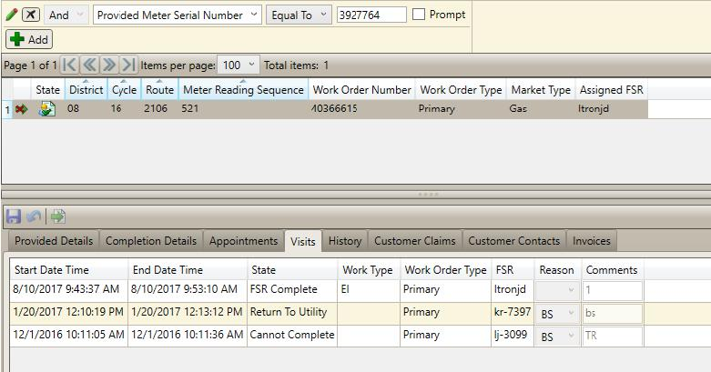
ILXJ And Provided Meter Serial Number "
Equal To
3927764
- Prompt
AddJ
Page 1 of 1 1S « 2) >1 Items per page: 100 " Total items: 1
State District Cycle Route Meter Reading Sequence Work Order Number Work Order Type Market Type Assigned FSR
1 t. ‘2 08 16 2106 521 "10366615 Primary Gas ltronjd
A • I
ed Detail etion Details Appointments Visits LIfistglikomer tomerContal
Con
Start Date Time End Date Time State
8/10/2017 9:43:37 AM 8/10/2017 9:53:10 AM FSR Complete
Work Type Work Order Type FSR Reason Comments
El Primary Itronjd
1/20/2017 12:10:19 PM 12/1/201610:11:05 AM
1/20/2017 12:13:12 PM 12/1201610:11:36 AM
Return To Utility Cannot Complete
Primary kr-7397 BS
Primary lj-3099 BS
bs
TR

"Exhibit
B"

Exhibit Package Page 11

Meter# 3921164
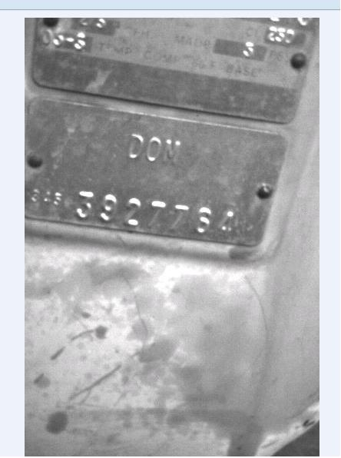

"Exhibit B"

Exhibit Package Page 12

As found read before the ERT retrofit
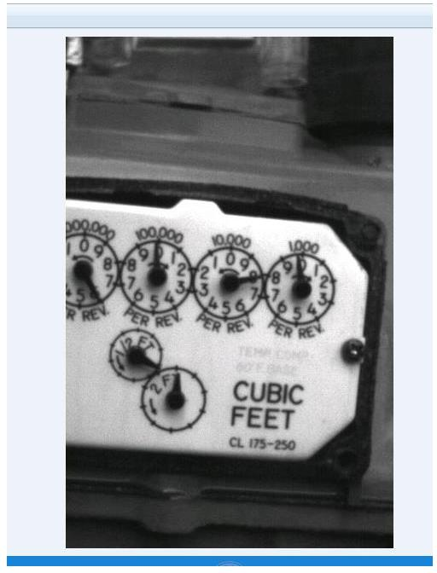

"Exhibit B"

Exhibit Package Page 13

ERT# 95197907 Installed – As left index read
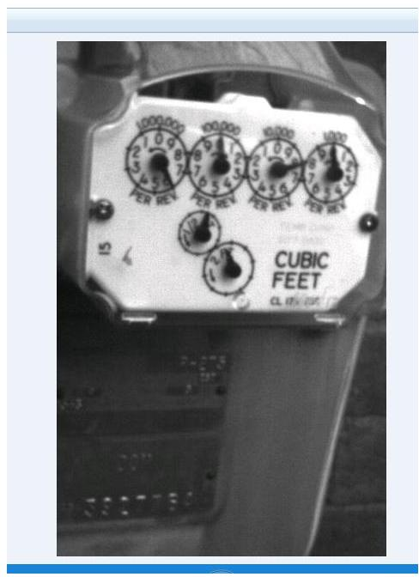

"Exhibit B"

Exhibit Package Page 14

ERT retrofit complete
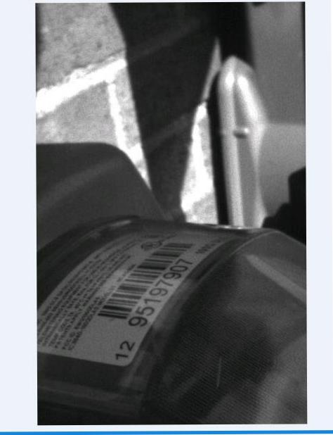

"Exhibit B"

Exhibit Package Page 15

EXHIBIT C

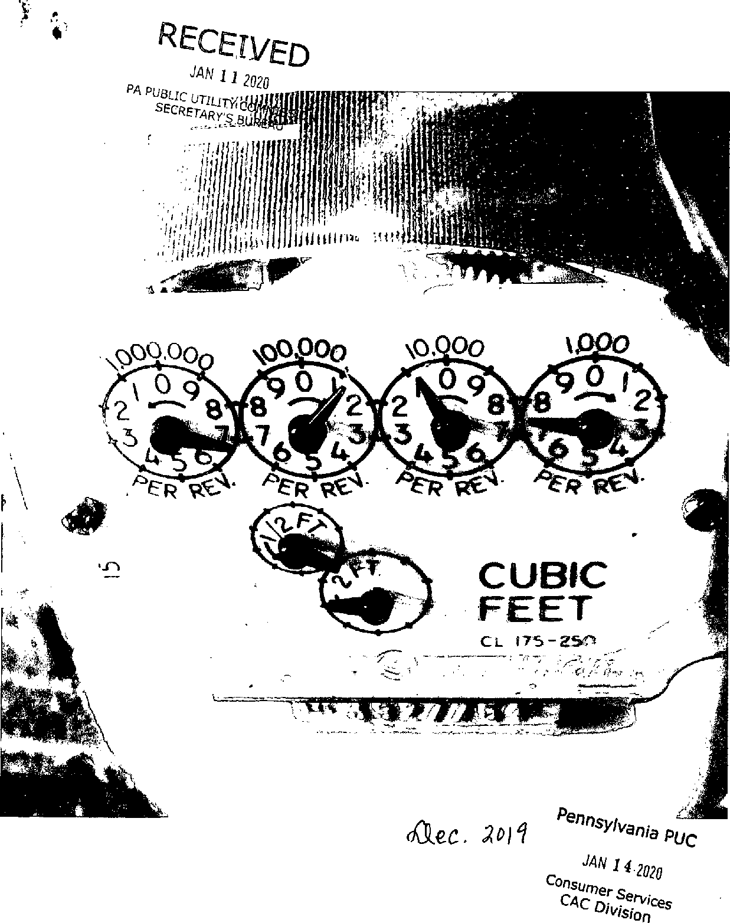
Exhibit Package Page 16
"Exhibit C"

Exhibit Package Page 17

EXHIBIT D

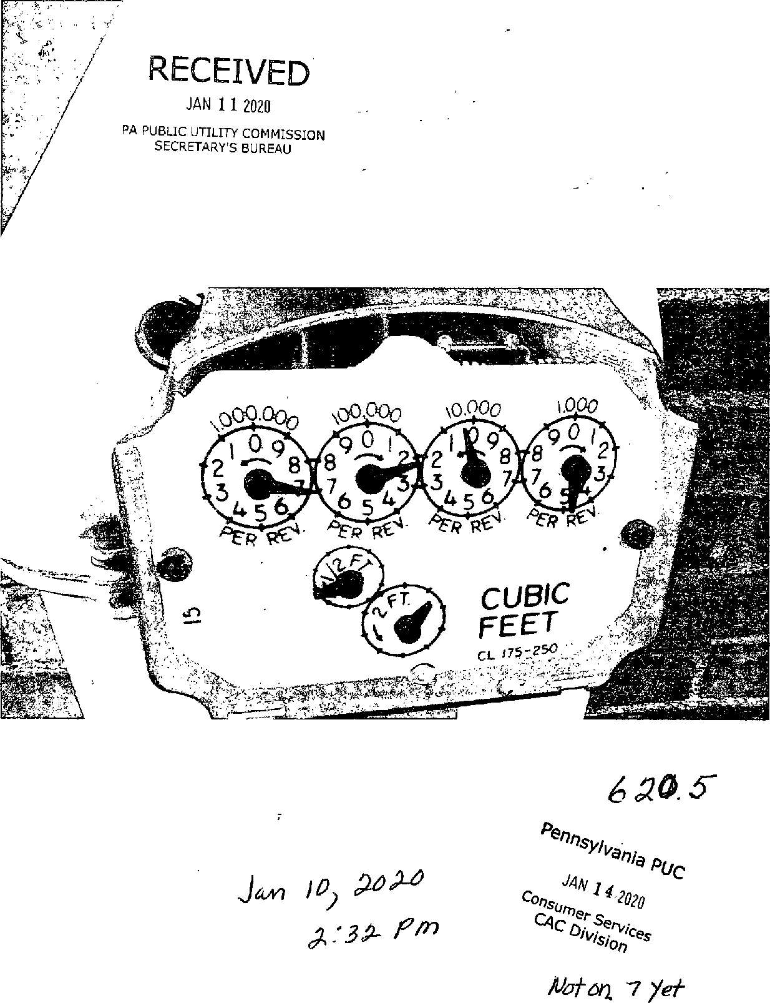
Exhibit Package Page 18
"Exhibit D"


"Exhibit D"
 | Exhibit Package Page 19



Exhibit Package Page 20

EXHIBIT E

2013
Service To | Meter  Reading | Reading  Type | Gas (MCF) | ^{Degree}  Days | Days
9/19/2012 | 374.1 | EST | 1.2 | 41 | 28
10/18/2012 | 374.5 | ACT | 0.4 | 302 | 29
11/19/2012 | 379.0 | EST | 4.5 | 630 | 32
12/19/2012 | 382.0 | ACT | 3.0 | 714 | 30
1/18/2013 | 391.1 | EST | 9.1 | 982 | 30
2/20/2013 | 401.3 | ACT | 10.2 | 1,221 | 33
3/21/2013 | 409.3 | EST | 8.0 | 885 | 29
4/23/2013 | 413.4 | ACT | 4.1 | 597 | 33
5/22/2013 | 414.9 | EST | 1.5 | 170 | 29
6/20/2013 | 415.4 | ACT | 0.5 | 89 | 29
7/22/2013 | 415.9 | EST | 0.5 | 0 | 32
8/22/2013 | 416.9 | ACT | 1.0 | 12 | 31
Total |  |  | 44.0 | 5,642

2017
Service To | Meter  Reading | Reading  Type | Gas (MCF) | ^{Degree}  Days | Days
9/21/2016 | 558.2 | EST | 0.5 | 0 | 30
10/20/2016 | 558.7 | ACT | 0.5 | 136 | 29
11/21/2016 | 563.3 | EST | 4.6 | 520 | 32
12/21/2016 | 568.5 | ACT | 5.2 | 912 | 30
1/23/2017 | 578.2 | EST | 9.7 | 953 | 33
2/21/2017 | 586.3 | ACT | 8.1 | 827 | 29
3/22/2017 | 593.7 | EST | 7.4 | 779 | 29
4/21/2017 | 595.8 | ACT | 2.1 | 307 | 30
5/22/2017 | 596.4 | EST | 0.6 | 217 | 31
6/21/2017 | 597.1 | ACT | 0.7 | 37 | 30
7/21/2017 | 597.6 | EST | 0.5 | 8 | 30
8/21/2017 | 598.1 | ACT | 0.5 | 0 | 31
Total |  |  | 40.4 | 4,693

2014
Service To | Meter  Reading | Reading  Type | Gas (MCF) | ^{Degree}  Days | Days
9/23/2013 | 417.6 | EST | 0.7 | 72 | 32
10/22/2013 | 418.1 | ACT | 0.5 | 156 | 29
11/21/2013 | 422.8 | EST | 4.7 | 624 | 30
12/20/2013 | 428.8 | ACT | 6.0 | 977 | 29
1/22/2014 | 438.8 | EST | 10.0 | 1,193 | 33
2/21/2014 | 451.5 | ACT | 12.7 | 1,276 | 30
3/24/2014 | 460.2 | EST | 8.7 | 1,036 | 31
4/23/2014 | 464.0 | ACT | 3.8 | 503 | 30
5/23/2014 | 465.0 | EST | 1.0 | 243 | 30
6/24/2014 | 466.2 | ACT | 1.2 | 15 | 32
7/23/2014 | 466.7 | EST | 0.5 | 4 | 29
8/22/2014 | 467.4 | ACT | 0.7 | 20 | 30
Total |  |  | 50.5 | 6,115

2018
Service To | Meter  Reading | Reading  Type | Gas (MCF) | ^{Degree}  Days | Days
9/20/2017 | 599.0 | EST | 0.9 | 58 | 30
10/19/2017 | 599.1 | ACT | 0.1 | 94 | 29
11/20/2017 | 605.1 | EST | 6.0 | 653 | 32
12/20/2017 | 610.5 | ACT | 5.4 | 830 | 30
1/22/2018 | 624.2 | EST | 13.7 | 1,404 | 33
2/20/2018 | 633.7 | ACT | 9.5 | 883 | 29
3/21/2018 | 640.9 | EST | 7.2 | 804 | 29
4/20/2018 | 647.0 | ACT | 6.1 | 688 | 30
5/21/2018 | 648.5 | EST | 1.5 | 165 | 31
6/21/2018 | 648.8 | ACT | 0.3 | 20 | 31
7/20/2018 | 649.3 | EST | 0.5 | 0 | 29
8/20/2018 | 650.2 | ACT | 0.9 | 0 | 31
Total |  |  | 52.1 | 5,596

2015
Service To | Meter  Reading | Reading  Type | Gas (MCF) | ^{Degree}  Days | Days
9/22/2014 | 468.1 | EST | 0.7 | 75 | 31
10/23/2014 | 468.9 | ACT | 0.8 | 266 | 31
11/21/2014 | 473.8 | EST | 4.9 | 659 | 29
12/23/2014 | 481.5 | ACT | 7.7 | 911 | 32
1/23/2015 | 491.3 | EST | 9.8 | 1,122 | 31
2/23/2015 | 503.4 | ACT | 12.1 | 1,356 | 31
3/24/2015 | 511.3 | EST | 7.9 | 970 | 29
4/23/2015 | 513.2 | ACT | 1.9 | 436 | 30
5/22/2015 | 513.9 | EST | 1.7 | 204 | 29
6/23/2015 | 514.8 | ACT | -0.1 | 34 | 32
7/23/2015 | 515.3 | EST | 0.5 | 4 | 30
8/21/2015 | 516.6 | ACT | 1.3 | 0 | 29
Total |  |  | 49.2 | 6,034

2019
Service To | Meter  Reading | Reading  Type | Gas (MCF) | ^{Degree}  Days | Days
9/19/2018 | 650.7 | EST | 0.5 | 11 | 30
10/18/2018 | 651.4 | ACT | 0.7 | 177 | 29
11/19/2018 | 657.6 | EST | 6.2 | 748 | 32
12/19/2018 | 663.0 | ACT | 5.4 | 945 | 30
1/21/2019 | 673.4 | EST | 10.4 | 1,051 | 33
3/5/2019 | 687.7 | ACT | 14.3 | 1,521 | 43
4/3/2019 | 694.0 | ACT | 6.3 | 754 | 29
5/3/2019 | 695.3 | ACT | 1.3 | 260 | 30
6/4/2019 | 696.1 | ACT | 0.8 | 126 | 32
7/3/2019 | 696.8 | ACT | 0.7 | 18 | 29
8/2/2019 | 697.4 | ACT | 0.6 | 0 | 30
9/3/2019 | 698.0 | ACT | 0.6 | 1 | 32
Total |  |  | 47.8 | 5,610

2016
Service To | Meter  Reading | Reading  Type | Gas (MCF) | ^{Degree}  Days | Days
9/22/2015 | 517.1 | EST | 0.5 | 8 | 32
10/21/2015 | 517.1 | ACT | 0.0 | 204 | 29
11/19/2015 | 520.0 | EST | 2.9 | 374 | 29
12/21/2015 | 524.7 | ACT | 4.7 | 755 | 32
1/25/2016 | 535.1 | EST | 10.4 | 1,163 | 35
2/23/2016 | 546.2 | ACT | 11.1 | 931 | 29
3/23/2016 | 551.2 | EST | 5.0 | 569 | 29
4/22/2016 | 554.8 | ACT | 3.6 | 438 | 30
5/23/2016 | 556.7 | EST | 1.9 | 256 | 31
6/23/2016 | 556.7 | ACT | 0.0 | 14 | 31
7/22/2016 | 557.2 | EST | 0.5 | 2 | 29
8/22/2016 | 557.7 | ACT | 0.5 | 0 | 31
Total |  |  | 41.1 | 4,712

2020
Service To | Meter  Reading | Reading  Type | Gas (MCF) | ^{Degree}  Days | Days
10/2/2019 | 698.4 | ACT | 0.4 | 9 | 29
11/1/2019 | 699.8 | ACT | 1.4 | 337 | 30
12/4/2019 | 708.4 | ACT | 8.6 | 906 | 33
1/3/2020 | 717.9 | ACT | 9.5 | 876 | 30
2/4/2020 | 727.8 | ACT | 9.9 | 941 | 32
3/3/2020 | 736.2 | ACT | 8.4 | 887 | 28
4/2/2020 | 741.1 | ACT | 4.9 | 574 | 30
5/1/2020 | 744.5 | ACT | 3.4 | 496 | 29
6/2/2020 | 746.6 | ACT | 2.1 | 261 | 32
7/1/2020 | 747.3 | ACT | 0.7 | 7 | 29
8/3/2020 | 747.9 | ACT | 0.6 |  | 30
8/31/2020 | 748.5 | ACT | 0.6 |  | 31
Total |  |  | 50.5 | 5,292

PEOPLES NATURAL GAS  Gas Usage Comparison  Name Jacquelyn Njai Acct. Num. 210000538202 Address 7801 Lloyd Ave Apt 116  Pittsburgh, PA 15218-1944 | Exhibit Package Page 21 | Page 1 of 1

Exhibit Package Page 22

EXHIBIT F

Please detach and return this coupon with a check made payable to Versi Peoples. een TO MAKE ACCOUNT CHANGES ON BACK OF COUPON, CHECK BOX HERE.

Exhibit Package Page 23
JACQUELYN NJAI
7801 LLOYD AVE APT 116 PITTSBURGH PA 15218-1944

For 24/7 account access: peopleseaccount.com
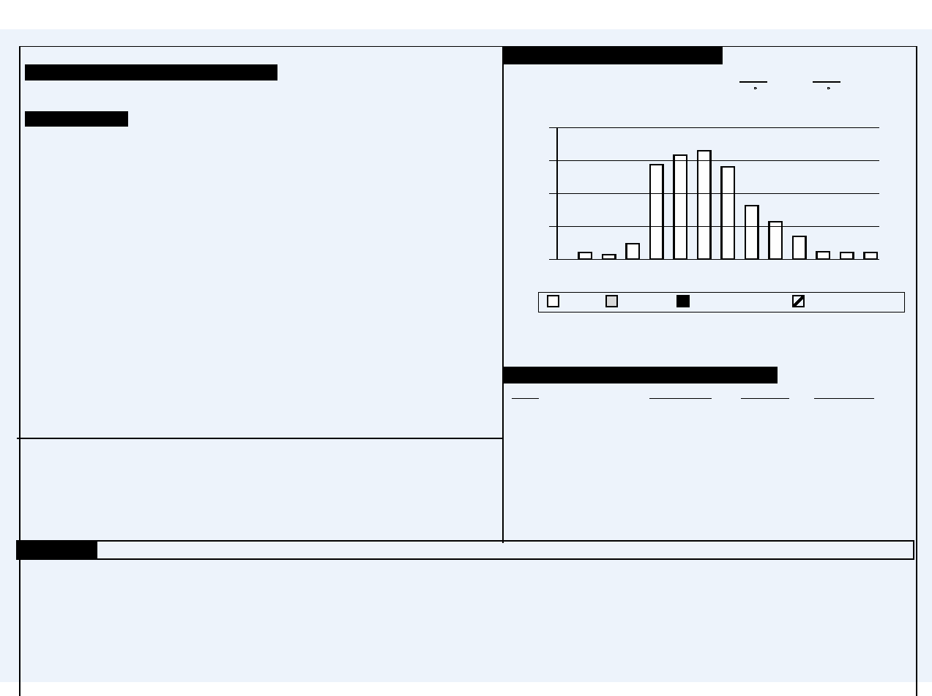
Account Number Date Prepared Next Meter Reading B
210000538202 Sep 1, 2020 10/29 - 10/30/2020 05
Please Pay
Total Current Charges $18.89
Total Account Balance $474.62
Summary of Basic Charges
Credits And Charges Since Your Last Bill
Balance from last bill $455.73
Balance $455.73
Current Charges
Residential (RS)(P)
Customer Charge - 1 Month $14.50
Commodity Charge $1.4833 per MCF .89
Delivery Charge
0.6 MCF @ $4.1500 2.49
Capacity Charge $1.7167 per MCF 1.03
DSIC Surcharge 0.13% .02 CR
Peoples current charges include $0.25 in state taxes.
Your PRICE TO COMPARE is $1.48 per MCF.
Shopping Information Box
When shopping for gas with a Natural Gas Supplier please provide the following:
Effective April 1, 2020, the Distribution System Improvement Charge (DSIC) decreased from 0.00 % to -0.13 %.
This charge funds the repair, improvement and replacement of natural gas pipelines and related infrastructure.
Did you forget to pay last month’s bill? As of Sep 1, 2020 , your account is past due. Please pay the full amount due
by Sep 23, 2020 . If you have already paid it, thank you. If you need assistance, you can make payment arrangements
by calling us at 1-800-764-0111.
Help people without heat or light by donating to the Dollar Energy Fund. Please add $1 to your monthly gas payment.
You can pay this bill by Credit / Debit Card or Electronic Check. Call ACI Speedpay at 1-866-338-5491.
Service Fees Apply. Visit our website at www.peoples-gas.com for further information.
Account Number: 210000538202
Rate Schedule: Residential (RS)(P)
If you are already shopping, know your contract expiration date.
Account Balance of $474.62 by SEP 23, 2020
For General Information call 1-800-764-0111. For an Emergency call 1-800-400-4271. Avoid an estimate - call in a read between 09/30 and by 5 p.m. on 10/01/2020.
Date Read Type Reading Difference
Meter Number 3927764
AUG 31, 2020 Actual 748.5 0.6
JUL 31, 2020 Actual 747.9
MCF Used in 31 Days 0.6
Monthly Usage Comparison
Average Daily Temperature 2019 2020
For This Billing Period 72 F 74 F
Gas Use in MCF
Billing Period And Meter Readings
12
9
6
3
0
2019
Actual Estimate Customer Read
Aug Sep Oct Nov Dec Jan Feb Mar Apr May Jun Jul Aug
Average monthly use: 4.2 MCF
Total annual use: 50.5 MCF
Adjusted Usage
2020


DUE DATE
Account Balance Amount Enclosed
$474.62
SEP 23, 2020
Account No.
210000538202

8394 804000768726

Take advantage of our Budget Payment Plan. Enjoy the convenience of paying a planned amount each month - a feature which is especially helpful during the winter.We periodically review budget accounts to adjust for any over or under payments.

JACQUELYN NJAI
7801 LLOYD AVE APT 116
PITTSBURGH PA 15218-1944 PEOPLES
PO BOX 644760
PITTSBURGH, PA 15264-4760
10002100005382020000000001889000000474629

Exhibit Package Page 24

EXHIBIT G

Exhibit Package Page 25

Ventyx Order Details Report

Order Header Information
Order Number |  | 60415159 |  | Zone |  | WILKZN09 |  | Scheduling Area |  | WILKZN09
Order Type |  | MC01 - Meter Maintenance |  | Priority |  | Utility Request Work |  | Owner |  | PNGC
Maint. Activity Type |  | RFB - Read for Billing |  | Appt Type |  | ALL DAY |  | Business Unit for Order |  | Field Metering Services
Order Status |  | 5 - Completed |  | Assigned To |  | George H Nelson |  | Business Unit for Technician |  | Field Metering Services
Location Information
Account # | 210000538202 |  | Premise |  | 60372561 |  | Tap Id | 6119065158
Name | Jacquelyn Njai |  | Premise Type |  | APT |  | Latitude | 40.42263667
Address | 7801 Lloyd Ave, Apt |  | Phone |  | 4129805746 |  | Longitude | -79.87727833
Address |  |  | Investment # |  | 65158
City | Pittsburgh |  | Zip Code |  | 15218-1944
State | PA |  | Call Ahead Requested |  | NO
Remarks | READ FOR BILLING CALLER NAME: CALLER'S TELEPHONE NUMBER:

Scheduling Information
SAP Created At | 12/12/2019 | 12:03:39
Created On Date | 12/12/2019 | 12:03:40 PM
Allocated Date
Dispatched Date | 12/12/2019 | 12:03:40 PM
Received Date | 12/13/2019 | 7:25:56 AM
Acknowledged Date
Enroute Date | 12/13/2019 | 9:44:00 AM
Onsite Date | 12/13/2019 | 9:56:35 AM
Suspended Date
Completed Date | 12/13/2019 | 10:01:51 AM
Canceled Date
Completed By | GEOR006 - George H Nelson
Completion Code | C - Complete
Completion Remarks | 711,5

Job Information
Riser Size | 1
Riser Type | NORM
ERT Number | ITRON ROCKWELL RESIDENTIAL ERT 100G DLS
ROM Number | N/A
Equipment (Old) | 3927764
Meter Kind & Size | 345 - 345 ROCKWELL 275 AL TC
Meter Location | Outside
Mainline Number | 2542
Mainline Pressure | L
Main 2 Curb Length | 1
Main 2 Curb Inches | 00
Measure Left Length | 26
Measure Left Inches | 00
Measure Right Length | 99
Measure Right Inches | 00
Marker Ball | N/A
Maintenance Plan | 7609
Read Route | 2106
Reader Codes | N/A
SLLS Due | N
Credit Detail
Amount | $0.00
Payment Amount | $0.00
Arrears Amount | $0.00
Collection Past Due | $0.00
New Security Deposit | $0.00
Reconnect Fee | $0.00
Current Bill | $0.00

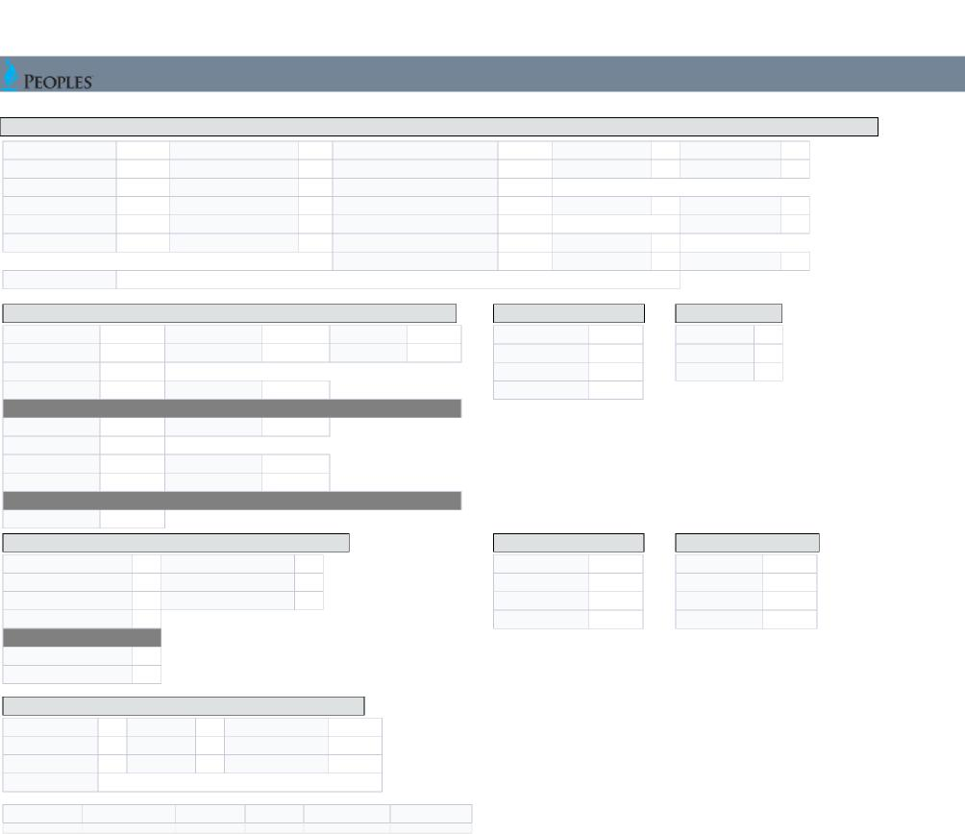
Status Left
Status Found
Appliance Code
Red Tag Reason
Red Tag Indicator
No Action Indicator
Exhibit Package Page 26
Meter Update
Completion Detail (If Any)
Meter Number | 3927764 | Meter Read | 7115 | Read Type | ACTUAL | Meter Inside Outside | O | Cannot Read | N/A
ERT Number | 95197907 | ROM Number | N/A | Remote Read | N/A | Meter Location Code | N/A | Cannot Read Reason | N/A
Meter Status (Found As) | ON | Curb Box Status (Found As) | ON | Curb Valve Inspected? | N/A
Meter Status (Left As) | ON | Curb Box Status (Left As) | OFF | 3 Way Valve |  | Lock Type N/A |  | Used Force Pump | N/A
Change Meter? | NO | Office Review | N/A | Riser Survey Completed - No Change | N/A |  |  | Performed Line Test | N/A
Meter Disconnected? | N/A | Left CGI Card | N/A | Riser Mfg. | NORM | Riser Size | 1
 |  |  |  | Gas Off? | N/A | ER Category | N/A | Damage | N/A
Completion Remarks 711,5

New Meter Number New ERT Number | N/A | New Meter Read ROM Number | # | New Meter K&S N/A
New Meter Number New ERT Number | N/A | New Meter Read ROM Number | N/A | New By Pass N/A
No ERT on Meter | #
Latitude | 40.42263667 | Longitude -79.87727833
Service Line Information (CSET and MVM Orders Only)
Regulator Installed | N/A | Regulator Type N/A
Marker Ball | N/A
Curb Box Left Feet | N/A | Curb Box Left Inch | N/A
Curb Box Right Feet | N/A | Curb Box Right Inch | N/A
AMR Meter Maintenance Only
New ERT Installed? N/A

Install/Change
House Line  HL Used Instrument | N/A
HL Test Pressure | N/A
HL Leak | N/A
HL Test Time | N/A

Dial Test
Dial Size
Dial Hand Move
Dial Time
N/A
N/A
N/A
Cold Weather Survey (PTS)
CWS Completion Code
N/A
Alternate Heat Source
N/A
N/A
Plans to Restore Gas Service
N/A
Gas Service Status
CWS Customer Name
Contact Relation
Occupants
No. of Members 60+
No. of Members less than 14
N/A
N/A
N/A
N/A
Electric Meter On?
N/A
Exterior Service Line
Internal Service Line
SL Used Instrument
N/A
ISL Outside Meter
N/A
SL Test Pressure
N/A
ISL Test
N/A
SL Leak
N/A
ISL Leak
N/A
SL Test Time
N/A
ISL No Test
N/A
High Bill Check
House/Room Temp | N/A | H/L Status | N/A | Residents Code | N/A
Thermostat Set | N/A | H/L Trace | N/A | Number of Occupants | N/A
Water Heater Temp | N/A | Foreign Load | N/A | Customer Satisfied | N/A
Src of Foreign Load | N/A

Exhibit Package Page 27

Manifold Met
Manifold Meter Meter Read Meter Read Type

5236879 | N/A | N/A

Exhibit Package Page 28

EXHIBIT H

Exhibit Package Page 29

Ventyx Order Details Report

Order Header Information
Order Number | 60417612 | Zone | WILKZN09 | Scheduling Area | WILKZN09
Order Type | MC01 - Meter Maintenance | Priority | Utility Request Work | Owner | PNGC
Maint. Activity Type | RFB - Read for Billing | Appt Type | ALL DAY | Business Unit for Order | Field Metering Services
Order Status | 5 - Completed | Assigned To | Kelly Fisher | Business Unit for Technician | Field Metering Services

Location Information
Account # | 210000538202 | Premise | 60372561 | Tap Id | 6119065158
Name | Jacquelyn Njai | Premise Type | APT | Latitude | 40.42263667
Address | 7801 Lloyd Ave, Apt | Phone | 2175722327 | Longitude | -79.87727833
Address | 7801 Lloyd Ave, Apt | Investment # | 65158
City | Pittsburgh | Zip Code | 15218-1944
State | PA | Call Ahead Requested | NO
Remarks | READ FOR BILLING PLEASE READ METER. CUSTOMER FILED COMPLAINT STATING METER HAS BEEN MISREAD. PLEASE VERIFY THE FIRST DIAL IS 7 SINCE IT HAS BEEN SLOW TO CROSS OVER FROM 6.

Job Information

Scheduling Information
SAP Created At | 01/21/2020 | 15:44:02
Created On Date | 01/21/2020 | 3:44:03 PM
Allocated Date
Dispatched Date | 01/21/2020 | 3:44:03 PM
Received Date | 01/22/2020 | 7:05:34 AM
Acknowledged Date
Enroute Date | 01/22/2020 | 10:21:39 AM
Onsite Date | 01/22/2020 | 10:27:29 AM
Suspended Date
Completed Date | 01/22/2020 | 11:03:21 AM
Canceled Date
Completed By | FISHERK - Kelly Fisher
Completion Code | C - Complete
Completion Remarks | CORRECT READ

Credit Detail
Amount | $0.00
Payment Amount | $0.00
Arrears Amount | $0.00
Collection Past Due | $0.00
New Security Deposit | $0.00
Reconnect Fee | $0.00
Current Bill | $0.00

Riser Size | 1
Riser Type | NORM
ERT Number | ITRON ROCKWELL RESIDENTIAL ERT 100G DLS
ROM Number | N/A
Equipment (Old) | 3927764
Meter Kind & Size | 345 - 345 ROCKWELL 275 AL TC
Meter Location | Outside
Mainline Number | 2542
Mainline Pressure | L
Main 2 Curb Length | 1
Main 2 Curb Inches | 00
Measure Left Length | 26
Measure Left Inches | 00
Measure Right Length | 99
Measure Right Inches | 00
Marker Ball | N/A
Maintenance Plan | 7609
Read Route | 2106
Reader Codes | N/A
SLLS Due | N

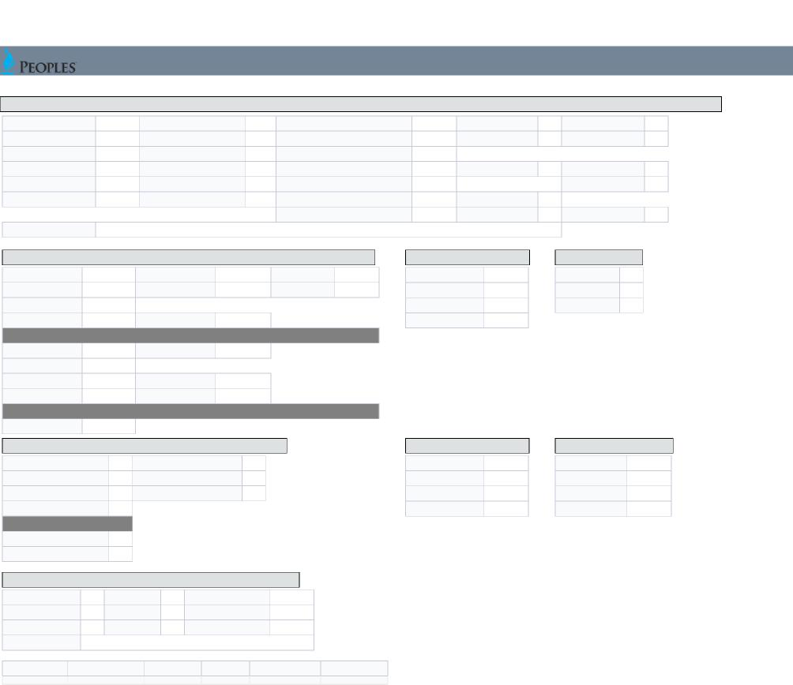
Status Left
Status Found
Appliance Code
Red Tag Reason
Red Tag Indicator
No Action Indicator
Exhibit Package Page 30
Meter Update
Completion Detail (If Any)
Meter Number | 3927764 | Meter Read | 7242 | Read Type | ACTUAL | Meter Inside Outside | O | Cannot Read | N/A
ERT Number | 95197907 | ROM Number | N/A | Remote Read | N/A | Meter Location Code | N/A | Cannot Read Reason | N/A
Meter Status (Found As) | ON | Curb Box Status (Found As) | ON | Curb Valve Inspected? | N/A
Meter Status (Left As) | ON | Curb Box Status (Left As) | ON | 3 Way Valve |  | Lock Type N/A |  | Used Force Pump | N/A
Change Meter? | NO | Office Review | TRUE | Riser Survey Completed - No Change | N/A |  |  | Performed Line Test | N/A
Meter Disconnected? | N/A | Left CGI Card | N/A | Riser Mfg. | NORM | Riser Size | 1
 |  |  |  | Gas Off? | N/A | ER Category | N/A | Damage | N/A
Completion Remarks

New Meter Number New ERT Number | N/A | New Meter Read ROM Number | # | New Meter K&S N/A
New Meter Number New ERT Number | N/A | New Meter Read ROM Number | N/A | New By Pass N/A
No ERT on Meter | #
Latitude | 40.42263667 | Longitude -79.87727833
Service Line Information (CSET and MVM Orders Only)
Regulator Installed | N/A | Regulator Type N/A
Marker Ball | N/A
Curb Box Left Feet | N/A | Curb Box Left Inch | N/A
Curb Box Right Feet | N/A | Curb Box Right Inch | N/A
AMR Meter Maintenance Only
New ERT Installed? N/A

Install/Change
House Line  HL Used Instrument | N/A
HL Test Pressure | N/A
HL Leak | N/A
HL Test Time | N/A

Dial Test
Dial Size
Dial Hand Move
Dial Time
N/A
N/A
N/A
CORRECT READ
Cold Weather Survey (PTS)
CWS Completion Code
N/A
Alternate Heat Source
N/A
N/A
Plans to Restore Gas Service
N/A
Gas Service Status
CWS Customer Name
Contact Relation
Occupants
No. of Members 60+
No. of Members less than 14
N/A
N/A
N/A
N/A
Electric Meter On?
N/A
Exterior Service Line
Internal Service Line
SL Used Instrument
N/A
ISL Outside Meter
N/A
SL Test Pressure
N/A
ISL Test
N/A
SL Leak
N/A
ISL Leak
N/A
SL Test Time
N/A
ISL No Test
N/A
High Bill Check
House/Room Temp | N/A | H/L Status | N/A | Residents Code | N/A
Thermostat Set | N/A | H/L Trace | N/A | Number of Occupants | N/A
Water Heater Temp | N/A | Foreign Load | N/A | Customer Satisfied | N/A
Src of Foreign Load | N/A

Exhibit Package Page 31

Manifold Met
Manifold Meter Meter Read Meter Read Type

5236879 | N/A | N/A

Exhibit Package Page 32

EXHIBIT I

Exhibit Package Page 33
Readings on Meter/Device Number 3927764
210000538202
Jacquelyn Njai
7801 Lloyd Ave. Apt. 116
Pittsburgh PA 15218-1944
The following is a list of readings on the meter from the company Customer Information System prior to
July 2012 when customer established service. The meter readings from July 2012 to present can be
found on customer’s Statement of Account.
The dial to the far left of this 4 dial meter is labeled on the meter as the 1,000,000 dial. This was prepared to show this dial makes a full revolution every two years or longer as follows:
3 – from February 2011 to February 2013 or 2 years
4 – from February 2014 to February 2015 or 2 years
5 – from February 2015 to October 2017 or 2 years and 7 months
6 – from November 2017 to December 2019 – or 2 years and 1 month
7 – from December 2019 to present
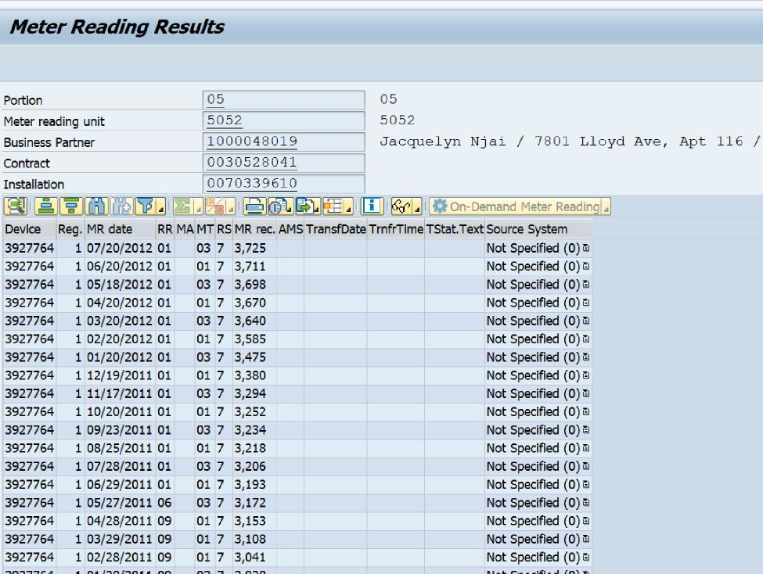
C-2020-3016134 - JACQUELYN N'JAI v. PEOPLES NATURAL GAS COMPANY LLC
JACQUELYN N’JAI
7801 LLOYD AVENUE
APT 116
PITTSBURGH PA 15218
217.572.2327
jredeemed@gmail.com
JENNIFER PETRISEK ESQUIRE
PEOPLES NATURAL GAS COMPANY LLC
375 NORTH SHORE DRIVE
PITTSBURGH PA 15212
412.208.6834
ACCEPTS E-SERVICE
Jennifer.Petrisek@peoples-gas.com

