PENNSYLVANIA
PUBLIC UTILITY COMMISSION

IN THE MATTER OF : A-00122829

Application of Martin Enterprises, t/a Martin CFS, 1038 New Holland Avenue, Lancaster, Lancaster County, PA 17601. 717-945-6583 To transport, as a common carrier, by motor vehicle, Household Goods in Use, between points in Pennsylvania. A-2021-3024827

EFFECTIVE: June 17, 2021

The Pennsylvania Public Utility Commission hereby certifies that after an investigation and/or hearing, it has, by its report and order made and entered, found and determined that the granting of the application is necessary or proper for the service, accommodation, convenience and safety of the public and hereby issues to the applicant this CERTIFICATE OF PUBLIC CONVENIENCE evidencing the Commission's approval to operate as a motor carrier.

In Witness Whereof, The PENNSYLVANIA PUBLIC UTILITY COMMISSION has caused these presents to be signed and sealed, and duly attested by its Secretary at its office in the city of Harrisburg this 17th day, of June, 2021.
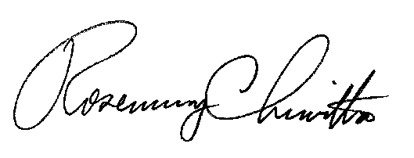

Secretary

