 | COMMONWEALTH OF PENNSYLVANIA  PENNSYLVANIA PUBLIC UTILITY COMMISSION  P.O. BOX 3265, HARRISBURG, PA 17105-3265 | IN REPLY PLEASE REFER TO OUR FILE
June 17, 2021

A-00122829

A-2021-3024827

Martin Enterprises
t/a Martin CFS
1038 NEW HOLLAND AVE
LANCASTER PA 17601

RE: Application of Martin Enterprises, t/a Martin CFS, 1038 New Holland Avenue, Lancaster, Lancaster County, PA 17601. 717-945-6583 To transport, as a common carrier, by motor vehicle, Household Goods in Use, between points in Pennsylvania. A-2021-3024827

To Whom It May Concern:

The records of the Commission show that the applicant has complied with the necessary requirements.

Enclosed, is the CERTIFICATE OF PUBLIC CONVENIENCE evidencing the Commission's approval of the right to operate as a motor carrier. The number on the Certificate, which is also the first A# at the top of this page, is the PA P.U.C. No. which should be used for identification markings on the vehicle(s).

Certificate holder is advised to become familiar with the requirements of 52 Pa. Code. Failure to comply with all applicable requirements may subject the carrier to penalties, including fines suspension of operating rights or cancellation of authority. Title 52 of the Pennsylvania Code may be accessed on the World Wide Web at www.pacode.com.

Kindly attach the enclosures to the compliance order previously issued and mailed to you.

Very truly yours,
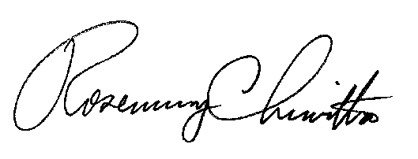

Rosemary Chiavetta
Secretary

NW

