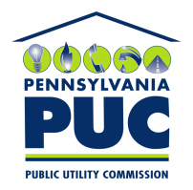 | COMMONWEALTH OF PENNSYLVANIA  PENNSYLVANIA PUBLIC UTILITY COMMISSION  400 North Street, Keystone Building, Second Floor  Harrisburg, Pennsylvania 17120 | IN REPLY PLEASE REFER TO OUR FILE
June 23, 2021

Via Certified Mail

Joe Colia
Park Power LLC
2098 West Chester Pike Suite 200
Broomall PA 19008

RE: Bond Verification Certificate
Park Power LLC
A-2012-2328664

Dear Mr. Colia:

Please find under cover of this letter the financial instrument filed on behalf of Park Power LLC because it is not acceptable.

The Commission requires a supplier to file an original bond, letter of credit, continuation certificate, amendment, or other financial instrument as part of a supplier’s licensing requirements under Section 2809(c) of the Pennsylvania Public Utility Code, including naming the Pennsylvania Public Utility Commission as the beneficiary or obligee of the security instrument along with all other required information on the document.

The enclosed Continuation Certificate names “Metropolitan Edison Company and/or Pennsylvania Electric Company” as the Obligee.

As the current Bond Continuation on file which lists Pennsylvania Public Utility Commission as the Obligee is valid through April 1, 2022, no further action is required at the time.

Sincerely,

Rosemary Chiavetta
Secretary of the Commission

Enclosures
RC:alw

