BEFORE THE
PENNSYLVANIA PUBLIC UTILITY COMMISSION

PENNSYLVANIA PUBLIC UTILITY COMMISSION :
BUREAU OF INVESTIGATION AND ENFORCEMENT :
:
V. : DOCKET NO. C-2021-3026447
:
TAKOUKAM TRADING LLC T/A AMERICAN TAXI :
2907 GREEN STREET :
HARRISBURG PA 17110 :

COMPLAINT

The Pennsylvania Public Utility Commission (Commission) is a duly constituted agency of the Commonwealth of Pennsylvania empowered to regulate public utilities within the Commonwealth. The Commission has delegated its authority to initiate proceedings which are prosecutory in nature to the Bureau of Investigation and Enforcement and other bureaus with enforcement responsibilities. Pursuant to that delegated authority and Section 701 of the Public Utility Code, the Bureau of Investigation and Enforcement hereby represents as follows:

- That Takoukam Trading, LLC, t/a American Taxi, Respondent, maintains its principal place of business at 436 South Cameron Street, Harrisburg, Pennsylvania, 17101, and has a mailing address of 2907 Green Street, Harrisburg, Pennsylvania, 17110.

- That Respondent was issued a certificate of public convenience for taxi authority by this Commission on July 13, 2017, at PUC utility code no. 6319785.

- That on May 24, 2021, the Commission received a complaint alleging violations of the PUC regulations.

- That on June 8, 2021, PUC Enforcement Officer Travis Griffith inspected a 2005 Toyota bearing registration no. TX50706 and vehicle identification no. JTDBE32K653031978 at the Harrisburg Transportation Center, 4th & Market Streets, Harrisburg, Dauphin County, Pennsylvania. The following violations were found:

- The inspection sticker had expired.
- The vehicle was more than ten years old.

- That Officer Griffith, along with Supervisor Alan Taylor, travelled to Respondent’s physical location 436 South Cameron Street, Harrisburg, Dauphin County, Pennsylvania, and met with owner Fiacre (Max) Takaoka. Officer Griffith requested Respondent bring in the other vehicles operated by Takaoka Trading for inspection.

- That Officer Travis Griffith inspected a 2008 Mitsubishi bearing registration no. TX50687 and vehicle identification no. 4A3AB36F88E015429. The following violations were found:

- The vehicle was more than ten years old.

- That the drivers of both vehicles stated they do not use the vehicle’s meter to calculate fares, but instead charge a flat rate for trips. There were no trip sheets being maintained by either driver.

- Officer Griffith and Supervisor Taylor also conducted an inspection of driver records for the employees during the meeting on June 8, 2021, at Respondent’s physical location specified in paragraph 5.

- Respondent failed to obtain and review a criminal history for three employees before allowing them to operate a vehicle.
- Respondent failed to obtain and review a driver history report for three employees before allowing them to operate a vehicle.
- Respondent allowed one driver to operate who is disqualified due to being convicted of a felony or misdemeanor relating to the suitability of the driver to provide safe and legal service.

- That Respondent, by allowing a vehicle to operate with an expired inspection sticker decal, violated 52 Pa. Code §29.405 and 75 Pa. C.S. §4703(a). The penalty for this violation is $250.00.
- That Respondent, by allowing a vehicle to operate which is more than ten years in age, violated 52 Pa. Code §29.314(c). The penalty for this violation is $500 per violation for a total penalty amount of $1,000.00.

- That Respondent, by failing to calculate the fare in accordance with the current tariff rates on file with and approved by the Commission, violated 52 Pa. Code §29.314(b)(6) The fine for this violation is $500.00.

- That Respondent, by permitting a driver to operate before obtaining and reviewing a recent criminal history, violated 52 Pa. Code §29.505(b)(1). The penalty for this violation is $250.00 per violation for a total penalty amount of $750.00.

- That Respondent, by permitting a driver to operate without obtaining and reviewing a driver history report, violated 52 Pa. Code §29.504(b)(1). The penalty for this violation is $100.00 per violation for a total penalty amount of $300.00.

- That Respondent, by allowing drivers to operate a taxicab when, due to their criminal history, they were neither qualified nor suitable to provide safe transportation to the public, violated 52 Pa. Code §29.505(b)(1). The penalty for this violation is $1,000.00.

WHEREFORE, the Bureau of Investigation and Enforcement hereby requests that the Commission fine Takoukam Trading LLC t/a American Taxi the sum of three thousand and eight hundred dollars ($3,800.00) for the illegal activity described in this Complaint and order such other remedy as the Commission may deem to be appropriate.

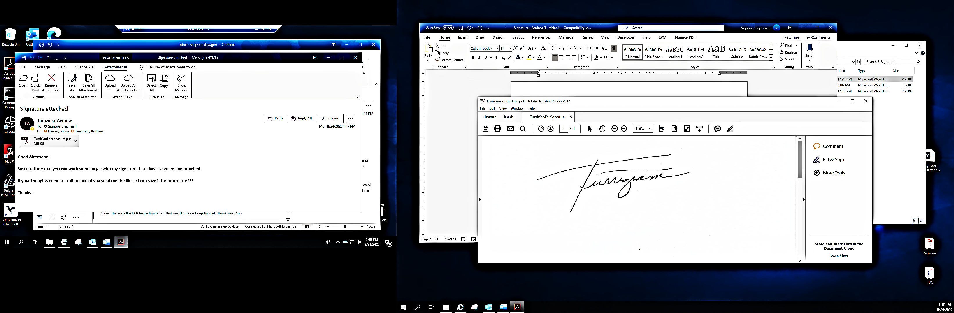
Respectfully submitted,

________________________________
Andrew Turriziani, Chief
Motor Carrier Enforcement
Bureau of Investigation and Enforcement
400 North Street
Harrisburg, PA 17120

VERIFICATION

I, Andrew Turriziani, hereby state that the facts above set forth are true and correct to the best of my knowledge, information, and belief and that I expect that the Bureau will be able to prove same at any hearing held in this matter. I understand that the statements herein are made subject to the penalties of 18 Pa. C.S. §4904 relating to unsworn falsification to authorities.

Date: ____July 2, 2021_____ ____________________________
Andrew Turriziani, Chief
Motor Carrier Enforcement
Bureau of Investigation and Enforcement

NOTICE

- You must file an Answer within twenty (20) days of the date of service of this Complaint. The date of service is the mailing date as indicated at the top of the Secretarial Cover Letter for this Complaint and Notice, 52 Pa. Code §1.56(a). An Answer is a written explanation of circumstances wished to be considered in determining the outcome. The Answer shall raise all factual and legal arguments that you wish to claim in your defense and must include the reference number of this Complaint. Your Answer must be verified, and the original shall be mailed to:

Rosemary Chiavetta, Secretary
Pennsylvania Public Utility Commission
400 North Street, 2nd Floor
Harrisburg, Pennsylvania 17120

Or you may eFile your Answer using the Commission’s website at www.puc.pa.gov. The link to eFiling is located under the Filing & Resources tab on the homepage. If your Answer is 250 pages or less, you are not required to file a paper copy. If your Answer exceeds 250 pages, you must file a paper copy with the Secretary’s Bureau.

Additionally, a copy should either be mailed to:

Michael L. Swindler, Deputy Chief Prosecutor
Bureau of Investigation and Enforcement
Pennsylvania Public Utility Commission
400 North Street, 3rd Floor
Harrisburg, Pennsylvania 17120

Or, e-mailed to Mr. Swindler at: RA-PCCmplntResp@pa.gov

- If you fail to answer this complaint within twenty (20) days, the Bureau of Investigation and Enforcement will request that the Commission issue a Secretarial Letter imposing a penalty. The penalty could include a fine, the suspension or revocation of your certificate of public convenience or other remedy.

- You may elect not to contest this complaint by paying the fine proposed in this Complaint by certified check or money order. Payment must be made to the Commonwealth of Pennsylvania and should be forwarded to:

Rosemary Chiavetta, Secretary
Pennsylvania Public Utility Commission
400 North Street, 2nd Floor
Harrisburg, Pennsylvania 17120

- Your payment is an admission that you committed the alleged violation and an agreement to cease and desist from further violations. Upon receipt of your payment, the complaint proceeding shall be closed.

- If you file an Answer, which admits or fails to deny the allegations of the Complaint, the Bureau of Investigation and Enforcement will request that the Commission issue a Secretarial Letter imposing a penalty.

- If you file an Answer which contests the Complaint, the matter will be assigned to an Administrative Law Judge for hearing and decision. The judge is not bound by the optional fine set forth above.

- Alternative formats of this material are available for persons with disabilities by contacting the Commission’s ADA Coordinator at 717-787-8714.

