|  |  |  |
| --- | --- | --- |
|  | COMMONWEALTH OF PENNSYLVANIA  PENNSYLVANIA PUBLIC UTILITY COMMISSION  400 NORTH STREET, HARRISBURG, PA 17120 | **IN REPLY PLEASE REFER TO OUR FILE** |

July 6, 2021

A-2021-3026215

A-00104300,F.1Am-A

PARKS MOVING SYSTEMS INC

740 COMMONWEALTH DRIVE

WARRENDALE PA 15086

### Cancellation of Certificate of Public Convenience

**Parks Moving Systems, Inc.**

**A-00104300,F.1Am-A**

To Whom It May Concern:

We have received notification of your intention to abandon/discontinue the common carrier service authorized at **A-00104300**, as required by 52 Pa. Code §3.381(a)(5).

**YOU ARE ADVISED:** That the certificate(s) issued at **A-00104300,F.1Am-A**, be and is ***cancelled***, and all rights, powers and privileges granted thereby shall forthwith cease and terminate. Carrier ***does not*** hold other active authority.

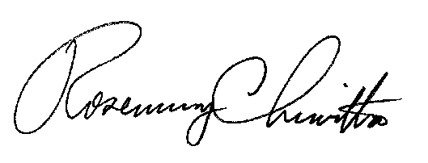 Very truly yours,

Rosemary Chiavetta

Secretary

#### Cc: Secretary’s Bureau – File

Bureau of Investigation and Enforcement – Safety Office