 | COMMONWEALTH OF PENNSYLVANIA  PENNSYLVANIA PUBLIC UTILITY COMMISSION  P.O. BOX 3265, HARRISBURG, PA 17105-3265 | IN REPLY PLEASE REFER TO OUR FILE

C-2021-3026714

Date of Service: July 6, 2021

GREENS TAXI INC
310 GRANT STREET SUITE 2310
PITTSBURGH, PA 15219

PENNSYLVANIA PUBLIC UTILITY COMMISSION
BUREAU OF INVESTIGATON & ENFORCEMENT
v.
GREENS TAXI INC

Dear Sir/Madam:

Please be advised that the attached complaint has been filed against you by the Bureau of Investigation & Enforcement.

Detailed instructions on how to proceed are contained in the NOTICE section, and you are advised to read everything carefully or consult with your attorney.

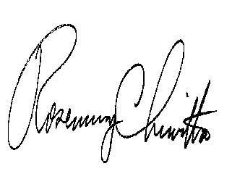
Very truly yours,

Rosemary Chiavetta
Secretary

Attachments

NW

