 | COMMONWEALTH OF PENNSYLVANIA  PENNSYLVANIA PUBLIC UTILITY COMMISSION  P.O. BOX 3265, HARRISBURG, PA 17105-3265 | IN REPLY PLEASE REFER TO OUR FILE

C-2021-3026622

Date of Service: July 14, 2021 RESERVE

NATIONAL MEDTRANS LLC
992 S 2ND STREET
RONKONKOMA, NY 11779

PENNSYLVANIA PUBLIC UTILITY COMMISSION
BUREAU OF INVESTIGATON & ENFORCEMENT
v.
NATIONAL MEDTRANS LLC

Dear Sir/Madam:

Please be advised that the attached complaint has been filed against you by the Bureau of Investigation & Enforcement.

Detailed instructions on how to proceed are contained in the NOTICE section, and you are advised to read everything carefully or consult with your attorney.

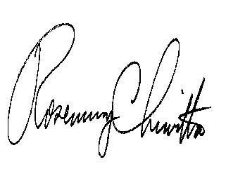
Very truly yours,

Rosemary Chiavetta
Secretary

Attachments

nw

