 | COMMONWEALTH OF PENNSYLVANIA  PENNSYLVANIA PUBLIC UTILITY COMMISSION  P.O. BOX 3265, HARRISBURG, PA 17105-3265 | IN REPLY PLEASE REFER TO OUR FILE

C-2021-3027142

Date of Service: July 14, 2021

EXTREME HEALTH CARE SERVICES LLC
1916 NORTH 4TH STREET
HARRISBURG PA 17102

PENNSYLVANIA PUBLIC UTILITY COMMISSION
BUREAU OF INVESTIGATON & ENFORCEMENT
v.
EXTREME HEALTH CARE SERVICES LLC

Dear Sir/Madam:

Please be advised that the attached complaint has been filed against you by the Bureau of Investigation & Enforcement.

Detailed instructions on how to proceed are contained in the NOTICE section, and you are advised to read everything carefully or consult with your attorney.

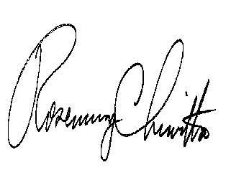
Very truly yours,

Rosemary Chiavetta
Secretary

Attachments

NW

